March 1, 2021

United Nations Global Compact

Transparency and Disclosure Team

685 3rd Ave

New York, NY 10017

Dear Sir/Madam,

**Request for Grace Period on Extension of Submitting Communication on Progress (COP).**

We recognize that a key requirement for participation in the UN Global Compact is the annual preparation and posting of a Communication on Progress (COP) that comprises of a CEO statement of continued support for the UN Global Compact, a description of practical actions with regard to the principles of the UN Global Compact, and a measurement of outcomes or expected outcomes.

We would like to request an additional 90 days to the current COP deadline, with a new COP submission date of 5/30/2021. We make this request so that we can be aligned to the launching of our annual ESG/Sustainability report, external website changes, etc.

We hereby ask for an extension period in order to be able to post a COP that describes our company’s efforts and progress to implement the principles of the UN Global Compact. Our new COP report will be posted on the UN Global Compact website by 5/30/2021 at the latest.

Sincerely yours,

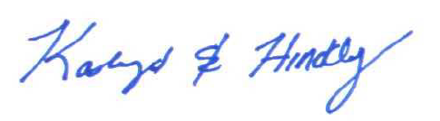

Kathryn Hinckley