11 February 2021

To our stakeholders:
We recognize that a key requirement for participation in the UN Global Compact is the annual preparation and posting of a Communication on Progress (COP) that comprises of a CEO statement of continued support for the UN Global Compact, a description of practical actions with regard to the principles of the UN Global Compact, and a measurement of outcomes or expected outcomes.
We are late in creating, sharing and posting our COP report due to all resources currently devoted to the build and development of our mid-term sustainability strategy which outlines our commitment to the Sustainable Development Goals, net zero and electronic waste reduction.
We hereby ask for an extension period in order to be able to post a COP that describes our company’s efforts and progress to implement the principles of the UN Global Compact. Our new COP report will be posted on the UN Global Compact website by 14 May 2021.
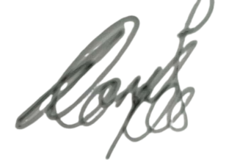
Sincerely yours,

Suhale Vorajee
Group Marketing Director

