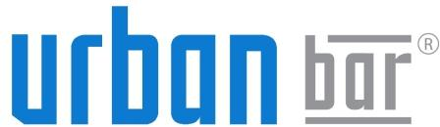

Sandbar AP Ltd, The Glasshouse, Highfields Business Park, Kneesworth, Royston Herts SG8 5JT United Kingdom
T: +44 (0)1763 244 473 F: +44 (0)1763 246 154
www.urbanbar.com

23.01.21
Could we please request a grace period of 90 days to complete our COPs.
A combination of staff redundancies, part time working and other CV19 related issues has unfortunately meant the completion of COPs have been neglected.

Thanks for your understanding
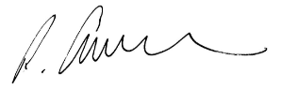

Richard Andrews

