Linklaters LLP
One Silk Street
London EC2Y 8HQ
Telephone (+44) 20 7456 2000
Facsimile (+44) 20 7456 2222
DX Box Number 10 CDE

UN Global Compact
New York

25 January 2021

Grace letter

Dear stakeholders
We recognize that a key requirement for participation in the UN Global Compact is the annual preparation and posting of a Communication on Progress (COP) that comprises of a CEO statement of continued support for the UN Global Compact, a description of practical actions with regard to the principles of the UN Global Compact and a measurement of outcomes or expected outcomes. We are pleased to have submitted our COP returns in a timely way every year since joining the UNGC.
This year, we are late in creating, sharing and posting our COP report. We are currently undertaking a wide review of future commitments related to sustainability and, with the COP report being one of our principle external communication channels, it seems appropriate to delay publishing this year’s return until it reflects our new set of priorities. We hereby ask for an extension period in order to be able to post a COP that better describes our efforts and progress to implement the principles of the UN Global Compact. Our new COP report will be posted on the UN Global Compact website by 30th April 2021 at the latest.
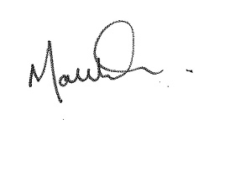
Yours faithfully

Matt Sparkes
Head of Sustainability
Linklaters LLP

