To our stakeholders:

We recognize that a key requirement for participation in the UN Global Compact is the
annual preparation and posting of a Communication on Progress (COP) that comprises of
a CEO statement of continued support for the UN Global Compact, a description of
practical actions with regard to the principles of the UN Global Compact, and a
measurement of outcomes or expected outcomes.
We are late in creating, sharing and posting our COP report due to COVID 19 restrictions
in our operating status and ability. We hereby ask for an extension period in order to be
able to post a COP that describes our company’s efforts and progress to implement the
principles of the UN Global Compact. Our new COP report will be posted on the UN Global
Compact website by 16th April 2021 at the latest.

Sincerely yours,
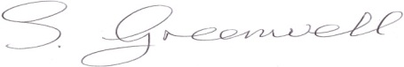
Stephen Greenwell | Director of QHSSE
e: stephengreenwell@securewest.com
t: +44(0)1548856001
w: www.securewest.com | www.spheretravelrisk.com | www.securewest-training.com | www.elearning.securewest.com

