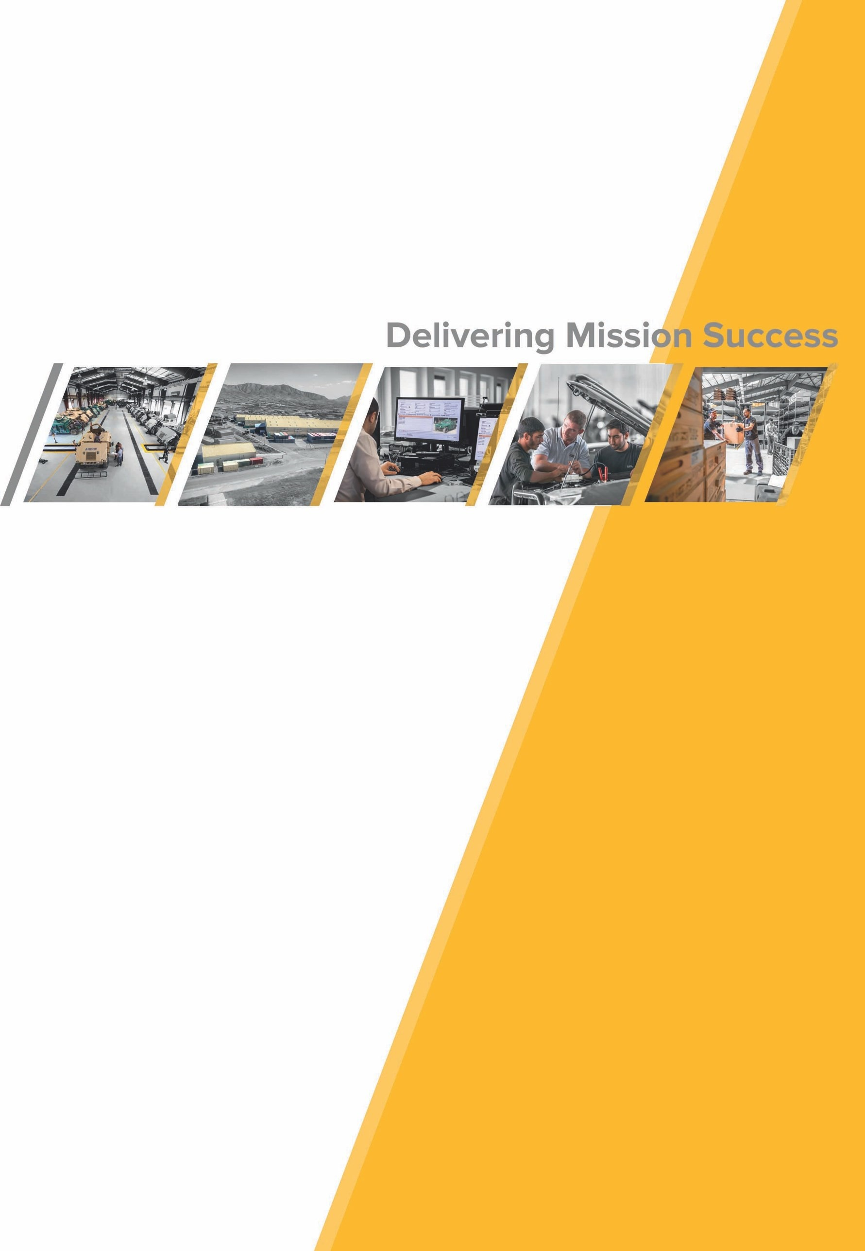

Sustainability Report
UNGC Communication on Progress 2019

Contents
Introduction 3
Our Stakeholders 4
Materiality 4
CEO Statement 6
Overview Of AMS 7
At a glance 8
Our History 8
Ethical & Responsible Operations 9
Statement from CFO 10
Board and Corporate Structure 11
Board of Directors 11
Corporate Structure 12
Compliance and Governance 13
Legal 13
Concerns regarding ethics 14
Delegating Authority 14
Risk and opportunity in our environment 15
Our top 3 Risks 15
Leadership team 16
Our Products and Services 17
Our Global Facilities Footprint 19
Supply Chain and Procurement 21
Suppliers 21
Supplier Ethics 21
Promoting sustainable procurement practices 22
Integrating Sustainability 22
Responsible Consumption 23
Managing Emission 23
Responsible Waste Management 24
Statement from Group HR Director 26
Our People 27
Training and Development 27
Our Diverse Workforce 28
Investing in Human Health 29
Safety at AMS 30
Sustainability Strategy for the Future 31
Aspirations 32
Delivering Value by Delivering on Our Purpose 32
Future initiatives 35

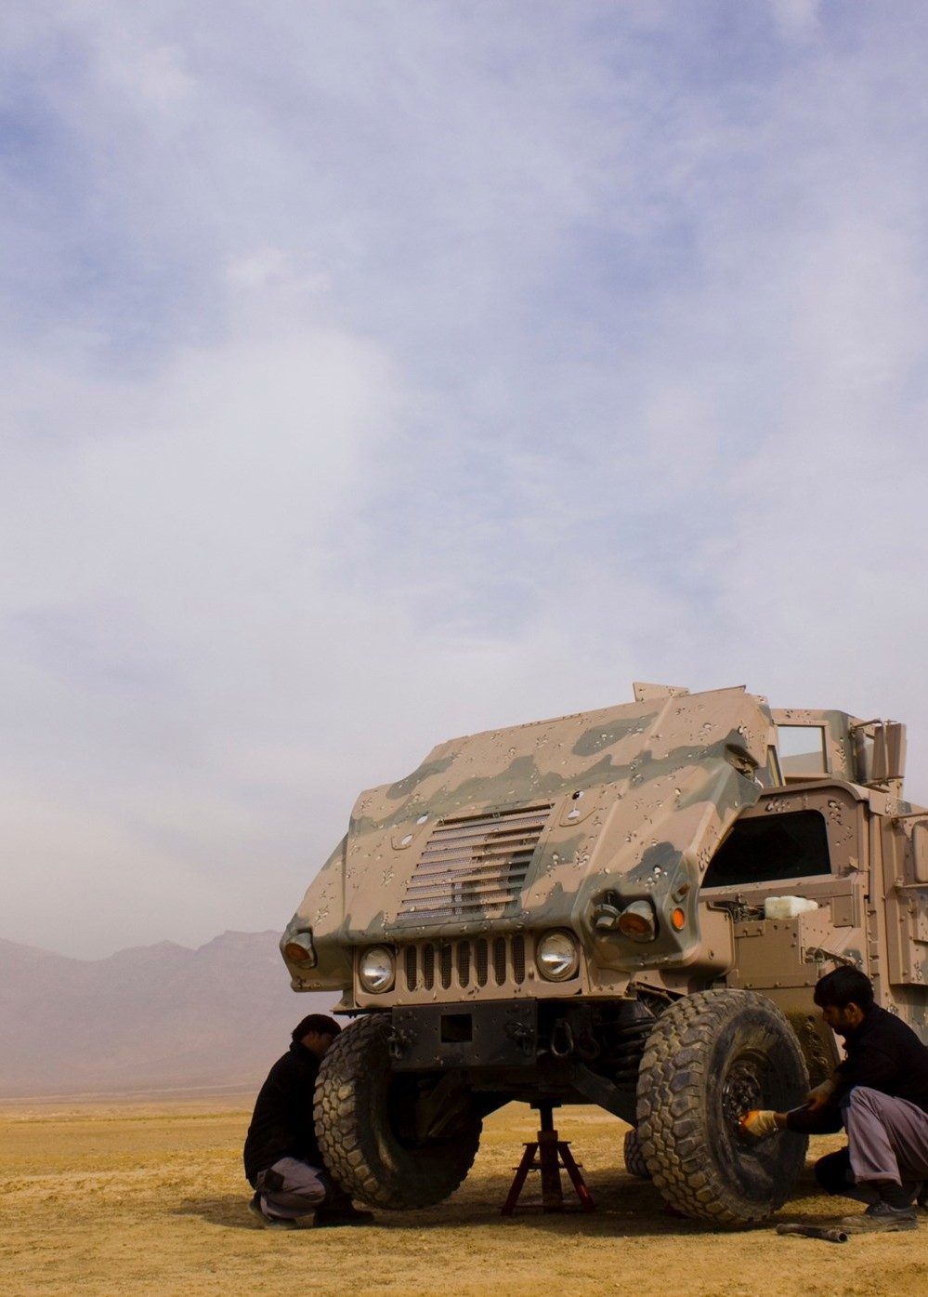
Introduction
3

The United Nations Global Compact is an international initiative that addresses human rights, labor, environmental and corruption issues through a commitment to ten principles. AMS has been a signatory to the UNGC since 2013. AMS subscribes to the 17 United Nation Sustainable Development Goals (SDGs) and 10 United Nations Global Compact (UNGC) principles within the sphere of our influence.

This 2018 UNGC Communication on Progress (COP) will further be referred to as our Sustainability Report. The content of the report is aligned with the UNGC’s Advanced level reporting and is intended as a stand-alone document. Primarily, the report summarizes activities occurring in the 2018 calendar year i.e.: 01 January 2018 to 31 December 2018. Further to this our sustainability report will be released annually in April, once financial audits are complete. The sustainability statements have not been independently assured by a credible third-party auditor. This report covers our global operations, including entities over which AMS exercises majority control, including operations and departments that have the potential to generate significant impacts.

We support public accountability and transparency, and welcome feedback from our stakeholders on our progress to promote the 10 UNGC principles and 17 United Nation Sustainable Development Goals (SDGs).

This COP is available on our website (www.ams.global) under the ‘Media Center’ section. Should you have any questions please direct these to info@ams.global for the Group HR Directors attention.

Our Stakeholders
We have determined the content for this report by including consideration of our operations and performance in the wider context of sustainability issues, as well as ensuring stakeholder inclusiveness, and completeness of information.

In context, everyone who is affected by our business, and everyone who affects it, is consider an AMS stakeholder. Engagement with our stakeholders - who include employees, suppliers, vendors, customers, communities, shareholders, governmental and nongovernmental organizations, industry peers and academics – enables us to strengthen our license to operate and brings increased concentration on our transparency goals. Given the fluidity of our business, when deciding who to engage or approach, we need to assess and define stakeholders for situations.

Materiality
This report is prepared in accordance with the International Integrated Reporting Council’s (IIRC) International Integrated Reporting Framework and provides our stakeholders with a concise and transparent assessment of our ability to use our financial expertise to do good and create sustainable value. For further information on the scope of the services performed by our external assurance providers please contact info@ams.global.

Reporting period | Annually per calendar year for the reporting period 01 January to 31 December. Submitted in April of the following year.  First UNGC Communication on Progress was submitted in 2013  Reporting was previously due in February however as of 2019 AMS changed the reporting to April to fall in line with the Annual Financial Statement audit release due to our intention of our sustainability being audited by an external  vendor in future.
Financial and non- financial reporting | The report extends beyond financial reporting and includes non-financial performance, opportunities, risks and outcomes attributable to or associated with our key stakeholders, which have a significant influence on our ability to  create value.
Targeted readers | This report is primarily intended to address the information requirements of long- term investors (our equity and preference shareholders, bondholders and prospective investors). We also present information relevant to the way we create value for other key stakeholders, including our staff, clients, regulators  and society.
Defining Value | Value creation is the consequence of how we apply and leverage our capitals in delivering financial performance (outcomes) and value (outcomes and outputs) for all stakeholders while making tradeoffs. Our value-creation process is embedded in our purpose described as part of our business model  and integrated into the way we think and make decisions.
Materiality | We apply the principle of materiality in assessing what information is to be included in our integrated report. This report focuses particularly on those issues, opportunities and challenges that impact materially on AMS and its ability to be a sustainable business that consistently delivers value to shareholders and our key stakeholders. Our material matters, influence our  group’s strategy and inform the content in this report.
Contact | To ask questions, add comments or make statement please contact  info@ams.global and have the email addressed to the Group HR Director.

4

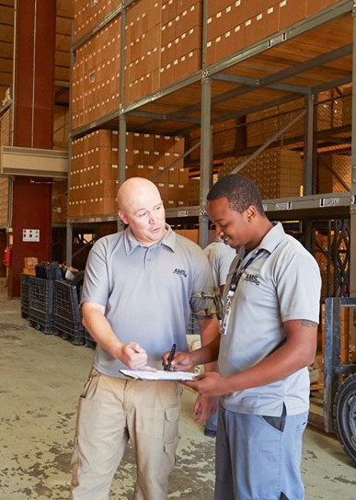
5

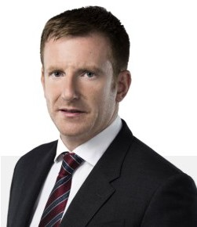
CEO Statement

AMS are pleased to reaffirm our continued commitment to the United Nations Global Compact, in accordance with its’s ten principles with respect to human rights, labor, environment and anticorruption. This confirmation follows our original commitment of 2013 and supports our intention to advance the principles.

In our capacity as global providers of resilient, cost-effective mission support solutions for governments and defense sector clients operating in high-risk locations, AMS supports and respects the protection of human rights within the Company’s scope of influence and endeavors to conduct our business operations accordingly.

Our reputation for integrity is central to achieving our commercial goals and leverages our corporate and social responsibilities. At AMS our corporate values drive our business success and we are devoted to protecting and strengthening our corporate culture. We therefore expect every AMS employee to uphold high professional and ethical standards in all business conduct.

The company has undergone significant growth, yet we continue to develop and sustain partnerships with communities, social entrepreneurs, governments, NGOs, and corporations worldwide. Our strategy remains aligned to the United Nations’ Sustainable Development Goals, focusing on increasing economic growth, access to quality education and fair employment, and taking steps to promote good health and well-being. By incorporating the Global Compact principles into our strategy, policies and procedures, and establishing a culture of integrity, AMS aspires to not only uphold our basic responsibilities to people and the planet, but also to set the stage for the long-term success of our stakeholders and our communities.

With the support of our shareholders, I firmly believe that AMS can only become stronger, whilst continuing our journey to deliver the best experience to all its stakeholders. The overarching goal is to deliver and continually surpass a high level of service excellence, innovation and dependability across our full range of products and solutions.

Yours sincerely,

Andrew Robertson Chief Executive Officer
Automotive Management Services

Overview Of AMS
Automotive Management Services (AMS) brings expertise, innovation, and service excellence across a broad range of mission solutions, providing resilient, long-term and cost-effective support to Government, Humanitarian and Commercial Organizations.

As a leading provider of mission support capabilities, we are committed to being at the forefront of technology and innovation, delivering superior capability in tandem with maximized cost efficiencies. A company-wide digital transformation has enabled us to simplify processes across all products and service offerings; driving improved compliance adherence and enhancing our non-operational processes.

AMS works closely with clients, enabling them to meet evolving mission sustainment requirements, technical training solutions, and supply chain and logistical needs; ensuring the highest standards of performance and mission readiness is achieved in rapidly changing and difficult environments.

With a well-established international presence, we maintain a network of offices and local businesses serving customers in the Americas, Africa, Central Asia, Europe and the Middle East. With a workforce of more than 3,400 members, we currently operate across more than 60 countries. AMS’s highly experienced team of professionals are dedicated to securing success for customers while upholding the highest standards of compliance, quality and integrity across all our operations.

As a business we pursue activities in mission sustainment, however, human resources and employee relationship management is critical to our success. We have created avenues for employees to voice their grievances anonymously and directly into executive management from anywhere in the world via any medium they choose. In addition, we have launched our own Learning Management System allowing us to continue investing in our people on a worldwide basis, through training and education, thereby furthering their professional development. As part of our social responsibility, we continue to create shared value in the areas in which we operate.

Brands we currently support are Navistar, Allison Transmission, Ford, Scania, Kalmar, Mack, Toyota, Cummins, Volvo Construction Equipment, Renault Trucks, Panhard, Textron, General Dynamics and AM General.
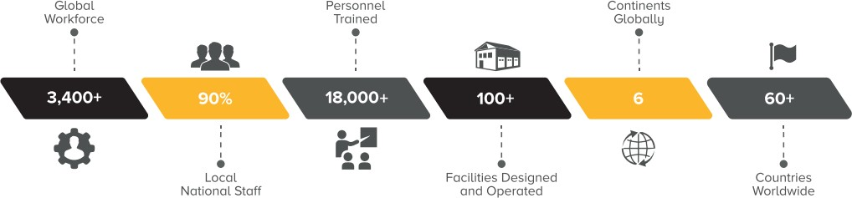

What makes AMS unique and differentiated?

Extremely experienced management teams
We have managed our expenses wisely over time and despite ongoing investment in the business to sustain future growth, we continue to look for cost optimization opportunities.

Selective deployment of our capital and funding bases to optimize economic outcomes

Unique corporate culture

At a glance

Operating in 60
Countries

Over 3400 Employees

5
Core Business Services

400 actively used suppliers

134,000
Vehicles and Equipment Globally

37
Nationalities

Our History
2001 -
2004
>Operations begin in Pristina, supporting NATO KFOR mission in Kosovo
>Service Centers opened in Iraq, Kenya and Afghanistan
>USG (US Government) awards Afghanistan Technical Equipment Program (A-TEMP) contract in Afghanistan to support the entire MOI vehicle fleet
>Navistar product support contract for 8,500 vehicles awarded in Iraq to support both MOI 2005 - and MOD
2010 >AMS wins NTV and HMMWV contracts in support of US Forces in Iraq
>USG awards components overhaul to AMS, providing support to the Afghan National Army
>Fleet Management contract is awarded by GSA for 6,500 vehicles in support of US Forces 2011 - >Liberia operations win United Nations contract for maintenance of fleet
2014
>AMS awarded authorized dealerships status for Navistar Defense in the UAE and Afghanistan
>Component overhaul average 3,500 units/mo
>Roads and Transport Authority contract to improve commercial vehicle workshop 2015 - standards in the UAE
2016 >USG contract to inspect and repair all incoming defense vehicles to the Afghan National
Defense Security Forces (ANDSF)

2017 -
Present
>Award of National Maintenance Strategy (NMS-GVM) by USG sees AMS doubling existing Afghanistan footprint to support MOD and MOI fleets
>United States Army Africa (USARAF) contract AMS to train officers from Central African Republic, Burundi, Cameroon, Gabon and Rwanda
>Opening of Saudi Arabia operations to support government fleets

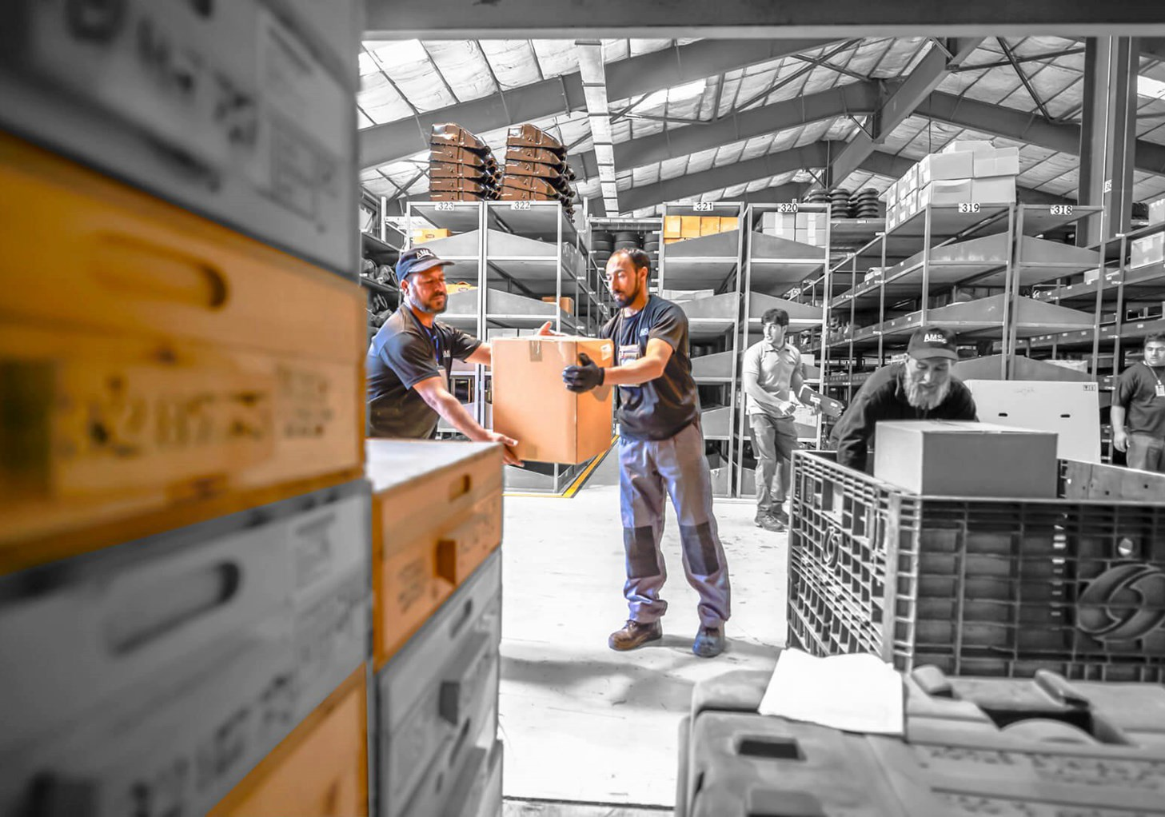
Ethical & Responsible Operations
9
We consistently put efforts to maintain a healthy and safe working environment for our employees and contractors, and safety is our top priority. Our organization is known for its efforts towards safety in the workplace and winning the trust of our customers. We protect our shareholders investment and actively collaborate with stakeholders and local communities.

AMS strongly stands beside its set of Core Values and Business Principles and requires every employee to comply.

Our Purpose | Our Vision | Our Values  - Can-Do attitude  - Integrity  - Innovative thinking  - Initiative  - Ownership  - Respect  - Teamwork
To exceed our customers’ | To be a trusted provider
expectations by consistently | of Integrated Mission
delivering service excellence, | Sustainment Solutions to
innovation and dependability | Government and Defense
across our full range of | organizations operating in
products and solutions. | remote and austere
 | environments.

Statement from CFO

This report represents a milestone in our evolution as a company. From our roots as a small company in 2001 providing expeditionary fleet sustainment services to NATO Forces in Kosovo during the Balkans conflict. Today, we continue to grow our operations, through a well-established international presence serving customers in the Americas, Africa, Central Asia, Europe and Middle East, becoming the leading fleet and equipment solutions provider to Governments and Defense sector clients with operations spanning across the globe – successfully managing and maintaining fleets, transferring knowledge and Creating Shared Value within the communities where we operate.

At AMS, the business is conducted in all respects according to the ethical, professional and legal standards. It is company policy to base all commercial decisions solely on commercial criteria which serves the company’s business interests and fosters constructive relationships with organizations and individuals doing business or seeking to do business with AMS. Further, the company implements a strict policy to not tolerate any fraud or corruption, including in the procurement or execution of contracts.

AMS conducts business with reputable customers, involved in legitimate business activities with funds derived from legitimate sources, as the company is fully committed in complying with anti-money laundering laws. The company further encourages its employees to report known and suspected business violations through channels set out in the Code of Business Ethics and Conduct without fear of retaliation.

We take pride in how our people operate ethically and with integrity while delivering excellence to our clients. At AMS, compliance is everyone’s responsibility. It's at the core of our corporate reputation, embedded in the work we do and is critical to our growth strategy.

As a continuous commitment to improve AMS’ policies and procedures, during 2018, we reviewed and updated all of our policies, developed and implemented a group-wide training and awareness program and advanced our audit capabilities and whistleblowing processes. Further, the entire AMS team is committed to upholding sound principles of financial reporting and corporate governance and to meeting the requirements of various regulatory institutions, including the governing laws and regulations.

Sincerely,

Rizwan Saleem
Chief Financial Officer
Automotive Management Services

Board and Corporate Structure

Board of Directors
Our board of directors provides strategic guidance to safeguard shareholder value creation within a framework of prudent and effective controls. This enables risk to be assessed and managed to ensure long-term sustainable development and growth. The board has ultimate accountability and responsibility for the performance and affairs of the company and ensures that the group adheres to high standards of ethical behavior.

A board director or prescribed officer is prohibited from using his or her position, or confidential and price-sensitive information as a benefit for himself or herself or any related third-party, whether financial or otherwise. Directors and officers are also required timeously to inform the board of conflicts, or potential conflicts of interest that they may have in relation to particular items of business or other directorships. The majority of AMS’s board members are independent directors, which ensures that the interests of the minority shareholders are protected. Comprehensive registers are maintained of individual directors’ interest in and outside the company and are updated and signed by the directors, with details noted by the board at each board meeting.

The board has some engagement with the business;
- Following an annual strategy session between the Senior Management of AMS, the board interrogates and approves the Business Strategic Framework
- The board conducts onsite visits to various operations and business units, while one-on-one meetings may be requested by individual members.
- The board is the highest governance body for the organization externally
- The CEO is the highest governing board member for AMS internally

The board are committed to fulfilling the following responsibilities;
- Ensure that a robust strategy process is defined and executed by management
- Drive compliance with appropriate legislation (including regulations), supervisory codes and appropriate best practices
- Protect the interests of the group’s stakeholders and ensure fair, responsible and transparent
people practices
- The board should ensure that there is a framework of prudent and effective controls

A member of the leadership team or management staff is prohibited from using their position or confidential and price-sensitive information to benefit themselves or any related third party, whether financially or otherwise. Any conflicts of interest must be reported as per our internal Conflict of Interest policy.

Corporate Structure
For the purpose of this report, the company, Automotive Management Services, refers to the companies privately owned 100% by OMNI Technical Solutions;
- Automotive Management Services FZ-LLC
- Automotive Management Services Middle East LLC
- AMS Mission Sustainment FZE
- No Lemon Automotive Management Services
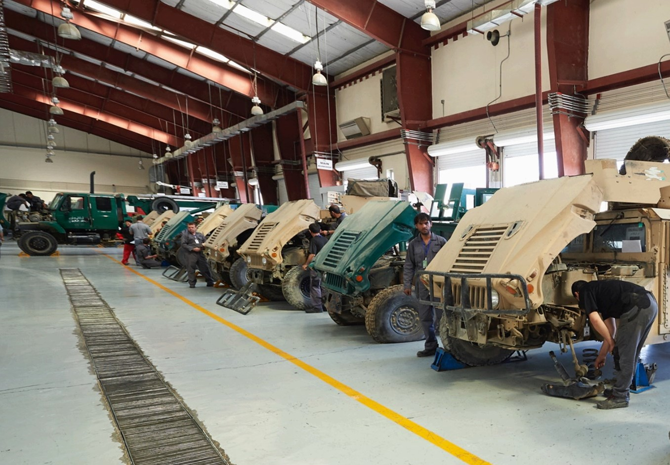
- National Maintenance Services

Compliance and Governance

AMS are committed to high standards of governance, ethics and integrity. We embrace best in class practices and robust institutional frameworks to ensure our services are secure and stable.

To ensure the fulfilment, correspondence or conformity within statutory laws, rules and policies, ISO standards, etc., AMS implemented a compliance department. This builds the framework to address topics related to compliance standards, anti-corruption, internal and external compliance incidents, conflict of interests, quality, facility, environment, security, safety, competition and antitrust to the executive board and management. The output of the compliance meetings includes decisions and actions related to these topics and supports initiatives for improvements.

We have a philosophy of doing business responsibly, which means doing business ethically, remembering that legal business is not always ethical business. Responsible or ethical business is based on a trust relationship with stakeholders. Trust is created by having a sound strategy and business offering, ethical leadership, and a commonly accepted set of values staff members live by, which in turn leads to effective governance, and risk and compliance management. All of this will help build our reputation, brand and shareholder value.

We are constantly reviewing these practices to ensure that we consistently act in the best interests of our stakeholders. Mission Support providers are expected to adapt to regulatory changes quickly, which means we have to entrench good governance practices, while retaining the flexibility to respond proactively to the fast-changing regulatory environment. We believe that good governance can contribute to living our values through enhanced accountability, strong risk and performance management, transparency and effective leadership.

AMS carry out internal audits to cover a vast array of areas of the business. This ensures our people and departments comply, with what we say we do in our policies and procedures.

The audits (both internal and external) are meticulous and examines every department of the business. Where gaps are highlighted, they are addressed, and an essential action plan is created and implemented. Once implemented periodic follow-up audits will take place to ensure non-compliances are completed to satisfactory levels. Additionally, AMS employ the services of external financial auditors (using one of the big four companies) to ensure financial governance is covered and meets our own internal standards of assurance and best practices.

AMS are ISO 9001 certified, which exemplifies our commitment to best international standards and how we strive to continually improve. Additionally, in 2019 any individuals or company that AMS enters into a contractual relationship with, are put through our due diligence protocols. The due diligence will be strengthened as we are currently implementing a due diligence software platform via Navex Global (called Risk-Rate). This will assist AMS via an automated due diligence solution to check individuals or companies against a raft of watch-lists and provide AMS with a risk evaluation based on the data received and presented to them.

Legal
2018 saw AMS extend is Compliance Department to include a Legal subsection. Due to our areas of operation, AMS have a high risk of non-compliance with a myriad of laws and regulations and risk of infringement of sanctions. We understood we needed to take additional ownership. The newly developed Legal department ensures that any legal aspects, potential clients, contracts etc. are filtered through the Business Compliance/Legal Department ensuring contractual relationships are above board, transparent and that risks are assessed and mitigated. To assess risks and opportunities, AMS

has implemented a Risk and Opportunity Management procedure to systematically identify, evaluate, and manage the whole range of AMS business risks and opportunities.

Concerns regarding ethics
AMS has a stringent Code of Ethics and Business Conduct, an Anti-Corruption and Anti-Money Laundering Policy along with a Whistleblowing Policy. These policies form an integral part of AMS and are distributed amongst stakeholders, including shareholders, personnel and third parties via AMS’s Document Control Management System, vendor agreements as well as through training programs.

Any Compliance Incidents are handled by Human Resources and the Business Compliance Departments, in accordance with AMS requirements. The findings shall be reported to the Board of Directors. If a violation has occurred, AMS will take such disciplinary or preventive actions, as it deems appropriate.

Our employees must report any, and all anti-corruption or human rights violations through our Whistle Blowing Hotline (managed either internally at top management level or to an independent external party (Light house), depending on the employee’s preference of where to report). To ensure that even illiterate employees understand about human rights, labor, anti-corruption or environmental issues and reporting, AMS have a local employee travel across all sites to teach the same, face to face in Dari, Pashtu or English. During the 2018 reporting year, no anti-corruption or human rights violations were reported.

Driving Ethical awareness
We promote ethical awareness by;
- Amongst our staff
  - Awareness training
  - Acknowledgement and declaration to follow policies such as the Code of Business Ethics, Whistleblowing, Anti-bullying and Victimization, Anti-corruption and Combatting Trafficking in persons
  - During every employee’s induction they are provided with ethics training as well as sign declarations that they comply with policy.
- Amongst our suppliers
  - Acknowledging our policies like the Code of Business Ethics and Combatting Trafficking in person for all suppliers when they are placed on the vendor list.

Enabling Reporting
AMS provide various means that an employee can report any ethical violations. The details for all the below are placed on highly viable areas (noticeboards) for employees to view. They can also find the details on the Document Control Management System.
- AMS whistle blowing hotline, email or phone available
- Lighthouse -external investigations company, email or phone available
- Face to Face

Delegating Authority
The AMS governance system is based on the delegation of responsibilities from the Board of Directors to CEO, and from CEO to the Vice Presidents (VPs) of the business areas and VPs of regions.

At the core of the governance system are AMS constituting documents (Memorandum and Articles of Association) and internal policies, including AMS Code of Business Ethics and Conduct, Delegation of Authority Policy. These documents describe how legal entities and employees are expected to carry out activities and operations and sets forth the limits of their authority to act.

Risk and opportunity in our environment
Our material matters are evident in our key risks and opportunities and represent the issues that have the most impact on our ability to create value. These change over time as new trends and developments shape the macro environment and our stakeholders’ needs evolve. We determine our material matters through the following process:

- Identify
Identify all issues that have the potential to impact our earnings sustainability and the ability to create value for our stakeholders. The process of identifying potential material matters is a groupwide responsibility requiring input from all business units and divisions and taking into account input and feedback from all our stakeholders. Areas of potential impact that are assessed, include financial, environmental, social, strategic, competitive, legislative, reputational and regulatory matters (including political and policy matters).

- Rank
Rank the issues identified according to greatest relevance in the current operating context and highest potential to impact significantly on the viability of our business and relationships with stakeholders.

- Apply and Validate
Apply the material matters lens to inform our long-term business strategies and targets as well as short-to-medium term business plans. This is done primarily through the execution of our strategy.

- Assess
Assess the material matters continuously to ensure that our strategy remains relevant.

Our top 3 Risks
The top 3 risks the organization will face in 2019 have been identified as;
- Business Risk
While we cannot mitigate political and economic risks, our proactive risk management practices seek to understand and prepare for the impacts of alternative outcomes on our business.

- Cyber Risk
Cyber risk continues to escalate exponentially in line with local and global trends, which has led us to separate it in isolation from the range of financial-crime risks.

- Market Risk
Volatile, uncertain, complex and ambiguous external environment.

Leadership team
Years of Tenure
10-15
6-9
3-6
0-3
5

4

3

2

1

0
Executive Leaderships Tenure at AMS
Number of Executives
Our leadership team brings together years of experience in Government and Private Sector, diverse perspectives and unique business insights. The team is responsible for setting the strategic direction of the company and supporting our passion for continual innovation.

A major strength of our leadership team is the diversity of our leadership team’s tenure. As the highest governance body, a Code of Conduct was developed by executives to start AMS’s stance on our mission and values, compliance and responsibilities, corporate ethical standards and respect for human rights, corporate sustainability, as well as Anti-Bribery & Corruption issues. A member of the leadership team or management staff is prohibited from using their position or confidential and price-sensitive information to benefit themselves or any related third party, whether financially or otherwise. Any conflicts of interest must be reported as per the Conflict of Interest policy.

Frequent Senior Management meetings are held to discuss an array of topics from financial, operational, compliance, technological, HR etc., where all current initiatives and upcoming ones are discussed, risks discussed, knowledge is shared and best practices are onboarded and enacted to constantly improve the company's standing in all of these areas.
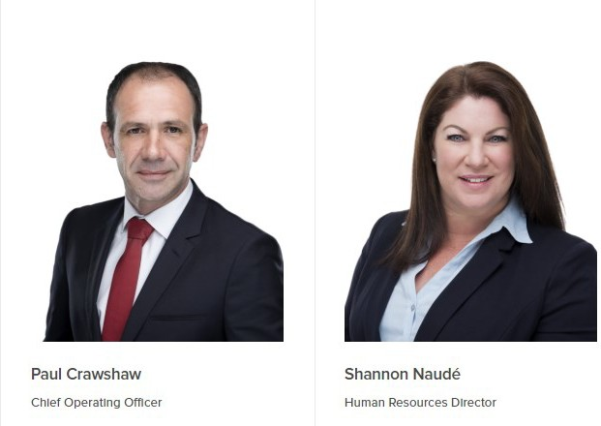
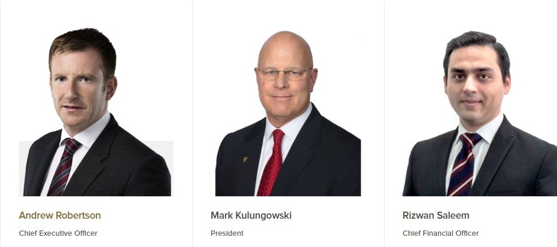
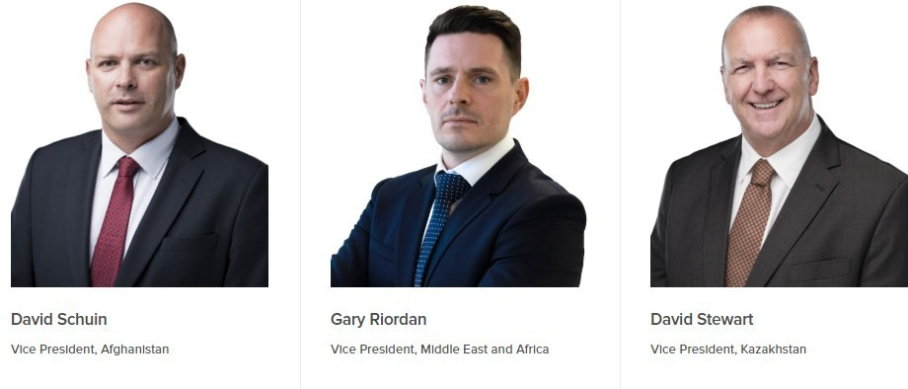
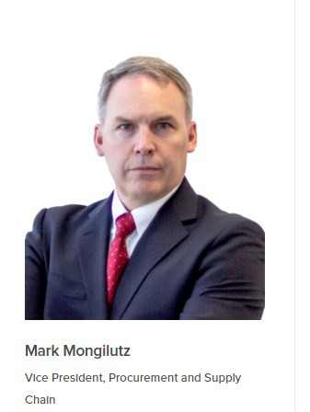
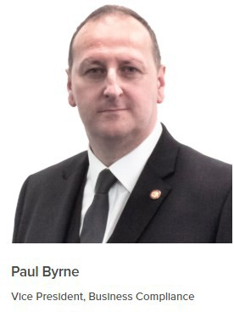

Our Products and Services
Our expertise is in providing resilient, cost-effective mission sustainment solutions to Government, Humanitarian and Commercial Organizations. Our core business services include:

Our Product/Service Our areas of Strength and Differentiation
Fleet Management & Product | - Scheduled and unscheduled maintenance  - Major component overhaul  - Full reset capability  - Custom designed turnkey facilities - mobile maintenance and recovery teams  - Armaments and systems repairs  - Field workshop deployment
Support Programs
Designed to meet our client's operational
requirements through improved product
reliability and vehicle safety, increased fleet
operational readiness, and reduced fleet
operating costs which significantly extend
vehicle and equipment lifespan.

Base Operations and Life Support | - Flexible turnkey solutions to suit client operations  - Containerized solutions to national maintenance facilities  - Total camp management services provision  - Existing facility extension  - Integrated security solutions - communication devices and IT support
Services
From design, engineering, construction, and
communications, to supply chain
management, life support and facility
management, AMS provides a full range of
Base Operations & Support Services for small
deployments to large scale operations in
austere environments.

Program Management Software | - Developing, managing and supporting database solutions and custom web portals  - Flexible and scalable to match fleet and operating environments  - Multi-lingual options including Dari, Arabic and French  - Accessible, robust and secure  - ERP and systems integration capability  - In-house development and support team
AMS has developed a range of program
management software solutions allowing clients to control and manage their entire portfolio of assets from a single unified platform with integration capabilities to client's ERP
systems

Training, Mentorship and Capacity Building | - Maintenance / Overhaul & Reset / Workshop Management  - Armaments and System Maintenance Training  - Supply Chain Management / Warehouse / Logistics  - Multi-Level Options from basic to advanced and Train-The- Trainer  - Armored / Non-Armored Vehicle Driving Training  - Instructor Led and e-Learning options
Designed to build enduring capabilities through
consultancy, training, education, mentoring and enabling. Our programs equip our clients with the knowledge, skills and best practices
needed to operate in high-risk and conflict afflicted areas.

Procurement, Supply Chain and Logistics | - Purchasing, Ordering and Quality Control  - Vehicle and Equipment Sales  - Tools and Workshop Equipment  - Camp Services, Construction and Catering Supplies
With over 15.000 tons of freight moved annually.
our Procurement, Supply Chain & Logistics services provide a complete end-to-end solution to ensure our clients goods arrive safe and secure, on time every time. Our extensive experience of operating in austere environments gives us the knowhow in delivering supplies to remote
and forward operating base locations.

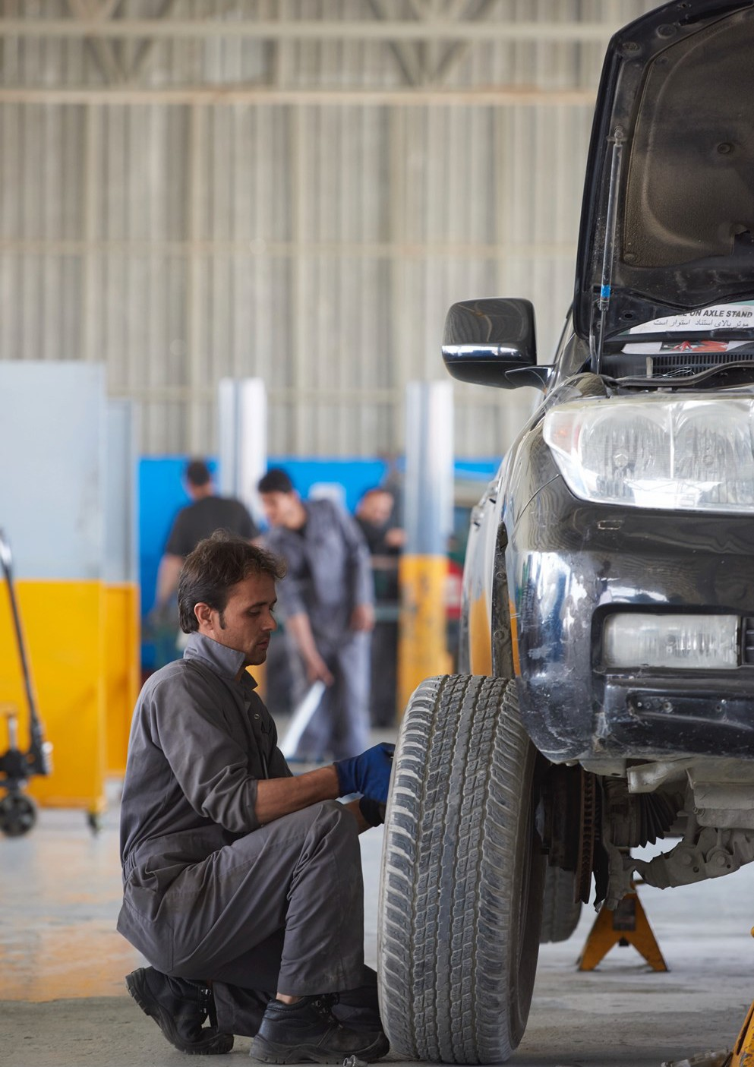
18

Our Global Facilities Footprint
AMS have a well-established international presence and maintain a network of offices and local businesses serving customers in the Americas, Africa, Central Asia, Europe and the Middle East. Our business operations are found within a few challenging environments providing services to Government, Humanitarian and Commercial Organizations.
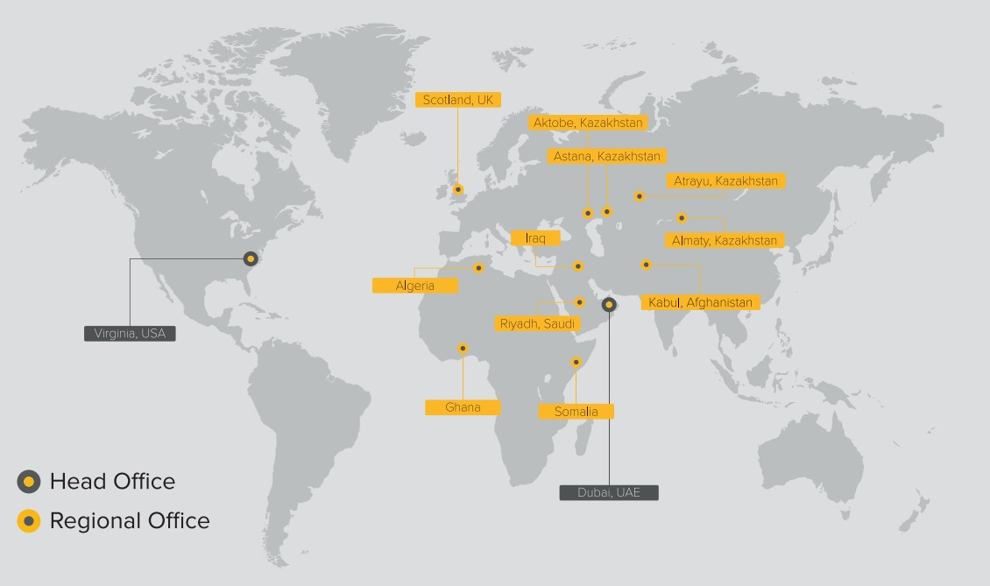

We build and maintain relationships with the local communities by creating employment opportunities, building trust and positively advancing the communities in which we operate.

Our value addition at host regions also includes complying with taxes and other levies to the governments and helping maintain long lasting alliances. AMS operates with the highest ethical standards and in a socially responsible manner by giving back to the communities where it operates. Our responsibilities towards our people, society and the environment are taken very seriously, and we align all our activities with the relevant legal and international standards.

AMS are committed to being at the forefront of technology and innovation, delivering superior capability in tandem with maximized cost efficiencies. We have commissioned new facilities globally aimed at enhancing integrated logistics services to customers ensuring their products are delivered on time and in the most cost-effective manner.

Our company believes that our biggest asset is our people. Employee happiness has a wide and positive effect on productivity within the workspace. At AMS, we invest in resources and aim to create a workspace that encourages our employees to strive to reach their full potential. Our employees show remarkable levels of commitment and involvement in the development of the organization. Throughout 2018, AMS aimed to reach higher levels of operational standards, with significant steps instituted in the field of health, safety, environment and employee welfare. In Q4 of 2018, AMS piloted its very first Employee Satisfaction Survey at a Head Office level. The pilot survey allowed us to benchmark 2018, as well as get valuable feedback on the business, its managers and work pressures.

19

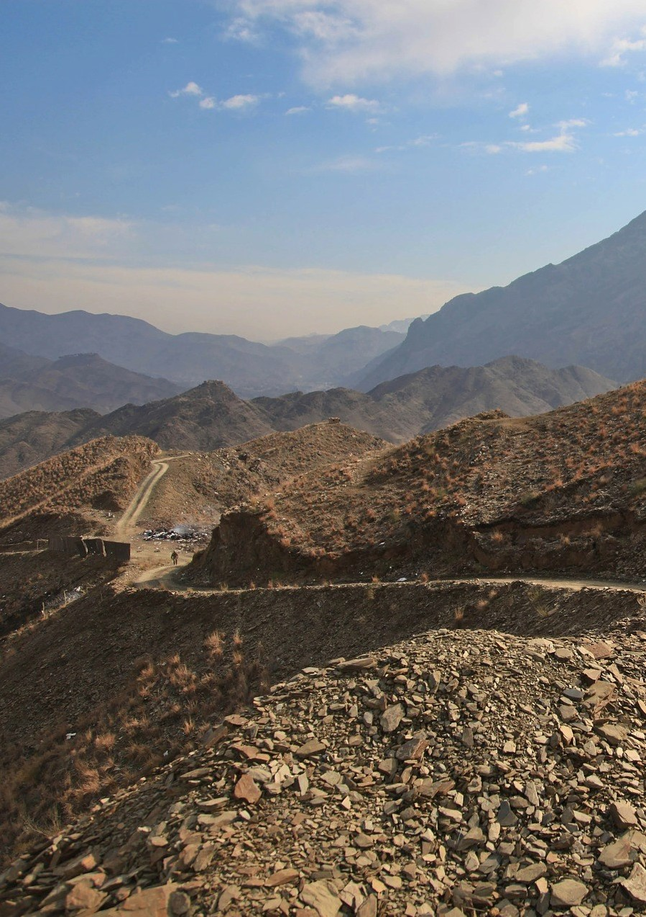

OUR EXTENSIVE EXPERIENCE OF OPERATING IN AUSTERE ENVIRONMENTS GIVES US THE KNOWHOW IN DELIVERING SUPPLIES TO REMOTE AND FORWARD OPERATING BASE LOCATIONS
20

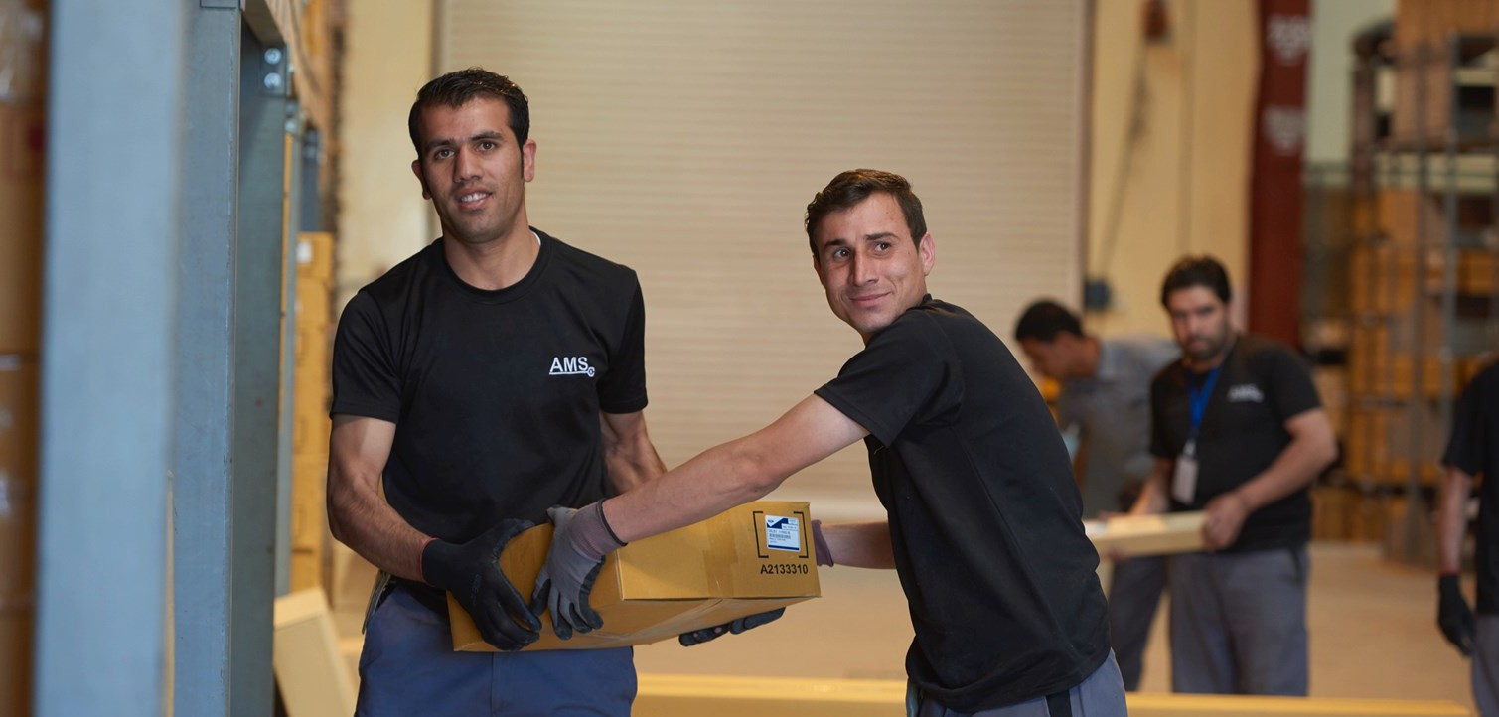
Supply Chain and Procurement
21
With over 15.000 tons of freight moved annually, our Procurement, Supply Chain & Logistics services provide a complete end-to-end solution to ensure our clients goods arrive safe and secure, on time every time. Our extensive experience of operating in austere environments gives us the knowhow in delivering supplies to remote and forward operating base locations.

Suppliers
Since AMS focuses on Mission Sustainment product’s our suppliers are indicative of the same. Currently AMS has approximately 1200 suppliers of which approximately 400 suppliers are actively used throughout the supply chain at any point in time. As far as reasonably possible AMS try to procure goods from local sourcing, promoting local capacity building.

The types of Suppliers engaged are;
- Manufacturers
- Authorized distributors
- General traders
- Consultancy providers
- Freight forwarders
- Contractors and
- Professional services

Our suppliers are wide spread across the globe and are selected based not only on price but also quality and reliability. Our suppliers are generally based in; Afghanistan, Canada, Denmark, France, Germany, Italy, Sweden, United Arab Emirates, Kazakhstan, Russia, Malaysia, Netherlands, United Kingdom, United States, Thailand, South Africa, Somalia and Algeria.

During 2018 AMS expanded its Supply Chain business by supplying to two new locations, Algeria.

Supplier Ethics
AMS’s current annual parts procurement orders exceed USD110 million. In addition, we have USD5
billion worth of assets that are managed by AMS globally.

With the magnitude of parts orders, we must ensure that what we teach regarding ethics and compliance, in our locations we hold a stringent practice in our supply chain. When registering vendors, we ensure that all vendors understand and agree to our terms and conditions.

As part of our vendor registration process, we flow down various policies including our Code of Business Ethics & Conduct as well as Combatting Human Trafficking Policy to them. AMS will disqualify any vendors not willing to sign up to our terms, conditions and flow down policies. As part of our own due diligence on supplier we ensure to do Conflict of Interest Checks. All Conflicts are shared with the Compliance and Legal department in the business.

Promoting sustainable procurement practices
In support of SDG Goal 12, AMS have centralized the procurement department team to promote sustainable public procurement practices. The centralized process mitigates some risk in the form of bias or conflict of interest.

To ensure we build the local communities and businesses where we operate, AMS donates stock that it is writing off. In 2018 an example of this was the partnership between AMS and Organize for Liberia (OFL). OFL‘s commitment to upholding high ethical standards and accountability to its donors, stakeholders and communities served, is what sets OFL apart from other deserving entities. Materials donated will either be used as aftermarket parts and sold for money or as teaching material in technical collages, with the intention and purpose to benefit the youth of Liberia. OFL’s mission is to promote Science, Technology, Engineering and Mathematics in Liberia. AMS were able to donate approximately USD91,000.00 worth of stock.

Integrating Sustainability
AMS are committed to achieving leadership in sustainability. We aim to adopt new solutions which enhance our economic success and develop our business sustainably. Since the inception of the company in 2001, AMS have been determined to operate in a manner that is transparent, safe, timely, and with a high-quality service with high customer satisfaction in regional and global markets. We realize our responsibilities towards the environment and the communities in which we operate. AMS strives to cater to internal and external stakeholders while ensuring a high level of performance. Providing a customer-centric business culture by delivering superior services has been the focus of the company.

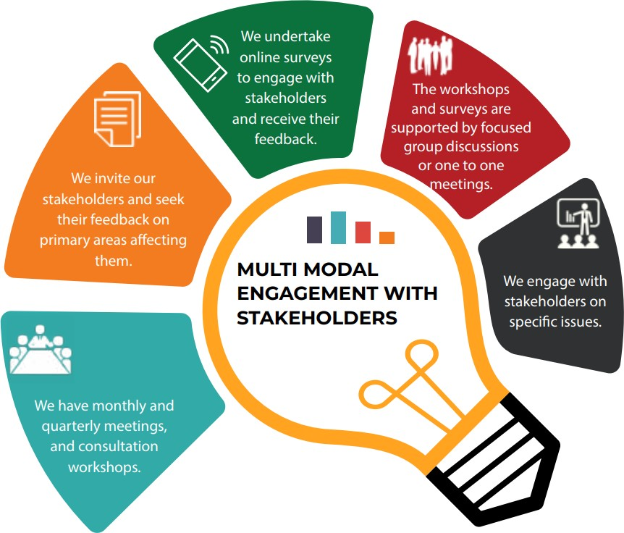
We recognize the importance of diversity and we highly value our diversified group of stakeholders spread across our supply chain and operations. We believe that continuous engagement with our stakeholders to analyze our positive and negative impacts will help us work in the right direction and succeed as a responsible corporate
citizen.

CONTINUOUS ENGAGEMENT WITH OUR STAKEHOLDERS HELPS US SUCCEED AS A RESPONSIBLE CORPORATE CITIZEN

This multi-modal open-door approach on stakeholder engagement supports our commitment to build transparent and constructive relationships with our partners, in order to deliver sustainable services. Such engagements also help us ensure that our approach towards sustainability reporting is in line with stakeholder expectations.

Responsible Consumption

Managing Emission
2018 was the fourth hottest year on record, according to two independent reports released today by NASA and the National Oceanographic and Atmospheric Administration (NOAA). NOAA reported that 2018 was so hot that global land- and ocean-surface temperatures were 0.79 degrees Celsius above the 20th-century average. The trend isn't a new one. Nine of the 10 warmest winters have happened since 2005, and five of the warmest years on record happened within the last five years, or from 2014 to 2018.

The reporting year witnessed extreme weather events, such as the Florence and Michael Hurricanes in the US, major wildfires across the globe, monsoon ﬂoods in the Indian subcontinent and continuing severe drought in parts of Africa.

The increase in global average temperature is attributed to increasing concentration of Greenhouse Gases (GHGs) in the atmosphere. Over the last century, the combustion of fossil fuels has increased the concentration of the atmospheric GHGs, most of which is due to human activities.

With a severe El Nino expected in 2019, AMS understands the responsibility on its shoulders towards GHG mitigation. While we are aware that our business provides logistical services, which involves the consumption of a considerable volume of fuel, we are taking steps towards GHG emission reduction. We undertake ongoing measures to reduce the GHG intensity of our operations. We strive to achieve SDG Goal 12 (Responsible Consumption) this by optimizing our electricity and fuel consumption. This year we continued our efforts towards low carbon development through the following initiatives:

- Route Optimization
Careful route planning is fundamental to the way AMS’s mobile technicians do business. Since AMS have our own in-house Fleet Management system (Fast trax), which is constantly updated to ensure the highest accuracy, we are able to complete GPS mapping and route tracking to minimize the distance travelled by mobile technicians resulting in the reduction of fuel consumption as well as corresponding GHG emissions.
- Office Consolidation
AMS started 2018 with 4 office locations in the UAE. In quarter 4, all offices were consolidated under one roof in Jafza Free Zone. The reduction in office space reduces the grid electricity consumption and the resultant GHG emissions.
- Repair and Maintenance
Our largest project in Afghanistan completes the repair and maintenance of the Afghanistan National Police Force and Afghanistan National Army. We undertake periodic, scheduled and preventative maintenance of their vehicles using only high-end OEM standard products. In addition, we ensure that appropriate tire pressures are correct, reducing fuel consumption by 3% per vehicle and ultimately GHG emission reduction.
- Driver Training
AMS complete dozens of awareness campaigns on efficient driving practices to help in reducing fuel consumption. We train our drivers to enhance fuel efficiency by adopting the following precautions:

  - Drive smoothly and anticipate situations as far ahead as possible to reduce braking and acceleration.
24
  - When slowing down or driving downhill, remain in gear but take the foot oﬀ the accelerator as early as possible.
  - Avoid Excessive speed and reduce idling.
  - Servicing the vehicles regularly maintains engine efficiency and results in reduced fuel consumption thereby reducing GHG emissions.

Responsible Waste Management
A sustainable approach to tackle waste management is of utmost importance to AMS. We ensure that we protect the environment where we operate diligently and implement various waste management practices to the best of our abilities

We at AMS head office, UAE, manage the waste generated through our operations responsibly by adopting the principles of circular economy. These principles extend beyond typical waste management practices. Our waste management strategies try to maximize the value of the waste streams by keeping the resources in use for as long as possible, and then by recovering and regenerating products at the end. We have classified the waste generated at our head office into five different types depending upon waste properties and disposal method. These include general office waste, oil, tires, liquid and solid waste.
GENERAL
OFFICE WASTE
TIRES
WASTE TYPES
AT AMS
LIQUID WASTE
SOLID
WASTE

General Office Waste
As part of our efforts to reduce the waste generated, we undertook a waste characterization activity to identify the waste type and their source at the office. The major constituents included waste paper towels, paper, single-use plastic bottles, plastic cutlery, cardboard and food waste.

We firmly believe in reducing waste at the source, which is a crucial part of our waste management strategy. We aim to achieve this in 2020 by doing away with the use of paper towels and single-use plastic from our head office. In 2018 alone we have stopped the use of single use water bottles by providing only 5-gallon bottled water in the office. Employees then were required to bring their own glass or water canister for water refills.

AMS also want to ensure that the paper we use is previously recycled and will be recycled safely and securely after use. By doing this we reduce our carbon footprint. We ensure to use companies that provide ethical recycling methods, such as our provider, Shred-it.

Liquid Waste
The head office premises consist of the office building, warehouse, workshop and tanker washing area. The liquid waste generated from the workshop includes used engine oil, antiknock agents, and other solvents.

All these liquids are collected in a separate and secure container and are disposed through authority approved waste management contractors. To reduce the quantity of waste oil and solvents, we change oil only when necessary and use long-lasting synthetic oil for our tankers. Use of long-lasting synthetic oil means that we can operate our tankers for a longer duration without changing oil frequently, leading to reduced waste oil generation.

Solid Waste
The solid waste generated from the workshop consists mainly of used oil filters and discarded metallic spare parts. The used oil filters have lead plating and therefore we take the utmost care in segregating the waste so that it doesn’t get mixed with the general waste stream. These discarded waste materials are carefully stored in separate bins based on their quantity and size, after being thoroughly drained.

To reduce the quantity of discarded oil filters, we change oil only when necessary and use long-lasting synthetic oils so that the frequency of filter change is reduced. The solid waste is disposed of through authority approved waste management contractors.

Tires
Being one of the leading fleet maintenance and mission support service providers in Afghanistan, our client’s vehicles are used almost non-stop throughout the year. Therefore, the need for effective tire maintenance is vital for our business. Tires are the most wearable parts of our ﬂeet. The worn-out tires that are no longer suitable for use in our vehicles contribute to waste.

In our efforts to recycle and reuse as much as we can, we have committed 2019 to retreading and recycling of tires in Afghanistan. The process is similar to the manufacturing of a new tire where the worn tread is buffed away, and a new tread is bonded to the tire body. Retreading tires eliminate the substantial volume of tires being sent to the landfill each year.

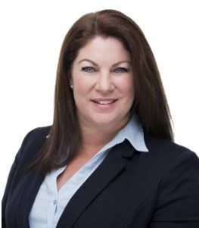
Statement from Group HR Director

I am proud to reaffirm AMS’s responsibility to the 10 United Nations Global Compact (UNGC) principles and to confirm our commitment to the 17 United Nation Sustainable Development Goals (SDGs) within the sphere of our influence.

Since our beginning in 2001, AMS has undergone periods of extreme growth, establishing the Company as a highly accomplished mission sustainment provider to Governments and Defense sector clients operating in
predominantly austere environments. 2018 brought extensive change and saw the evolution of AMS policy and process, through a complete evaluation and overhaul. The establishment of a Talent Development division with an initial focus on producing and delivering policy training and awareness, ensured zero justification for not upholding the updated policies and AMS corporate governance.

AMS is a multicultural, multinational, multiracial, people driven business. Our people are the face of our Company and our culture is underpinned by our corporate values, and through the integration of these into our daily operations. We are a Company devoted to protecting and strengthening our culture and each employee has the responsibility to uphold exceptional professional and ethical standards in every aspect of their business conduct.

AMS nurtures multicultural understanding within our business and we are committed to attracting, training, and maintaining a diverse workforce that represents the cultural diversity of the world in which we operate

Our richly diverse workforce consists of more than 37 nationalities and this international mindset is reflected in our daily operations; supporting change and development across the globe. AMS is a staunch advocate for diversity, development and inclusion. We work to positively impact the lives of our employees and the communities in which we operate. The Company is honored to have gained a reputation for supporting, developing and empowering local talent, thereby delivering real value propositions and enabling sustainable impact in challenging environments.

In this annual Communication on Progress, we describe our actions to continually improve the integration of the Global Compact and its principles into our business strategy, culture and everyday operations.

Sincerely,

Shannon Naudé
Group Human Resources Director Automotive Management Services

Our People
Our people are the greatest strength and assets of AMS. We are committed to providing our employees with an environment that nourishes their growth and motivates them to enhance their performance. Multiple employee engagement programs such as AMS’s annual parties, sports activities and clubs are organized take place every year. AMS are also keen on developing the employees in a way that their self-confidence is improved. By 2020 AMS are committed to opening a Toastmasters club within the office.

We value our employee feedback as a mechanism to improve the process. As previously mentioned, 2018 marked the first year of AMS conducting an Employee Satisfaction Survey across the Head Office level. The pilot survey allowed us to benchmark 2018, as well as get valuable feedback on the business, its managers and work pressures; allowing us to take inputs to formulate strategies for the next year. This survey will become an annual occurrence at minimum, measuring our effectivity and listening to our employees.

Training and Development
We consider the development of our employees important and provide them with periodic training programs to develop their skills and also to keep them abreast with the latest technological trends within our scope of operations. These trainings are targeted to enhance their skill sets and encourage personal growth. Such practices also help the company grow by meeting and exceeding the expectations of our customers with increased quality performance.

In 2018 AMS set up a Learning and Development department within the business. This saw an in-house Learning Management System (LMS) being developed. The LMS holds courses that are designed with the employees needs in mind. It has content rich and well-structured learning programs, that will teach employees about policy and procedure (Compliance and Ethics) as well as professional development (Excel). The training is conducted in various ways to ensure all training is done in a language they understand, is capable to adjust to the needs of the employees through self-paced learning or face to face for those who do not have access to a computer or are illiterate. In addition, AMS noticed the large demand for language training in the business. The requests were from the Afghanistan Local National employees either wanting to learn how to read and write or to learn English. AMS listened and opened its own Language Center with qualified teachers with learning material. The facility boasts a training center with electricity, water and is sheltered from the elements. Doors opened in 2018 giving employees the opportunity to attend this free of charge development during their workday over the course duration.
27

AMS are committed to building the capacity of local communities. With over 17 years of experience we know what makes a workshop work in challenging environments. Our workshops are sophisticated and meet all safety codes. We are committed to working with local communities and building their skills so that they too can provide for their families, building up communities one by one. AMS are one of the only companies in Afghanistan, firstly offering local Afghans work at a fair salary, as well as a structured training course. Our company boasts a learning journey that takes technicians on a fully structured Apprenticeship, Journeyman and Craftsmen vehicle repair and maintenance training.

Our Business Ethics Policy is shared with all employees to gain their commitment to ensure all our operations are managed in an ethical and responsible manner. The policy is inclusive of AMS’s commitment towards anti-corruption and protection of human rights. Our employees can report any anti-corruption or human rights violation to the right people through our Whistle Blowing Hotline (managed either internally at top management level or to an independent external party (Lighthouse), depending on the employee’s preference of where to report). To ensure that even illiterate employees understand human rights, labor, anti-corruption or environmental issues and reporting, AMS have a local employee travel across all sites to teach the same, face to face in Dari, Pashtu or English. During the 2018 reporting year, no anti-corruption or human rights violations were reported.

Our Diverse Workforce
AMS are proud of our corporate culture, which is based on our corporate values: can-do attitude, integrity, innovative thinking, initiative, ownership, respect and team work. AMS is committed to the principle of equal employment opportunity for all employees and to providing employees with a work environment free of discrimination and harassment. All employment decisions at AMS are based on business needs, job requirements and individual qualifications, without regard to race, color, religion or belief, national, social or ethnic origin, sex (including pregnancy), age, disability, sexual orientation, gender identity and/or expression, marital, civil union or domestic partnership status, past or present military service, or any other status protected by the laws or regulations in the locations where we operate. AMS will not tolerate discrimination or harassment based on any of these characteristics.

AMS’s diverse workforce comes from 37 nationalities. The figure below shows the figures for the close out of December 2018. All data has been collected from our HR system. AMS do not have temporary workers and all employees are permanent contractors on fixed term contracts. Dubai Head Office is the only portion of the business on open ended contracts.

Our remuneration policy outlines all information regarding remuneration. Since this is proprietary information as it is used in contracts please contact Info@ams.global if you require information or the policy regarding the same. All salaries are evaluated annually and are based on the current market rates well as years of experience. HR is accountable for ensuring total remuneration is distributed fairly and is committed to ensuring that the remuneration of executive management is fair and responsible in the context of overall employee remuneration. In addition, 100% of employees receive regular performance and career development review.

Investing in Human Health
As part of our Corporate Social Responsibility, AMS conducts a free medical check-up for all new and incoming employees. This is extended further where all employees deployed to areas other than the UAE go for a free annual medical.

AMS are committed to SDG, Goal 3 (Good Health and Well Being). As a duty of care to our employees AMS provide free annual medical screenings. The screenings include; CBC Count, TB Tests, Full medical check, Dental, optical and psychological screening. This annual medical is our way of ensuring that employees do not contract any diseases, especially since many of the countries that we operate in, are prone to dangerous diseases with limited advanced medical facilities to treat them. In addition, employees may not deploy to any of our areas of operation without the following vaccinations; Diphtheria, Typhoid, Tetanus, Hepatitis A and B, Polio, Meningitis and Yellow fever (if deploying to Africa).

All deploying employees are provided with extensive medical insurance ensuring all medical, disease and ailments are treated. An extension on these policies include medical or political evacuations done by a highly capable evacuation and extraction company. As a company with strong interests in our employees, we are committed to their welfare whilst they are away from their homes and families for extended periods. For our local national employees, we are working hard to ensure our employees have free medical insurance. 2018 saw AMS start a pilot medical facility in Kabul, Afghanistan. This medical facility provides onsite free medical attention, free essential vaccinations and basic drugs and dressing.

Safety at AMS
Safety of employees and the community is of extreme importance for AMS. We ensure that the highest levels of safety are adhered to when working at our sites, facilities and across our logistic supply chain. Our safety performance is enhanced due to an increased focus on leadership visibility, frontline supervision, safety ownership, intervention, barrier thinking and HSE reporting.

We take the occurrences of workplace accidents or any other incidents very seriously and investigate the root causes to prevent any such incidents from happening in the future. The occurrence of any unfortunate incident is accurately recorded, investigated, and analyzed. These details help us to identify the need for corrective actions and gives us opportunities for implementing preventive measures.

In order to better respond to emergency situations in the workplace and on the road, we have prepared an extensive ‘emergency response plan’. This plan enables us to coordinate and deal with emergency situations that we might face in our day to day operation. To ensure eﬀective implementation of the emergency response plan, we have trained company personnel, stocked emergency response equipment, and prepared drivers on how to handle emergency situations and post-response activities. The roles and responsibilities of the individuals involved are clearly defined and documented for future reference. Periodical emergency drills are conducted in coordination with the police, ambulance, civil defense and authorities on all sites.

Safety Seminars
Workshop employees are required to attend Electrical and Workshop Safety seminars. This educates approximately 600 employees from various functions like admin, finance and workshop regarding the main causes of home and industrial fires. It also teaches employees about electrical malfunctions which could occur due to improper maintenance of electrical equipment. The seminar also includes a discussion on ‘How to protect oneself and others from the hazards of electricity’.

First aid and Fire Marshal Training
All sites are required by AMS to have a qualified first aid and fire marshal on site, this course is refreshed annually to ensure that employees are always equipped with the latest knowledge on how to approach various situations. We follow all local legislation regarding how many first aid and fire marshals are required per capita on site.

Emergency Response Drill
Emergency response plans are an essential component of workplace safety. The Emergency Response (ER) readiness is tested periodically on all sites to ensure employees know what to do in case of a real emergency.

The ER drill includes the below guidelines to check the overall ER preparedness of the site:
Perform headcount to ensure safe evacuation
Providing basic first aid to injured
What to do with flammable products
Maintain communication during emergency
What to do after an emergency

Sustainability Strategy for the Future
AMS are fully committed to the 2030 Sustainability Strategy with our key focus on a groupwide plan. After our 2018 year we have chosen to refocus in 2019 and commit ourselves to strategies specifically focuses on sustainability within our current operations. We plan to work together to set targets, define target indicators and develop medium to long term initiative programs.

The decision to refocus in 2019 was due to a multi-stage analysis completed with various stakeholders to the business. The analysis focusses on past efforts as well as future goals to ensure that our visions align with our employees, customers, shareholders, suppliers, government agencies and other valuable stakeholders to the business.

At AMS we are committed to local capacity building and are focused on working in partnerships to make the entire value chain more mindful of their use of resources and the impact it has. We intend on educating, mentoring and enabling the local communities in which we operate to improve their lives by providing solutions that face their challenges.

Sustainability is also a central part of our group corporate strategy because not only do we demand high standards, but our customers are demanding more sustainable products and services in the market. We want to prove that working in austere environments does not exempt anyone and in turn does not mean that nothing can be done to help but rather that we can all do our part to make the 2030 agenda possible.

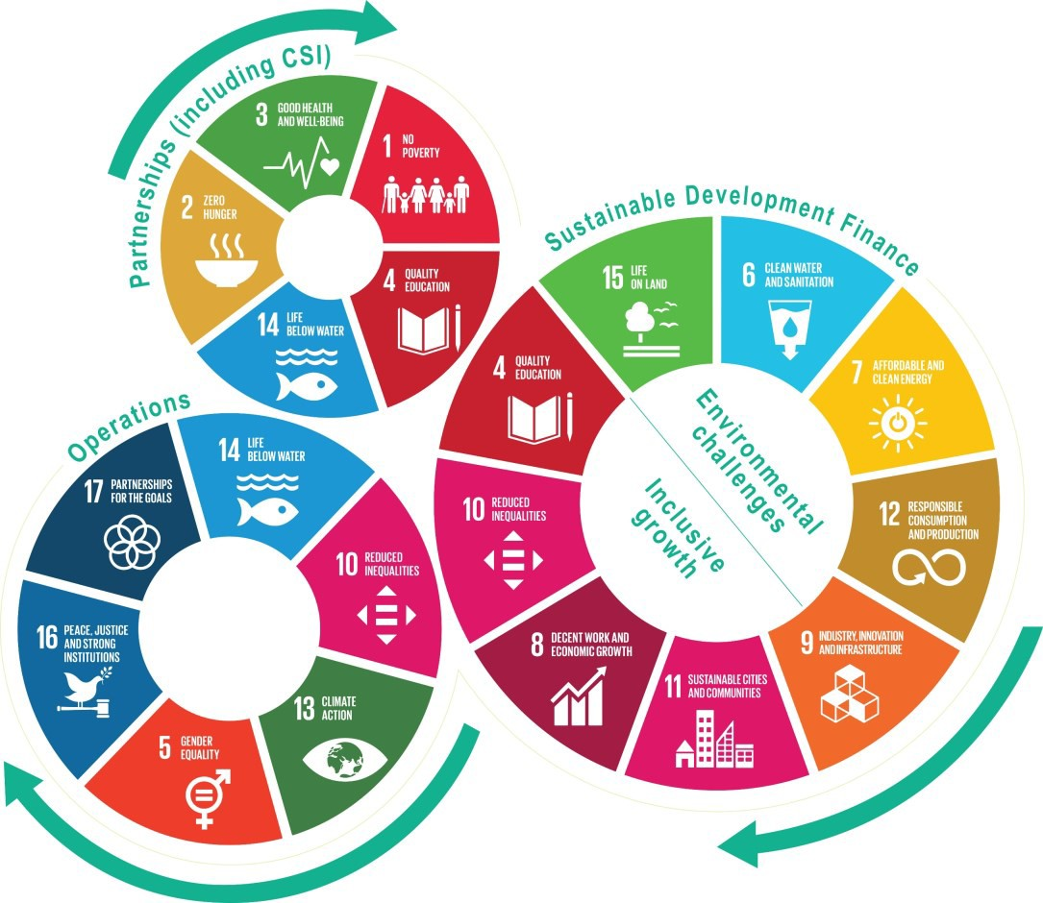
Our position in society brings both opportunity and responsibility, where we believe we can create shared value every day. By adopting operating procedures and pursuing policies that enhance our competitiveness while advancing positive socio-economic impact on the communities in which we operate we intend to protect and enable our most valuable assets, our people, their communities and the planet.

Aspirations
We achieve sustainable progress by setting our standards high. Our aspirations are:

Governance & Ethics Full transparency and integrity | Global Provider  Be a global provider of resilient, cost-effective mission sustainment solutions to Government, Humanitarian and  Commercial Organizations | Safety  Improved vehicle and site safety
Program Management Support  Program management software solutions allowing clients to control and manage their entire portfolio of assets from a single unified platform with integration capabilities to  client's ERP systems | Unlocking Talent Realizing and unlocking everyone’s potential | Product Support Improved product reliability and vehicle safety, increased fleet  operational readiness, and reduced fleet operating costs which significantly extend vehicle and equipment lifespan
Local Capacity Building Educating, mentoring and enabling the local communities in which we operate | Supply Chain  Provide end to end procurement, supply chain and logistic solutions that arrive safely and securely every time in remote and austere environments

Delivering Value by Delivering on Our Purpose
We understand that our success depends on the degree to which we deliver value to society. It is therefore important to understand our role in society and how society can be different because AMS is a part of it. Our Mission Sustainment products and services play a crucial role in facilitating Government, Humanitarian and Commercial Organizations achieving their mission success regardless of where their business operations are. AMS are there to help them take their business from where they are to where they are required. A deep understanding of one’s purpose helps to guide strategy and decision making in this regard and should result in an optimal balance between long-term value creation and short-term results.

Delivering on our vision and purpose will create a purpose that will require the considered development and delivery of products and services. These will satisfy unmet societal needs, enabling a thriving society, creating long-term value, maintaining trust and ensuring the success of our brand.

The United Nations (UN) Sustainable Development Goals (SDGs) provide for a universal agreement on economic, social and environmental priorities to be met by 2030. AMS are fully committed to the 2030 goals with our key focus on a groupwide plan. A groupwide sustainability plan will allow AMS to

identify opportunities for business innovation and growth and they define the “good” in our purpose. With this in mind, we have reoriented our approach to focus on the most material SDG targets through our three main points of leverage: Products and Services, Operations, and Partnerships.

Employees
Our employees are key to making AMS a great place to work. Motivated and skilled staff, together with efficient and value-creating solutions, services and operations, offer value to our clients. Staff as part of society, contribute materially to the communities in which they live and work.
Value created by:
- Employing local nationals in the jurisdictions in which we operate building local communities
- Rewarding staff for the value they add through various reward schemes
- Creating job opportunities as the business grows
- Fully inclusive workforce through employment equity and equality
- Developing our staff through continuous learning and development

Clients
Supporting additional organizations in their mission sustainment solutions results in greater revenue growth, while sustainable business practices and world class risk management mitigate AMS against potential issues.
Value is created by:
- Safeguarding our client’s inventory
- Enabling mission success through high quality products and services in austere environments
- Developing innovative solutions that
meet our clients’ specific needs
- Providing resilient, long-term and cost- effective support

Shareholders and broader stakeholder base
Value Created by:
- Delivering value to our shareholders by increasing net asset value, dividends and earnings
- Positively transforming economies and societies through ongoing investment in communities and local economies based in austere environments
- Contributing meaningfully to government budgets through our own corporate taxes, staff paying personal taxes
AMS
Value created by:
- Maintaining a strong balance sheet, which contributes to a safe and stable company that instils confidence and protects against downside risk
- Generating sustainable financial returns, growing revenue, managing and mitigating risks, managing our expenses wisely, while optimizing our cost base

IN ORDER TO ACHIEVE OUR TARGETS
WE AIM TO …

STAFF
… attract, develop and retain highly skilled and
talented workforce …
… exceed customers’ expectations and become a trusted provider of mission sustainment
solutions …
… grow profit
sustainably to create
shareholder value …
… effectively
manage risk…
… and create shared
value.

CLIENTS

SHAREHOLDERS

REGULATORS

SOCIETY

Future initiatives
Our initiatives are what guide us in our sustainability report and strategy.
Goal 3  Good health and well being | - By 2020 to provide enhanced medical insurance to our local national employees by opening more regional medical centers for our employees  - To increase the standard of our free local clinics to include medical attention for infectious diseases, non-communicable diseases and  service capacity and access, among the general population
Goal 4  Quality Education | - By 2023 to substantially increase youth and adult youth and adults who have relevant skills, including technical and vocational skills, for employment, decent jobs and entrepreneurship.  - By 2020 increase business and professional skills like Microsoft skills, and health and safety. We hope to have at least 100 employees complete the online learning for the same.  - By 2022 become accredited by an international body for our educational offerings in our Apprentice, Journeymen and Craftsmen programs to provide our employees with skills that allow entrepreneurship and decent employment opportunities to our employees  - By 2019 open a Toastmasters club
Goal 5  Gender Equality | - To promote Women’s Empowerment principles, AMS would like to increase our senior and executive management by 25% by 2022.  - To start reporting on gender equality through operations by 2019  - By 2026 increase women and disabled employed by 10% throughout the organization  - By 2019 ensure that for every senior management position at least  one candidate interviewed is female
Goal 12  Responsible Consumption and Production | - By 2020 develop a procurement portal on the AMS website where all RFP/ RFQ will be posted. To promote fair trade and avoid bias or conflicts of interest all suppliers will be able to submit their proposals  - By 2020 Evaluate suppliers on their response to risk  - By 2022 complete suppliers audit to includes: Fire safety equipment/procedure, hazard prevention, Occupational hazard prevention, degree of being environmentally friendly, financial stability to avoid redundancy, quality of product and training their  staff on hazardous materials
Goal 13  Climate Action | - By 2021 implement greater recycling programs to ensure a sustainable environment



   



