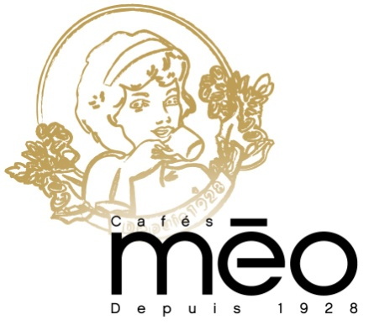

Lille, 30 june 2020

our stakeholders:

We recognize that a key requirement for participation in the UN Global Compact is the annual preparation and posting of a Communication on Progress (COP) that comprises of a CEO statement of continued support for the UN Global Compact, a description of practical actions with regard to the principles of the UN Global Compact, and a measurement of outcomes or expected outcomes.

We are late in creating, sharing and posting our COP report due to : We are waiting analysis report.

We hereby ask for an extension period in order to be able to post a COP that describes our company’s efforts and progress to implement the principles of the UN Global Compact.

Our new COP report will be posted on the UN Global Compact website by begining of June at the latest.

Sincerely yours,

Mr d’Almeida
Quality Manager

