LANTRADE GLOBAL SUPPLIES LTD (LGS)

UN GLOBAL COMPACT REPORT

Communication on Progress
2019

Table of Contents

Statement of Continued Support 3

The 10 Principles of the Global Compact 4

- Human Rights 4

- Labour Standards 5

- Environment 9

- Anti-corruption 12

- Summary 13

- Conclusion 14

Statement of Continued Support

At LGS our primary objective remains that of providing an efficient and cost-effective service in the global quest to further democracy. Within its role in this market, LGS is committed to all of the 10 Global Compact principles.

Through our work and interaction with other cultures, we have the privilege of seeing the change and fascinating evolution of the democratic process and social development around the world. We consider ourselves immensely privileged to be part of this movement to give everyone a voice regarding the leadership of their communities.

At the time I write this we are in the grip of the COVID-19 global pandemic. As yet we do not know how far we are through the crisis, how many lives will be lost and how many months of turmoil and disruption we have yet to face. At this moment more than ever, we are reminded of the importance of cooperation at every level of our communities. Maybe this year will herald new consideration of our value systems, and a look at how appropriate our political and social structures are.

Our interpersonal, inter- and intra-community relationships are the bedrock of our societies and we are mindful of how much we owe to those who have striven for democracy in their resolve to uphold human rights and justice for the individual.

March 2020
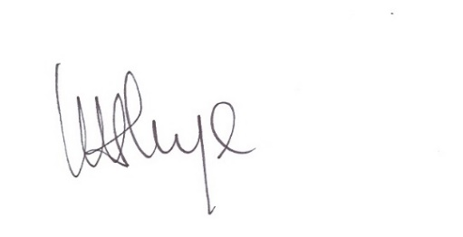
Lynda Nye
Managing Director
Phone: +44 (0) 1895 822205

The 10 Principles of the UN Global Compact

HUMAN RIGHTS

Principle 1:

Businesses should support and respect the protection of internationally acclaimed human rights.

Unless the betterment of human rights is at the forefront of what we do, we believe that other areas of progress carry less weight. Respect for the rights of the individual must surely be at the centre of everything we do and be the driving force for our commitment to development.

This year we have been involved with the African Prisons Project (APP). This organisation, founded by Alexander McLean, helps many in prison in East Africa to fight for justice. APP supports inmates, many of whom have been incarcerated without charge or a fair trial to become educated in the legal process. Many become lawyers and present their own cases and those of others who are also unjustly imprisoned.

The LGS employees who attended the gala dinner, held to raise funds for this charity, were humbled to be able to make a small contribution to the work of those who are seeking to promote human rights of others, often in extremely difficult circumstances. We are constantly moved by the stories that come back that demonstrate the strength of the human spirit in the most oppressive and unjust of conditions.

We shall continue to support this worthy cause throughout the year.

Principle 2:

Businesses should ensure they are not complicit in human rights abuses.

We are committed to upholding and developing respect for the rights enshrined in the Universal Declaration of Human Rights.

LGS never cooperates with companies seen or known to be breaching any human rights. Our staff are trained to enable them to recognise and be aware that the values are upheld by organising regular factory visits to ensure practices within its supply chain are adhered too.

We endeavour to provide a working environment free from such prejudices as racial discrimination, religious intolerance, pay equality. We aim, to the best of our ability, to promote our values on a global level. We strive to encourage our suppliers to examine their practices as a result of our zero tolerance towards human rights abuse.

LABOUR STANDARDS

Principle 3:

The business should uphold freedom of association and the
effective recognition of the right to collective bargaining.

As a small company in a relatively niche market there is no industry trade union LGS is therefore fully supportive of members who wish to join one of the big unions e.g. Unite or Unison. LGS treats its employees with respect and provides an environment that is efficient, safe and open to hear ideas, opinions and thoughts. In encouraging advancement and fulfilment in every role, through either specific training or mindfulness.

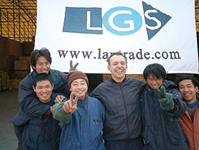

Principle 4:

Businesses should uphold the elimination of all forms of forced and compulsory labour.

LGS continues to only deal with companies if they confirm they do not engage in forced labour. LGS provides its employees with an employment contract which ensures we take full responsibility for providing employees with fair employment conditions and they are aware of their rights, responsibilities and duties.

In cases where we have limited control over preventing unfair work practices, we have adopted procedures to ensure to the best of our ability that our chosen suppliers are not involved in any form of forced and compulsory behaviour. Large scale projects are monitored throughout the supply process and we regularly visit sites on both unannounced and scheduled visits. We appreciate the importance of employing local people to help ensure that site employees are protected.
Principle 5:

Businesses should uphold the effective abolition of child labour.

We believe that it is the inalienable right of every child to be free from the encumbrance of work until they have received a minimum of school education. Ideally every young person would benefit from ongoing training once they start in the workplace, although we recognise that opportunities and expectations vary around the world. LGS condemns any practice of child labour and is committed to ensuring that it never engages with companies who use child labour. We fulfil our commitment by having regular contact with our suppliers and their employees. However, should an incident of child labour be uncovered, LGS would use its influence over suppliers to promote ethical labour standards and ensures appropriate measures are taken.

Were we to learn that a supplier was using child labour we would immediately desist from using them and make their identity known throughout the supply chain.

Principle 6:

Businesses should uphold the elimination of discrimination in respect of employment and occupation.

We are interested solely in attracting people with the relevant skills and experience. We love diversity and the wealth it brings to our day to day lives and the enrichment it brings to our business. We can only report positively about the effects of having a diverse pool of people on the LGS team.

We aspire to lead by example in the hope that our suppliers adopt the same non-discriminatory policies. Job reviews and training records are monitored regularly and kept up to date to enable promotion, in an environment which promotes equal opportunities and job satisfaction. We believe that the diversity of our team is the driving force behind our success.

ENVIRONMENT

Principle 7:

Businesses should support a precautionary approach to environmental challenges.

At LGS we are passionate about the planet. We know that goods have to be manufactured cost effective and economically realistic ways, but we strive to ensure that to the extent we can we minimise the amount of environmental damage that may be caused by the manufacture of our products.

The biggest potentially damaging factor in the markets in which LGS operates is the use of airfreight rather than sea freight to transport goods. We encourage our customers to plan ahead in order to be able to avoid using this damaging mode of transportation.

Principle 8:

Businesses should undertake initiatives to promote greater environmental responsibility.

We believe firmly that while none of us can change the world on our own, if we all do our bit, change can come about. Wherever possible our staff cycles to work or travels by train. When travel by car is necessary, we endeavour to use electric vehicles. We are passionate about minimising waste in the office; we use both sides of paper; we do not use paper cups, we have a cupboard of mugs available for all to use; we recycle everything possible from paper to print cartridges.

We talk to our customers about ways in which they may take a more environmentally friendly approach to providing the services that they do. While we obviously want to sell our products, we do not hesitate to suggest reusing products whenever possible.

Principle 9:

Businesses should encourage the development and diffusion of environmentally friendly technologies.

LGS actively encourages the use of environmentally friendly and more eco-efficient technologies. We aim to involve some of the below practices:
- Recycled, recyclable and/or biodegradable content
- Plant based materials
- Reduction of polluting substance
- Reduction of greenhouse gas emissions
- Renewable energy
- Energy-efficiency
- Multi-functionality
- Low impact manufacturing

LGS carries out spot checks and regularly visits factories to oversee production and continuously communicates with suppliers. This ensures the most efficient technology is used during the production process.

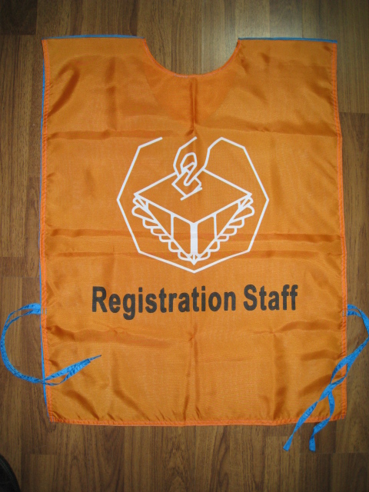

ANTI-CORRUPTION
Principle 10:

Businesses should work against corruption in all its forms, including extortion and bribery.

Corruption hurts everyone. Transparency is key, whether it be in our reporting and accounting or in our pricing and manufacturing. We continue to strive to attain the highest levels of good governance and where possible, to support eradicating corruption. We have regular contact with our industry peers and provide internal training and development initiatives with all our employees.

LGS will never knowingly be complicit in any aspect of corruption. All aspects of our business are open to scrutiny, we would turn down the opportunity to take part any work that we felt was not totally legitimate.

Summary

The following summary of LGS company policies reflects ongoing strategies implemented by the company to put in place and maintain standards we feel are in keeping with the aims and objectives of the Global Compact. The following tables are therefore the same as previous years and reflect our continued endeavours.

Current Company Policy | Action | Outcome | Future Aims
Support and respect the protection of internationally acclaimed Human Rights | Staff attended an internal communications workshop on Human Rights. | A greater understanding and knowledge of Human Rights on a global level. Providing a mutually beneficial growth for all parties. | To source and support further charities whose aim is to correct abuse of Human Rights.
Non-complicit in human rights abuses | Continual appraisal and reinforcement of the guiding principles Universal Declaration of Human Rights and the CRC. | A corporate environment free of fear, functioning transparently and honourably in the communities we trade with. | Ongoing assessment of our business practices. This will ensure we execute these guiding principles
Uphold freedom of association and effectively recognise the right to collective bargaining | Structured communication forums across the organisation, and with stakeholders, including suppliers, partners and manufacturers. | Employees and partners who feel empowered to take responsibility - at a personal level - for positive corporate citizenship within the communities we work. | To continue empowering our staff and stakeholders, enriching their insight and understanding of the guiding principles.
Uphold the elimination of all forms of forced and compulsory labour | Regular personal presence on site.  Engaging positive influences in culturally sensitive environments. | A corporate environment free of fear, functioning transparently and honourably in the communities we trade with. | Become more active as a positive influence against forced and compulsory labour.
Uphold the effective abolition of child labour | Rigorous adherence to a zero-tolerance policy towards child labour. | Knowledgeable, culturally and legally sensitive interaction with communities in order to provide sustainable, credible and mutually beneficial economic growth for all parties. | Explore opportunities to invest in child-related charities supporting the communities in which we operate.
Eliminate discrimination in respect of employment and occupation | Implementation of appropriate internal and external recruitment and training programs.  Provide suitable and appropriate working environments which meet Health and Safety standards, and which secure our investment in duty of care for our staff. | The provision of a working environment that offers equal opportunities for skills and advancement in the most fully inclusive manner to a diverse and all-inclusive staff complement. | Continue our program of internal training and evaluation, in order to best identify strengths and weaknesses, and focus on correct any potential imbalance.
Support a precautionary approach to environmental challenges | Ongoing research to keep abreast of global environmental challenges. | The provision of economically beneficial services in a manner that supports the protection and sustainability of the environment. | To continue empowering our staff and stakeholders, enriching their insight and understanding of the guiding principles.
Undertake initiatives to promote greater environmental responsibility | Constant evaluation of existing interactions.  Strategic selection of sustainable practices. | The provision of a cost-effective yet environmentally sound business model. | Continue our program of internal training and evaluation, in order to best identify strengths and weaknesses, and focus on correct any potential imbalance.
Encourage the development and diffusion of environmentally friendly technologies | Constant research, networking and evaluation of innovations and opportunities in technological advancement. | The provision of a constantly improving offering, one which meets the need for the sustainability of global environments. | Selectively focus on key methods to improve the information and research channels.
Work against corruption in all forms, including extortion and bribery | Application of rigorous standards of compliance internally, with a zero-tolerance policy towards corruption, extortion and bribery. | The provision of a transparent service to our clients and our stakeholders, in which all parties strive to achieve best practice and responsible corporate citizenship. | Refine and develop our recruitment and training methods, internally and externally, to provide a better universal understanding of the problem and the solutions. Support  Support for the Howard League for Penal Reform.

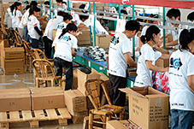

Conclusion

At LGS we are very proud to operate in a way that upholds and respects the principles of the UN Global Compact. We are a small organisation but are passionate about what we do and feel very privileged to be operational in markets where we hope to make a difference.

As we face today’s global pandemic, never has it been more important that our leaders are strong, fearless and act with the utmost integrity. While the COVID-19 virus is causing pain and suffering for many, we hope that there will be positive lessons and outcomes once this difficult time has passed. Let our common humanity prevail and the UN continue to foster the furtherance of compassion throughout the world’s nation.

LGS will continue to play its small part in striving to inculcate the best of human kind in its dealings with all those with whom it comes into contact.

