Tranbjerg, 02.04.2020
PLE

To our stakeholders:

We recognize that a key requirement for participation in the UN Global Compact is the annual preparation and posting of a Communication on Progress (COP) that comprises of a CEO statement of continued support for the UN Global Compact, a description of practical actions with regard to the principles of the UN Global Compact, and a measurement of outcomes or expected outcomes.

We are late in creating, sharing and posting our COP report due to the COVID-19 crisis. Key employees have been ill and in quarantine while other key employees have had to take extra holidays to provide home education for their children because the schools are closed. We would like to stress the fact that is not our CSR activities that are delayed; only our annual communication about them.

We hereby ask for an extension period in order to be able to post a COP that describes our company’s efforts and progress to implement the principles of the UN Global Compact. Our new COP report will be posted on the UN Global Compact website by 22nd July 2020 at the latest.

Sincerely yours,

Troldtekt A/S

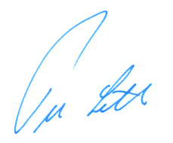

Peer Leth
CEO

+45 87478130
ple@troldtekt.dk

