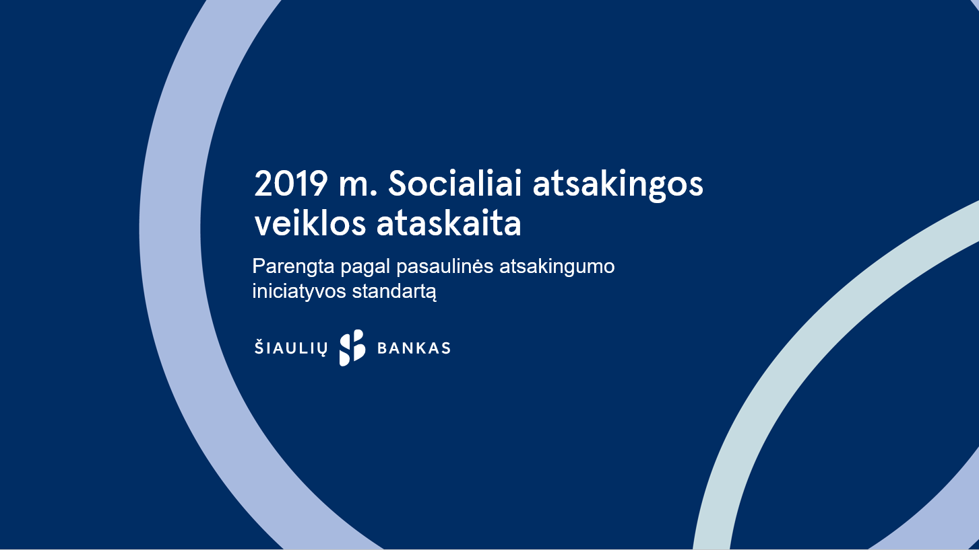

A Report on Socially Responsible Activities for the Year 2019

developed in compliance with the standard of

the global responsibility initiative

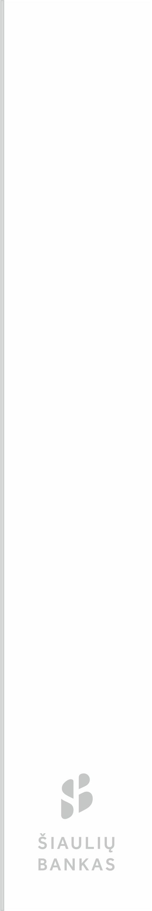

TABLE OF CONTENT

**ABOUT THE REPORT**  3

THE MANAGER'S WORD  4

STRATEGY AND ANALYSIS 5

DESCRIPTION OF THE COMPANY  6

ETHICS AND INTEGRITY 10

MANAGEMENT OF THE COMPANY 12

EMPLOYEES 15

ENGAGEMENT OF STAKEHOLDERS  16

PARAMETERS OF THE REPORT  19

ECONOMIC EFFICIENCY 21

TRANSPARENCY AND CORRUPTION PREVENTION  23

ENVIRONMENTAL PROTECTION 25

RELATIONSHIPS WITH EMPLOYEES 27

COMMUNITIES AND THE GENERAL PUBLIC 29

COMPLIANCE 31



# 

# ABOUT THE REPORT

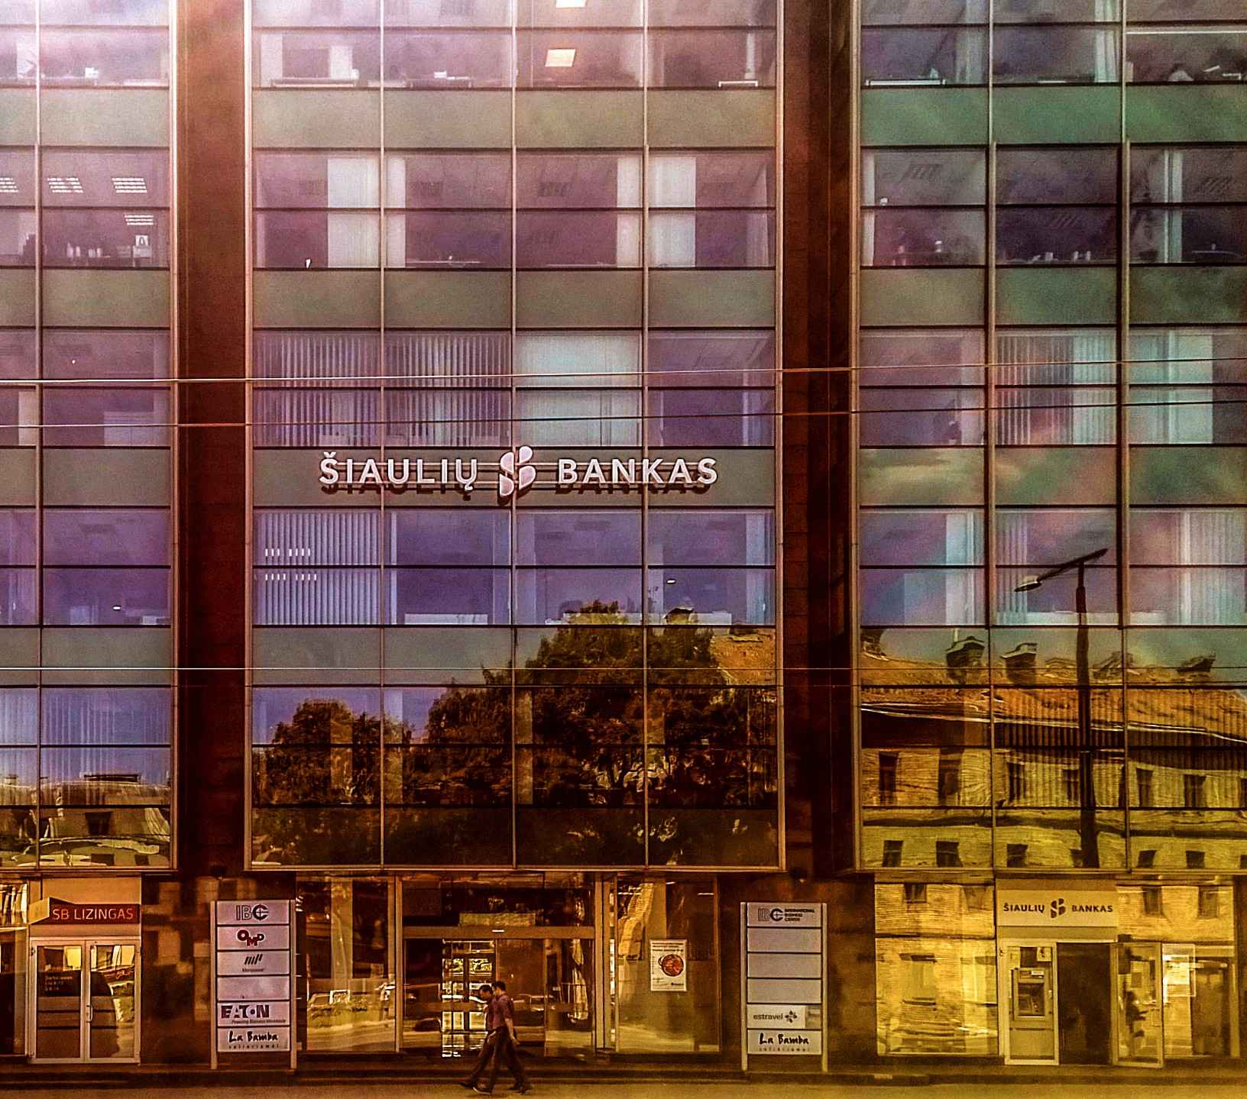

Since 2008, Šiaulių Bankas has been a member of the "Global Compact" initiated by the United Nations. In its Social Responsibility Report, the Bank follows the principles of the Global Compact and, for the third time this year, reports basing on the recommendations of the Global Reporting Initiative (GRI).

Since 2010, the Bank has provided comprehensive Corporate Social Responsibility Reports, which are publicly available on the Bank's website under the heading "Social Responsibility" and "Global Compact". This report presents the social responsibility report of Šiaulių Bankas for January-December 2019.

The present Corporate Responsibility Report presents the Bank's relationship with employees, customers and the community in the areas of environment and responsibility.

Any questions or comments regarding the report on socially responsible activities should be addressed by sending an email to [komunikacija@sb.lt](mailto:komunikacija@sb.lt).



GRI

102-14

# THE CEO‘S WORD

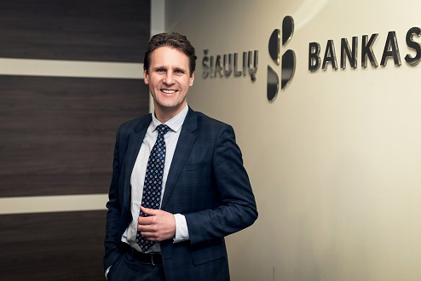

*Vytautas Sinius, the Chief Executive Officer of Šiaulių Bankas*

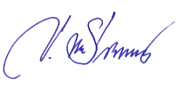

*Every day we strive to be closer to our customers, closer to our communities and closer to Lithuania. We are a Lithuanian bank and we are proud of it! Our efforts and achievements are related to and influence the people of our land. By providing financial services to our clients, we undoubtedly contribute to their well-being, realisation of their ideas and ambitions.*

*Šiaulių Bankas is much more than a financial institution: for our clients we are creators of new opportunities, for the society we are the employer, creating jobs not only in the major cities of the country, but also in the towns. For communities, we are a supporter of initiatives. Well, for the employees, we are a partner for self-realisation, providing the opportunity to grow with professional knowledge and implementing a wide variety of projects.*

*Unlike other market players, we respond to the needs of the public by taking the position not to close customer service units, but rather to invest in their renovation.*

*We are happy to be a part of our society, but we are also aware of our responsibilities. Socially responsible activities give meaning to our work.*

*In the 2019 Corporate Social Responsibility Report, you can find out about the approach of Šiaulių Bankas to sustainable activities and the specific work that we have done being closer to Lithuania.*



GRI

102-15

STRATEGY AND ANALYSIS



**Main Impacts, Risks and Opportunities**

The Bank continually assesses potential risks and opportunities, taking into account the nature and long-term strategy of the group companies. We are responsible and accountable to supervisors as well as to investors and our clients.

**Economics**

Every day the Bank contributes to the growth of the Lithuanian economy. By offering a wide range of financing instruments for small and medium-sized businesses, the Bank aims to promote the development and growth of these businesses. As a major partner of apartment building renovation in the country, the Bank contributes to energy efficiency increase projects.

**Social Sphere**

In order to contribute to the well-being of society, Šiaulių Bankas supports cultural, financial literacy, sports and social initiatives. It also encourages entrepreneurship among the population and regularly reports on business development opportunities.

**Environment**

The Bank aims to consistently reduce the amount of resources it consumes, preserve the environment, and encourage staff to use reusable tools in their daily operations.

# 

# DESCRIPTION OF THE COMPANY

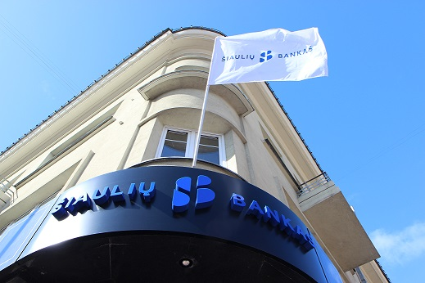

Established in 1992, Šiaulių Bankas is a sustainably and stable growing financial institution with a diversified shareholder base distributed among Lithuanian and foreign shareholders, including the European Development and Reconstruction Bank, which owns 26 percent of the Bank's shares.

By providing professional financial services to private and corporate clients, the Bank strives to be a reliable, flexible and attentive financial partner that is committed to growing the country's potential as well as the well-being of its citizens and businesses.

**Priority fields of activities of the Bank:**

* business financing;
* consumer financing.



GRI

102-1

Services for private and business clients**:**

* Bank service plans for a set monthly fee (for Private Customers);
* opening and administration of bank accounts in euro and foreign currency for Lithuanian and foreign clients;
* transfer of funds in euro and foreign currency to accounts with banks operating in Lithuania and abroad;

GRI

102-2

* collection of utility bills and other contributions;
* electronic invoice service, periodic and escrow payments;
* account management in an online banking system;
* mobile banking services;
* issuance and administration of payment cards;
* provision of various short- and long-term credits;
* foreign currency exchange trading;
* conclusion of various types of deposit agreements;
* investment services:
* brokerage of securities transactions on stock exchanges;
* OTC trading of securities;
* consultancy with regard to the issue, acquisition and transfer of securities;
* accounting for shares issued by companies;
* issuance of debt securities;
* preparation of prospectuses for the emissions of securities;
* other investment services;
* distribution of commemorative coins, numismatic sets, etc.

**Headquarters**

The Bank's head office is located in Šiauliai.

**Location of the Performance of Operation Activities**

The Bank's branches operate in the main Lithuanian cities and regional centres, which are financially active. Banking services are provided throughout Lithuania.

**Ownership and Legal Form**

Šiaulių Bankas is a public limited liability company.

Shares issued by the Bank are included in the Nasdaq indices. On 31 December 2019, the number of the Bank’s shareholders was 5391.



GRI

102-3

**Served Markets**

Banking services are provided in the Republic of Lithuania.

**The Scale of the Organisation**

GRI

102-4

In 2019, the Bank Group generated EUR 51.5 million in unaudited net profit. Compared to 2018, last year's typical operating income of the Bank Group grew by 16 percent.

GRI

102-5

GRI

102-6

Non-recurring activity result

Recurring activity result

**Information on Employed Personnel and Other Workers**

On 31 December 2019, the Bank had 737 employees,

together with Bank Group companies - 831 employees.

On 31 December 2019, 80 percent of the Bank's employees were women and 20 percent men.



GRI

102-7

**Precautionary Principle or Method**

Refer to the report criterion 102-30.

**More information is available in the Part “Financial Risk Management” of the Explanatory Notes to the Financial Statement for the Year 2019**

GRI

102-8

GRI

102-11

University

College

Special secondary

Secondary

31 – 40 years

< 30 years

51 – 60 years

41 – 60 years

> 60 years

**External Initiatives**

Since 2010 Šiaulių Bankas is a participant of the United Nations initiative "Global Compact".

**Membership in Associations**

Organisations, associations and associate structures in which the Bank participates:

* Association of Lithuanian Banks
* Society for Worldwide Interbank Financial Telecommunication (SWIFT)
* Nasdaq Baltic Stock Exchanges (Nasdaq Vilnius, Nasdaq Riga, Nasdaq Tallinn)
* MasterCard Worldwide international organisation of payment cards
* ISACA
* Lithuanian Confederation of Employers
* Šiauliai Chamber of Commerce, Industry and Crafts
* Šiauliai Association of Industrialists
* Kelme District Business Association
* Klaipeda Chamber of Commerce, Industry and Crafts
* Klaipėda Association of Industrialists
* Mažeikiai Business Association



GRI

102-12

GRI

102-13

* Akmene District Business Association
* Kaunas Chamber of Commerce, Industry and Crafts
* Panevezys Chamber of Commerce, Industry and Crafts Utena Branch
* Tauragė County Business Association
* Panevezys Chamber of Commerce, Industry and Crafts
* Vilnius Chamber of Commerce, Industry and Crafts
* Šilale District Business Union
* Lithuanian Association of Financial Brokers
* Association of Human Resource Management Professionals
* BNI Recommendation Marketing Service

ETHICS AND INTEGRITY



The employees of the bank follow three basic sets of principles in their daily activities:

* Bank values
* Code of Ethics
* Customer Service Standard

The Bank's four sustainable values (trust, professionalism, respect, responsibility) were purified by the employees of the bank who attended the 2014 Global Banking Conference.



Since 2015, a value game has been playing in the bank to make it easier to understand and adopt bank values and behaviours that describe them. Its purpose is to identify the behaviours most in line with the bank's values in everyday situations. The game of values encourages employees to collaborate, exchange views and make joint decisions. All new bank employees play such a game during Newbie's Days, which are held quarterly.

GRI

102-16

The Bank follows the Code of Ethics - it does not tolerate any form of inequality, violence, psychological or similar pressure manifestations or forms of discrimination at work.

The Bank has implemented a common anonymous reporting intranet channel designated to the Compliance Officer, through which any employee can report any breach of regulatory requirements happening in the bank. Such report is investigated and, if confirmed, prompt actions are taken to remedy the breach.

The customer service standard defines employee behaviours in customer service.

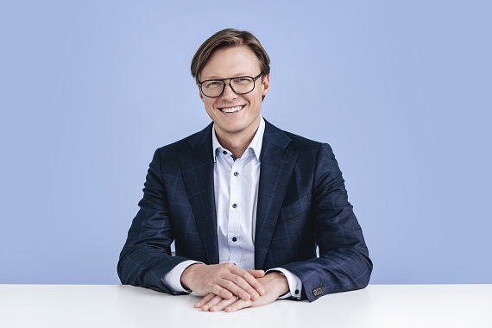



**Consultation Mechanisms and Ethical Issues**

The Bank has mechanisms for anonymous reporting to the Compliance Officer and to the Chairman of the Bank's Nominating Committee. Anonymous messages can be submitted at any time during the day on the bank's intranet site. The mechanism for reporting to the Compliance Officer is designated to notify about any possibly unlawful actions of the employees of the Bank Group (including also managers) - theft of the property of the bank, its clients, partners, employees, fraud, misuse of office position, conflicts of interests, allegations of non-compliance with the provisions of the Bank's Code of Ethics or other internal legal acts of the Bank, etc. The Bank's Compliance and Prevention Department is responsible for this mechanism.

GRI

102-17

The Notification to the Chairman of the Nomination Committee provides an opportunity to confidentially (albeit anonymously) report any committed or suspected violation of the opinion of an individual member of the Bank's body or of a small group of members that could harm the Bank's interests.

GRI

102-18

All communications are confidential and anonymous upon request. All new bank employees are introduced to the reporting channels during newbie training.

Information on ethical and unethical behaviour is provided in the Code of Ethics of the Bank.

No reports were received during the year 2019.



# MANAGEMENT OF THE COMPANY

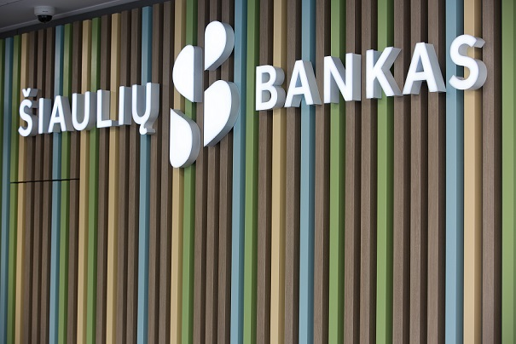

**Management Structure**

General Meeting of Shareholders

**Supervisory Council** – collegial supervisory body

**Management Board** – collegial management body

**Chief Executive Officer** – sole management body

**More details are available in the "Bank Management" section of the Annual Report.**

**Composition of the Supreme Management Body and its Committees**

GRI

102-22

**Members of the Management Board of the Bank:**

* Algirdas Butkus – Chairman of the Board
* Vytautas Sinius
* Donatas Savickas
* Daiva Šorienė

GRI

102-23

* Vita Urbonienė
* Jonas Bartkus
* Ilona Baranauskienė

The Bank has Risk Committee, Audit Committee, Nomination Committee, Remuneration Committee, Loan Committee, Risk Management and Regional Loan Committees.

GRI

102-24

**More details are available in the sections "Management of the Bank" and "Members of the Committees Established in the Bank and Their Activities" in the Annual Report**

**Chairman of the Supreme Management Body**

The Chairman of the Management Board of the Bank is Algirdas Butkus.

**Nomination and Election of the Supreme Management Body**

The members of the Management Board are elected, recalled and supervised by the Bank's Supervisory Council. The term of the office of the Management Board shall be four years. The number of the terms of office shall be unlimited. If individual members of the Management Board are elected, they shall be elected until the end of the term of office of the existing Board.



**Conflicts of interests**

Members of the Bank's Supervisory Council and the Management Board act in the interest of the Bank and its shareholders, avoiding conflicts of interest. All transactions with the Bank's executives are made at market conditions. The Rules of Procedure of the Bank's Board of Directors state that a member of the Management Board must avoid activities that may cause a conflict of interests. Before taking up his duties, a member of the Management Board must disclose all information to the Bank which may give rise to a conflict of interests and keep this information up to date. A member of the Management Board shall not have the right to vote and participate in the meeting of the Management Board when dealing with the issue related to his / her activities on the Management Board or regarding his / her liability. Likewise, when the Management Board is dealing with matters that a member may have an interest in, or when the Bank may be in danger due to the lack of objectivity of the Board member.

**The Role of the Supreme Management Body in Defining Purpose, Values and Strategy**

The Management Board analyses and evaluates the material submitted by the CEO of the Bank on the implementation of the Bank's business strategy and organisation of the Bank's activities.

**More detailed information is available in the section "Related Party Transactions" of the Annual Report.**

GRI

102-25

**The Collective Knowledge of the Supreme Management Body**

Board members regularly attend the most important economic conferences in the country. Once a year there is a strategic top management session where the members of the Management Board and the Supervisory Council hear on topics ranging from global economic trends to socio-demographic environments, innovation, strategic management, etc.

GRI

102-27

**The Assessment of the Performance of the Supreme Management Body**

The Bank's Nomination Committee shall assess the structure, size, composition and performance of the Bank's management bodies on an annual basis and make recommendations for changes, as appropriate. The assessment of the management bodies shall be presented in the annual report of the Nomination Committee. One of the functions of the Nomination Committee is also to regularly assess the skills, knowledge and experience of individual directors and report to the collegial body.

GRI

102-29

GRI

102-26

**Identification and Management of Economic, Environmental and Social Impacts**

GRI

102-28

Economic, environmental and social impacts are assessed at top management level when planning the company's activities.

**Risk Management Process Efficiency**

The Bank analyses, assesses, assumes and manages the risks or groups of risks it faces in its operations.

The risk management policy adopted by the Bank's Supervisory Council and the risk management process developed on the basis thereof, helps to ensure the integrity of the risk management process within the Group.

The purpose of the risk management policy is to define the risks and the principles of the management thereof in the activities of the Group. Whereas various risks faced by the Group are interdependent, their management is centralised. For this purpose, the Bank has a Risk Management Committee. One of the main goals of the Bank's Risk Management Committee is to organise and coordinate the risk management system. The Group reviews its risk management procedures and systems regularly, at least annually, in the light of market developments, new products, and newly emerging best practice principles.



GRI

102-30

Every year Šiaulių Bankas' Group of Enterprises carries out self-assessment. This process analyses the types of risks that may arise from banking activities and have a significant impact on the Bank’s Group. The main types of risks faced by the Group are the following: credit, market, liquidity, concentration, operational, IT and compliance risks.

**More details are available in**

**The section Financial Risk Management of the Explanatory Note to the Financial Statements 2019.**

GRI

102-32

**The Role of the Supreme Managing Body in Sustainability Reporting**

The report is reviewed by the Manager of Administration of the Bank.

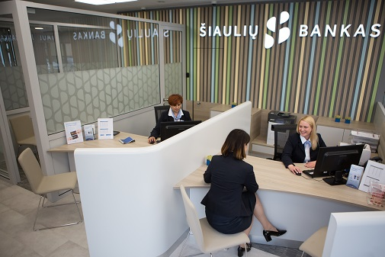

# EMPLOYEES

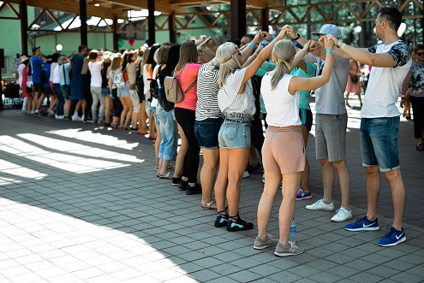



**Remuneration Policy**

Remuneration for employees at the Bank is determined by the Remuneration Policy, Procedure for Awarding Bonuses, Procedure for Allocation, Calculation and Payment of Variable Remuneration, Rules for Calculation and Payment of Wages and Related Benefits, Rules of Procedure and other internal legislation.

GRI

102-35

GRI

102-36

**Section “Remuneration Policy” in the Annual Report**

**Process for Determining Salaries**

Since 2017, the Bank has been relying on the Korn Ferry Hay Group methodology, which is based on salary scales for specific job levels determining salaries. The margins are determined by looking at the national market as a whole, also taking into account regional differences (except for managerial positions). This allows the internal and external justice of the remuneration to be assured.



# ENGAGEMENT OF STAKEHOLDERS

GRI

102-40

The List of Stakeholder Groups

|  |  |
| --- | --- |
| Stakeholders | Methods of Engagement i |
| Employees | * Social initiatives; * Suggestion making and implementation possibilities. Possibility to notify the compliance officer; * Annual activity discussion interview; * The Bank's intranet; * Events. |
| Shareholders | * Regular reports; * Performance presentations to investors; * Meetings of shareholders. |
| Customers | * Customer service quality research; * Communication in social networks; * The Bank’s website; * Events for customers. |
| Suppliers and partners | * Attendance at meetings. |
| Regulatory authorities | * Regular reports; * Attendance at meetings. |
| Communities, society | * Sponsorship and support projects; * Educational activities. |
| Associated structures | * Corporate Social Responsibility Report. |
| The media | * Press releases; * Comments; * Events; * Meetings. |

**Identification and Selection of Stakeholders**

Stakeholders have been selected in consideration of the nature of the activities of the organisation and on who or what the organisation can make direct or indirect influence as well as who or what makes influence on the organisation.

**Approach for Stakeholder Engagement**

Customer feedback is sought through Mystery Shopper and Net Promoter Score (NPS) surveys. Customer feedback is sought through Mystery Buyer Surveys, Customer Referral Index (NPS Indicator) Surveys and Customer Service Quality Surveys as well as Employee Sales Skills Surveys in the Lithuanian Commercial Banking Sector.

The Mystery Shopper Survey evaluates the quality of customer service at the bank's branches. The study assesses where customer service needs to be improved and where employees are performing flawlessly. The survey data is used as a basis for the annual training of customer service managers.

.



The purpose of the NPS indicator survey is to find out how private and business customers value Šiaulių Bankas. During the year 2019, two NPS studies were conducted. One was carried out by an external company and the other by responsible employees of the bank.

GRI

102-42

The purpose of the survey on customer service quality and employee sales skills in the Lithuanian commercial banking sector is to measure and compare the fulfilment of key customer service quality criteria in the Lithuanian commercial banking sector, to identify the strongest and weakest service areas and to evaluate customer service quality trends. The 2019 mystery buyer survey was conducted once by an external company.

GRI

102-43

Other ways of stakeholder engagement are presented in the section Indicator 102-40.

**Main Topics and Issues Raised**

In 2019, for the second year in a row, Šiaulių Bankas became the best customer service bank. Customer service quality is rated at 94.9 percent and outperforms the market average by more than 12 percent.

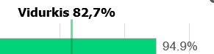

**Average 82.7 %**

Corporate clients

The survey revealed the strengths and areas for improvement in customer service, with the best performing units being encouraged by awards.

Private clients



GRI

102-44

According to the NPS indicator survey, lots of customers were satisfied with the banking services, and electronic banking was the most frequently identified as the area for improvement. The NPS figure was 65 in 2019 and 60 in 2018.

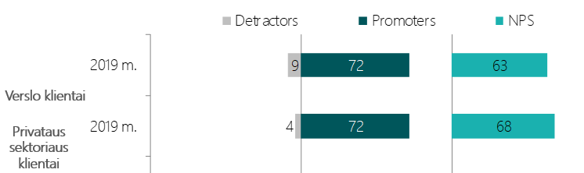

# PARAMETERS OF THE REPORT

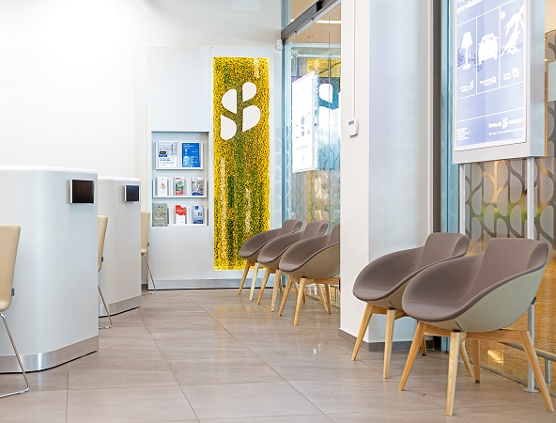

**Entities Included in the Consolidated Financial Statements**

**Subsidiaries of the Bank**

**Directly controlled subsidiaries:**

SB Lizingas UAB (financial lease, consumer loans)

Šiaulių banko lizingas UAB (financial lease and operating lease)

Šiaulių bankas Property Fund UAB (Real Estate Management)



GRI

102-45

SBTF UAB (real estate and movable property management, administration)

Minera UAB (real estate management)

Pavasaris UAB (development of the quarter of Multi-Apartment Buildings)

Bonum Publicum UAB (life insurance)

Šiaulių Bankas Investment Management UAB (Investment Management)

GRI

102-46

**Indirectly controlled subsidiaries:**

UAB Sandworks (real estate management)

Apželdinimas UAB (landscaping, environmental management)

**More detailed information is available in the section “Group of the Bank’s Enterprises” of the Annual Report**

**Defining the Boundaries of the Report Content and Topics**

The report selects those topics and criteria for which the bank collects data and which can be precisely evaluated. New, additional criteria are measured each year.



**The List of Important Topics**

The socially responsible activities of the Bank aiming at improving the quality of life in Lithuania, promoting sustainable economic development and the environment are focused on the areas where the Bank can and does strive to make a positive impact, i.e.:

* employees;
* customers of the Bank;
* environmental protection;
* communities and general public.

This report covers topics relevant to all these areas.

**Reporting Period**

The report is for the year 2019.

GRI

102-47

**Date of the Latest Report**

Since 2017, the Bank has been reporting under the Global Reporting Initiative (GRI) standard. This report is the third.

GRI

102-50

**Reporting Cycle**

GRI

102-51

A report on socially responsible activities is prepared annually.

**Contact Point for Questions Related to the Report**

Questions and comments regarding the report on socially responsible activities can be submitted by e-mail [komunikacija@sb.lt](mailto:komunikacija@sb.lt).

GRI

102-52

**Notifications on Reporting in Compliance with GRI standards**

GRI

102-53

The present report has been developed in compliance with the basic version of the GRI standards.

**External Inspection**

GRI

102-54

The present report is audited.

GRI

102-56



# 

# ECONOMIC EFFICIENCY

GRI

201-1

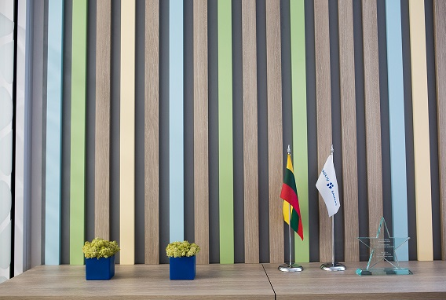

**Direct Economic Value Created and Distributed**

Basing on performance results, the Annual General Meeting decides on whether to pay dividends to shareholders.

Data on dividends paid by the bank:

|  |  |  |  |
| --- | --- | --- | --- |
| ***Year, for which dividends are paid*** | ***2016*** | ***2017*** | ***2018*** |
| *Percentage of face value* | 1.72 | 1.72 | 10 |
| *Amount of dividend per share, Eur* | 0.005 | 0.005 | 0.029 |
| *Dividend Amount, Eur* | 1 887 442 | 2 264 938 | 17 421 064 |
| *Dividend to Group Net Profit Ratio, Percentage* | 4.3 | 7.1 | 33.0 |

Significant Indirect Economic Impact

**Small and Medium Business Financing**

One of the priority activities of the Bank is financing of small and medium businesses. In developing this area of activity, the Bank also promotes the development of small and medium-sized enterprises (SMEs). The Bank actively uses a variety of financial engineering instruments to provide financing to companies that would not be able to obtain normal credit, thereby contributing to their growth.

Of all banks operating in Lithuania, Šiaulių Bankas has the most products with the European Union instruments administered by Invega UAB: a shared risk instrument for SME financing, various portfolio guarantees for SME loans, factoring and leasing.

**Renovation of Multi-Apartment Buildings and Regional Development**

The Bank aims to promote economic development in the country's regions and to reduce differences between them. One of the measures is financing of renovation (modernisation) of multi-apartment buildings. A large number of multi-apartment building renovation projects are taking place outside major cities. These projects involve the companies administering the buildings and the construction contractors, and create jobs in the regions.

Šiaulių Bankas is the leader in financing of the renovation of multi-apartment buildings - 2 out of 3 multi-apartment buildings renovated in Lithuania are financed by Šiaulių Bankas. At the end of 2018, Šiaulių Bankas signed a guarantee agreement with the European Investment Bank for the implementation of multi-apartment building renovation projects. Under this agreement, Šiaulių Bankas has allocated up to 150 million euros in addition for the renovation of multi-apartment buildings.



**Other Projects of Modernisation**

GRI

203-2

The Bank also participates in the energy efficiency improvement program. In 2018, an agreement was signed with the Public Investment Development Agency (PIDA) and continued in 2019, whereby the Bank, as a financial intermediary and contributing with its own funds, financed the modernisation of municipal buildings. The total amount for the implementation of the financial instrument is EUR 36.16 million. This financial measure is aimed at increasing the energy efficiency of municipal public buildings, reducing greenhouse gas (CO2) emissions, and ensuring the compliance of public building infrastructure with hygiene standards. The measure is funded by the European Regional Development Fund.

GRI

204-1

Furthermore, since 2019 the Bank calls to submit credit applications for renovation of cultural heritage objects. Credit funds are invested in attractiveness of objects, commercial payback, adaptability to public needs. Funding is provided by the Cultural Heritage Fund established by the Public Investment Development Agency (PIDA), the Ministry of Finance of the Republic of Lithuania and the Ministry of Culture of the Republic of Lithuania. Šiaulių Bankas was selected as the fund manager. The Cultural Heritage Fund received EUR 5.2 million from the European Regional Development Fund.

**Local Procurements**

**In 2019, over 90 percent of all purchases came from local suppliers.**





# TRANSPARENCY AND CORRUPTION PREVENTION

GRI

205-1



Assessing the Risks in Relation to Corruption

**Prevention of Money Laundering**

The Bank exercises responsibly the prevention of money laundering and terrorist financing by consistently and purposefully implementing and developing existing and new measures to prevent money laundering and terrorist financing as well as applying them in the Bank’s activities:

* identification of customers, customer representatives and beneficiaries;
* Collecting and verifying information about the purpose and nature of business relationships (applying the "Know Your Customer" rule);
* monitoring of business relationships and monetary transactions;
* identification of suspicious monetary transactions and information conveyance to the Financial Crime Investigation Service, etc.

Existing and new anti-money laundering measures are being developed taking into account: legal acts regulating the prevention of money laundering and terrorist financing in the Republic of Lithuania, FATF (Financial Action Task Force), EU, UN, US legal requirements.

**Prevention of Corruption and Conflicts of Interests**

The actions that can be defined as cases of intolerable corruption are defined in the Code of Ethics of Šiaulių Bankas AB.

To avoid potential conflicts of interest, the Bank's employees make annual declarations of financial interests.

The Bank pays all taxes to the State of Lithuania responsibly, complies with applicable legislation, prepares and participates in tenders in a transparent manner.

The Bank implements the requirements of the Foreign Account Tax Compliance Act (FATCA) and the Common Reporting Standard (CRS).





**Communication and Training on Anti-corruption Policies and Procedures**

The employees of the Bank are committed to comply with the Code of Ethics of Šiaulių Bankas AB, which distinguishes the following principles, as the most important:

* the principle of good faith,
* responsibility and accountability,
* the principle of respect for the law, person and his/her rights
* the principle of impartiality, objectivity and justice,
* the principle of exemplary behaviour.

GRI

205-2

The Code of Ethics regulates which actions can be considered as intolerable cases of corruption. All new employees of the Bank are familiarised with the Code of Ethics.

GRI

205-3

**Corruption cases confirmed and actions taken**

Any corruption-related incidents were not identified in 2019.

**Legal Action against Anticompetitive Behaviour and Antitrust Practices**

GRI

206-1

Any such actions were not detected during the reporting period.

# 

# ENVIRONMENTAL PROTECTION

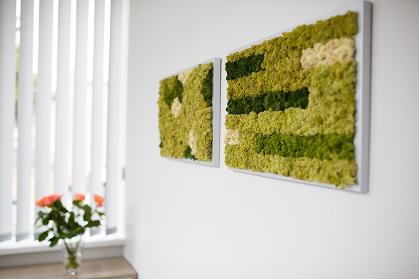

**Consumption of Materials for Packaging**

1406 kg of various packaging products (envelopes, paper and plastic bags, promotional packaging, money locks, etc.) were manufactured for the Bank's needs. The production of plastic payment cards - 394 kg,

**Energy Consumption in the Organisation**

**Fuel Consumption**

|  |  |  |  |
| --- | --- | --- | --- |
|  | *2017*  *Consumption in tonnes* | *2018*  *Consumption in tonnes* | *2019*  *Consumption in tonnes* |
| Petrol | 96.72 t | 91.83 t | 84.49 t |
| Diesel | 67.70 t | 72.00 t | 82.21 t |



GRI

301-1

**Electricity Consumption**

|  |  |  |  |  |
| --- | --- | --- | --- | --- |
|  | *2017* | | *2018* | *2019* |
| ***Electricity*** | | 2549.443MWh / 1127.046 MWh | 2596.167 MWh / 1401.795 MWh | 2641.681 MWh / 461.441 MWh |
| ***Percentage of renewable sources*** | | 44 % | 54 % | 17.47 % |

GRI

302-1

**Gas Consumption for Heating**

158199 kWh of gas were consumed during the reporting period.

|  |  |  |  |
| --- | --- | --- | --- |
|  | *2017* | *2018* | *2019* |
| *Gas* | 109306 kWh | 207360 kWh | 158199 kWh |

There are two types of heating used in the organisation -

central and gaseous. At present, it is not possible to estimate the energy resources used for central heating.

**Reducing Energy Consumption**

In order to minimise fuel consumption and reduce pollution emissions to atmosphere:

* The bank uses an electronic booking system for business cars, which allows planning business trips in groups and traveling to business trips by the minimum possible numbers of transport vehicles;
* Bank employees traveling on business trips within Lithuania are encouraged to travel by public transport (for example, by train, bus);
* the organization of meetings involving staff and partners from different cities in modern teleconferencing rooms in Vilnius, Kaunas, Klaipėda and Šiauliai, as well as the use of fixed telephones at workplaces, Skype and other means of communication are encouraged.



GRI

203-4

In order to reduce the amount of paper used, internal and external document management systems were continued in 2019 to reduce the need for printable documents.

Back in 2018, the bank launched the first robot to automate the manual operations related to payment card transactions.

GRI

305-1

**Direct (Scope 1) Greenhouse Gas Emissions**

Not calculated.

GRI

305-2

**Indirect energy (Scope 2) GHG emissions**

Not calculated.

GRI

307-1

**Non-compliance with Environmental Laws and Regulations**Any non-compliance with environmental laws and / or regulations was not identified during the reporting period.

# RELATIONSHIPS WITH EMPLOYEES



**Recruitment and Staff Turnover**

The Bank promotes long-term working relationships with its employees. As of 31 December 2019, 30 percent of the Bank's employees had worked for more than 10 years. During the reporting period, the total turnover of employees was 13.8 per cent. (13.2 percent in 2018 and 14.5 percent in 2017).

On 31 December 2019, the Bank had a total of 737 employees and the Bank Group had 831 employees. Compared to 31 December 2018, the number of employees at the bank increased by 3.2 per cent.



GRI

413-1

**SB logo centrinis (baltas)**

GRI

401-3

404-1

404-2



GRI

401-1

New staff by gender in 2019:

GRI

401-3

Number of new employees by region in 2019:

|  |  |
| --- | --- |
| **Region** | **Number of new employees** |
| Kaunas Region | 30 |
| Klaipėda Region | 23 |
| Šiauliai Region | 19 |
| Vilnius Region | 52 |
| **Total:** | **124** |

**Parental Leave**

All employees, regardless of gender, are entitled to parental leave.

**Further details are available in: the section “Employees”**

**of the Annual Report**



*Employees who took parental leave in 2019 \**

|  |  |
| --- | --- |
| Gender | The number of employees |
| Women | 55 |
| Men | 0 |
| Total: | 55 |

* this number includes both parental leave granted in 2019 and continuing parental leave.

*Parental leave granted in 2019*

|  |  |
| --- | --- |
| Gender | The number of employees |
| Men | 7 |

*Number of employees returning to work after parental leave in 2019 by gender\**

|  |  |
| --- | --- |
| Gender | The number of employees |
| Women | 27 |
| Man | 1 |
| Total: | 28 |

*employees returning for work / redundancies after AVP.

**The Average Number of Training Courses Per Employee Per Year**

The average number of training days per year for bank network employees was 2.2 days. The staff of the Centre and the regional units received on average 9.5 hours of external training per year.

**In-service Training and Transition Assistance Programs**

The staff development system includes the adaptation process for newcomers, vocational training, specific training (compulsory training regulated by LT legislation) and general competency training.

GRI

401-3

Newbie Days are designated for Newbie Adaptation Program. In 2019, the program for new employees was completely updated. All new employees of the Bank take part in the two-day lasting Newbie Days event, which introduces the Bank's activities, structure and functions of departments. They hear about the Bank's services and products, processes, ongoing projects. We play the Bank Values game. Managers from different fields share their professional experience, encourage, and wish for easy engagement. In 2019, nearly 100 new employees attended Newbie Days.

GRI

404-1

Every year the Bank's network employees - customer service managers and group managers - receive training on upgrading the bank's product knowledge and customer service skills. The purpose of these trainings is to provide, consolidate and develop customer service, proactive sales skills, change employee attitudes, and familiarize employees with existing or new Bank products and services. In 2019, 15 such training projects took place.

GRI

404-2

During the reporting period, the Bank also hosted a "Funding Solutions Forum", an in-house lecturer program, procurement process organisation and negotiation competency training, money laundering and terrorist financing prevention training. The staff of the Centre units developed their expertise by participating in external conferences and seminars.

In 2019, we continued with the expansion of the Club of Leaders created by the Academy of Management. The Club of Leaders was held in three cities and was joined by newly recruited executives.



# COMMUNITIES AND THE GENERAL PUBLIC

**Cooperation with Educational, Cultural Institutions or Organizations**

**In 2019, the bank sponsored:**

* Cultural centres of Utena, Alytus District, Varena, Rokiskis;
* Utena Business and Information Centre;
* Panevėžys District Municipality Administration, Anykščiai District Municipality Administration and Visaginas Municipality Administration;
* The Faculty of Economics of Vilnius College.

**In 2019, the bank cooperated:**

* Assessed project work of 4th year students of International Banking, of the Faculty of Economics and Business Administration of Vilnius University;
* Lectured on economics lessons for the 10th form pupils of Tytuvėnai Youth School, students of Kelmė District Adult Education Centre, pupils of Šiauliai Romuva Gymnasium and Šiauliai Saulėtekis Gymnasium, Panevėžys Minties Gymnasium;

GRI

413-1

* Bank staff gave lectures to the 5th form pupils of the Ginkūnai Sofia and Vladimir Zubovas School in Šiauliai district and to the 3rd grade pupils of Šiauliai Juventa progymnasium;
* Participated in Wanted Career Days at Kaunas University of Technology and SMART START Career Fair organized by Vilnius College, Faculty of Economics.

**Strengthening Communities**

Being a Lithuanian capital bank and introducing a new image strategy to the public in 2019, the Bank strives to be closer to communities and focuses on fostering the traditions of cities and towns in the country, supporting cultural life in Lithuanian regions, and contributing to the promotion of sport and the promotion of financial literacy.

In 2019, the Bank provided over EUR 152,000 in support for community, cultural and sports projects:

* For city celebrations;
* Pažaislis Music Festival;
* Lithuanian Musician Support Fund;
* Sea Festival in Klaipeda;
* For basketball club Šiauliai;
* Dakar Rally (for the crew of V. Žala and S. Jurgelėnas);
* And for other projects.



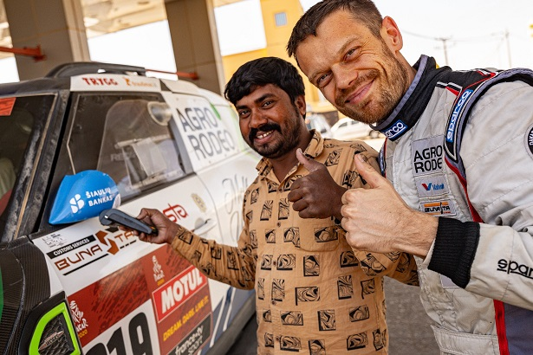

GRI

413-1

**Reducing Social Exclusion**

Since 2014, in cooperation with the public institution “Good Will Projects”, the Bank has been providing an opportunity for customers:

* To donate cash in donation boxes located in the Bank's branches;
* we also provide Bank Link service free of charge for the project aukok.lt.

In 2019, donations boxes collected EUR 1,767.63, which were transferred to the Public Institution Goodwill Projects

# COMPLIANCE



**Inconsistencies in Product and Service Information and Labelling**

Any such cases were not detected by the Bank during the reporting period.

The Bank's Contact Centre registers customer complaints or claims for information about services or products.

In 2019, any cases of non-conformities, when the Bank or the Group’s Enterprises would be fined or warned concerning inappropriate information about services, were not registered.



GRI

417-2

**Justified Complaints about Customer Privacy Violations and Customer Data Loss**

The Bank has not received any reasoned complaints about any violations of customers’ privacy.

.

GRI

418-1

**Non-compliance with Socio-economic Laws and Regulations**

The Bank has not identified any cases of non-compliance with social or economic laws or regulations.

GRI

419-1

