March 27, 2020

H.E. António Guterres
Secretary-General, United Nations New York, NY 10017 USA

Dear Mr. Secretary General,

I am pleased to reaffirm IMA World Health’s ongoing support for the ten principles of the UN Global Compact with respect to human rights, labor, environment and anti-corruption. We are committed to upholding the UN Global Compact and its principles in the strategy, culture and day-to-day operations of our organization and to engaging in collaborative projects which advance the broader development goals of the United Nations, particularly the Sustainable Development Goals.

In our Communication of Engagement, we make a clear statement of this commitment and of the actions we are taking to enact it in our organization’s operations to our stakeholders and to the general public. We also pledge to participate in and engage with the UN Global Compact in the following ways:
- Partner with organizations and communities serving the most vulnerable, in order to end poverty, injustice and human suffering
- Engage UN Global Compact business participants as they implement and report on their sustainability efforts.
- Connect with UN Global Compact local networks for synergy on our shared efforts to meet the principles.
- Support issue platforms and workstreams that best fit with our scope of work, such as gender equality, climate change and food and agriculture.

We support public accountability and transparency and commit to report on our progress every two years according to the Global Compact Communication on Engagement policy.

Sincerely,

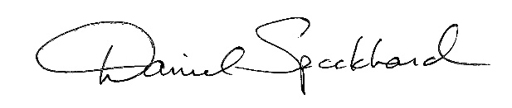
Ambassador Daniel Speckhard Chief Executive Officer
IMA World Health

1730 M Street, NW, STE 1100, Washington, DC 20036 USA 202.888.6200 www.imaworldhealth.org

