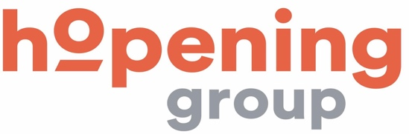

03/27/ 2020

To our stakeholders:

We recognize that a key requirement for participation in the UN Global Compact is the annual preparation and posting of a Communication on Progress (COP) that comprises of a CEO statement of continued support for the UN Global Compact, a description of practical actions with regard to the principles of the UN Global Compact, and a measurement of outcomes or expected outcomes. We are late in creating, sharing and posting our COP report due to the fact that we had not paid our fees for the year 2019 until December and most recently, because of the sanitary crisis that has requested a lot of time and efforts into assisting our clients in maintaining their fundraising activities.
We hereby ask for an extension period in order to be able to post a COP that describes our company’s efforts and progress to implement the principles of the UN Global Compact. Our new COP report will be posted on the UN Global Compact website by 03/04/2020, max. 90 days from COP deadline at the latest.

Sincerely yours,

RebeccaPBarros
Rebecca Previtera Barros
Communications Officer

