INTERCULTURA
COMMUNICATION ON PROGRESS

March 6, 2020

LETTER FROM OUR FOUNDING DIRECTORS
Intercultura Costa Rica Language and Cultural Center is pleased to continue to support the United Nations Global Compact. We are proud to have furthered efforts to improve our company and community through the Ten Principles of the Global Compact, as they relate to human rights, labor rights, environmental protection, and anti-corruption.
We continue to make the Global Compact and its principles part of the strategy, culture, and day-to-day operations of our company, sharing the principles with our employees, partners, clients, and the public. We continue to implement processes to help us monitor our progress in achieving the goals set forth in the Ten Principles and have pledged to challenge ourselves and everyone around us – suppliers, customers, competitors, and neighboring businesses – to improve our global community.
In our annual Communication on Progress, we describe our latest actions to improve the integration of the Global Compact and its principles into our business strategy, culture and daily operations. We also commit to sharing this information with our stakeholders using our primary channels of communication.
Sincerely yours,
Laura Ellington & Adelita Jiménez
Founding Directors

Human Rights Report

Intercultura provides our employees with safe and healthy working conditions, employee training and incentives, protection of employee privacy, viable grievance mechanisms to express legal, personal and professional concerns, equal gender rights, published policy against sexual harassment in the workplace, and encouragement of employee diversity and hiring practices that promote ethnic and GLBT diversity and presence in the workplace. The following list provides an overview of our actions in support of human rights:

2020:
- Joined the Costa Rican Tourism Board and Child Protection Agency (ICT- PANI) code of ethics pact in prevent sexual exploitation of minors, with a training for our Sámara staff.
- Offered a Suicide Prevention workshop for young people in Sámara Ccontinues to offer free classes to girls aged 12-17 from the shelter for abused girls “Siembra”
- Continues to offer free “Puertas Abiertas” English classes to single mothers from the at-risk area “Guarari”
- Donates to the non-profit alternative schools and associations for children’s education, including CREAR, Samara Pacific and Canto del Corazón
- Donates to Camino de Esperanza rehabilitation center for those with drug addictions
- Continues to offer scholarships for employees, their children and families, students in economic need and those with disabilities
Ongoing:
- Anti-discrimination hiring practices – active hiring of all ages, ethnicities, religions and gender expressions: 20% of our staff is non-traditional Costa Rican (ie. Not Catholic, heterosexual, white or latino, or within the average 22-5 age range) We have three out of nine managers who are homosexual, 2 out of 6 Spanish teachers who are homosexual, one is muslim, 5% of our employees are over 60, 40% are from countries other than Costa Rica, 3 % are of Indian descent, 5% are of african descent, and 1% is of asian descent. 70% of our staff are women.
- Cultural activities, offered free to community and staff, including yoga, dance and cooking.
- A variety of ethnicities and minorities in our staff: our upper-level managerial staff is comprised of 1 African American woman, 3 Latina women, 1 European woman, and 2 gay Costa Rican men.
- Gender equality: we have a higher percentage of female employees than male (70% - 30%).
- Diversity in age, with employees ranging from 21 to 73 years of age.
- Intercultura is committed to helping further international proclaimed human rights in our communities in all possible ways:
- We offer need-based scholarships to foreign teen students for our Teen Spanish Immersion in Costa Rica program; in 2020 we will help 10% of students with costs.
- As a commitment to our communities we provide nonprofit coordination of foreign volunteer programs and encourage students to get involved in the communities. Last year we had a total of 320 volunteers. On average, 50% of volunteers are involved in social programs (daycares, orphanages, child-protection, elderly homes), 30% worked in teaching programs, 10% were involved in animal care, 8% in environment, and 2% in medical programs. The Costa Rican Ministry of Public Education Program requested our help in sending them volunteer teachers for help in the public school systems.
- We support all social placements with a donation of $30-$50 per volunteer, in addition to their fees and lodging costs.
- We conduct activities with students to educate and inform them of current events associated with Human Rights issues in Latin America. An example is the recent approval of the application of IVF through private and state-funded medical faciltiies. The procedure had been banned for 16 years in Costa Rica, the only country in Latin American that had prohibited IVF. The International Human Rights Court finally overturned national legislation and hundreds of Costa Rican women may now access the procedure. As of 2020, IVF is now in practice and the first couples are waiting to give birth.

2. Labour report

Intercultura abides by all aspects of Costa Rican Labor Laws, which includes the grievance mechanisms set up by the Labor Ministry. To date we have had an official complaint filed against the company through the Labor Ministry or any other governmental organization. The following are some of the processes that indicate our philosophy in this regard:

2020:

- Continues with the non-profit branches of our school: “Homestay Program” and “Volunteer Program”, in accordance with our philosophy of creating ethical economic programs that give back to the communities that host us.
- Has implemented a recognition of excellence program for teachers of English and Portuguese
- Gives private health insurance to all foreign teachers
- Offers paid monthly teacher development
- Continues to offer sponsored professional development opportunities to employees.
- Has established a yearly budget for professional development for employees in each campus
- Has started a wellness initiative for teachers with free coaching sessions and wellness workshops
- Is implementing emotional intelligence workshops and Non-violent communication workshops for teachers and admin staff
- Now offers Diversity training to staff
ONGOING:
- 100% of employees receive the 13th month Aguinaldo pay as mandated by Costa Rican Labor Law, equal to one month’s extra salary.
- We invested $7,000 in total last year in training, education and free-time incentives for employees.
- We have grievance mechanisms set in place with trained administrative employees who handle complaints. Periodically, certified psychologists and other labour specialists lead our employees in workshops including a review of anonymous comments regarding their employment and evaluation of staff and school directors.
- We have yearly team-building workshops offered by outside companies which offer a further avenue for expressing employee concerns in a safe environment.
- We have an Occupational Health Policy Manual and an Emergency Procedures Manual as guides for employees regarding health and safety requirements in the workplace. We provide employees with a safe working environment by ensuring all cleaning and working materials are safe and nontoxic; we address fire prevention and emergency procedures in case of fire, earthquake or tsunami; we provide a guide for our committee to prevent possible accidents and investigate any that do occur, and to ensure the Health Manual guidelines are followed and that periodic inspections of all workplaces and employees are carried out to prevent illnesses and mishaps.
- All employees are insured both with the state health insurance system and with the private INS work-place accident coverage.
- All foreign hire employees are given private medical and dental insurance for them and their dependents, including pets.
- We value the individual skills of employees. We believe they are our strongest asset and strive to help them improve wherever possible by continuing personal and professional development. This includes workshops for teachers and administrative staff, second or third language courses (Portuguese, English, German, French), conferences and higher education programs.
- We offer incentives beyond what is legally required, for example company social gatherings and/or outings for staff and homestay mothers, including meals, music, gifts and raffle prizes.
- 100% of employees are eligible for additional incentives (monetary, emergency assistance, interest-free loans, study-sponsorship, flexible scheduling and other).
- Every employee is aware of the terms and conditions of their employment, the voluntary nature of their employment and their freedom to leave. Each employee knows his or her job description and employees are kept current, up to date, and involved in the decision process on any changes that may occur to their positions. Intercultura has never been charged with, indicated for, or in any way whatsoever involved in forced labor.
- There exist no false promises or threats, and we do not engage in withholding wages under any circumstance. Everyone in the company works with full knowledge of their pay rates, overtime rates, and time off policies. This information is readily available to all employees. Employees conduct both their regular work and overtime hours of their own free will, and are reimbursed for any overtime.
- Management maintains current, annual research to confirm fair wages including living costs and wage rates for similar jobs in the industry to ensure our employees are receiving the highest salary they deserve and that the company can afford to pay. We consistently pay above the country-wide minimum and average wages for each position.
- We continue to distribute a Welcome Pack for our new employees, a manual with our company’s policy for the teachers and administrative staff, safety issues, contingency plan and more.
- We have implemented a yearly company evaluation called “Help Us to Improve”, so our staff members can evaluate the company in general, colleagues, environment, and more.
- We have replaced performance reviews with the Talentum Feedback Process, highlighting employee strengths and how to best implement them, and providing training programs to work on growth ideas for any weak areas, thus providing better motivation for employees and more positive reinforcement.
- The Foreign Language Department sends teachers links to videos that show common processes of their best work, so they can review and better understand the information before coming to the training. This is a concept call Blended Learning and we implement this in the English classes too.
- Recognition and personal motivation (English and Portuguese Department): We acknowledge and recognize “The Teacher of the Month" according to the students’ evaluations and which teacher decorated the classroom the best. Also, in each meeting we do a "big ups" in which teachers can write reviews of other teachers who have helped them with something and this is read to the whole staff. In 2014 we started with Portuguese classes, and now all staff can take courses free.
- We are committed to reducing all forms of child labor and exploitation within our network. Intercultura has adequate and provable mechanisms of age verification maintaining copies of every employee’s official government issued identification cards and/or passports. For all employees, a minimum age of 18 is required.
- We ensure our employees are provided with enough work and high enough wages compared to national average standards, so that adults are able to support their families. Therefore, children need not supplement the incomes of our employees.
- We offered 34 scholarships to local children and adults for English classes at our Heredia campus last year, and continue to offer for this year.
- The CREAR association continues to develop the teen and pre-teen program with Intercultura’s support: these programs are aimed at keeping teens in school through graduation, aiding them in applying to and attending college, and providing marketable workplace skills.

3. Environmental Report
This year, Intercultura continued to sponsor daily, salaried, beach clean-up program; environmental programs run by our partner, the CREAR association for local children and teens; and give financial and logistical support for monthly volunteer clean-up efforts ($890 in the last year). In Heredia, we finally went green with fully functioning solar panels now working on both campuses.
2020:
- Is fully solar powered at both campuses
- Has eliminated plastic spoons and coffee stirrers in both campuses, replacing them with reusable spoons in sámara and bamboo sticks in Heredia
- Has started a company-wide digital transformation focused on administrative processes in order to reduce the amount of paper used
- Does not allow local people selling food on or around campus to use plastic or Styrofoam containers
ONGOING:
- We campaigned once again to get the Ministry of Health to assist in eliminating mosquito breeding-grounds in Sámara, and supported the community-wide clean-ups of organic and plastic trash.
- At our schools, we have hot air hand dryers instead of towels, faucets with auto-turn-off pressure knobs, recycling bins throughout each campus for students and staff to use.
- We no longer use photocopies in our classrooms, but instead digital copies via our interactive whiteboards.
- Any food sold on campus must be packaged in recyclable materials.
- The solar panels in both campuses have reduced energy consumption from $2,600 per month to $240 per month total in both campuses.
- We continue to reforest almond and palm trees on the beach in front our of campus and on roads and nature reserves in the area.
- Last year, the company donated $2,750 to various community organizations including local public schools, community churches, for children who want to participate in national athletics, tree planting projects, community clean-ups, recycling centers, child orphanages, animal shelters, and environmental reserves.
- We continue to make our beachfront rancho available for community organizations, associations and public schools that need it for graduations, activities, meeting, etc., free of charge. We also lend equipment and electronics to the development association for events in the community hall.
- We continue to have an active role in the municipal council to improve transparency in governance, and to implement a 30-year plan that prioritizes environmental protection, social development and sustainable infrastructure development.
- We co-sponsored the SAMARUN Race to raise funds for community initiatives.
- The Cultural Park of Sámara is now a reality, and we provide ongoing support for maintaining this forested area in the middle of town as a public park.
- We planted trees donated by ICE and local associations in schools and public areas, sponsored 3 low-cost castration campaigns of dogs and cats at low cost, organized 7student-led beach cleanups, filled in the eroded entrance to the beach, contributed to materials to fix town sewers in collaboration with City Hall, offered/hosted free computing and responsible tourism workshops to the Sámara community, subsidized German and French courses ($20 per month, free for Intercultura staff), and Free community adult-education courses in conjunction with the INA

4. Anti-Corruption Report

2020:

- We continue to work with the municipality in Sámara to combat endemic local corruption regarding building laws and environmental protection evaders. We provide consulting, physical infrastructure for community activities on this topic, and lead by example in transparent and legal practices regarding adherence to zoning regulations, permits, patents, denunciations of those who abuse environmental protection regulations, timely tax payments and other
Ongoing:
- Intercultura is committed to fighting all forms of government and other corruption. We strive to eliminate corruptive actions by filing official complaints, documenting corruption with real photographs and witness records and creating as much objective input as needed to begin the process of change.
- Intercultura continues to participate in the Sámara Security Committee through the development association, which works in conjunction with local authorities to eliminate police corruption and improve public security efforts in our town.
- We have denounced inhabitants engaging in illicit activities such as drug dealing and bribery of government officials aimed to cover up environmental abuses and allow the perpetuation of enrichment at the cost of the environment.
- We have also denounced noise-pollution and sanitary waste-water uses, and as a result of inaction on the Health Ministry’s part, we have also denounced them for corruption, as they are the public entity in charge of ensuring environmental compliance laws.
- We continue to refuse to provide bribe money to local officials in return for favourable or preferential treatment in terms of municipal benefits.

5. MEASUREMENT OF OUTCOMES:

Our measurements of outcomes are qualitative and quantitative. We have seen the following favourable outcomes since we began implementing our Sustainable development goals:
- Ensure healthy lives and promote well-being for all at all ages:
  - we have seen through our scholarship programs that men, women and children have been able to obtain better- remunerated jobs after completing Intercultura´s English and Portuguese low-cost language programs
  - The youth program addressing the issue of teen suicide and depression has resulted in an increased number of contacts from local youth via the youth association we partner with, leading to treatment of depression before it becomes a more serious problem.
- Ensure inclusive and equitable quality education and promote lifelong learning opportunities for all
  - The language programs we offer are for all ages, nationalities and other differential factors. We offer scholarships to those students who cannot afford to pay but demonstrate merit and commitment.
  - One paraplegic student who studied with us intensively for 2 years on a full scholarship now has full-time employment, whereas before he was unable to fund work.
  - Single mothers from a socio-economically disadvantaged neighbourhood are provided free English classes, and 4 have now graduated from the program and found bilingual jobs which enable them to provide a decent living for their families.
- Achieve gender equality and empower all women and girls
  - We specifically target women and girls in our scholarship outreach efforts, and have seen the advances not only in job and school success rates, but also in higher self-esteem and increased participation in extra-curricular activities.
  - Women are the recipients of our Puertas Abiertas full scholarship program.
  - Women represent the majority of our management posititions, including: 2 founding directors, 1 Foreign Language Department Director, 1 administrative director, 1 general manager, 2 Team Leads, 2 Student Life Directors, and 1 Marketing Director.
- Promote sustained, inclusive and sustainable economic growth, full and productive employment and decent work for all
  - Our salaried positions are always above minimum wage and our hiring practices have enabled us to provide job opportunities to marginalized groups including Nicaraguans, other immigrant groups (Perú, Colombia, Argentina), and social minorities. Our Executive Director is openly homosexual, as are two team leads and two teachers.
  - Our highest-paid jobs cannot be more than 5 times our lowest-paid jobs, ensuring more pay equality from cleaning lady to manager.
  - Absenteeism has diminished by 20% since we started offering employees free onsite yoga, zumba and latin dance classe within their scheduled work time, onsite.
- Build resilient infrastructure, promote inclusive and sustainable industrialization and foster innovation
  - All our facilities are constructed of sustainable materials, in accordance with local anti-sismic regulations, and optimizing use of space, light and natural ventilation.
- Take urgent action to combat climate change and its impacts
  - Our installation of solar panels in both campuses (5 buildings in total), has drastically reduced our carbon footprint and eliminated 98% of our reliance on traditional energy sources.
- Protect, restore and promote sustainable use of terrestrial ecosystems, sustainably manage forests, combat desertification, and halt and reverse land degradation and halt biodiversity loss
  - Our reforestation programs have created new-growth trees on the beachfront public land, replacing trees lost to disease, human intrusion and lightening. We now have approximately 60 new trees in and around our campus.
- Promote peaceful and inclusive societies for sustainable development, provide access to justice for all and build effective, accountable and inclusive institutions at all levels
  - We are creating more transparent feedback tools for employees, and have seen a rise in employee suggestions and addressing of issues pertinent to their status. These have been rapidly resolved in accordance with CR labour law and our business norms.
  - We continue to emphasize volunteer programs as a way to promote intercultural interaction, tolerance-building and understanding, and had approximately 270 students this year participate in the program.
CONTACTS:

Laura Ellington, MA.  Founding Director |  | Adelita jimenez M.  founding director
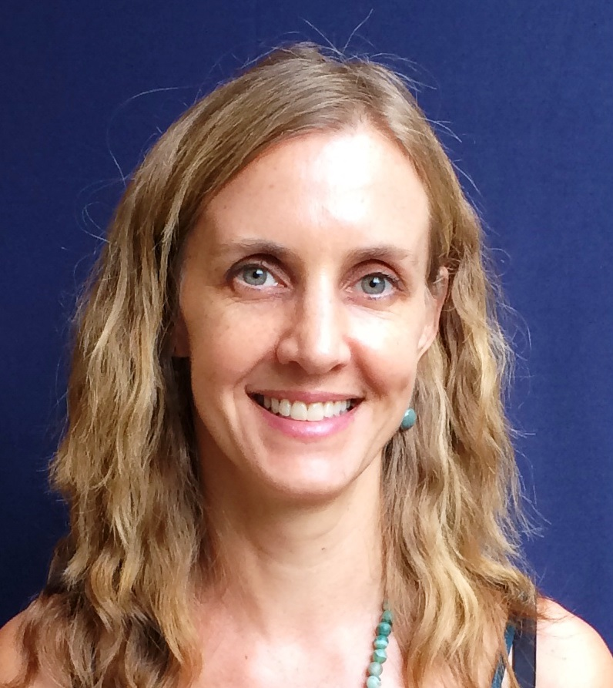 |  | 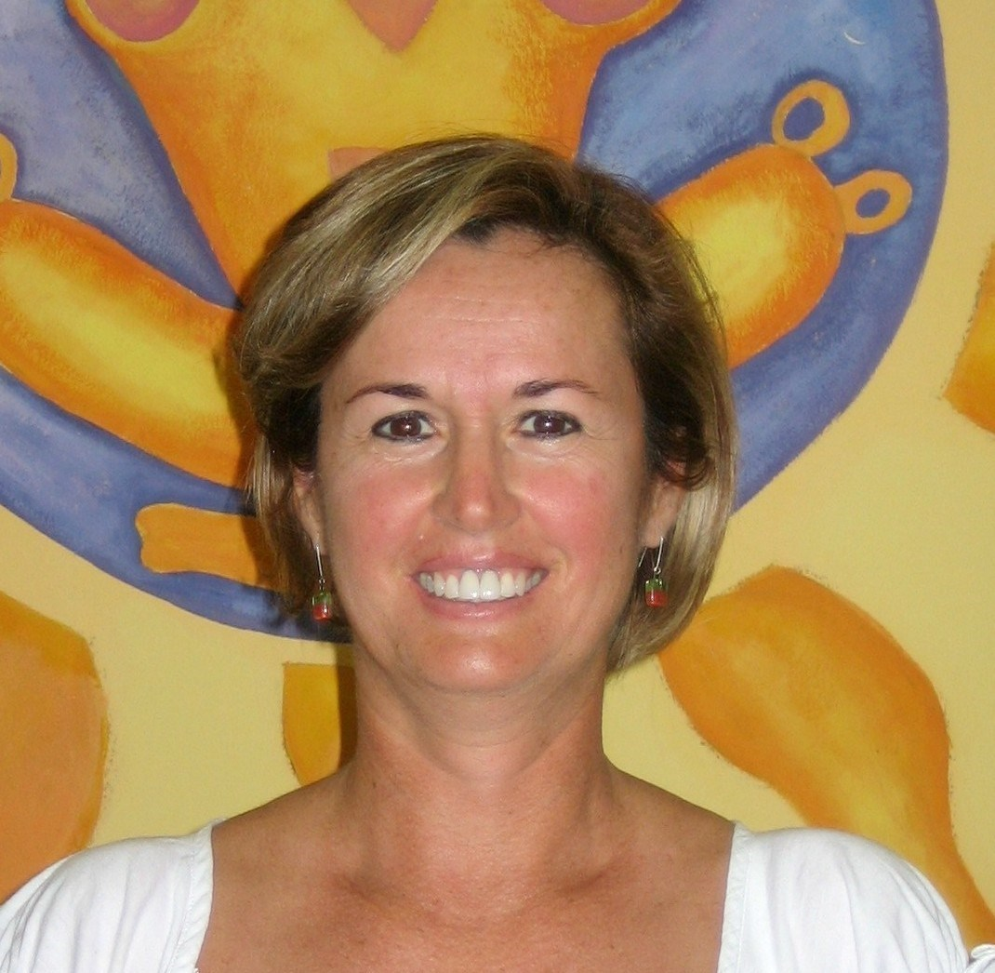
laura@interculturacostarica.com adelita@interculturacostarica.com

