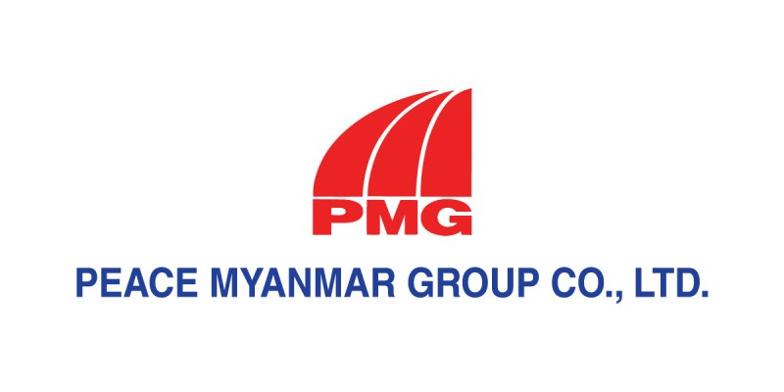

UN Global Compact Communication on Progress

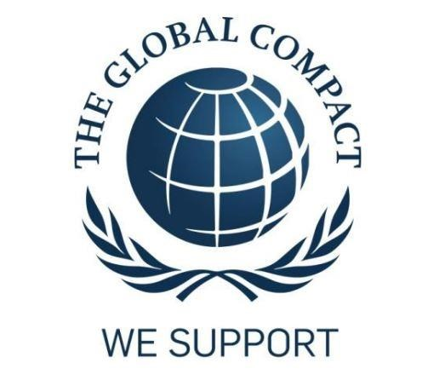

6th March 2018

5th March, 2020

Peace Myanmar Group Company Ltd.
No.1, Corner of Zawtika Lane & Bayint Naung Main Road,
Ward (4), Kamayut, Yangon, Myanmar
Tel: +95 (01) 538412, 538413 Fax: +95 (01) 510553
Website: www.pmg.com.mm

Statement of Commitment
H.E. Ban Ki- Moon
Secretary-General
United Nations
New York, NY 10017 USA
Dear Mr. Secretary-General,
On behalf of my organization, Peace Myanmar Group Co., Ltd., I am pleased to acknowledge that we support the Ten Principles of the United Nations Global Compact, in the areas of Human Rights, Labor, Environment and Anticorruption.
With this communication, we express our intent to advance those principles within our organization and our stakeholders. We are committed to making the Global Compact and its principles part of the strategy, culture and day-to-day operations of our company, and to engaging in collaborative projects which advance the broader development goals of the United Nations, particularly the Millennium Development Goals. Peace Myanmar Group Co., Ltd. will make a clear statement of this commitment to our stakeholders and the general public.
We recognize that a key requirement for participation in the Global Compact is the annual submission of a Communication on Progress (COP) that describes how we effort to gradually development and maintain the ten principles of the United Nations Global Compact. It includes, how we practices ten principles to integrate our company policies, organizational culture, and structure.

Sincerely yours,
Mr. Tun Linn
Managing Director
Peace Myanmar Group Co., Ltd.

HUMAN RIGHTS PRINCIPLES
Principle 1: Business should support and respect the protection of internationally proclaimed human rights;
Principle 2: Make sure that they are not complicit in human right abuses.
PMG has been a member of UNGC since 2016. We strongly respect and adhere the Universal Declaration of Human Rights. We are all equally entitled to our human rights without discrimination. Our company are embedded in our numerous operating processes and control mechanisms above all of our departments and each level of the organizations by “Human Rights”. We ensure that our business practices are not complicit in any human right abuses throughout the entire organizations at all levels from senior management to entry level operations.
We are trading company and we believe that employees are our key assets and we are most proud of the growth in our people after fulfilling their career planning and development. PMG has 7 branches within the country. They are in Magway, Pyay, Pyinmanar, Mawlamying, Sittwae, Dawei and Hinthada. Human Resource regulations and policies set up by the Head Office is implemented with same standards at all branch offices on working hours, overtime wages, support on health, education and personal development benefits with no discrimination. We coach and train our employees not only for company benefit but also for their career and life. We provided with the necessary knowledge and skills to perform their day to day jobs; for example induction training for new employee, on the job training, in house training and external training are provided. We support professional growth of our employees by encouraging individuals’ creativity, innovation and development, creating brain storming session which enables each individual to build his/her skill sets.
We have an open policy with our employees. Policies on human rights is shared amongst all employees and monitored by assigned team and middle management level to follow and act accordingly. It is our policy to maintain a model workplace which is free from harassment and other forms of discrimination based on race, color, religious, sex, age, disability and sexual orientation. We inform our employees internally about new projects and seek the views of community and respect the right to information and participation. Company provides employment and fair wages to workers and supports right to work, to adequate standard of living. We assign work to each employee to fit with their skills and to get more experiences for

their career. We give fair wages to our employees at the start of every month and we close all the public holidays announced by Government.
Our employees are provided health care and we contribute to the right to health. For the health of employees, vaccinations of anti B hepatitis virus and medical checkups conducted. Blood donation at the national bank is also our proudly CSR effort. Since 2014, we have been engaged in 18th blood drives. We give all our employees a chance to give back to the community by donating much needed blood supplies at the Myanmar National Blood bank. At the moment, our employees and friends of the company have donated over 3000 blood bags. While this hugely benefits the community, these blood drives also create bonding and workplace happiness for our employees. They get their blood checked (for example, an employee discovered he had Hepatitis C and the company has contributed significantly for his medical expenses to get treatment) and they enjoy a day of free.
A Committee has been formed for Safety and Prevention of Accidents and ear plugs are given to be worn to prevent damage to the ears due to noise; masks also have to be worn to prevent damage to the lungs due to dust and ashes and other safety equipment have been provided. The private clinic with a nurse is placed at the company and we can give urgent treatment to employees if the accidents are happened. Our management also made for safety of employees by organizing Fire safety committee and safety trainings are also given to employees.
Donated the PMG purified drinking water 0.3-Liter (5016) bottles , 0.5-Liter (2000) bottles and 1-Liter (400) bottles for Myanmar Traditional Boxing Festival, Deboer Scholarship Fund Raising Event, Women Day's event, Tournament Organization Myanmar, Run Free competition, etc. PMG family never hesitates in donation. Donations have been made by going to places suffering from Flood and providing drinking water and other essentials to victims of floods and storms.
Beside from CSR activities, our company holds annual charity activities according to Myanmar Traditional and culture. The Warso occasion, Thadingyut offerings, Kahtina robe offering and donation to monastic education are example for events of charity activity.

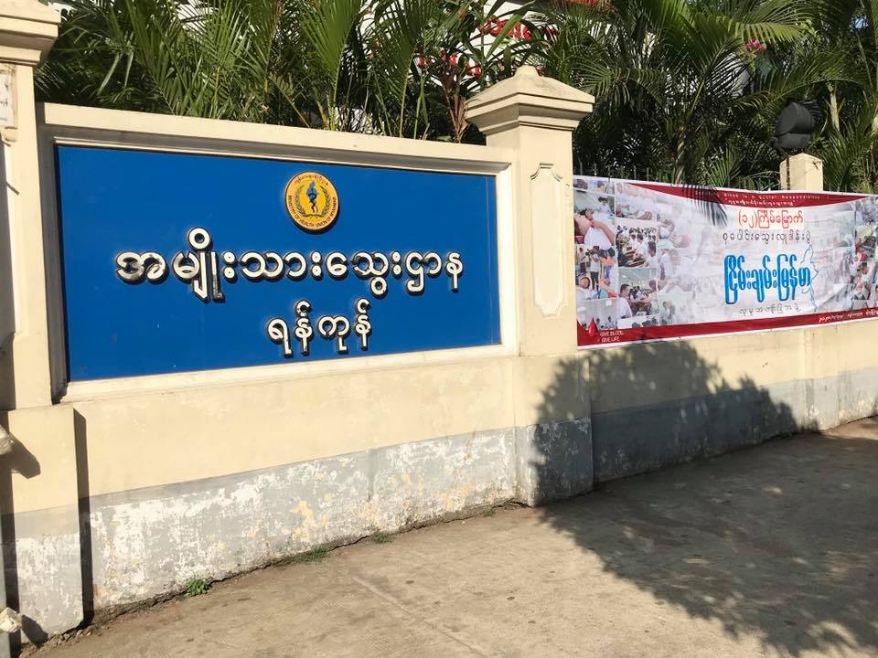
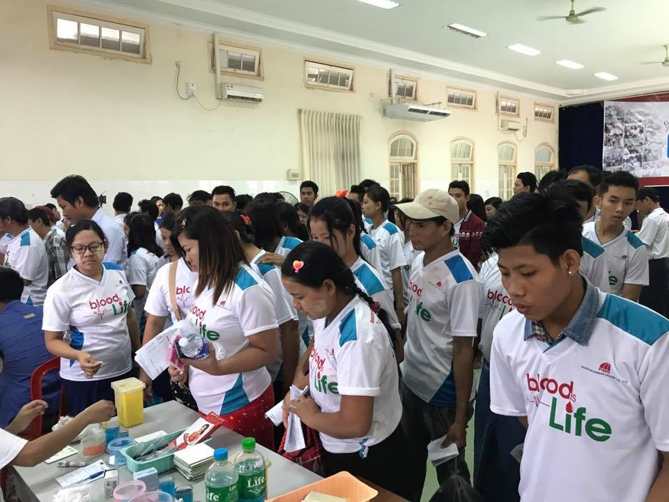
BLOOD DONATION OF PMG FAMILY TO NATIONAL BLOOD BANK

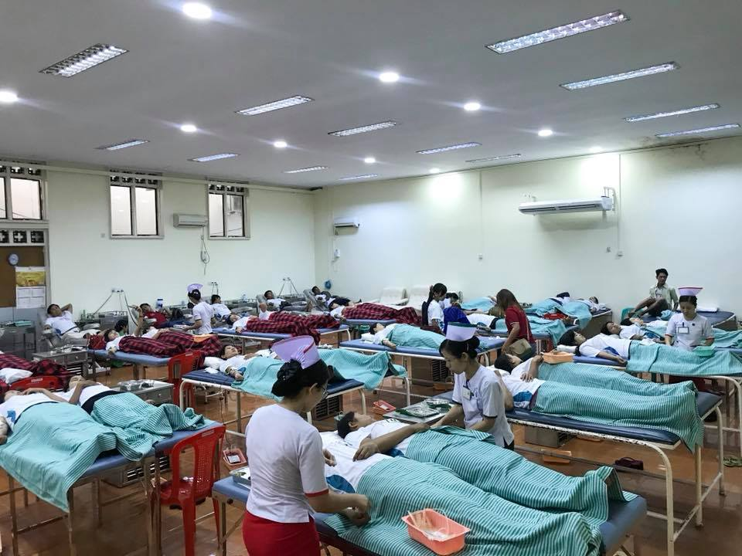

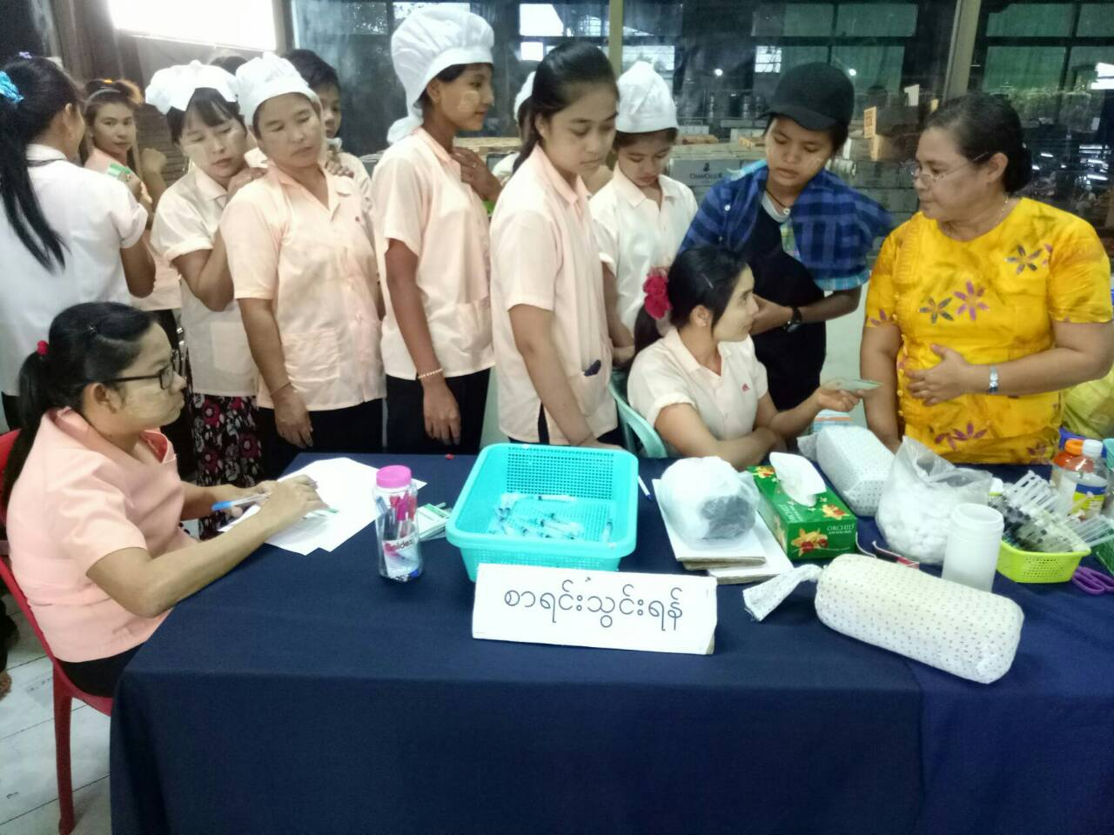
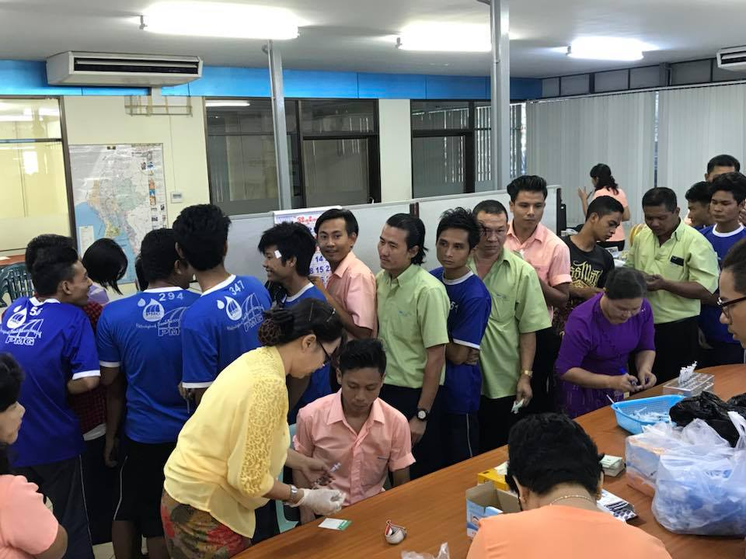
Vaccinations of anti B hepatitis virus
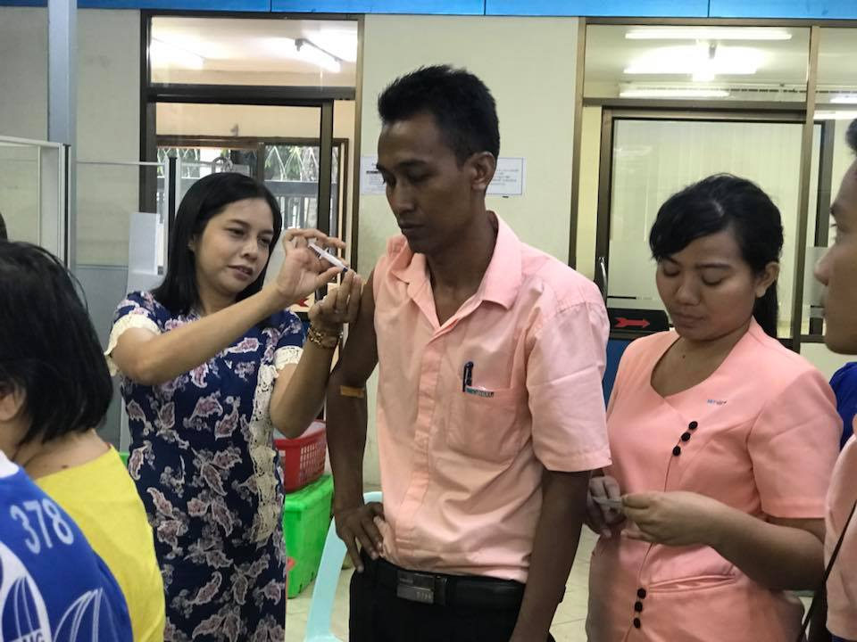
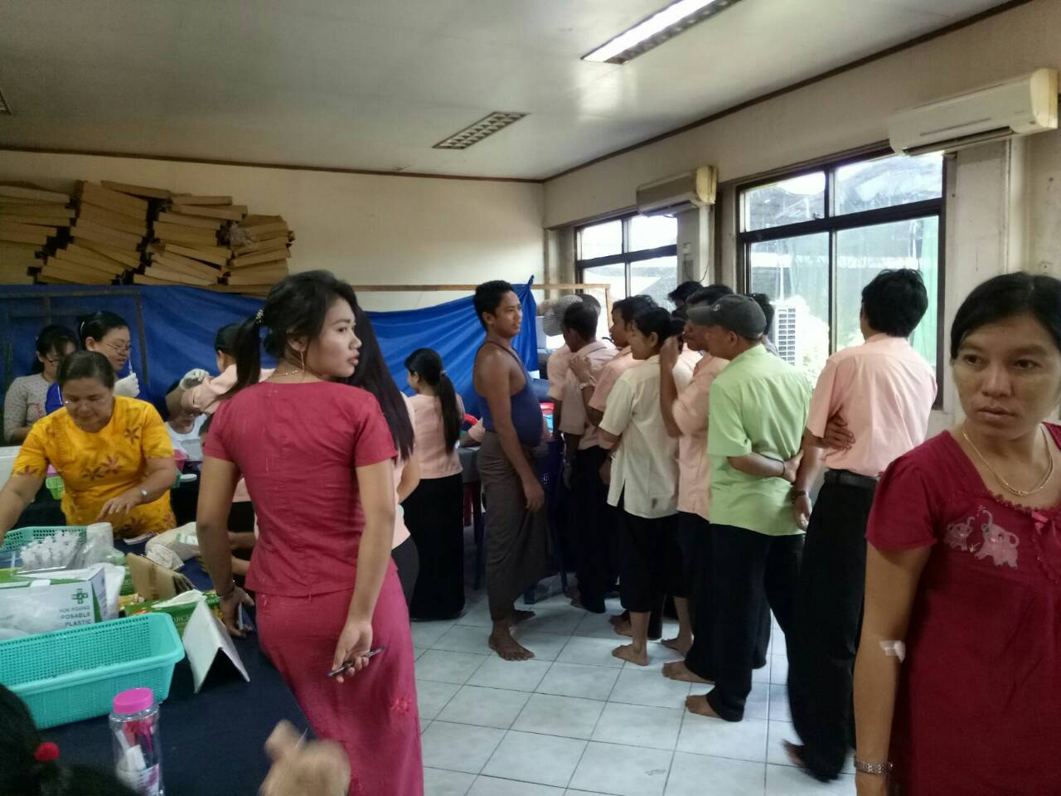

DONATION OF DRINKING WATER
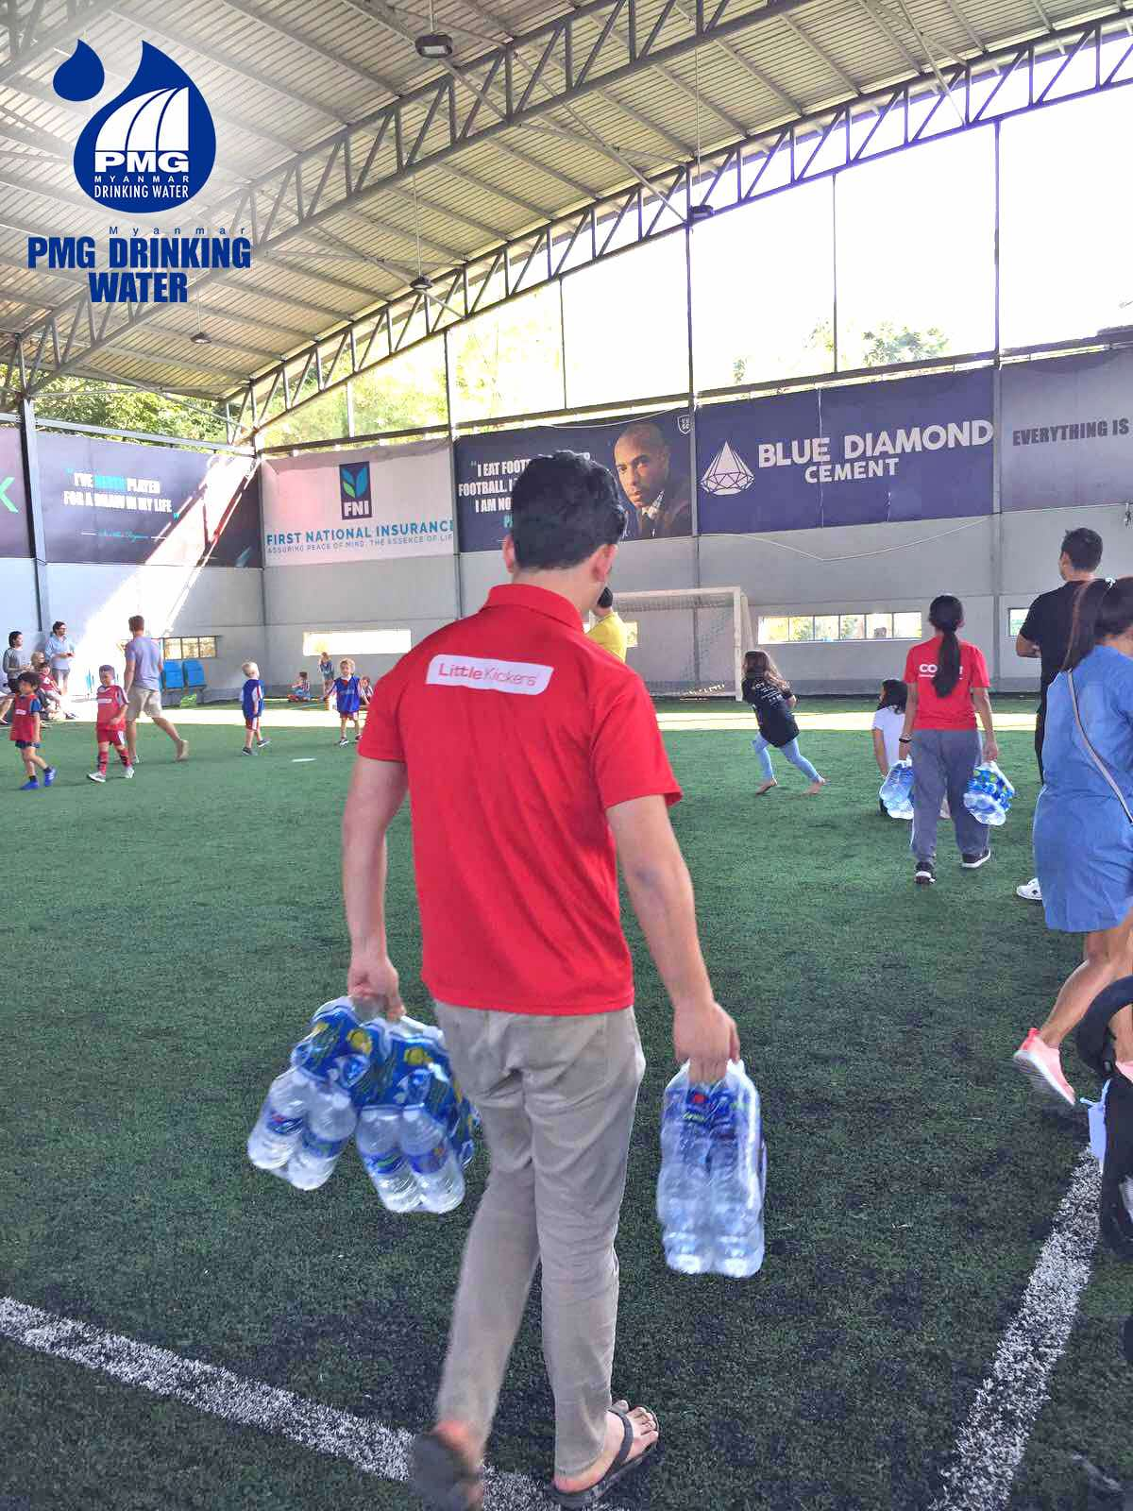

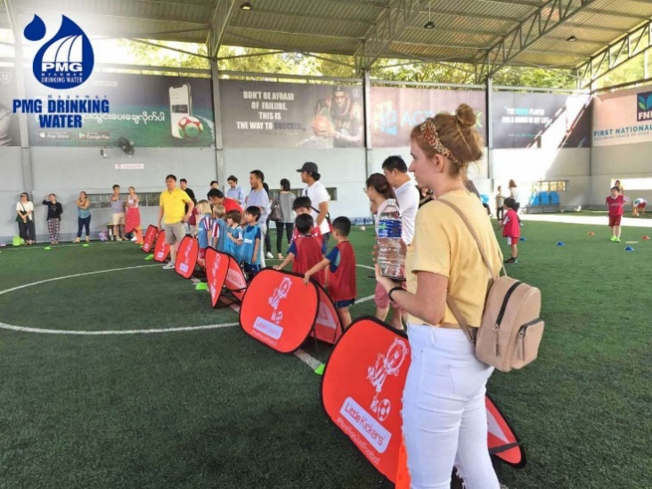
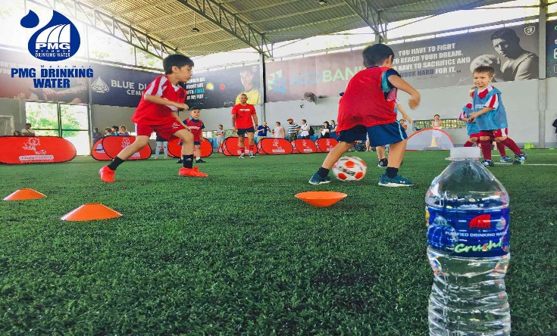
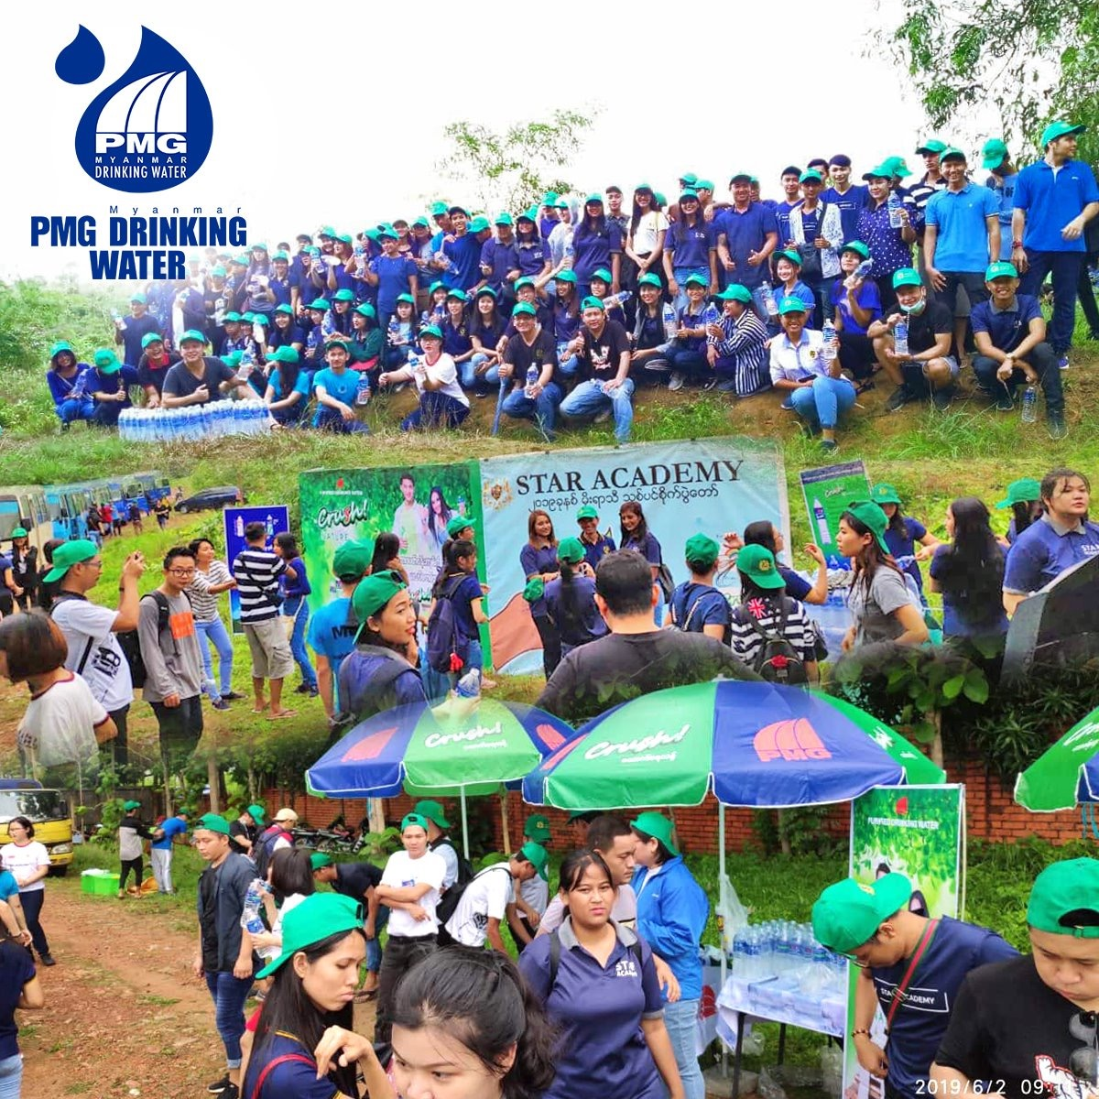

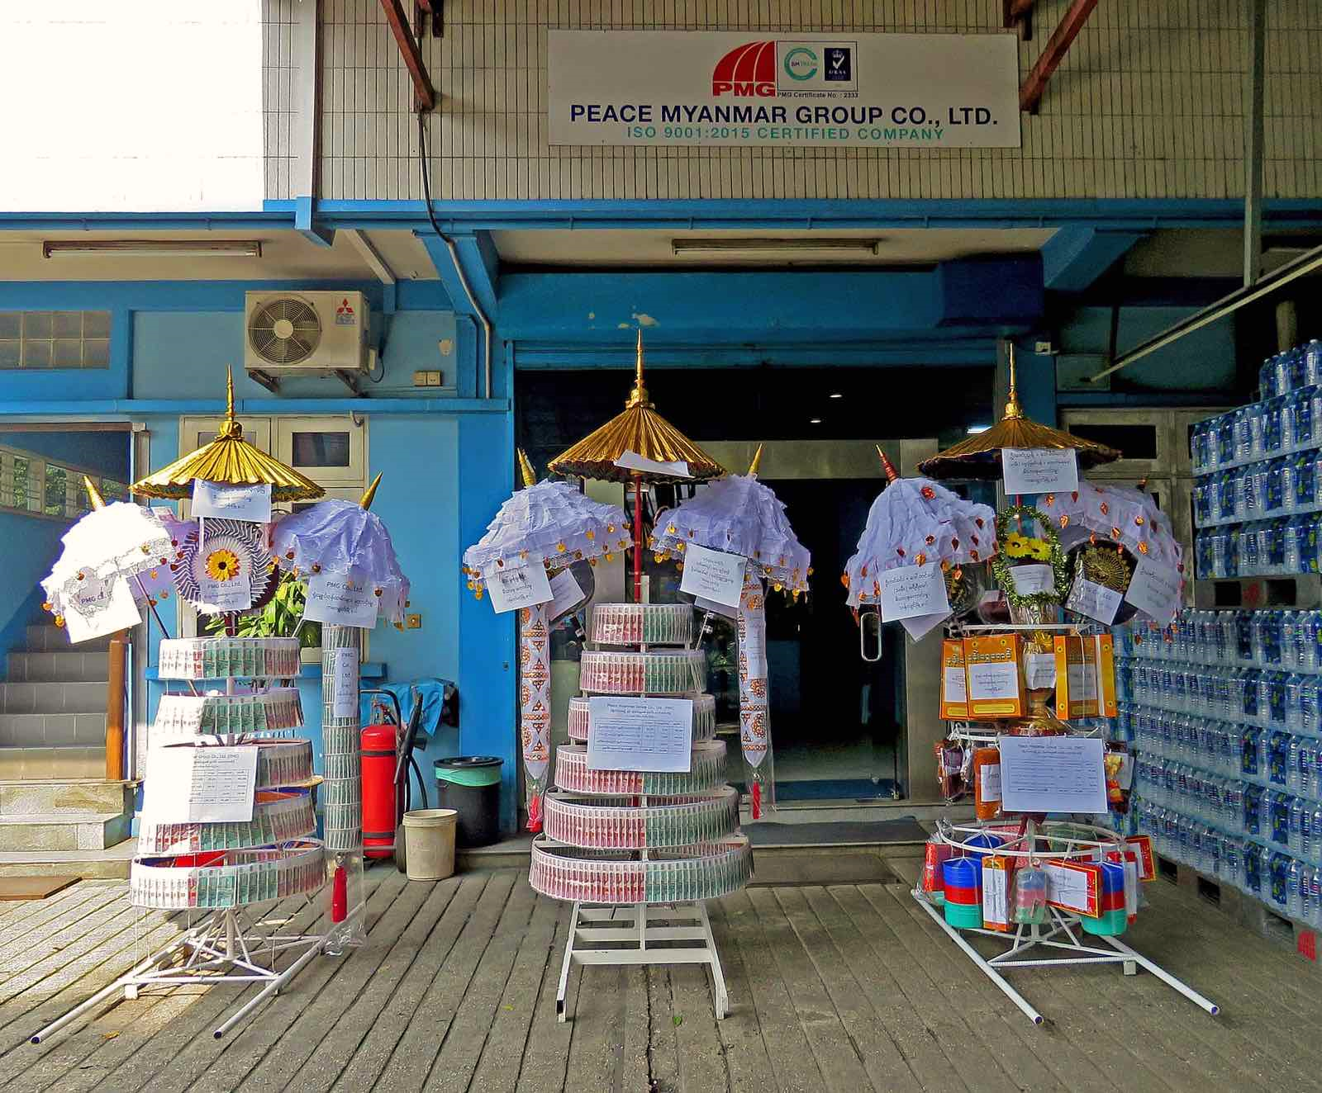
KATHINA ROBE OFFERING
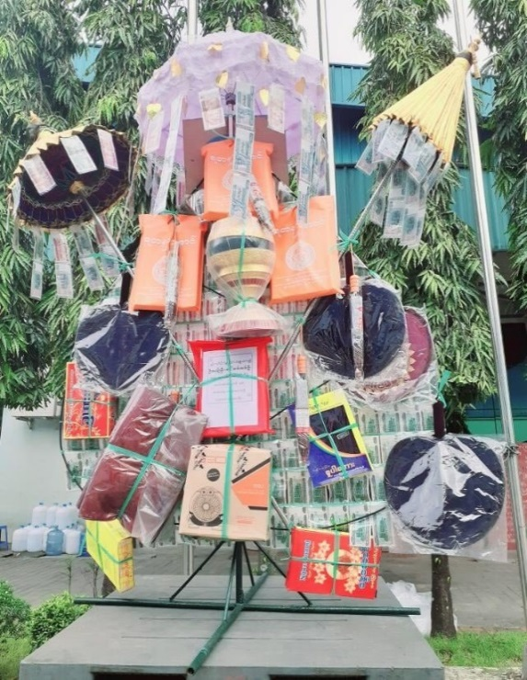

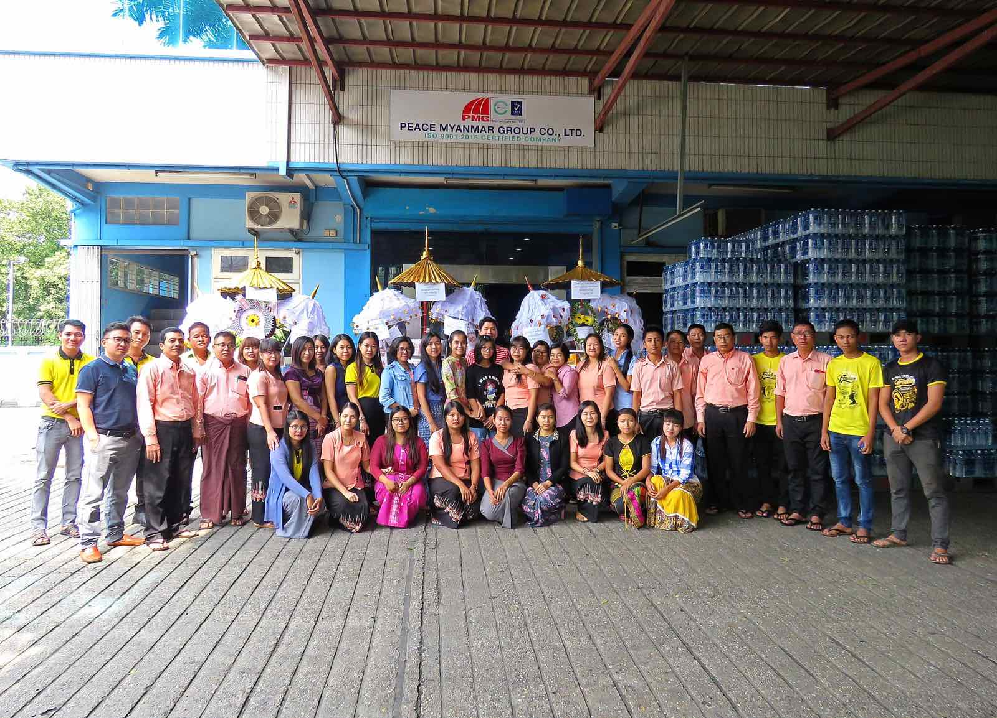
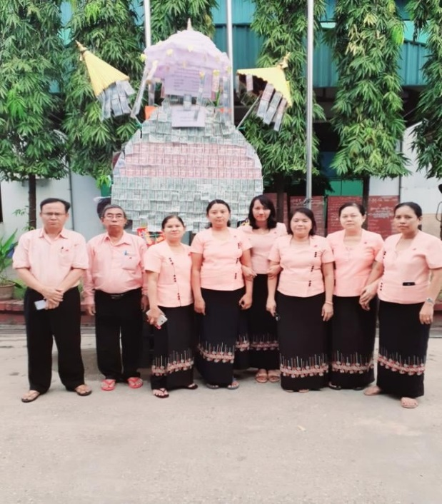

KATHINA ROBE OFFERING
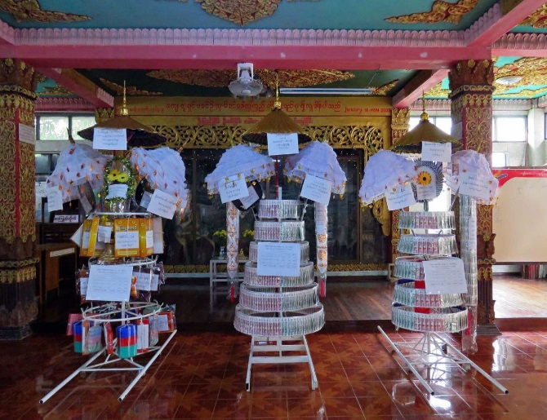
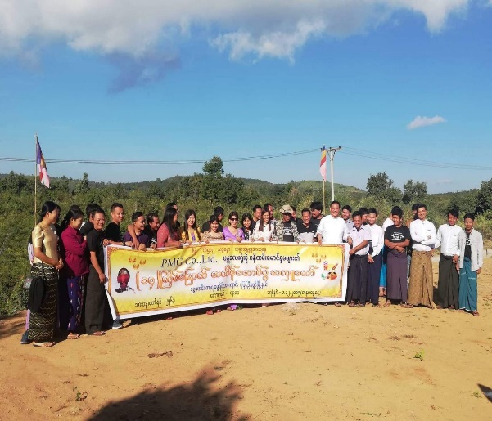

LABOR PRINCIPLES
Principle 3: Business should uphold the freedom of association and the effective recognition of the right to collective bargaining;
Principle 4: the elimination of all forms of forced and compulsory labor;
Principle 5: the effective abolition of child labor; and
Principle 6: the elimination of discrimination in respect of employment and occupation.
PMG Company upholds the freedom of association and the effective recognition of the right to collective bargaining. We created a Workers Manual with standards from the Ministry of Labors for the responsibility of employers and employees. Our Human Resource department states clear written policies of employee rights and responsibilities for compensation & benefits, rules & regulations. Our policies requires our business partners and suppliers to adhere to our labor policies when hiring staff and working with our employees. We do not practice torture, child labor, forced and compulsory labor within our organization or within the practices of any of our business partners and/or supplier.
We also emphasize on company policy to uphold the freedom of association and collective bargaining. We practice 44 hours' work week and 2 times overtime allowances for extra hours in our company's Workers Manual clearly. We create favorable workplace with the fresh air,

cleaning dining room. We also have open door policy with our employees. We have no form of forced labor. We do not practice child labor; our employment policy is personnel above 18 years old.
All the employees can work in large space happily together without discrimination and working closely with managers and colleagues of different backgrounds can have teamwork. We encourage employee motivation that celebrated monthly birthday party within the company. Top and senior management of the company takes full responsibility of the protection of labor rights within our organization. We also encourage employees to support each other as a family, protect and educate each other to understand and stay aligned with company labor policies and become good performance and responsible persons in the company.
We follow the law of the Labor Union of Myanmar and then we welcome them to educate our HR department and attend the training and workshop held by the Labor Union of Myanmar. HR departments share update information to the management and employees internally.
Our general HR benefits are as follows: monthly salaries & overtime allowances, travel and meal allowances, transportation provision, Social Security Insurances at Social Security Board
for the employees, yearly leave entitlements; 6 days of casual leave, 10 days of earned leave, 14 weeks of maternity leave, 15 days of paternity leave, 30 days of fully paid medical leave are clearly expressed in Workers Manual of our company. Apart from these leaves, our company also allow to employees to get 7 days of Leave for Funerals and Bereavement which is not mentioned in labor law. All of our offices close accordingly with all gazette holidays and national holidays.
There is opportunity for each individual regardless of race, color, gender, religion, national or ethnic origin, disability, marital status, veteran status, or any other occupationally irrelevant condition. In our employment program, we strongly emphasize non-discrimination on workers and among workers. Then we have a good gender balance in PMG, female also have equal opportunity to male. We give fully maternity leave to pregnancy according to law and we do not discriminate against women and violate the right to work for female. Moreover, all workers have right to believe and practice their religions.

2020 New Year Celebration Party
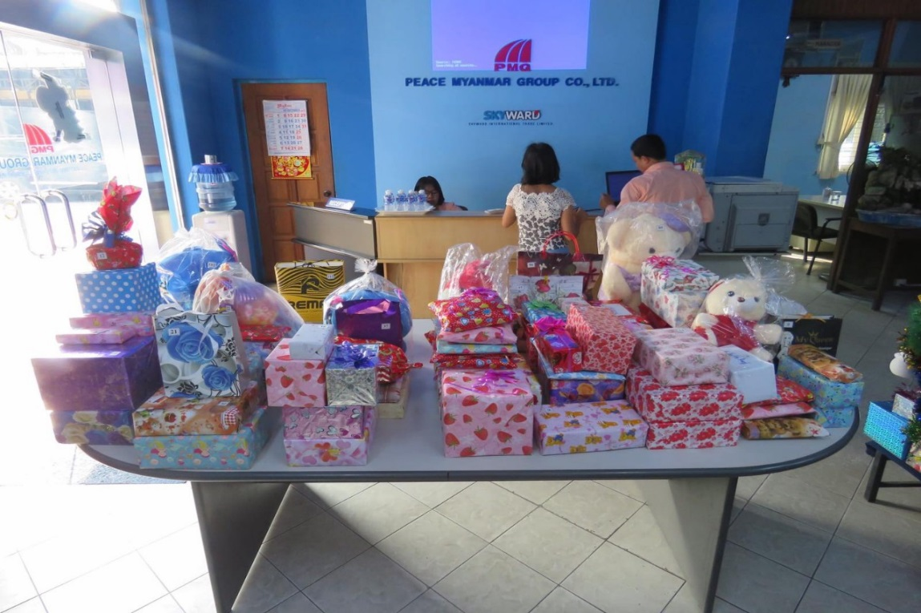

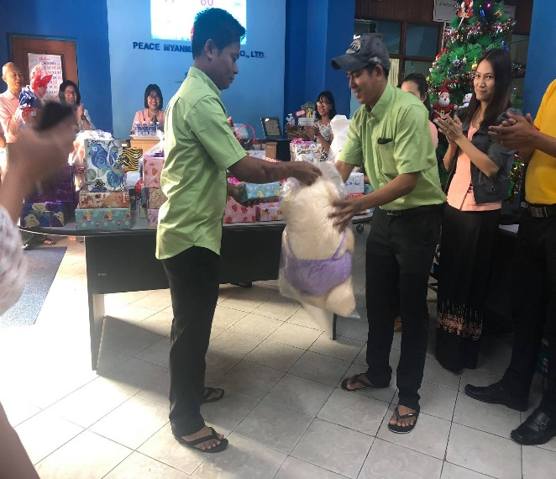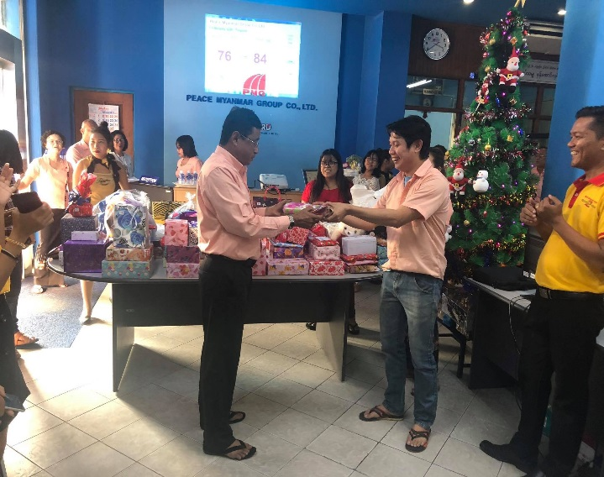
=

Monthly Birthday Party for Employee
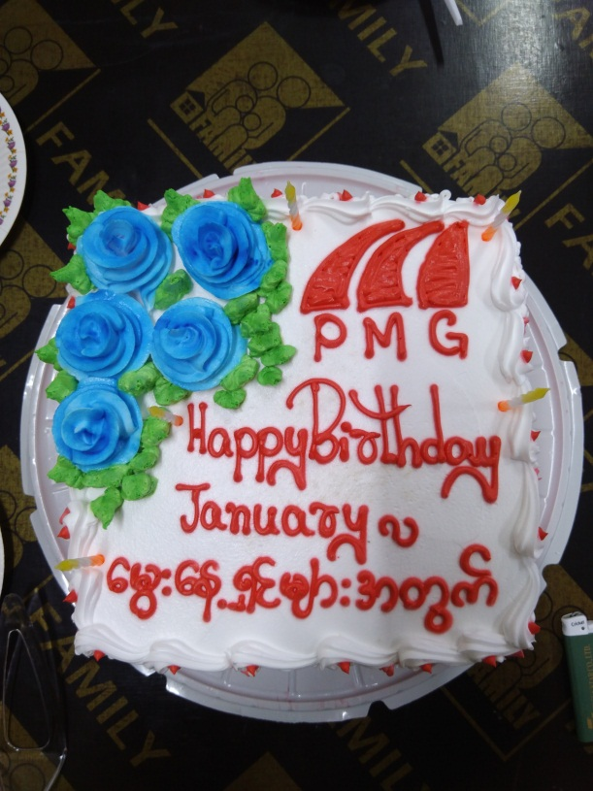
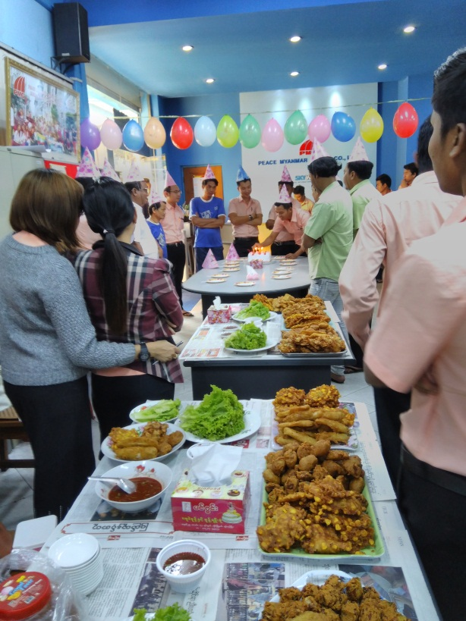

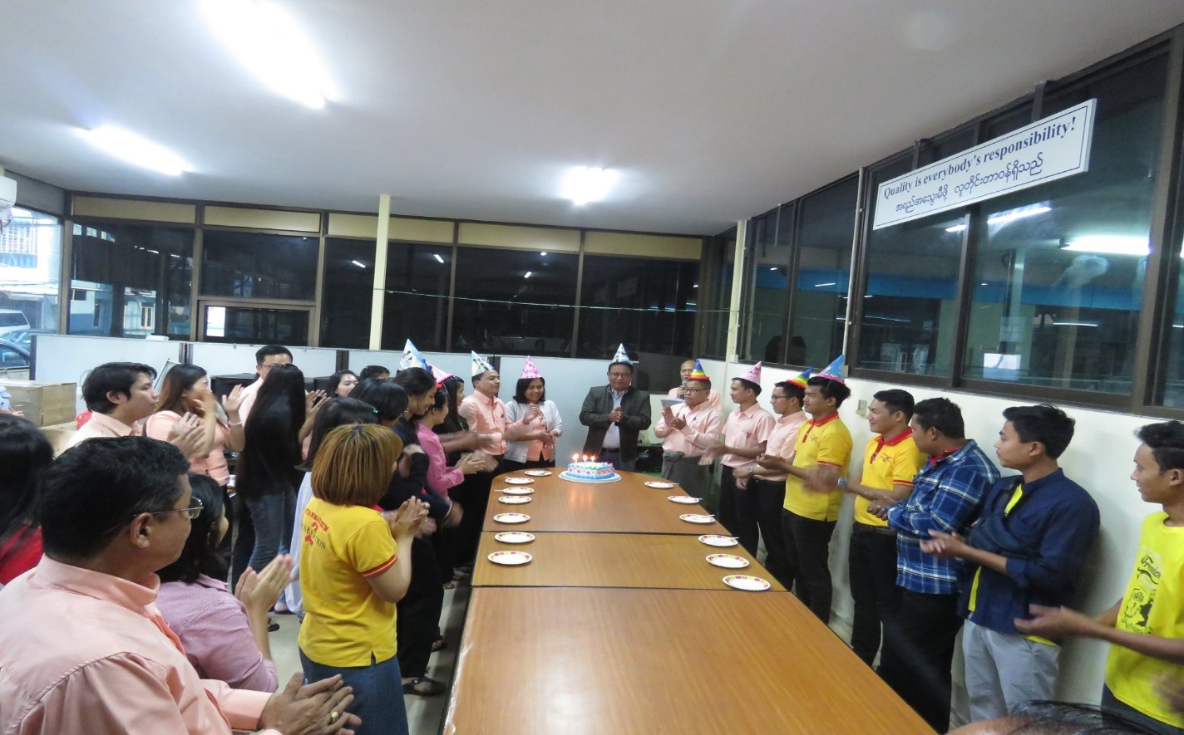

We have a systematic reviewing system by senior management on the company’s labor policy to ensure that our organization is acting within accordance of the law. We are continually assessing and reviewing on previous records if any handlings of these policies to evaluate how we can improve our company policies.

ENVIRONMENT PRINCIPLES

Principle 7: Business should support a precautionary approach to environment challenges;
Principle 8: undertake initiatives to promote greater environment responsibility; and
Principle 9: encourage the development and diffusion of environmentally friendly technologies.
Although the State had officially fixed the programs for Conservation of Natural environment, the Company with its own awareness has been carrying out the cleansing of waste water project beginning from May 2005 to till in stages and is now carrying out the 6th project with amendments.
The wastes from the factory are disposed systematically. For example – broken rice and paste are sold off as animal feed, boiler ashes are given to agricultural farms free of charge, in order that the waste products do not affect the natural environment, the waste paste are sold to fish breeding ponds as fish feed which is beneficial to the factory and at the same time providing fish feed for the fish. In addition to that to lessen the emission of smoke from the Chimney of the factory, FBC boiler has been used, four stages; Air Zone, Fire Tube out, Air preheater, Cyclone separator has been made to reduce the dust and particles from the 100 feet chimney. And the final stage, a machine for suction of the same has been installed in the base of the chimney.
As the boiler ashes are not involved from the Dust Collector chimney, Carbon Dioxide, Acid Rain will not be happened, and also the environment is also protected from air pollution.
Other waste water are sent to the sedimentation ponds and the clear water is allowed to be cool in the underground tank in stages and at the last stage the filtration of the clear water is done exclusively and then disposed into the river by concrete pipes. To reduce the water resources and not to lose fertility and topsoil, water is used systematically and the used water is recycled and waste to the drain by concrete pipe.

To reduce the electricity, we used the Spark Proof Lights and energy saving LED Light in our company. A fish pond with a small garden and other flowering plants and shady trees has placed in the compound to ensure greenery and relieve the people from mental fatigue. Regular educating the managers, supervisors and employees are done to be responsible to protect the
environment and support on company’s policy. Middle management level have to share to their teams to be responsible by organizing knowledge-sharing activities among the employees to understand and improve methods to reduce waste and protect the environment.
Then, we also reduce the paper using by using the two sides of paper in copying and our departments are connected with local network and we distributes the customer order form, meeting minutes, work instruction with the e-mail or office outlook instead of using paper.

Mini-Garden with green plants and lake filled with recycle water
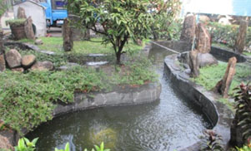
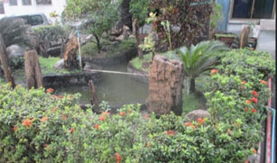

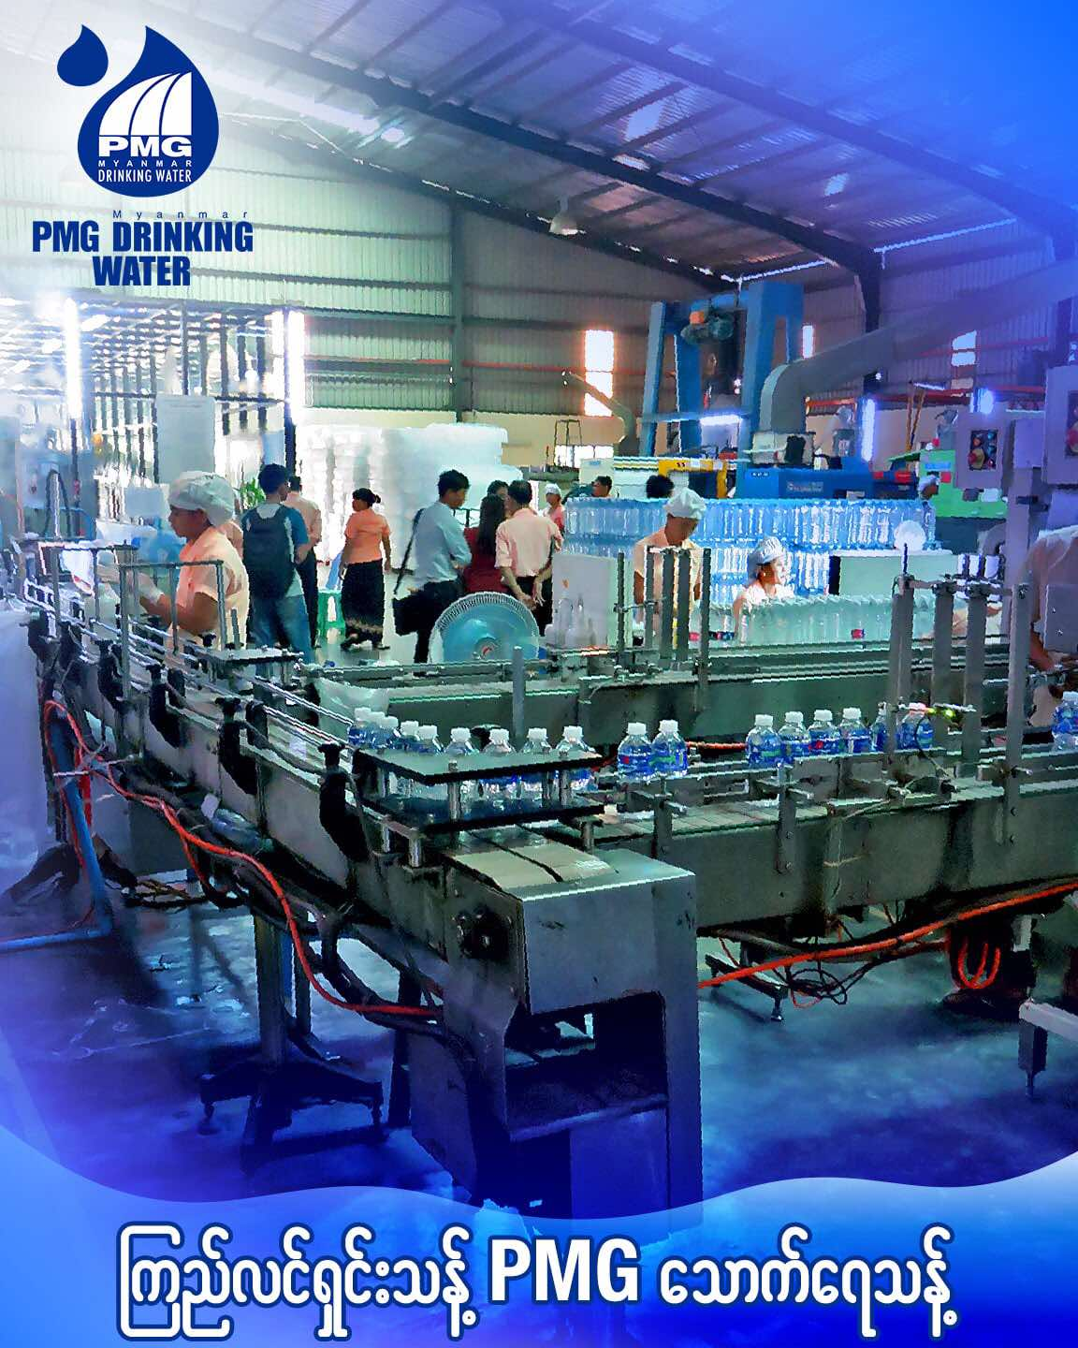

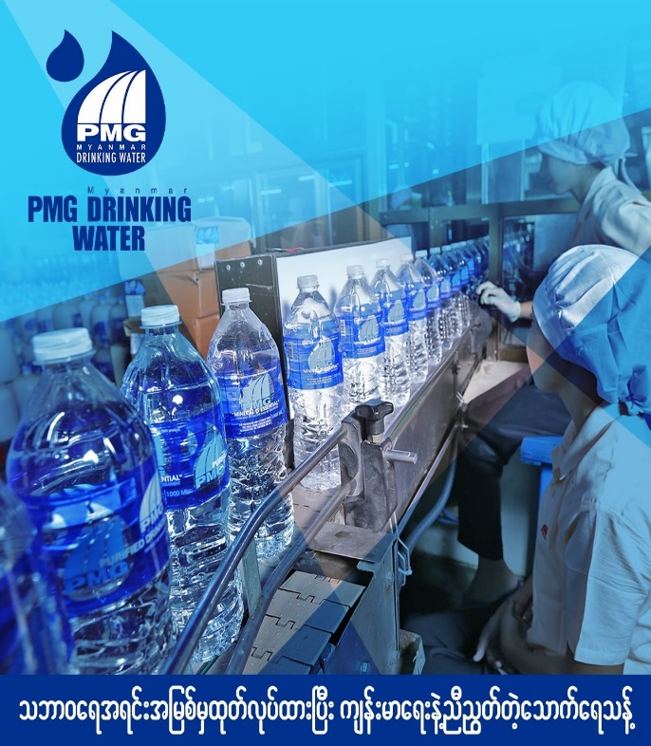

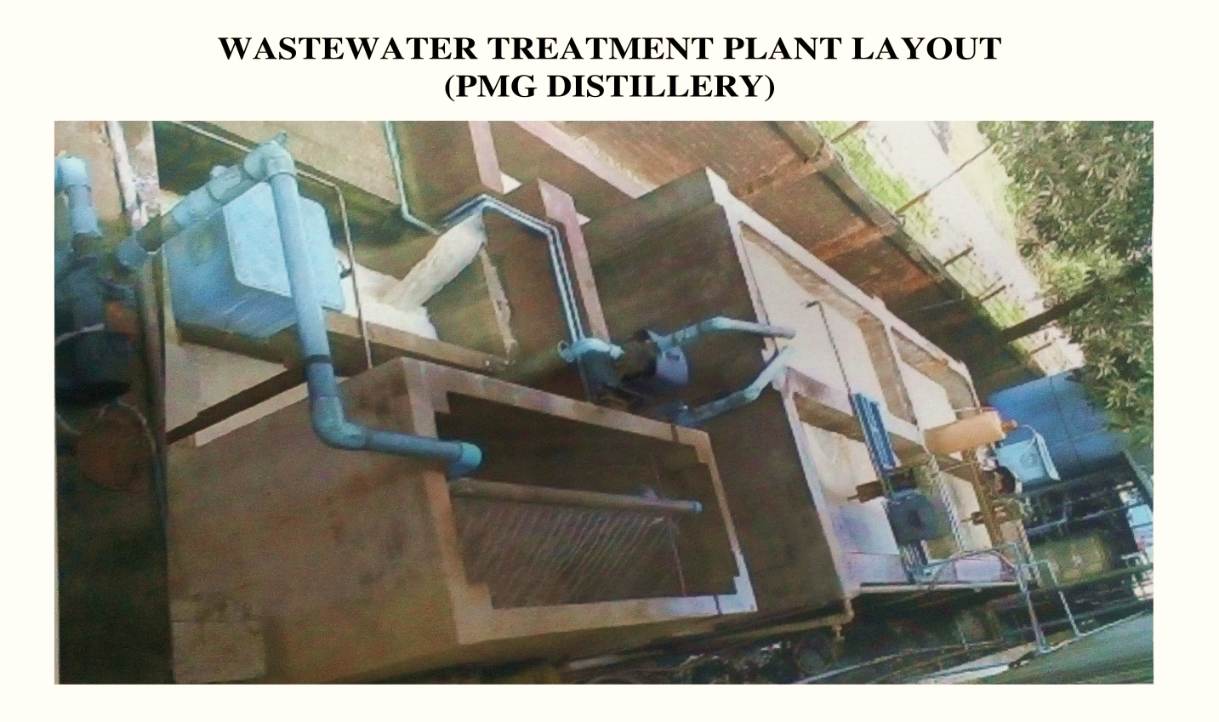
Cleaning and Safety activities
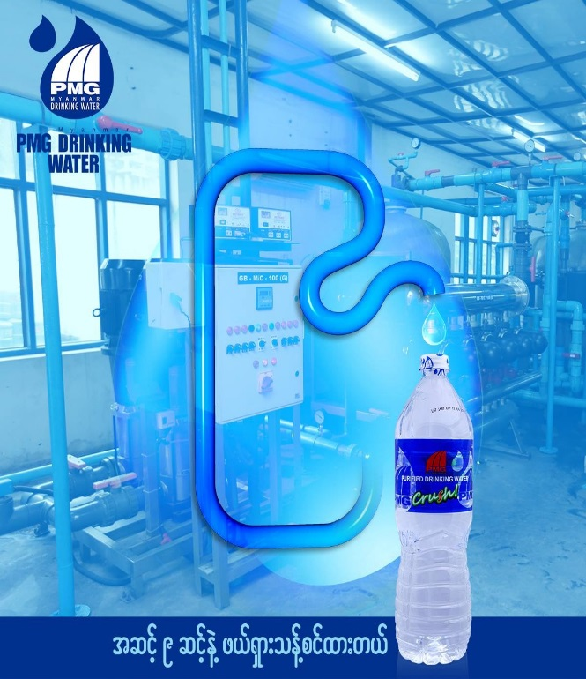

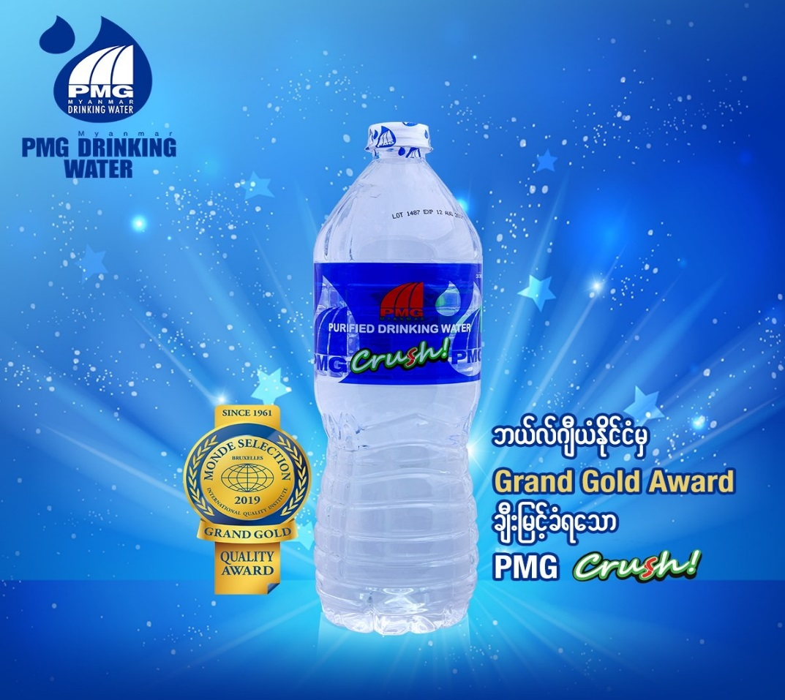

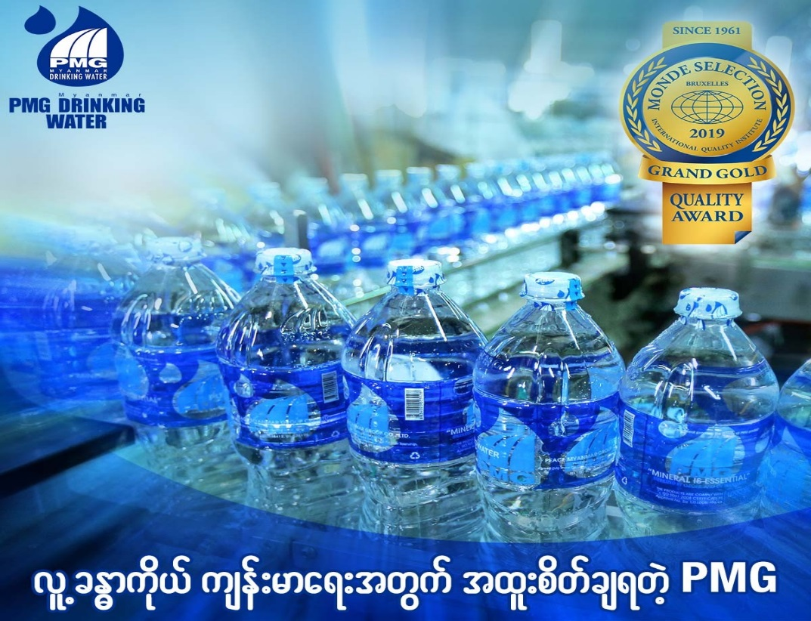

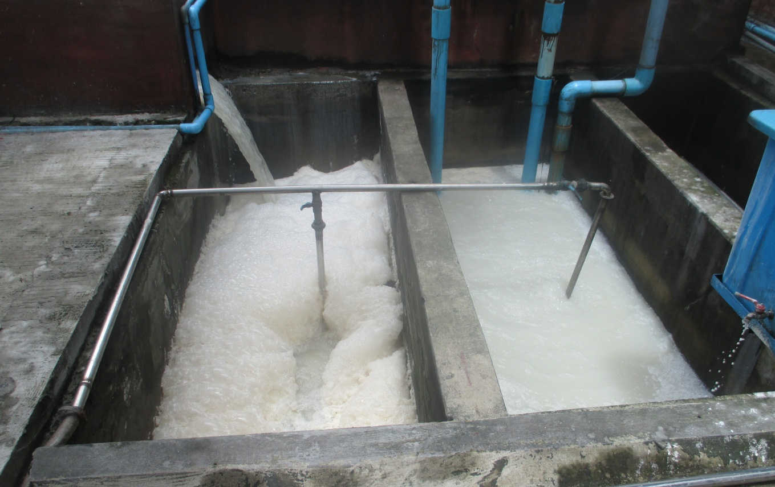
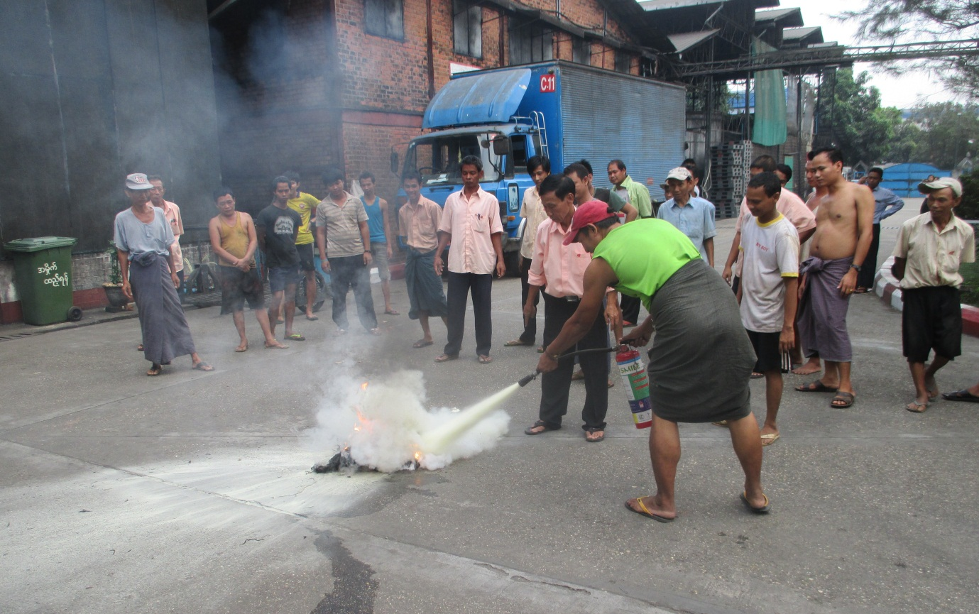

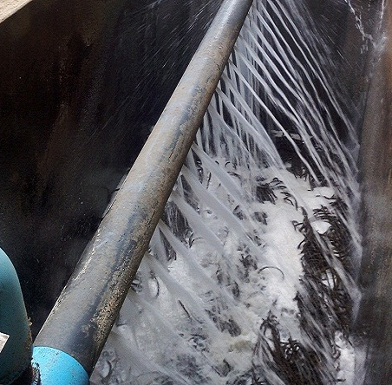

ANTI-CORRUPTION PRINCIPLE
Principle 10: Business should work against corruption in all its forms, including extortion and bribery.
We clearly state our employees and business partners of our company values to avoid for any form of extortion or bribery. We highlight our expectations on our ethics and values related with anti-corruption. Provide continued education for all level of employees up to about corruption, as well as what to do if one should encounter it. Commitment is made in compliance with all relevant laws, including anti-corruption laws within the company and among the stakeholders.
We do not tolerate any activities where people within our organization or business affiliates are affecting our community’s anti-corruption policies. The risk of bribery and corruption within our country is one of the main concerns. We will alert at all time of these risks and make clear to all stakeholders to respect these values.
We instruct our employees not to engage in corrupt practices. We feature articles on corruption and bribery to let the people know the destructive consequences on society, and we promote transparency as a way to help in anti-corruption. Again, we educate to new employees, existing

employees and business partners though our anti-corruption policy to ensure that the entire company’s activities are acting in accordance of these rules.
We guide our employees on what is considered malpractice in terms of bribery and extortion so they are aware of it when it is being practiced. Any incidences must be informed to HR and senior management upon finding out about situation where extortion or bribery may have occurred within company activities. The company anti-corruption policy are circulated amongst all stakeholders: employees, customers, business partners and its affiliates, to ensure that the entire company’s activities are acting in accordance of these rules.
Internal Audit within each department will be conducted yearly by top management and owners, to ensure that they all adhere to the anti-corruption policies. Our audits make audition to each department within our company monthly, quarterly and yearly not only the procedures to meet the ISO 9001:2015 standard but also practices to ensure there is no bad practices in accordance with the anti-corruption policy. Then, the report of each department directly goes to top management for any presence of bribery. If there is any practice that violates the anti-corruption policy, these are reviewed and taken necessary action.
Peace Myanmar Group Ltd is proud to be a member of UNGC and we fully support and adhere the 10 principles of UNGC guidelines. We are committed to an ethical and socially responsible company management.

ISO 9001: 2015 Certification of PMG Co., Ltd.
