***GLOBAL COMPACT COMMUNICATION REPORT 2020***





**KANSUK LABORATORY INDUSTRY AND TRADE INC.**

# CONTENTS / INDEX

1. GLOBAL COMPACT
2. SCOPE OF THE REPORT
3. ABOUT KANSUK

Quality policy

Message from the Chairman Message from the Director General Organization chart

Our Products

1. SUSTAINABILITY OF OUR BUSINESS
2. OUR SHAREHOLDERS
3. HUMAN RIGHTS AND WORKING CONDITIONS
4. ENVIRONMENT
5. ANTI-BRIBERY and -CORRUPTION
6. GOALS OF 2020

2

# GLOBAL COMPACT

The “United Nations Global Compact”, which was introduced and taken into effect by the United Nations in 2000, is an initiative that provides a framework for sustainable and responsible business practices to the companies.

The “Global Compact” has a great importance in that the business world supports the local and also the sustainable development by cooperating with the NGOs and local authorities. Fulfilling its activities in accordance with these principles since the day it was founded, **KANSUK LABORATORY INDUSTRY AND TRADE INC.** signed the Global Compact on 24.05.2010, and also showed its determination on the issue before the international platform**.** We have participated into the United Nations Global Compact which published ten basic rules with the aim of reaching at a better condition on human rights, employee rights, environment and fighting against corruption and which encourages private sector, labour, civil society and state authorities to act according to these principles.

3

The principles of the “Global Compact” are as follows. Human Rights

**Principle 1**: Businesses should support and respect the protection of internationally proclaimed human rights.

**Principle 2**: Business should make sure that they are not complicit in human rights abuses.

Labour

**Principle 3**: Businesses should uphold the freedom of association and the effective recognition of the right to collective bargaining

.

## Principle 4: The elimination of all forms of forced and compulsory labour.

**Principle 5: The effective abolition of child labour**

**Principle 6: The elimination of discrimination in respect of employment and occupation.**

Environment:

## Principle 7: Business should support a precautionary approach to environmental challenges.

**Principle 8: Business should undertake initiatives to promote greater environmental responsibility.**

**Principle 9: Business should encourage the development and diffusion of environmentally friendly technologies.**

Anti-Corruption

## Principle 10: Businesses should work against corruption in all its forms, including extortion and bribery.

# SCOPE OF REPORT

A report is communicated on the applicability and sustainability of the 4 issues and 10 principles that are stated in the global compact, in our company.

# ABOUT KANSUK

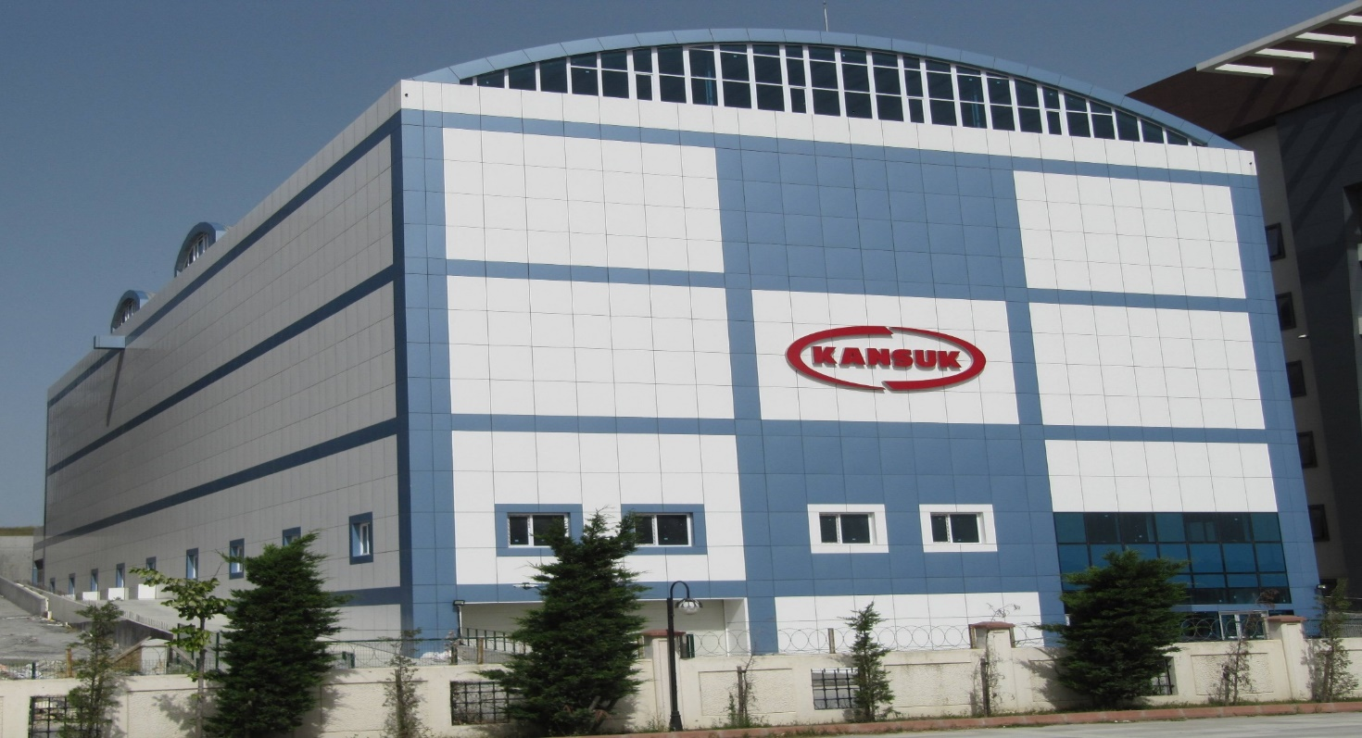

Kansuk Laboratory, was founded in 1960 by Dr. İsmet Sözen, continues to perform successful studies on pharmaceuticals and medicinal materials, up to date by keeping its feature of being family company, and completely local firm.

5

Kansuk Laboratory has been authorized by the T.R. Ministry of Health to prepare, manufacture, import and export formulas, and to provide hospitals and other pharmaceutical firms with these. Kansuk Laboratory has EN ISO 13485:2016  Quality Management Certificates as well as CE certificates for Blood bags, by performing manufacturing in accordance with the GMP.

Kansuk Laboratory is active in various fields including the manufacture of products for human use, serum and blood bag, import of blood products, and manufacture, import, technical service of medicinal device, import of weight control.

The Blood Bag manufacturing department was established in 1982 with the license of Biotest GmbH / Germany. The blood bags manufactured at this facility were exported to Western Germany and Holland for long years. The company continues its export activities to various countries at certain periods.

Kansuk Laboratory, the first and only blood bag manufacturer in Turkey, has been specialized in the field of blood thanks to its experiences that it gained for many years on this subject and to the recently received distributorships from the world wide known companies. Thus, it carries on its business in all subjects including collection of blood, separation of it into its components, processing of blood products, and turn-key blood projects. In order to expand the growth and higher the standards in the market, Kansuk has been supporting donor recruitment activities, training of blood bank personnel and users and all organizations working in this field

## KANSUK LABORATORY INDUSTRY AND TRADE INC.

**Address:** Yassıören Mahallesi Fırat Sokak No:14/1 Arnavutköy / İstanbul

**Telephone:** 0 212 592 15 76 pbx **Fax:** 0 212 580 37 72

[**E-mail:**kansuk@kansuk.com](mailto:kansuk@kansuk.com)

6

# ABOUT KANSUK

***OUR QUALITY POLICY***

In the fields of Pharmaceuticals, Blood Bags, Serum production, Blood products, Turkey Distributorship of Medical Devices and Medical Materials, in which we do business;

* According to our goal and targets, to comply with and improve a Quality management system that provides with the quality and safety of our products, by considering the risks which may arise in accordance to the conditions of the National and International standards and regulations, and maintain the efficiency of the Quality Management System
* By keeping the company always ready for the competition and Economical crises, to stand in the fast-globalizing world
* To solve the possible customer complaints as soon as possible, to provide all quality certificates related to our subject, to develop new products meeting the requirements of the age by taking also the requests of our customers into account, and to present products which our customers can use safely, they may prefer in terms of quality and service, by improving the qualities of the current products,
* To provide our staff with a working environment in which they can work efficiently in comfort and safe without worrying about the future and economic problems, which is an important factor in determination of quality of our products,
* To be a firm fulfilling the Social duties on blood donation, training support, and protecting environment,
* By reviewing our Policy basing on thought of continuous improvement, to make the necessary updates according to the current conditions.

We, Board of Directors of Kansuk Laboratuarı Sanayi ve Ticaret A.Ş., support the system, and are determined to realize these plans and maintain their sustainability by allocating the necessary resource.

Dr. İsmet Sözen

Chairman of the Board of Directors

7

# ABOUT KANSUK

MESSAGE FROM CHAIRMAN OF THE BOARD OF DIRECTORS



Acting against the world wide violation of natural richness that the fast-development causes and of the human rights, our firm has been in conscious of such issues against the labour and environment since it was founded, and has been continuing in our studies accordingly.

As a pharmaceutical firm, we have always been against the studies which may negatively affect the human health.

Being one of the leading firms agreeing on the Global Compact, we have been moving forward on this direction by making our firm gain ground thanks to applying these principles completely into our working conditions, and making the employees adopt these principles.

We will keep on sharing the improvements that we will accomplish every year by complying with the principles of Global Compact, with our shareholders.

TOLGA SÖZEN

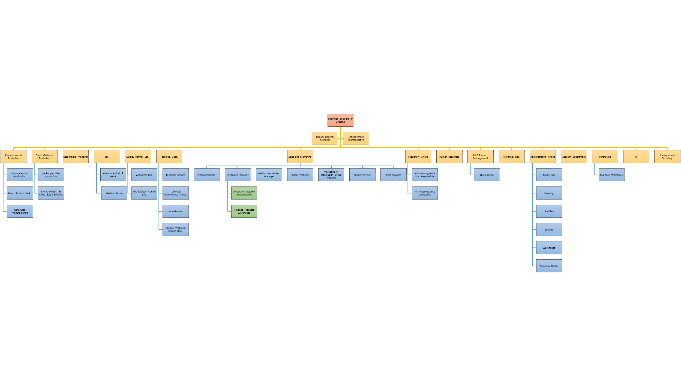

# ORGANIZATION CHART

# ABOUT KANSUK

**OUR PRODUCTS**

**PHARMACEUTICALS**

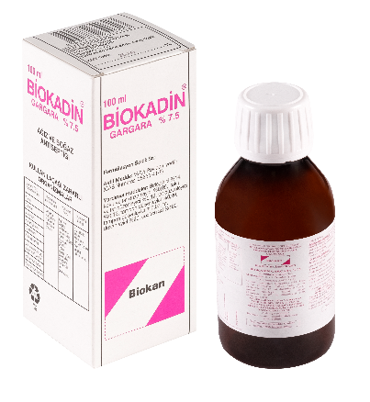  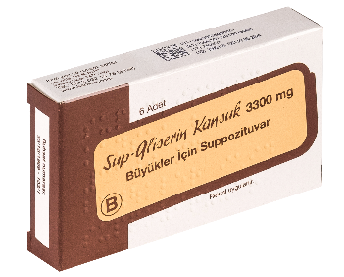 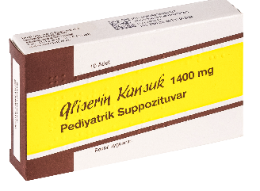

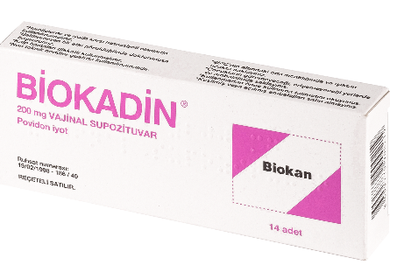 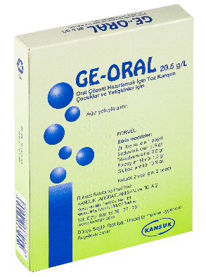

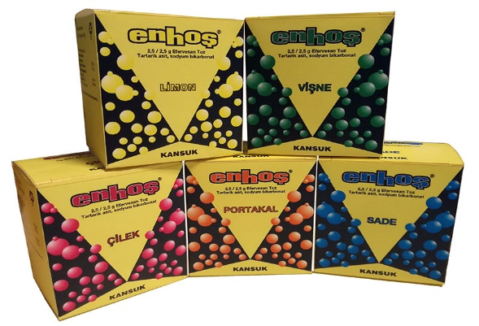 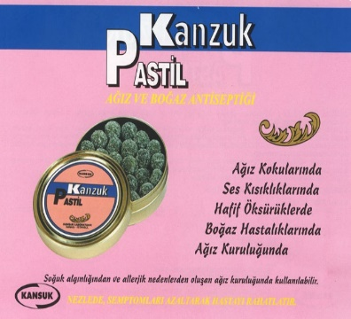 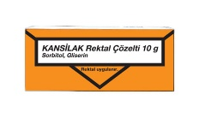

* Sup-Gliserin Kansuk B 3300 mg Büyükler İçin Suppozituvar
* Gliserin Kansuk 1400 mg Pediyatrik Suppozituvar
* Biokadin Standardize Solüsyon 30ml , 100ml ve 1000 ml
* Biokadin 200 mg Vajinal Suppozituvar
* Biokadin Gargara 100 ml
* Kanzuk Pastil
* Enhoş 2,5/2,5 g Efervesan Toz
* Ge-Oral 20.5 g/L Oral Çözelti Hazırlamak İçin Toz Karışım
* Kansilak Rektal Çözelti 10 g

**BAG SYSTEMS**

CONVENTIONAL BLOOD BAG SYSTEMS

TOP&BOTTOM (K2) BLOOD BAG SYSTEMS

TRANSFER BAGS

SOLUTIONS

BLOOD BAG SYSTEMS WITH LEUKOCYTE FILTERS

PLATELET LEUKOCYTE FILTER SETS

IPP PLATELET LEUKOCYTE FILTER SETS

KANBARRIER RBC LEUKOCYTE FILTER SETS

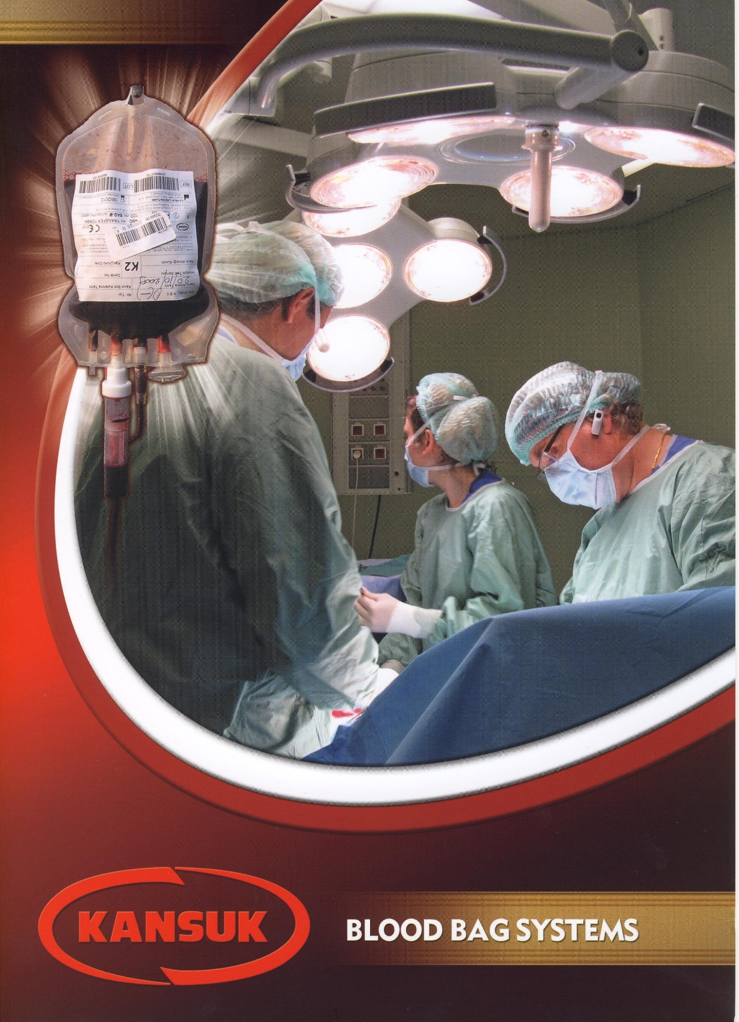

**IMPORT PRODUCTS**

INTRATECT 5 g/ 100 mL IV infüzyon için çözelti içeren flakon  
INTRATECT 10 g/ 200 mL IV infüzyon için çözelti içeren flakon

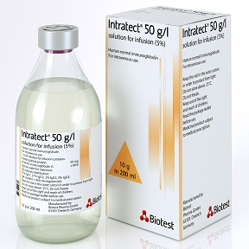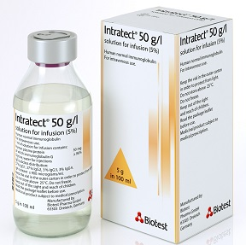

**PENTAGLOBİN 50 mg/mL, 50 mL IV İnfüzyon İçin Çözelti İçeren Flakon**

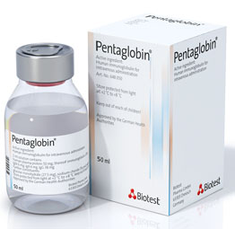

**HEPATECT CP 500 IU/10 mL IV infüzyon için çözelti içeren flakon**

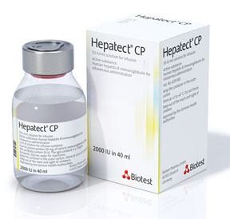

# SUSTAINABILITY OF OUR BUSINESS

By making our manufacture more productive, and consumptions more conscious, it relies on determining our goals, making plans, establishing strategies, and fulfilling these Thus, we have been making contribution to our sustainability by moving through our quality policy.

Having this view, KANSUK;

* + Does not swerve on the product and service quality.
  + Believes the key to success is to work in a productive, disciplined, and planned way.
  + Has a participant, fair and democratic administration, and an organization that has comprehended the necessity of being corporate, has been learning, and is open to criticism.
  + Has the feeling of responsibility towards the society, and sensitive to environment.
  + Is against the bigotry and conservatism on the way to the future.
  + Believes in the power of team spirit in creating a calm working environment.
* Is customer-focused, determines the demands and expectations of the market, and leads its manufacturing activities accordingly.
* Gives value to cleaning and order, motivates economy, and is against the wastage.
* Gives value to human, and support sharing.

# OUR SHAREHOLDERS

Kansuk recognizes any person, institution and organization, which affects the activity of Kansuk, or which is affected directly or indirectly by the activity of it, as its shareholder.

It is the basis of corporate communication strategy of Kansuk to create relations based on mutual benefit, trust and transparency with all of our shareholder groups.

Shareholders of Kansuk laboratory;

* Current employees of Kansuk
* Suppliers
* State institutions and organizations
* Customers
* Beneficiaries or users of our products
* Near public

# HUMAN RIGHTS AND WORKING CONDITIONS

## Principle 1: Businesses should support and respect the protection of internationally proclaimed human rights.

* Insures the employees and their families, and provide with their social security.
* Prevents forced-discharge of employees.
* Enables the employees become conscious by supporting them with training.
* Solves the customer complaints soon.
* Occupational health and safety training is provided at new entrances and is being renewed periodically.
* Necessary adjustments were made in connection with the minimum wage regulation issued in December.
* Ethical behaviors related to business partners are included in existing agreements as the 'Ethic Rules of the Kansuk'.
* The necessary precautions have been taken regarding the 6 work accidents that occurred in 2019 and in this way repetition of such accidents has been prevented.

Training duration for the year 2019:

|  |  |  |
| --- | --- | --- |
| Number of Training Issues | Total training duration | Quality-improving Training Hour x person |
| 22 | 2434 | 1444 |

## Principle 2: Business should make sure that they are not complicit in human rights abuses.

* Provides the staff with a working environment in which they can work efficiently in comfort and safe without worrying about the future and economic problems.
* Develops new products meeting the requirements of the age, and presents products which our customers can use safely, by improving the qualities of the current products.

## Principle 3: Businesses should uphold the freedom of association and the effective recognition of the right to collective bargaining

* Enables the employees mention their demands and request by holding process evaluation meetings, and the higher administration realizes these within conditions in this direction.

## Principle 4: The elimination of all forms of forced and compulsory labour.

* Concludes work agreement with the employee, and gives the right to terminate the agreement reciprocally in case of dissatisfaction.

## Principle 5: Businesses should effectively abolish the child labour

* In our firm, staff under 18 is not employed.

|  |  |  |
| --- | --- | --- |
| Total Employees | Between 18-30 | Above 30 |
| 217 | 68 | 149 |
| %100 | % 31 | % 69 |

## 6. The elimination of discrimination in respect of employment and occupation.

- No discrimination of male-female is made at recruitment phase and during employment. This is clear in the male-female rate of employees.

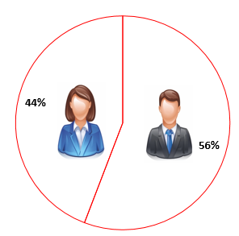

* Recruitments are performed by considering the quality and education according to the department to work at.

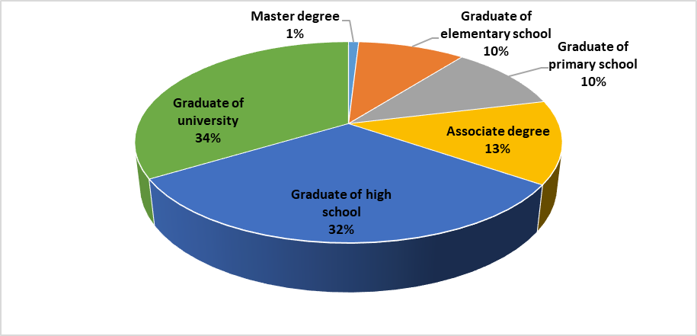



* Discrimination is prevented by the annual evaluation of quality profiles of the employees.
* The staff is not labored basing on their civil status.

|  |  |  |
| --- | --- | --- |
| Total Employees | Married | Single |
| 217 | 137 | 80 |
| %100 | % 63 | % 37 |

# ENVIRONMENT

## Principle 7: Business should support a precautionary approach to environmental challenges

* The regulation on waste is conformed to, and its actuality is followed.
* Training is given on the regulation on waste.
* Medical and laboratory wastes are delivered to the municipality.
* The paper waste is delivered to the concerned company.
* Finished printer cartidges are given to the authorized firm to support recycling.
* Harm to the environment is prevented by giving the waste batteries to the authorized company.
* Electronic waste is given to the authorized company.
* In 2019, 25462 kg of papers and packaging wastes, and 1190 kg plastic wastes have been agreed to be recycled by the authorized company.
* In 2019, an agreement has been reached with an authorized body for the recovery of 72,29 kg of electronic waste.
* The chemicals used in the laboratory can be taken and used under the control of the Quality Control Officer in a separate warehouse area.
* Suitable protective equipment for the use of chemicals is available.

## 8. Business should undertake initiatives to promote greater environmental responsibility

* Being in the ISO environmental committee, we take part in the environment protective studies via our Director General.

## Principle 9: Businesses should encourage the development and diffusion of environmentally friendly technologies

* Water saving is achieved by using dish washer in the dining hall and laboratory.
* Waste water is re-filtered, and re-used in the appropriate places according to the analysis result.

- At the transition areas of the factory, photocell devices are being used to save energy.

# ANTI-CORRUPTION

## 10. Businesses should work against corruption in all its forms, including extortion and bribery.

* Anti-corruption is achieved by that all expenditures are invoiced and controlled.
* The forgery and bi-invoicing are prevented thanks to the QR Code system that is applied for the pharmaceuticals manufactured or imported.

## 9) GOALS OF 2020

* To train the employees about the Global Compact.
* To make all of our employees adopt the principles of Global Compact by improving the labour conditions.
* To make saving in paper consumption for environment.