Communication on Engagement (COE) - Grace Period

Grace Period Letter Template

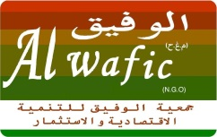
15/1/2020

To our stakeholders:

We recognize that a key requirement for participation in the UN Global Compact is the annual preparation and posting of a Communication on Engagement (COE) that comprises of a chief executive statement of continued support for the UN Global Compact, a description of practical actions in support of the UN Global Compact, and a measurement of outcomes or expected outcomes.

We are late in creating, sharing and posting our COE report due to Lebanon’s recent strokes and country’s critical situation.

We hereby ask for an extension period in order to be able to post a COE that describes our organization’s efforts and progress in support of the UN Global Compact. Our COE will be posted on the UN Global Compact website by 2020/02/14 at the latest.

Sincerely yours,
Mrs. Azal Hawwa Administrator

