COMMUNICATION ON ENGAGEMENT(COE)

National Diabetes Organization – DiaLeb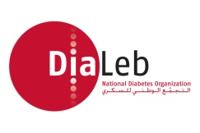

Period covered by this Communication on Engagement
From: 20-12-2017 To: 01-02-2020

Part I. Statement of Continued Support by the Chief Executive or Equivalent

Please use the box below to include the statement of continued support signed by your organization’s
Chief Executive or equivalent. 01.02.2020

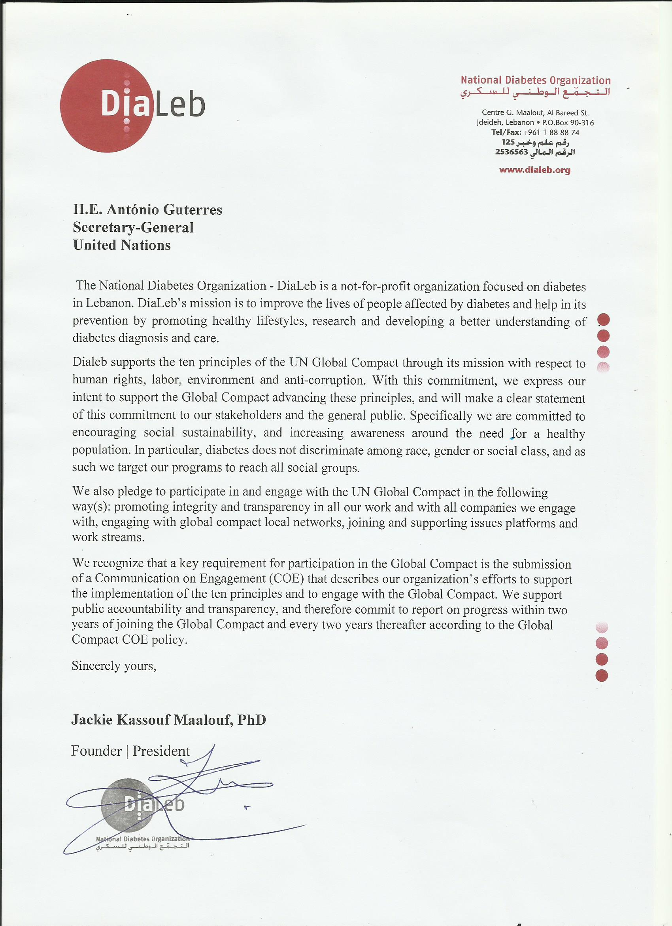

Part II. Description of Actions

Please use the box below to describe the actions your organization has taken in support of the Global Compact. It is strongly recommended that the actions taken are related to one or more of the specific activities suggested. Please refer to the complete list of suggested activities for your type of organization found here.

DiaLeb carried out multiple events and awareness sessions throughout Lebanon. The purpose of these events is to promote SDG # 3 on Good Health and well-being.
Actions to Promote SDG #3 Good Health and Well-being:
- Carry out awareness sessions in schools, universities, workplaces, communities

- Promote awareness and distribute information about diabetes and related diseases via online, and social media networks, and in print form at all events, municipalities and multiple clinics and hospitals.

- Provide patient support groups to those affected by diabetes along with patient education sessions

- Provide free glucose testing to all present at any awareness event and refer any at risk cases to a relevant professional for follow up care

- Encourage a healthy and active lifestyle by promoting exercise and a healthy diet

- Provides training sessions for professionals (dietitians, nurses, pharmacists, physicians, fitness trainers ) Center or education

Join and collaborate with Global Compact Local Networks

Part III. Measurement of Outcomes
Please use the box below to include the most relevant qualitative and/or quantitative indicators to measure the outcome of the activities described in Part II above.

