Communication on Progress: Winya Indigenous Furniture Pty Ltd, Australia
December 2018 to December 2019

- Statement of Continued Support

17 December 2019

To our stakeholders:
Winya is a small company. But we believe that the Global Compact Principles and the Sustainable Development Goals are just as relevant to small businesses as to multinationals. The Principles are especially important for every small business who wants to grow to become a larger business and be proud of what they are doing on their journey.

I am very pleased to confirm that Winya Indigenous Furniture Pty Ltd (Winya) reaffirms its support of the Ten Principles of the United Nations Global Compact in the areas of Human Rights, Labour, Environment and Anti-Corruption, as well as our commitment to the operation of our business under the United Nation’s Sustainable Development Goals.

We have chosen to use the Small Business template because of our limited resources, but also to demonstrate how simple it is to make this commitment to a better future.

In this annual Communication on Progress, we describe our actions to continually improve the integration of the Global Compact and its principles into our business strategy, culture and daily operations. We are also committed to sharing this information without stakeholders and other interested parties, to assist their progress on this journey.

Sincerely

Greg Welsh

General Manager

www.winya.com.au

- Description of Actions

Winya values people, inclusivity and outreach initiatives. Winya has been recognised with multiple Awards for the way in which we engage with our staff, suppliers and the community in our extended supply chain. Winya is now Australia’s most Awarded furniture company:

2018 Awards
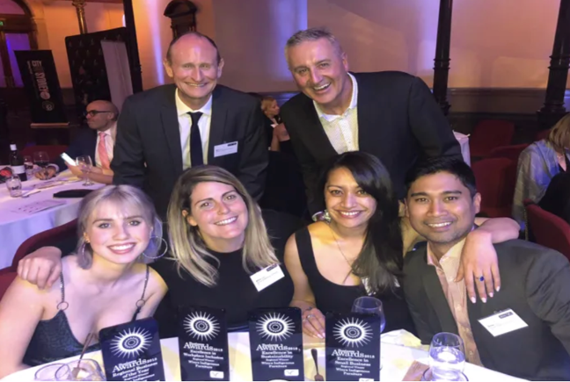
- Greg Welsh, Director of Winya was awarded a United Nations Award for Leadership in Sustainable Development Goals (Economic Empowerment of Indigenous Peoples)
- Australian Sustainability Award for best product Innovation: e-Board
- Chartered Institute of Procurement and Supply (CIPS): Award for Best Corporate Social Responsibility and Best overall business in Austral-Asia
- Procurement and Supply Association (PASA) Best Supplier Business
- 4 awards from the City of Sydney; Sustainability, Diversity, Best Small Business, Best Overall Business
- NSW State Chamber of Commerce Award for Diversity

2018 Finalist:
- Facility Manager’s Association (FMA)
- Banksia Foundation Award for Indigenous Leadership in Sustainability

2017 Awards:
- Building Industry Sustainability Award for Best Product
- Banksia Sustainability Award for Indigenous Leadership

Winya endeavours to set an example to all business by supplying the highest level of workplace safety for our employees, including sit-stand desking, seating and other ergonomic furniture and accessories to optimise employee health and well-being.

Winya’s staff policies and staff employment contracts specifically address our non-acceptance of bullying, discrimination or any form of harassment and clearly state the company actions in relation to any of these actions should they occur.

Winya has this year become strongly involved in the support of the LGBTIQ+ community within the corporate industry. Supporting the Indigenous pride body First Nations Rainbow through sponsorship and through using Winya’s platform to spread awareness. Winya has held several events specifically in the support of LGBTIQ+ peoples in both Pride Month and for Wear it Purple Day.

Winya also utilised its wall space and resources to put on art shows to drive sales of art work for remote Indigenous communities as part of its Indigenous outreach program. Additionally, Winya used its platform and resources being invited to the Salone del Mobile, the world’s largest design tradeshow to facilitate the display and exposure of several other Indigenous companies on a global stage.

Winya regularly inspects the factories in its supply chain both in Australia and overseas to verify safe work practices. Additionally, as part of Winya’s supplier compliance measures, Winya surveys its supply chain down two tiers to seek to verify workplace practices and that the workplaces are well managed and free of threats and intimidation of any sort.

This includes periodic site visits to our remote supplier locations and to the Prisons where we are engaged in workplace training for Indigenous inmates.

Winya’s Award winning e-Board allows Winya to manufacture Australia’s most sustainable office furniture, taking back old desks and diverting this otherwise scrapped product from landfill and converting this into new board, to make new office furniture.

Winya specifies the use of water-based adhesives and finishes in its manufacturing. Winya’s timbers are specified (and tested by Winya) as zero VOC (particularly Formaldehyde). Winya ensures its powder-coatings and paints are free from heavy metal. Winya avoids the Chrome plating of its metal products to avoid environmental risk and to assist in post use recycling.

And as further statement of our commitment to our people and the environment, in 2018 Winya became B-Corp Certified.

Labour

Winya specifically targets its Modern Slavery compliance down two levels within its supply chain and reduce the possibility of modern slavery in its dealings.

Winya is also particularly cognizant of this area of the Global Compact Principles because of the works we seek to do within the prison system, to provide training and accreditation for Indigenous inmates to assist them to become employable upon their release. The prison training work is both voluntary and receives some payment. The product is supplied in a closed loop to government agencies who are supporting Winya’s prison training initative. The product from this process is not going into general commercial circulation.

Why does Winya chose to do this work with prisons? It’s a key part of our Indigenous engagement program. In Australia, Aboriginal and Torres Strait Islanders account for 3% of the population yet represent up to 28% of the prison population and 46% of youth in detention. And a key driver of this is the lack of employment opportunity.

Winya’s staff and supplier’s staff are paid well above the Statutory Minimum wage in each of their jurisdictions. No bonded labour occurs, hourly staff are paid for additional work. No documents are withheld, and no other possible bonded processes exist down to two tiers in our supply chain. As a small business, checking beyond this level is currently beyond our resources.

Environment

Winya is ISO9001 – 2015 Certified and has comprehensive processes that direct all our procedures.

Winya also operates an ISO4001 Environmental Management System. This is not yet third party certified but Winya is looking to complete this in 2020.

Winya’s Award winning e-Board allows Winya to manufacture Australia’s most sustainable office furniture. E-Board uses old desks and diverts this otherwise scrapped product from landfill to convert this into new board, to make new office furniture.
Winya specifies the use of water-based adhesives and finishes in its manufacturing. Winya’s timbers are specified (and tested by Winya) as zero VOC (particularly Formaldehyde). Winya ensures its powder-coatings and paints are free from heavy metal. Winya seeks to avoid the Chrome plating of its metal products, wherever possible to avoid environmental risk and to assist in post use recycling.

Winya has moved its manufacturing to a local based factory which, is engaging with Winya’s Indigenous trainee employment program, but is also ISO4001 Certified and ISO9001 Certified. The local manufacturer also has a chair take-back program, receiving old chairs and recycling and re-purposing where applicable.

Anti-Corruption

Australia has criminal Legislation covering corruption, collusion, fraud and other unethical business behaviours which also extend to international operations and behaviours.

That said, Winya also now specifically addresses its behaviour expectations in each staff member’s employment contract and in the staff handbook.

We are aware of some competitors providing international travel to potential buyers and specifies to “see their manufacturing” in America and Europe. This practice is unacceptable in our view as it is a “bribe”.

Winya’s supplier engagement program around our Modern Slavery process extends to questions covering bribery, corruption and employment practices down two tiers.

- Measurement of Outcomes

Employment and Diversity Goals

Winya has > 50% female ownership

Winya has > 50% Indigenous ownership
Winya has 50% female staff

We have tried to have majority Indigenous staff but, this has become increasingly difficult as Winya has become a poaching ground for companies seeking trained Indigenous staff, so we are renewing our focus on increasing our remote community work programs and particularly those focused on supporting Indigenous women.

Winya has won both the City of Sydney and the NSW Chamber of Commerce Diversity in Employment Awards in 2018, as well as the Chartered Institute of Procurement and Supply’s best Corporate Social Responsibility award in Austral-Asia.

The most significant recognition was when Winya Director Greg Welsh was recognised by the United Nations as a Pioneer in the United Nation’s Sustainable Development Goals.

Winya has applied for the Australian Construct Awards Diversity and Inclusion award for our work within the LGBTIQ+ community.

Sustainability

Winya has always sought to be a leader in Sustainability.

In 2017, Winya won both the Australian Sustainability Award and the prestigious Banksia Foundation Award (the world’s longest running Sustainability Award) for its lounge seating range that took mine-site cleared timbers, from remote Australia with an Indigenous labour force. These timbers would have otherwise just been burned.

In 2018 Winya won the Australian Sustainability and the City of Sydney Awards for its new recycled melamine and MDF e-Board product. This was introduced in June 2018. Unfortunately, the take-up so far has been below our expectations as it seems Australia disappointingly likes to talk more about sustainability than actually doing something about it. Winya is continuing to grow this part of our business with a view to having all its customers order e-Board tables and desks in 2019 and then extending the use of e-Board into lounges and other products.

Winya is a rapidly growing small company. We believe that the Global Compact Principles and the Sustainable Development Goals are just as relevant to small businesses as they are to big ones.

