Siège Social
Parc d’Activités Point Rencontre2 avenue Madeleine Bonnaud
13770 VENELLES

Tél.: +33 (0)4 42 54 00 68
Fax.: +33 (0)4 42 54 06 78
E-mail: ph.roux@altereo.fr

Venelles le 25 novembre 2019

To ourstakeholders

We recognize that a key requirement for participation in the UN Global Compact is the annual preparation and posting of a Communication on Progress (COP) that comprises of a CEO statement of continued support for theUN Global Compact, a description of practical actions with regard to the principles of the UN Global Compact, and a measurement of outcomes or expected outcomes.

We are late in creating, sharing and posting our COP report.

We hereby ask for an extension period in order to be able to post a COP that describes our company’s efforts and progress to implement the principles of the UN Global Compact. Our new COP report will be posted on the UN Global Compact website 15 december at the latest.

Sincerely yours

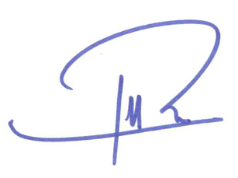

Paul-Henri ROUX
Communication Director

