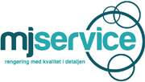 Communication on progress 2018-2019
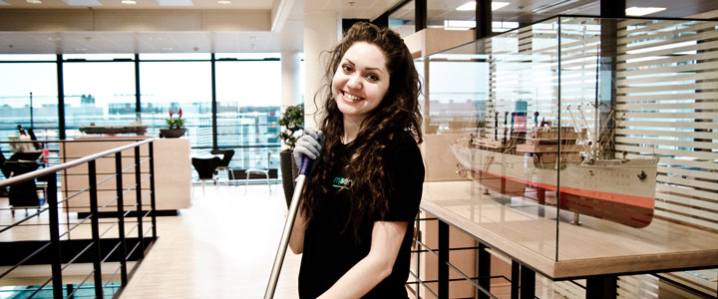

Statement of continued support by the chief operational offices
To our stakeholders
I am pleased to confirm that MJ Service reaffirms its support of the Ten Principles of the United Nations Global Compact in the areas of Human Rights, Labour, Environment and Anti-Corruption.
In this annual Communication on Progress, we describe our actions to continually improve the integration of the Global Compact and its principles into our business strategy, culture and daily operations. We also commit to share this information with our stakeholders using our primary channels of communication.
During the past year MJ service has worked with social and environmental issues in line with Global compact principles and we will continue to do so throughout our daily operations in the next year

Pia Larsen
Adm. Director

Human rights and Labour
Policies and goals
MJ Service supports the principles contained in the Universal Declaration of Human Rights (UDHR), the United Nations Global Compact and the fundamental principles that protect workers’ rights defined in ILOs- International Labour Organisation core conventions.
We expect that all our business partners work with human rights issues in a responsible manner and expect that they support the fundamental principles described in UDHR and ILOs core conventions as a minimum.
The wellbeing of our employees is very important to us and we make a concentrated effort to create a stress free and comfortable working environment.
In the coming year, MJ Service will continue to work with human rights and labour issues and will work towards ensuring that our suppliers are all aligned with the UNGC principles.
Assessment
Assessment of our policies, procedures, working conditions and employee rights occurs:
- Through the Danish compulsory annual work environment evaluation (APV). This is a process which enables us to look at both the practical and psychological aspects associated to the working conditions within our daily operations
- At our regular management meetings where Human rights and Labour issues are a discussion.
Implementation
Within our operations, we respect human rights primarily by providing safe and healthy working conditions for our employees and ensuring that human rights such as freedom of association, equal opportunity etc. are incorporated in human resource practices.
We have defined a number of policies that act as the guiding criteria for our activities relating to human rights and labour throughout our operations. These include our:
- Code of conduct
- Work environment policy
- Integration of new employees policy
- Sickness and follow-up policy
- Ethical behaviour policy for our employees and our sub-suppliers/contractors

We are members of an employee association which means that we are subject to their rules regarding collective bargaining, workers’ rights such as minimum wages and so on.
All employees are issued with a contract of employment which clearly states the terms and conditions of working at MJ Service. The contracts are in line with the applicable local laws and legislations in Denmark.
All our suppliers and customers are locally based and are not classified as such they have processes in place to address human rights impacts and Labour issues to meet the local rules and legislations applicable.
Our CSR work with these suppliers and customers is therefore mostly based on influencing them through information of our initiatives.
At MJ we like to think that human rights responsibility also extends to helping where we can so that people in less fortunate situations can improve their circumstances. We are therefore active and participate in humanitarian projects such as a project where we collect duvets used by students and pass them on to organisations and places that can use them such as refugee centres etc.
At MJ we also take refugees in business practice, and teach refugees in general practice in the Danish labor market.
Measurement of outcomes
MJ Service has not been subject to any investigations, legal cases or incidents involving Human Rights violations. We comply with all applicable rules and regulations covering our business.

Anti-Corruption
Policies and goals
Bribery and corruption in any form is not tolerated.

It is strictly prohibited to offer or receive gifts unless they are approved by MJ Service’s management and are reasonable, proportionate and made in good faith.

Facilitation payments are not allowed.
It is not allowed to select a business partners based on a receipt of gifts, hospitality or payment.
It is not allowed to make political contributions from company funds. Contributions made to charities or community projects must be approved by the MJ Service management and made in good faith.
Business partners must demonstrate a high degree of integrity, honesty, professionalism and compliance with MJ Service’s anti-bribery policy requirements and they must have a policy that prohibits bribery and corruption in any form.

We will continue to work with anti-corruption issues in the next period through further communication to MJ Service employees and business partners
Assessment
All expenses and transactions must be reported, properly documented and recorded. These records are used to assess whether any violations have occurred.
Third party accountants are also informed about our anti-corruption policy and are instructed to point out discrepancies in financial records.
Implementation
We have formulated a specific anti-corruption policy that is being communicated to all stakeholders.
Training is planned
The CO is ultimately responsible for handling any corruption or bribery issues.

Measurement of outcomes
MJ Service has not been involved in any legal cases, rulings or other events related to corruption and bribery
External accountants used by MJ Service have not yet identified any related corruption or bribery
Environment
Policies and goals
MJ Service is aware of the environmental impacts and we have formulated an environmental policy with the aim to reduce of environmental impacts throughout our operations.
Our goal is to reach a stage where our impacts are minimised to the full potential according to available technologies and procedures.
Our goal for the next period is to continue to reduce our CO2 foot print in the areas of chemical use, transport, energy use, waste management
Assessment
MJ Service engages external consultants to assess our environmental status and help us prepare an action plan for reducing our impacts
Implementation
MJ Service has continued to hold a Nordic Swan Ecolabel licence for its cleaning services, as well as window cleaning which means that we still comply with very strict criteria in the areas of:
- Chemical use which includes criteria about correct dosage, chemical use under 640 µl/m2, MSDS, more than 50% of ecolabelled chemicals used (We are over 90%) and a declaration for non-ecolabelled chemicals
- Transport, all our vehicles meet the requirements of Euro standard 5
- Waste covers waste sorting and plastic bags use
- Quality and Ethical issues covers both the quality system as well as proof that we are following laws and regulations applying to the cleaning services
- Use of Ecolabelled products and services covers all products used at MJ service including paper, printed materials, soaps, car washing and so on
- Using water system for window cleaning
- Training and information off all employees
Measurement of outcomes
There have been no environmental incidents as a result of our operations
MJ Service Holds and maintains a Nordic Swan Ecolabel licence

Future work
During the next year we will continue to work with issues relating to human rights, Labour, ant-corruption and environment.
Monitoring and complying to the Nordic Swan criteria is a big and continuous part of our environmental action plan.
We have just changed our company vehicles to new and more environmentally friendly cars. Employees will be instructed in environmental driving.
Within the next few months, we will invest in a new water system for use in window polishing.
In addition, we are working on digitizing more and more of our workflows to save paper.

