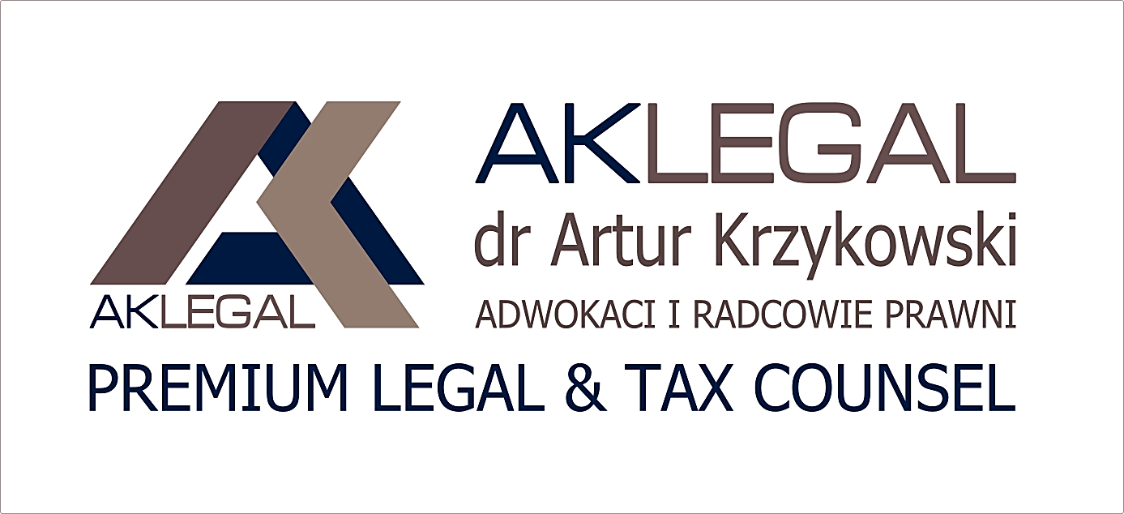

United Nations Global Compact
Communication on Progress (COP)
August 2018 – August 2019

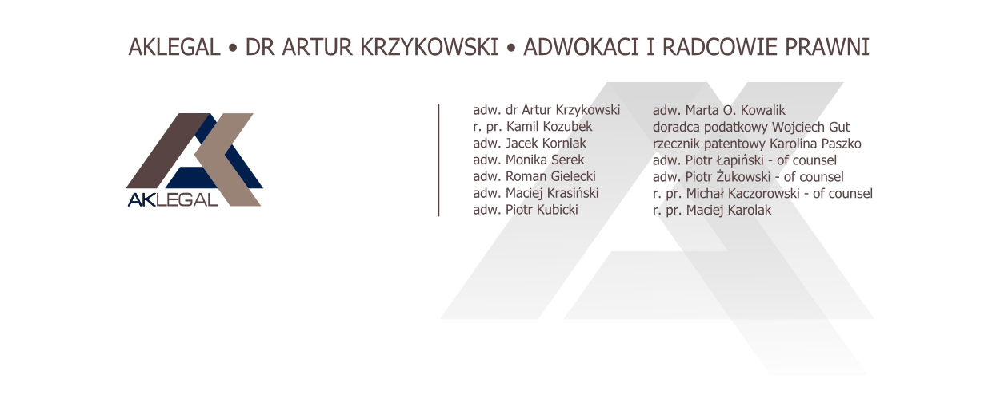

Warsaw, November,15th 2019

Statement of continued support

Dear stakeholders,
I am pleased to confirm that AKLEGAL reaffirms its support of the Ten Principles of the United Nations Global Compact in the areas of Human Rights, Labour, Environment and Anti-Corruption.
In this annual Communication on Progress, we describe our actions to continually improve the integration of the Global Compact and its principles into our business strategy, culture and daily operations. We also commit to sharing this information with our stakeholders using our primary channels of communication.
Sincerely yours,
PhD adv. Artur Krzykowski

Human Rights Principles
Principle 1 | Businesses should support and respect the protection of internationally proclaimed human rights;
Principle 2 | and make sure that they are not complicit in human rights abuses.

One of the fundamental rule in our professional practice is to protect and respect human rights. Day by day, we are trying to develop our awareness of human rights and their nowadays threats. There is no excuses for acting against human rights, both for our co-workers the same as for our clients.
Our co-workers applies and respects human rights not only during cooperation with our clients but also among ourselves. What is more, “protection and respect to human rights” is one of the criterion for establishing business relation with new clients. We do not cooperate with entities which acts with disregard for human rights.

Labour
Principle 3 | Businesses should uphold the freedom of association and the effective recognition of the right to collective bargaining;
Principle 4 | the elimination of all forms of forced and compulsory labour;
Principle 5 | the effective abolition of child labour;
Principle 6 | and the elimination of discrimination in respect of employment and occupation.

Recruitment process is available for all candidates. We do not grade people according to gender, origin, religion etc. The same practice take place during cooperation. Our team comprises of men and women and all of them are treated with respect and dignity. Moreover, everyone who is employed at AKLEGAL has work contract which precisely determine form and principles of our cooperation. What is more, we fulfil rule “equal pay for equal work”.
As an advocate and doctorate in law, I know how important is to constant develop skills and abilities. For this reason, our co-workers could participate in language courses and attorney’s or adviser’s trainings even if they need to leave work earlier or come later.

Environment
Principle 7 | Businesses should support a precautionary approach to environmental challenges;
Principle 8 | undertake initiatives to promote greater environmental responsibility;
Principle 9 | and encourage the development and diffusion of environmentally friendly technologies.

It is obvious for all workers at AKLEGAL that nowadays environment protection should be treated as a social responsibility. During our everyday life we support environment protection. It is obvious for as that we are obligate to safe water or segregate waste. We are also trying to eliminate printing – lots of necessary documents we store in the Cloud.
What is more, we cooperate with companies which guarantee environmentally friendly production and commodities. We buy energy-efficient electronic equipment and other environmentally friendly office supplies.

Anti-corruption
Principle 10 | Businesses should work against corruption in all its forms, including extortion and bribery.

As a law office we are conscious of illegality of corruption and gravity of this problem all over the world. As a Managing Partner of AKLEGAL, I could well and truly affirm that corruption is act which could not be accept and should be condemn.
We would like to point out that our co-workers are briefed that it is highly forbid to offer, give or promise bribery, financial or any other kind of gain to public sector workers’. Moreover, our co-workers are also warn about not accepting bribes and other unlawful benefits from clients and our business partners.

