PRINCIPLES OF RESPONSIBLE bUSINESS mANAGEMENT
Annual Report 2018-19

bIrla institute of management technology
Plot No. 5, Knowledge Park II, Greater Noida - 201306

Contents
1. Academic engagement 1
2. Consultancy and capacity building 2
3. Community outreach 10
4. Others 18
5. Publications 20
Annexure 1: Details of students’ field visits under “Responsible Business” course during the academic year 2018-19 21

Birla Institute of Management Technology, BIMTECH

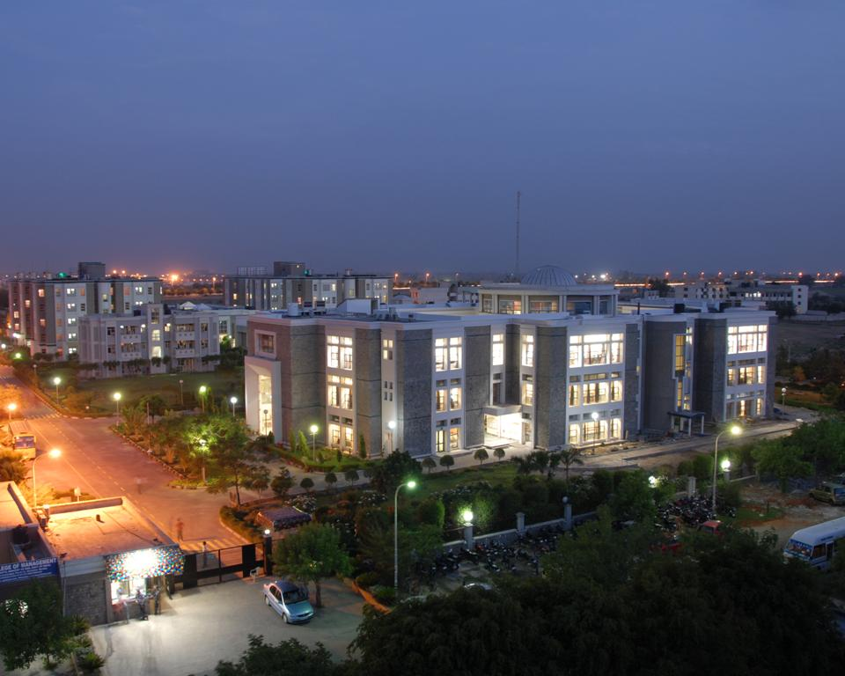
The Institute was established in 1988 under the aegis of the Birla Academy of Art and Culture. The Institute is supported by the B. K. Birla Group of institutions. The fully residential campus is located in Greater Noida, in the National Capital Region (NCR).

BIMTECH offers two-year AICTE (Ministry of HRD, Government of India) approved postgraduate courses like PGDM, General Management, PGDM, International Business, PGDM, Insurance Business Management, and PGDM, Retail Management. BIMTECH has been ranked in top 10 private business school of India in Business Today – AC Nielsen Survey, CNBC and MBAUniverse.com. The institute has been ranked 45 among all the best management institutions in India by National Institutional Ranking Framework (NIRF), Minister for Human Resource development.
BIMTECH is also accredited by NBA (National Board of Accreditation) amongst the highest quality Institutions. It has received A+ Ranking by NAAC. BIMTECH has 54 international academic and research partners including Maryland University, University of Nebraska, George Mason University, Philadelphia University, Frankfurt School of Finance and Management, KEDGE Business School, IESEG, FH Joanneum, Rouen Business School, Kozminski University, Jyväskylä University of Applied Sciences, Hertfordshire University, Hull University, Brock University and Asian Institute of Technology amongst others.

Vision

To develop ethical leaders with an entrepreneurial and global mind-set who shall strive for sustainability and inclusive growth.
Mission
- To be the preferred choice for students, faculty and recruiters.
- To create and disseminate knowledge in global context.
- To imbibe entrepreneurial culture through curriculum, pedagogy, research and mentoring.
- To equip students for global business leadership.
- To develop faculty as global thought leaders.
- To ingrain ethics, sustainability and inclusive growth in all its activities.
Values
- Ethics and Integrity
- Sustainability and Transparency
- Innovativeness and Entrepreneurship

The Ethos of Social Responsibility at the Birla Institute of Management Technology (BIMTECH)

The ethos of social responsibility at the Institute is no different from the value system of the House of the Birla’s, one of the oldest and the most respected industrialists in India. The Institute is modern and progressive in its outlook but retains its deep commitment to simplicity, respect, sensitivity and care for others and zeal to contribute positively to the progress of society.
The Institute exercises the tenets of ethics in its interactions and engagements with its various stakeholders.
Demonstrating the Universal Principles of Responsible Business Management, PRME and Sustainable Development

The Institute has adopted the Principles of PRME which are inspired by internationally accepted values, such as the United Nations Global Compact's Ten Principles, and provide an engagement structure for academic institutions to advance social responsibility through incorporating universal values into curricula and research. The principles help management institutions to seek and establish a process of continuous improvement in order to develop a new generation of business leaders capable of managing the complex challenges faced by business and society in the 21st century.
Developing the capabilities of students to be future generators of sustainable value for business and society at large and to work for an inclusive and sustainable global economy

The student fraternity is the key stakeholder for the Institution. Efforts are made to influence their minds and hearts with regards to being socially aware and responsible individuals and professionals.

Influencing Minds of students: Academic Curricula

The “Responsible Business and CSR”module which covers various aspects of Sustainability, Human Rights, CSR provisions according to the CSR Act in India and Corporate Governance is taught as a core across all programmes viz. PGDM, PGDM-IB, PGDM-Retail and PGDM-Insurance at the Institute.

The curriculum provides students understanding of relevant issues regarding Sustainability and CSR such as those related to Environment and Human Rights; corporate Governance and CSR.

Through a number of case studies, the students participate in underlining these issues and thinking critically. They also receive guidance in examining problem solving approaches by various corporates and social organisations.

The students participate in various seminars and conferences related to themes of Sustainability and CSR, enriching their understanding and acquiring various perspectives.

The Institute organises several guest lectures inviting people who are inspiring as they have made unique contributions in bringing social change and transformation.

The social exposure generates awareness and sensitizes students to existing social problems and challenges and helps them in building an attitude of social responsibility and become more conscious of their own actions, their impacts and their choices in life.

The Community Immersion Programme has been made mandatory under the Responsible Business module for the PGDM programmes at the Institute.
The program entails every student to devote ten hours in either village/ slums or CSR intervention sites of companies. This not only adds value to students- learning’ of responsible business, it sensitises them towards pressing developmental issues faced by people in villages/slums.

During these visits the students interact with various stakeholders including elected representatives, community leaders, and community members from the deprived and disadvantaged sections of the society.

Using structured questionnaires, the students collect information on socio-economic profiles of households (HHs) and take stock of various social welfare/security schemes of the government.

academic engagements

Community immersion of PGDM Students

The first-year students of PGDM, PGDM (International Business) and PGDM (Retail Management) participated in the “Community Immersion Programme” integrated with the Responsible Business module. The students conducted household survey in villages located in Jewar block of Gautam Buddha Nagar district in Uttar Pradesh. The details of field visits are given in Annexure 1.
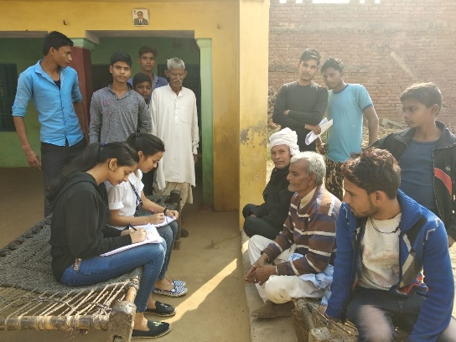
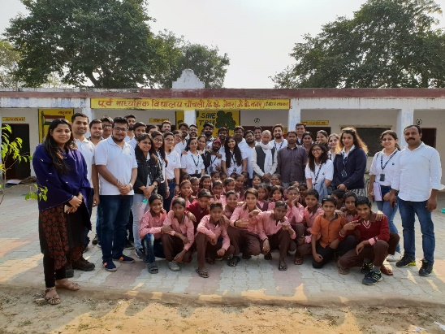

Students Visited Amazon’s Community Outreach Centre at Hoshiyarpur Village, Haryana, Chipanaya Buzurg village for a visit to the Accenture funded and supported Project site and Udayan Care Centres as part of their Responsible Business Course. The students interacted with the community members- beneficiaries of the project, about 50 odd women, young people and children.
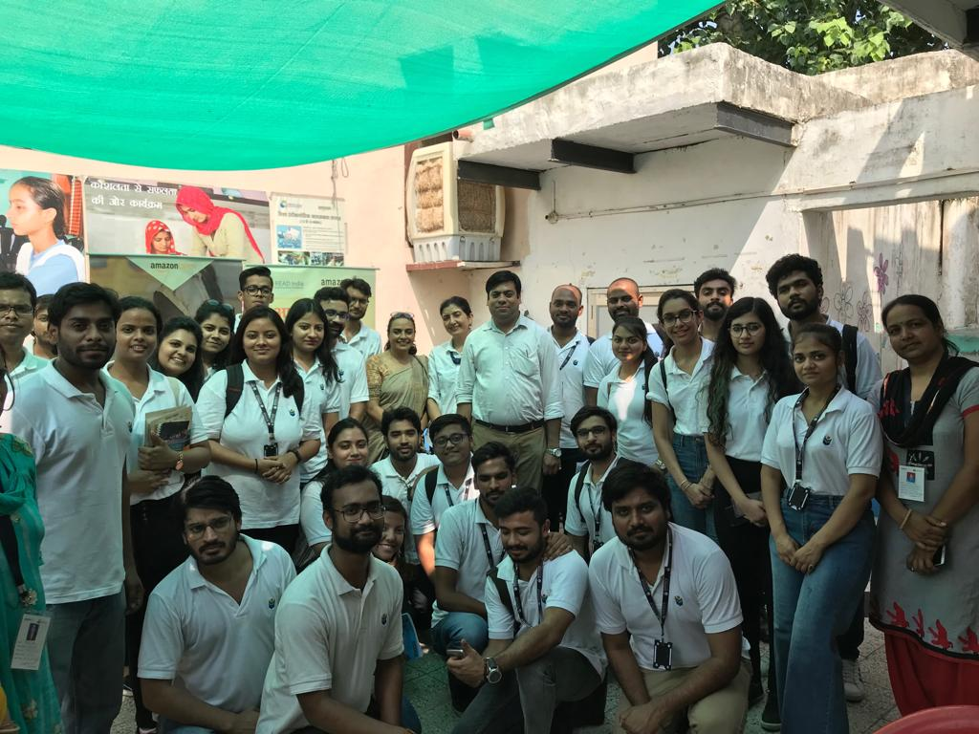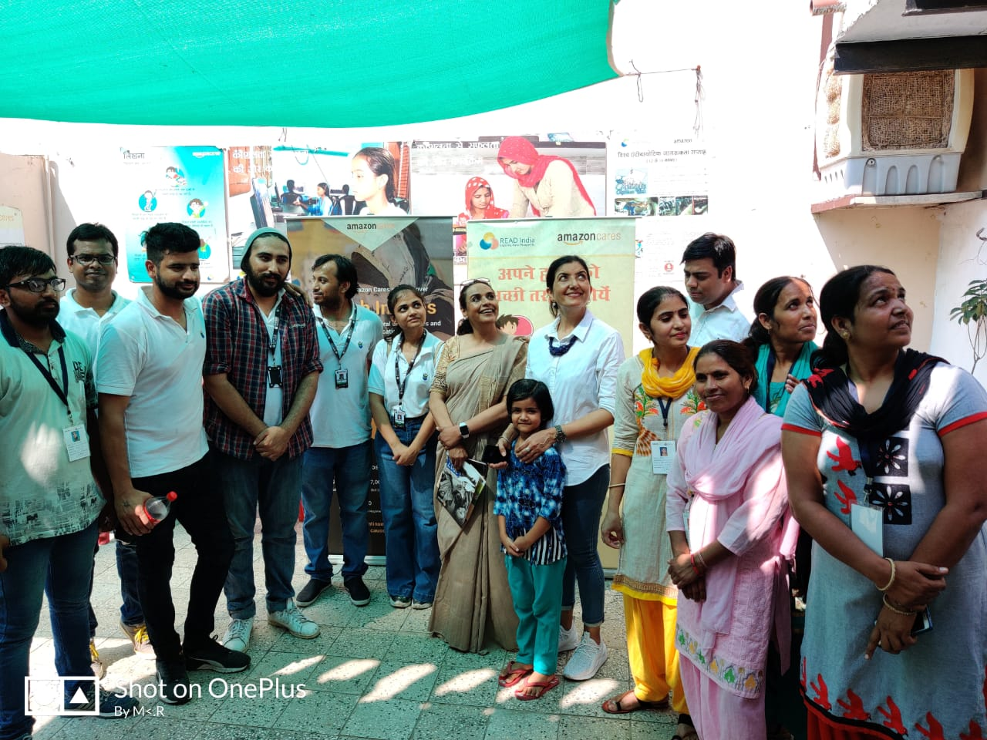
At Amazon Community Outreach Centres above.
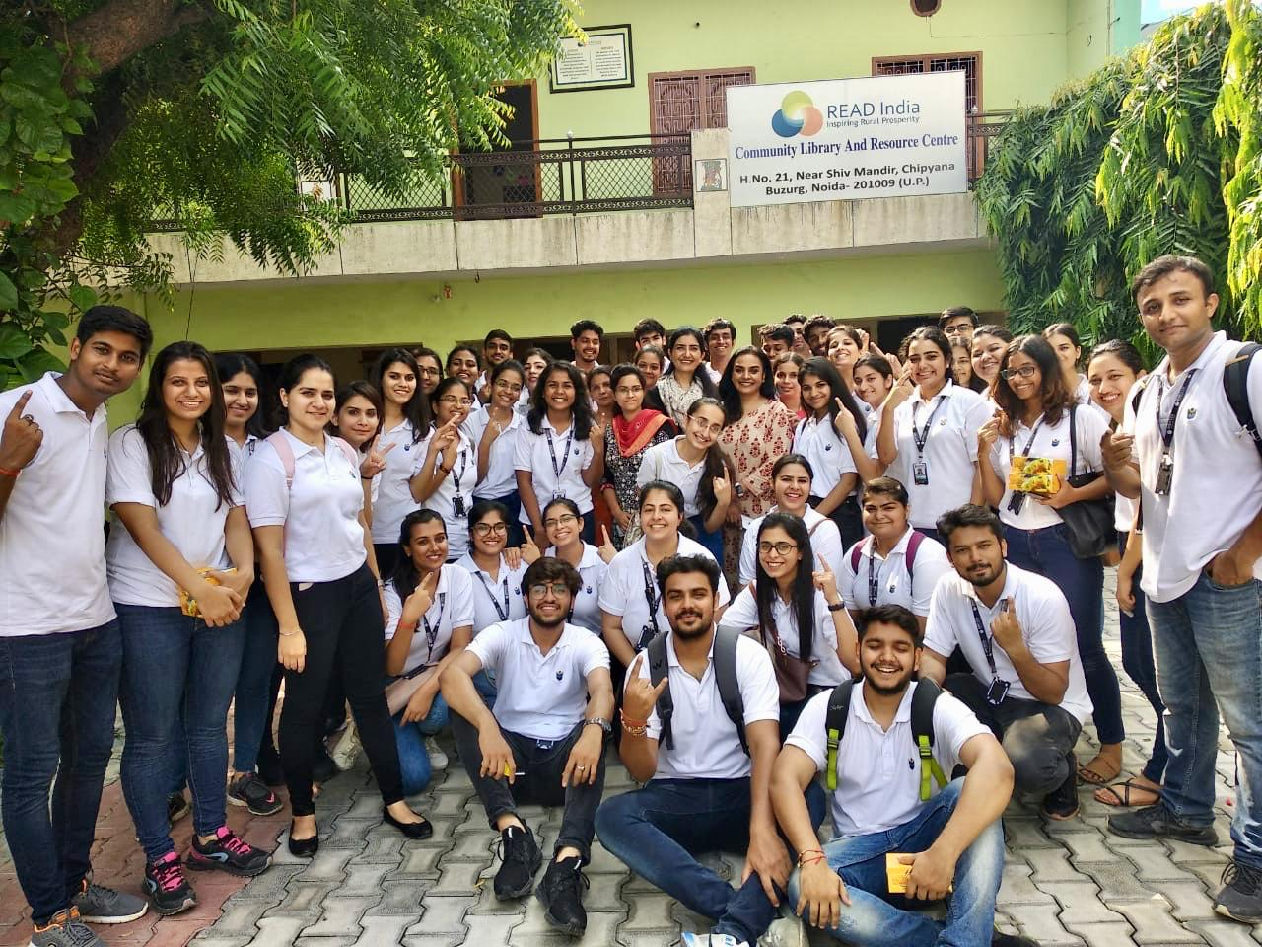
At READ India Accenture’s CSR Project Site.
The Visit to Udayan Care Greater Noida and Noida boys and Girls Centres exposed the students to child protection and juvenile justice regulations in the country, the role of corporate in supporting institutions working with state child protection committees and their work.
At Udayan Care 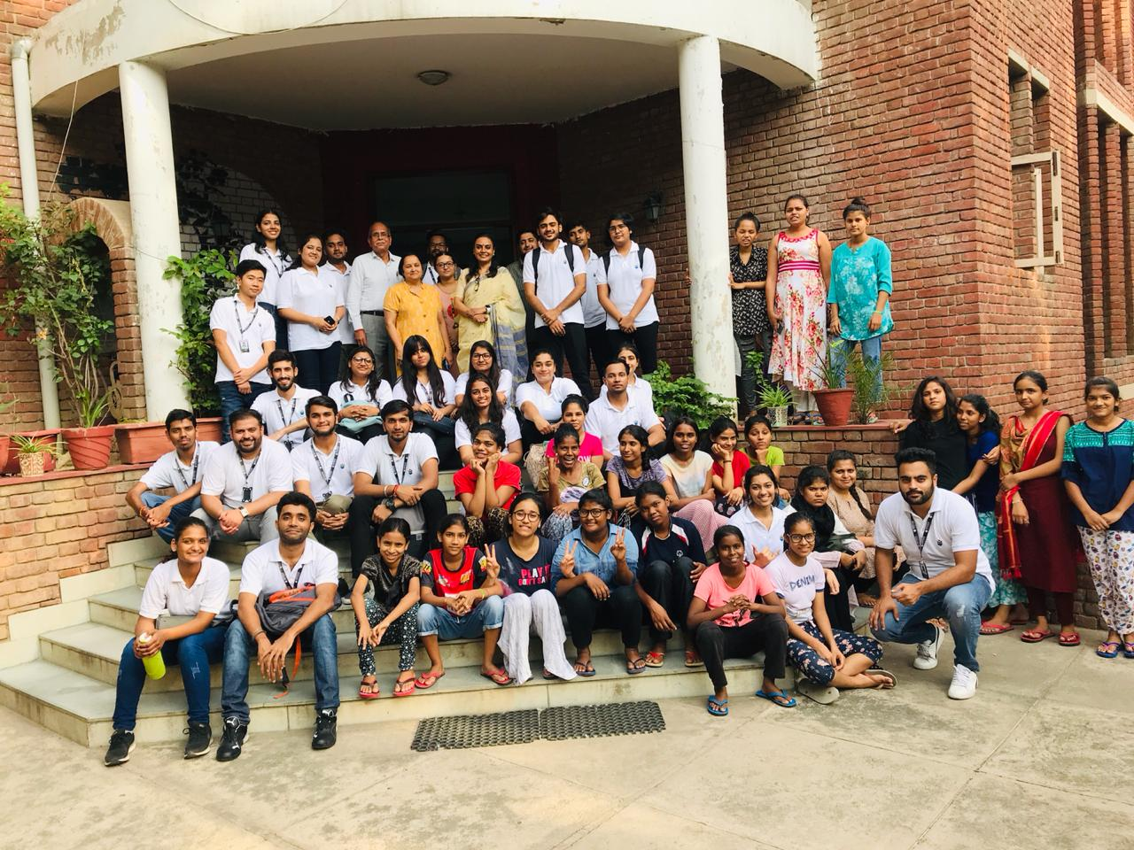
Conferences, National Summits and Workshops

The Institute has been organizing National and International Conferences in the area to promote awareness and provoke thought on the subject of Responsible Business and CSR.

The 14th Annual Convention of UN Global Compact Network of India was held successfully at Hotel Hyatt, Mumbai on the 31st of May 2019
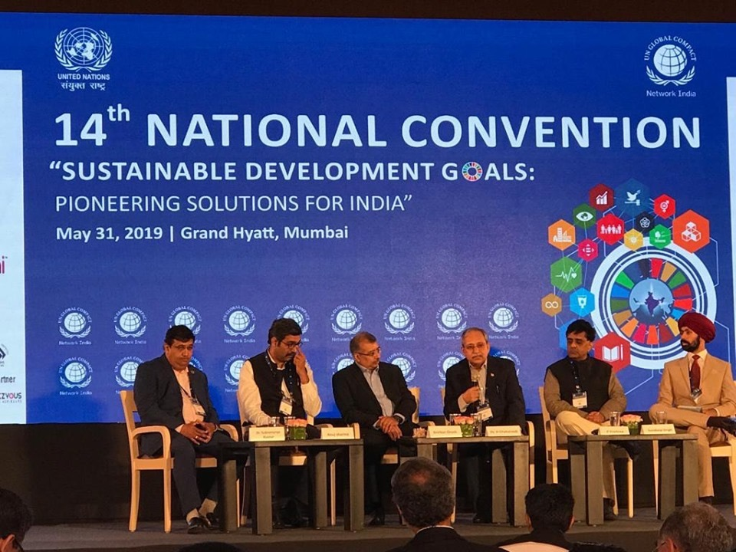
Dr Harivansh Chaturvedi, Director BIMTECH addressing the Annual Convention; attended by more than 500 delegates and addressed by over 50 speakers.
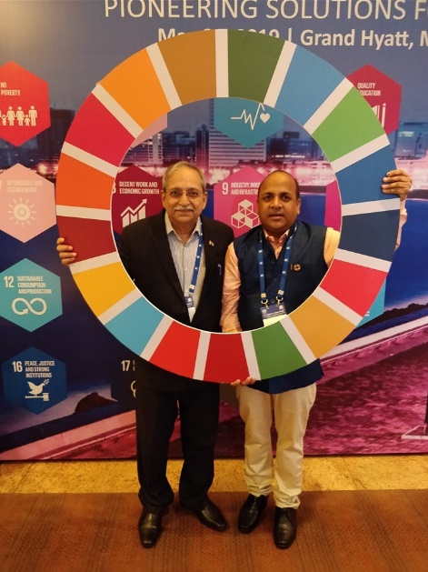 The theme of the convention was “Pioneering Solutions for SDGs in India". It was inaugurated by Niti Ayog member Dr Bibek Debroy. UNDP, India Chief, Dr Rajiv Dubey, Group HR Chief, Mahindra & Mahindra Group, Mr Vishvesh Prabhakar, MD, Accenture Consulting, Dr Uddesh Kohli and UNGCNI Director General Shri Kamal Singh were amongst the important speakers at the convention.
Director-BIMTECH, Dr Chaturvedi addressed the delegates twice during the two-day event. He participated in the UNDP Roundtable on Business Responsibility spoke in the plenary session “Technology and Innovation at the Heart of SDG Implementation".
6th Annual CSR Summit organised by BIMTECH and NHRDN in partnership with Think Through Consulting (TTC) and United Nations Development Programme (UNDP) on 17 and 18 Oct 2019 at Hotel Lalit Ashok, Bangalore.
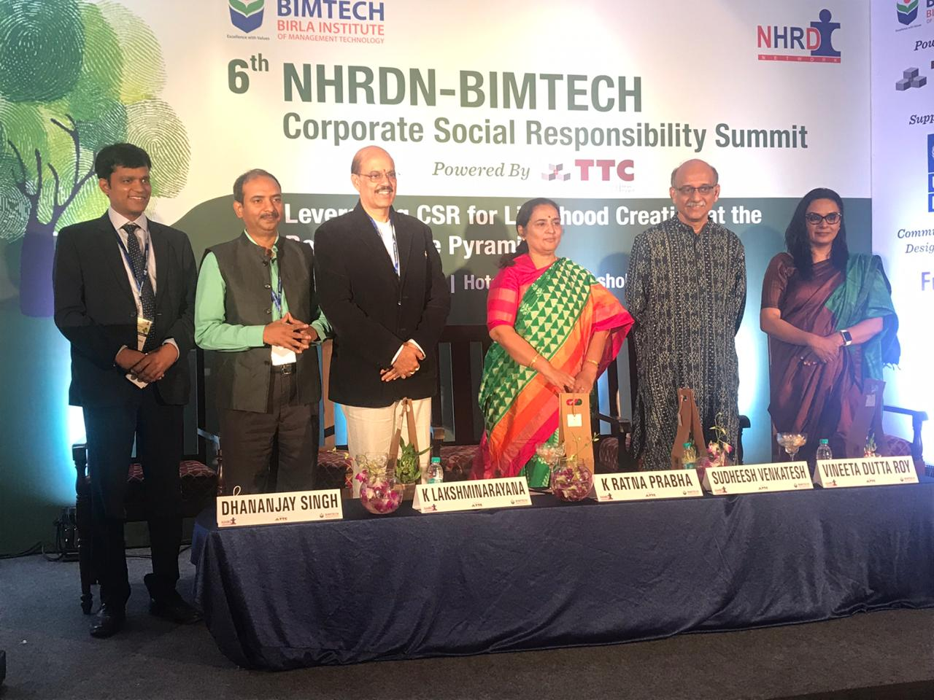
The participants in the Inaugural Session, with Former Chief Additional Secretary GoI, Ms Ratna Prabhakar, CEO-Azim Premji Foundation, Mr Sudeesh Venkatesh, CEO Shell MRPL-Mr K.Laxminarayana, Director General NHRD Mr Dhananjay Singh and Associate Prof and Lead CSR at BIMTECH -Dr Vineeta Dutta Roy.
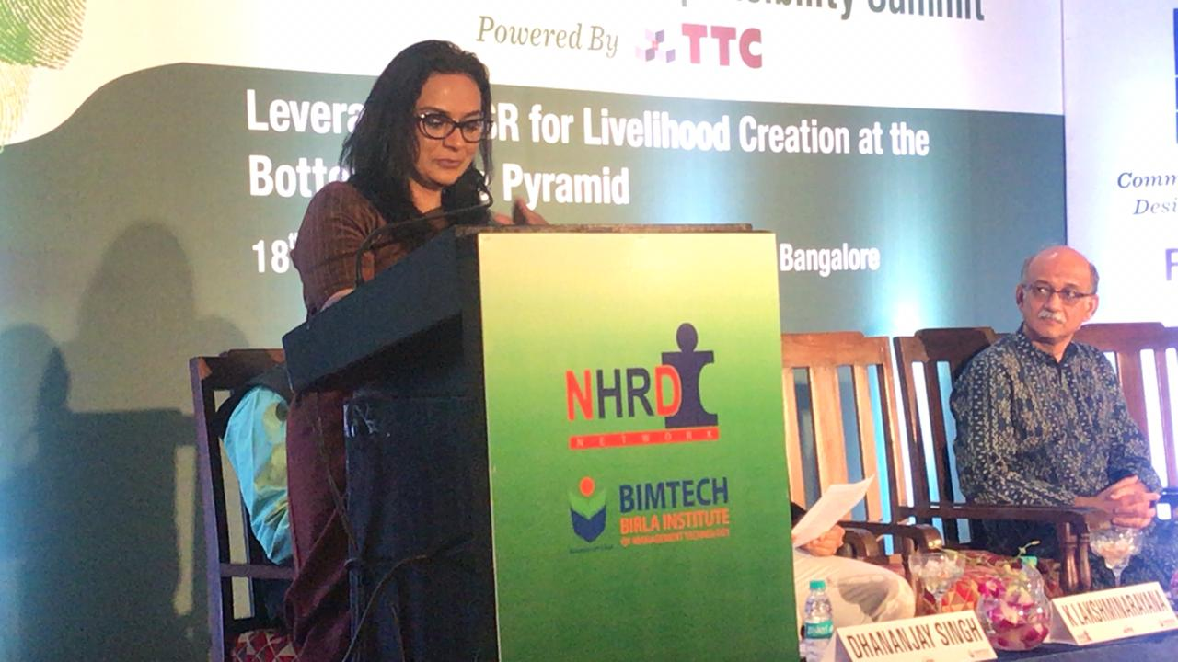
5th National CSR Summit organized by BIMTECH and NHRDN on 24th August 2018 at Mumbai
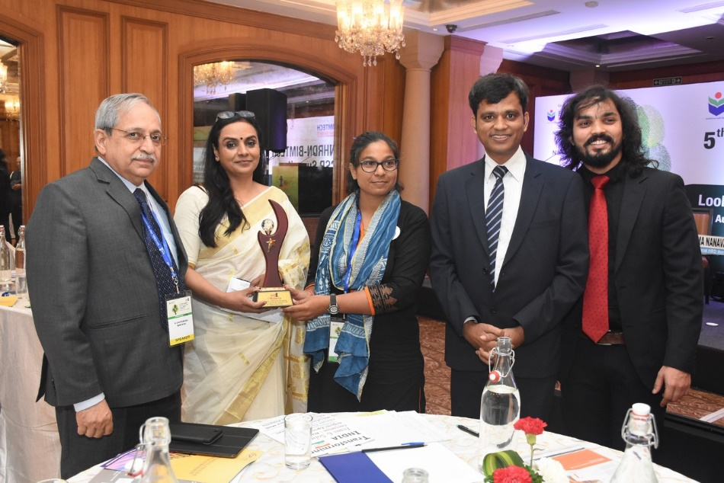
The 5th National CSR Summit was attended by more than 150 participants. About 20 CSR Heads of Companies were present during this event. Awards were also given to the prominent companies and NGOs who have excelled in CSR domain. Mr. Vinay P Sahasrabuddhe, President ICCR, Member of Parliament (Rajya Sabha) & Vice Chairman, Rambhau Mhalgi Prabodhini, Mr. Rajeev Dubey, Group President (HR & Corporate Services) & CEO (After-Market Sector) and Member Group Executive Board, Mahindra & Mahindra Ltd., Mr. Ranjit Singh, General Manager (CSR & Sustainability), Maruti Suzuki India Ltd. and Dr. H. Chaturvedi, Director, BIMTECH along with other dignitaries, addressed the audience during the event.
Roundtable Meeting of CSR Heads of companies
A roundtable of CSR heads of fifteen companies was organised by BIMTECH and NHRDN on 21st July 2018 in the office of Sh. Rajiv Dubey, Group president of HR & Corporate Services, Mahindra & Mahindra. Dr. Vineeta Dutta Roy represented BIMTECH during the meeting. The meeting also observed the presence of CSR head of ACC Ltd., HPCL, JSW, Eureka Forbes, Siemens, Yes Bank etc.
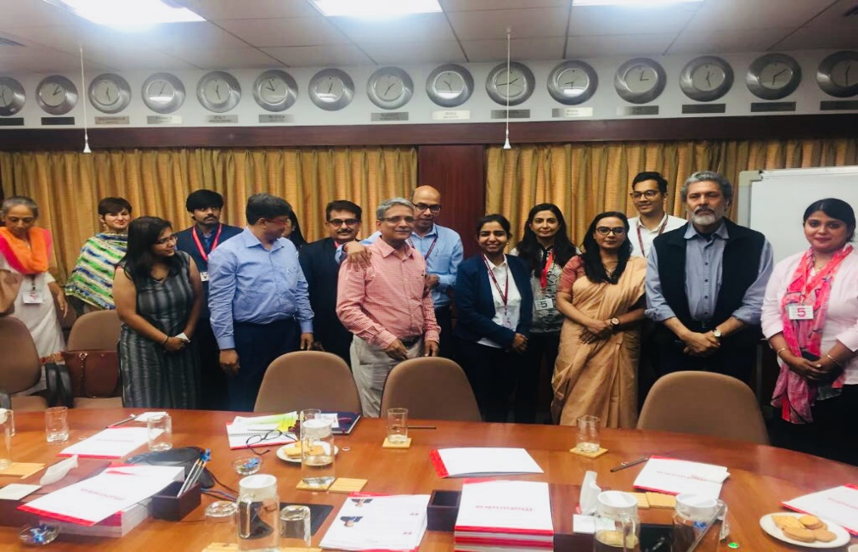
Picture: Round Table Meeting at Mumbai
UN GCNI 13th National Convention on “Sustainable Development Goals (SDGs): A Blueprint for Action”
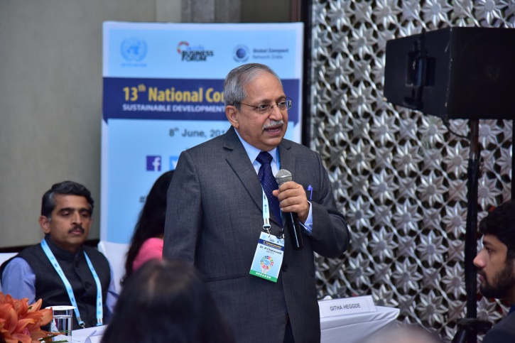
BIMTECH as an academic partner with Global Compact Network India organised the 13th National Convention on the theme of “Sustainable Development Goals: A Blueprint for the Action” on 8 June 2018 at Hotel Shangri-La, Bengaluru. The theme of the convention “A Blueprint for Action” emphasised on the real, on-ground actions that the businesses need to take to make a real impact on achieving the SDGs while also creating economic value for the nation.
Dr. H. Chaturvedi, Director, BIMTECH who was invited as speaker during the event shared his thoughts on “Providing Quality Higher Education & Lifelong Learning Opportunities for All in India”.
Prior to the above event, best case studies addressing at least one SDG were invited from across India from Public and Private sector companies, NGOs, and academic institutions. A Jury meeting was held on 28th May 2018 to select best case studies for the “Innovative Practices award on SDGs”. Dr. Vineeta Dutta Roy, Associate Professor and Lead CSR, BIMTECH was invited as jury member.
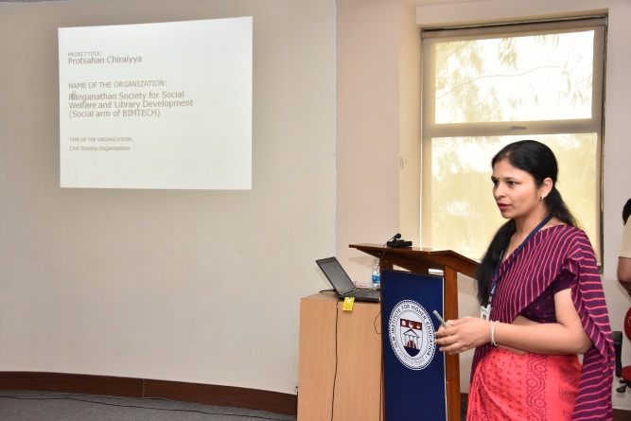
BIMTECH also participated in case study competition for the “Innovative Practices award 2018 on Sustainable Development Goals (SDGs)” organized by the Global Compact Network India (GCNI) for which a presentation was made by Prof. Monika Mittal, BIMTECH and Mr Satender Rana, Programme Manager, BIMTECH at IILM Institute for Higher Education, Lodhi Road, New Delhi on 2nd June 2018.
Workshop on “Corporate Social Responsibility for Agricultural Development” 17-18th October 2019.

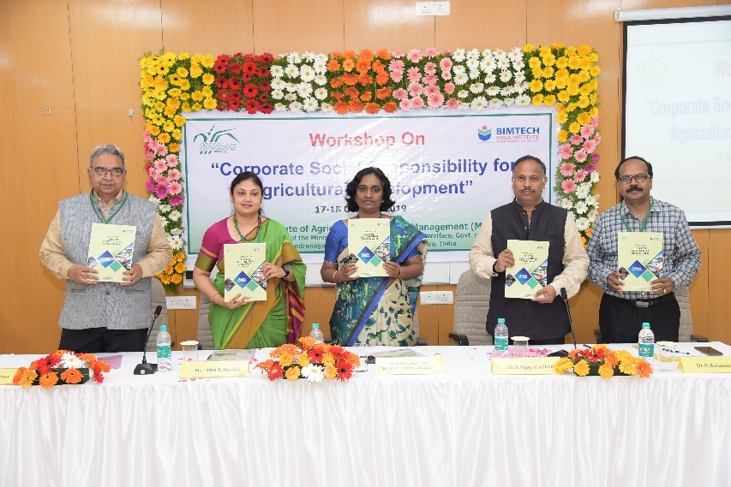
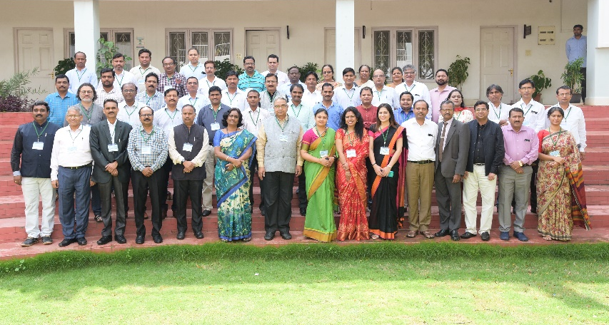
A workshop was organised jointly by Birla Institute of Management Technology (BIMTECH), Greater Noida, and National Institute of Agricultural Extension Management (MANAGE), Hyderabad on 17-18th October 2019. 34 organisations including corporate foundations such as Reliance Foundation, Ambuja Cement Foundation, JSW Foundation, Dalmia Bharat Cement, ITC Limited, ACC Limited, Indian Oil Corporation Limited, Bharat Dynamics Limited and NTPC Limited participated in the workshop. The themes for this year’s workshop are i) water management, ii) dairy and iii) innovative projects in the area of agriculture.
Workshop on CSR for Agricultural Development 2018
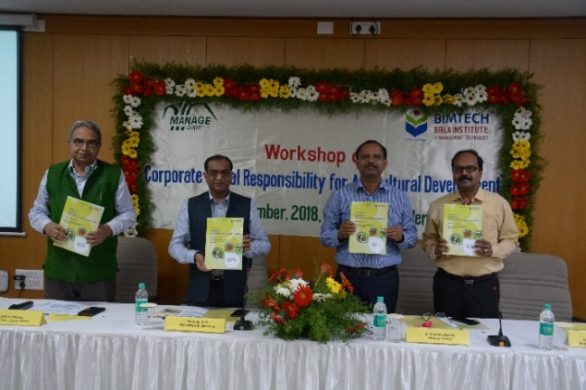
BIMTECH in collaboration with the National Institute of Agricultural Extension Management (MANAGE) organized its 2nd workshop on “Corporate Social Responsibility for Agricultural Development” at MANAGE Campus at Hyderabad on 19-20th November 2018.
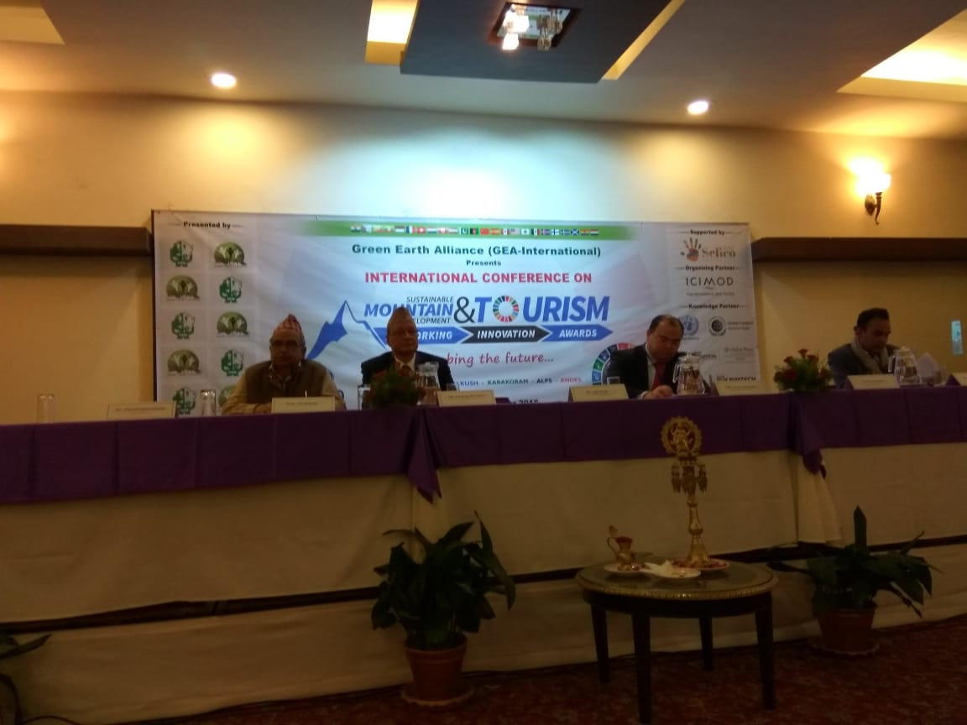
International Conference on Sustainable Mountain Development and Tourism
In order to raise some un-addressed yet fragile mountain development issues, Green Earth Alliance (GEA-International) organized 1st International Conference on “Sustainable Mountain Development & Tourism (SMDT)” at Kathmandu/Nepal. Prof. N. N. Sharma, Chairperson, Centre for Sustainability & CSR, BIMTECH was invited as speaker during the conference.

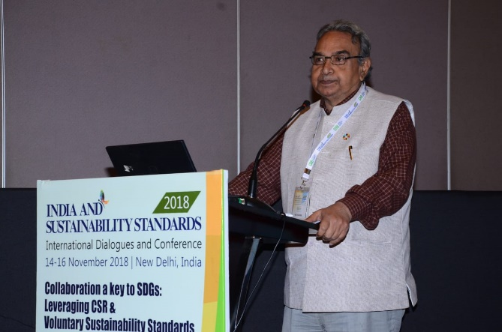
International Dialogue and Conference - India and Sustainability Standards
Prof. N. N. Sharma, Chairperson, Centre for Sustainability & CSR, BIMTECH was invited to address the participants during the 5th Annual Conference of Centre for Responsible Business (CRB) titled ‘Collaboration a key to SDGs: Leveraging CSR & Voluntary Sustainability Standards’ organized from 14-16 November 2018.
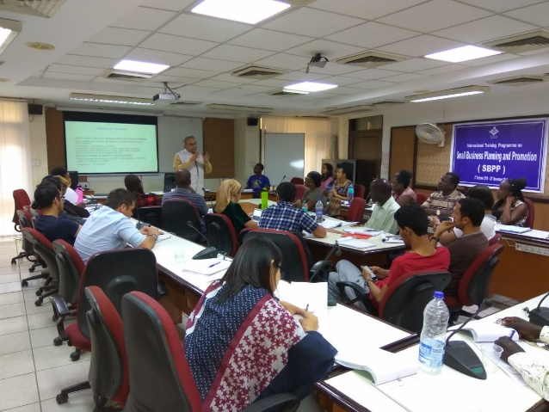
International Training Programme on Small Business Planning and Promotion
Prof. N. N. Sharma, Chairperson, Centre for Sustainability & CSR, BIMTECH took a training session during the International Training Programme on Small Business Planning and Promotion organized by The National Institute for Entrepreneurship and Small Business Development (NIESBUD), Noida. The training programme was attended by persons from 15 nations.
“Make in Odisha” CSR Conclave –Organised by Government of Odisha 2018
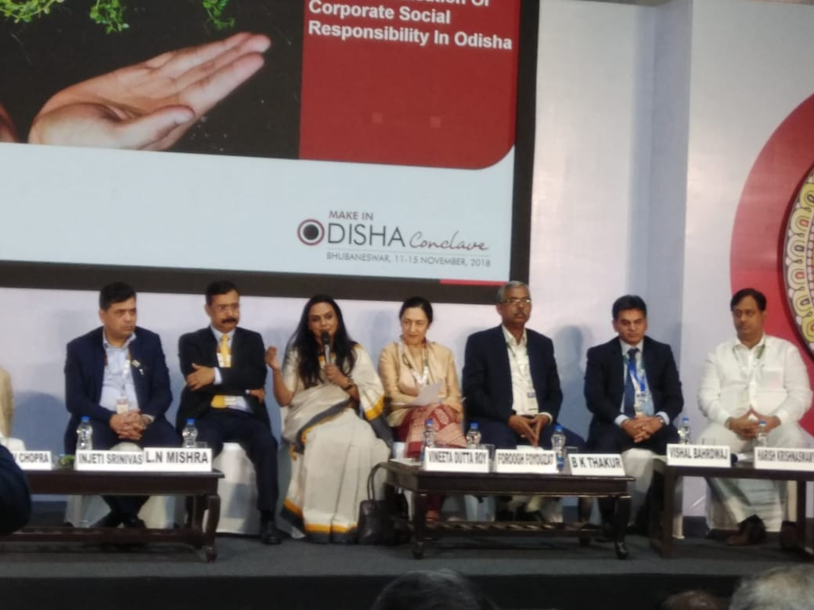
The Government of Odisha organized the Make in Odisha Conclave from 11-15th November 2018 at Bhubaneswar. During the event, Dr Vineeta Dutta Roy, was invited as jury member, eminent speaker and distinguished moderator on 14th November 2018.

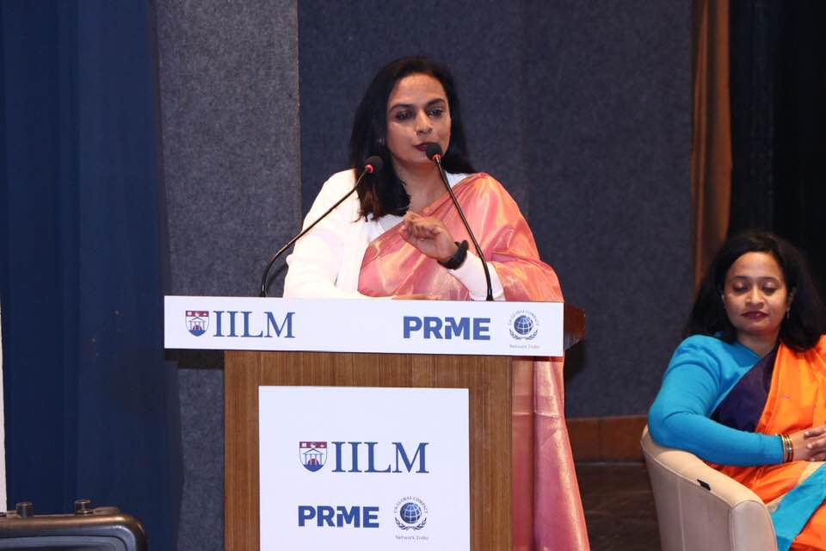
6th IILM International Conference on “Reimagining Sustainable Futures- The SDG Framework” from 31stJanuary – 2nd February 2019.
IILM released a book on the conference theme “Reimagining Sustainable Futures- The SDG Framework” on 31st January 2019. Dr Vineeta participated in the author’s Panel moderated by Dr. Bhaskar Chatterjee, Editor along with other dignitaries.
UN PRME - Delhi Meet
The PRME - Principles for Responsible Management Education (PRME) meet was organised by S.P.Jain Institute of Management and Research in New Delhi on Wednesday, July 11, 2018. The meet brought together eminent B-Schools and Universities from all over the country and provided a platform to academics working in the field of CSR and Sustainability to share their views on teaching, researching and inculcating values of ethics and sustainability through management curricula. The meeting was attended by Dr. Vineeta Dutta Roy, Associate Professor and Lead CSR, BIMTECH.
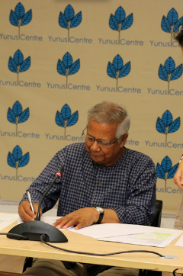
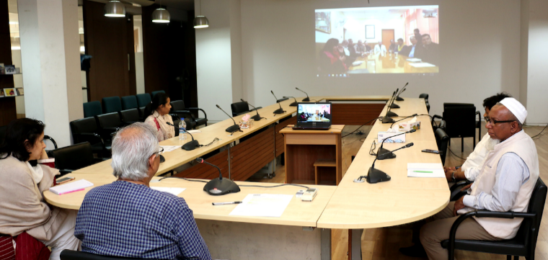
MoU signed with Yunus Centre, Dhaka
An MoU has been signed on 11th February 2019 with Yunus Centre, Dhaka for the establishment of Yunus Social Business Centre (YSBC) at BIMTECH.
Jagran Lake City University National Round Table at Bhopal
The Jagran Lake City University, organised a Round Table consultation of experts, civil servants, academicians and NGOs on Nurturing an Ecosystem for Social Impact” on 14th September 2019
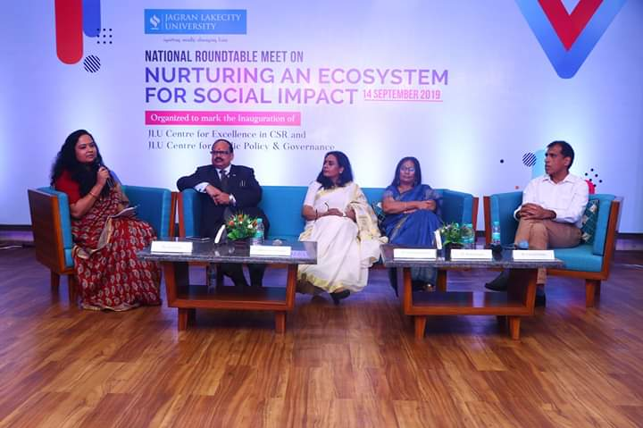
Dr Vineeta Duta Roy was invited as an expert during the National Round Table 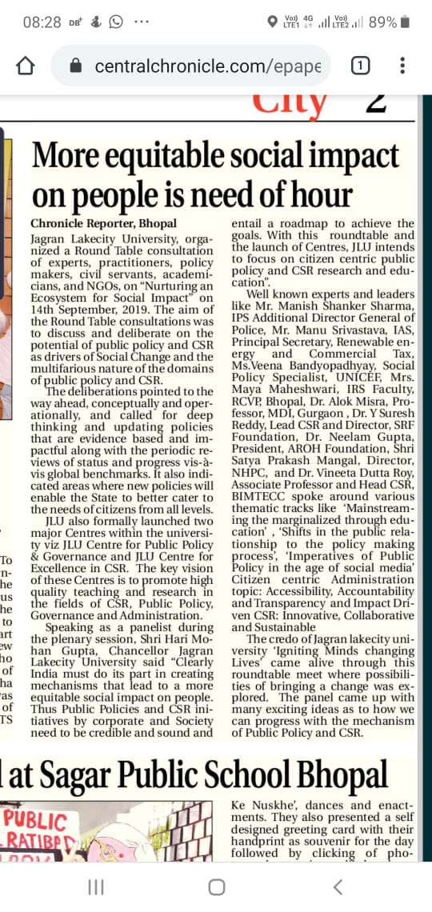
Knowledge Session held at Metro Bhawan, Delhi Metro Rail Corporation (DMRC) on 28th June, 2019 Responsible Business& CSR –Implication, Expectations and Responses
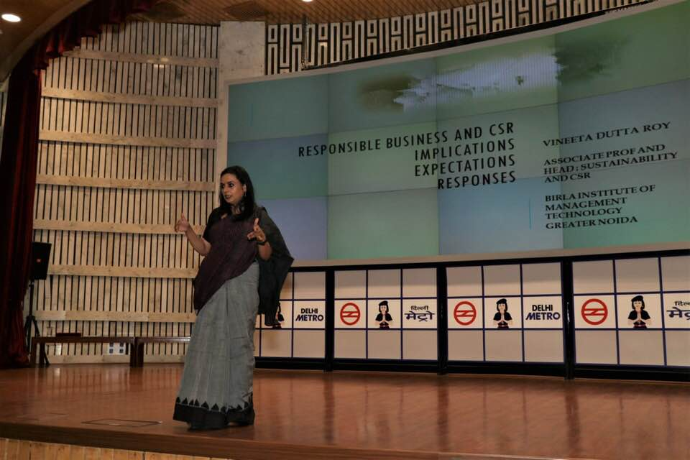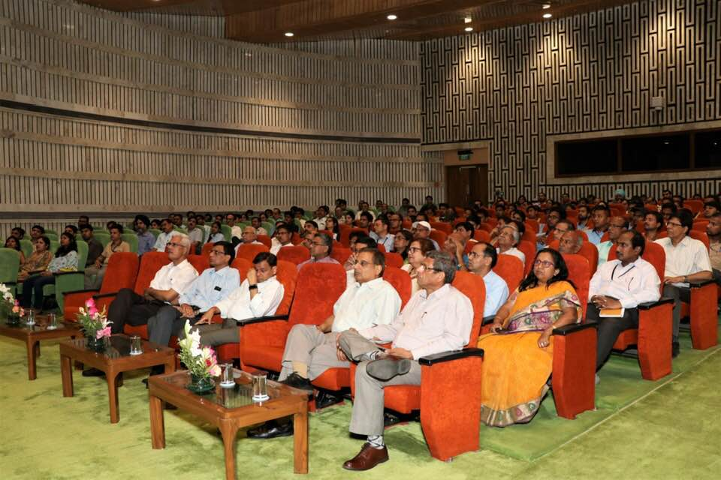
Dr Vineeta Dutta Roy, delivering her lecture as part of Knowledge Series at DMRC, New Delhi

8th Social Business Day, organized by Yunus Centre
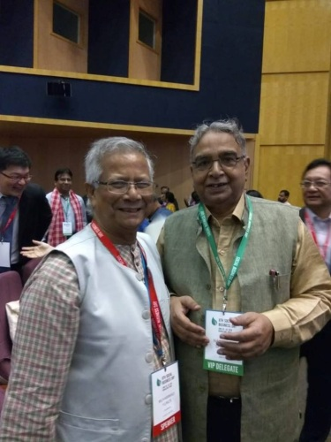
The 8th Social Business Day was organised by Yunus Centre on June 28-29, 2018 at Infosys Campus, Electronic City, Bengaluru. The event was graced by presence of Nobel Laureate Prof. Muhammad Yunus. Prof. N. N. Sharma, Chairperson, Centre for Sustainability and CSR, BIMTECH also attended the Social Business Day. The event was attended by nearly 1,100 delegates from more than 42 countries.

8th Subir Raha Memorial Lecture
BIMTECH students attended 8th Subir Raha Memorial Lecture delivered by Dr. R.A. Mashelkar, F.R.S., President of Global Research Alliance, Former Director General of Council of Scientific and Industrial Research (CSIR) on theme “ASSURED Inclusive Innovation: Path to CSR 2.” The event took place at ONGC Limited, New Delhi on Friday, July 13, 2018.
Book on Responsible Business and CSR “Demonstrating Responsible Business: CSR and Sustainability Practices of Leading Companies in India.
Dr Vineeta Dutta Roy, Associate Prof and Lead CSR and Sustainability at Birla Institute of Management Technology was conferred the Author Award for her book “Demonstrating Responsible Business: CSR and Sustainability Practices of Leading Companies in India” by the widely acclaimed CSR platform -The India CSR Network in an event held on April 1st, 2019 at New Delhi.
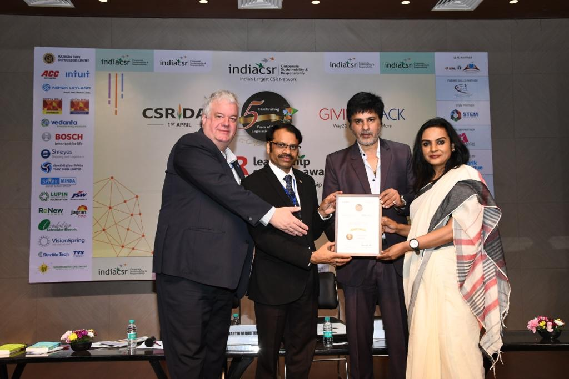
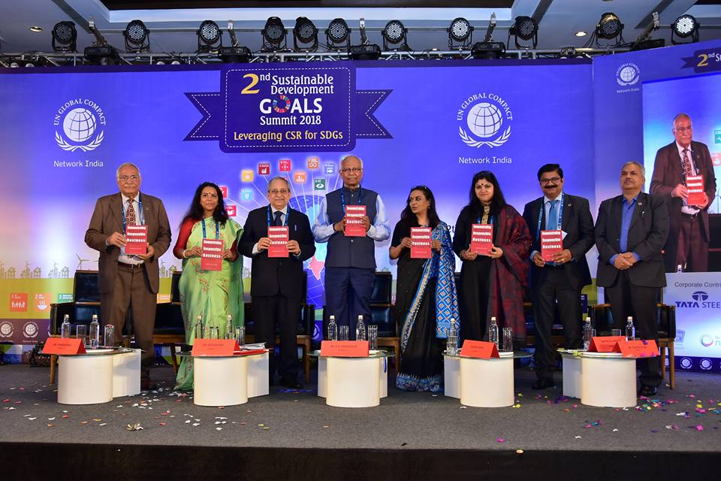
Dr Vineeta Roy receiving the Award from Mr Rahul Roy, a well-known film personality and Altruist; the dignitaries present are Dr Martin Neureiter, CSR expert and Mr Rusen Kumar, Managing Editor, India CSR
The book was pre-launched during the GCNI 2nd Sustainable Development Goals Summit. The Summit with the theme “Leveraging CSR for SDGs” was held on 12th December 2018 at Mumbai.
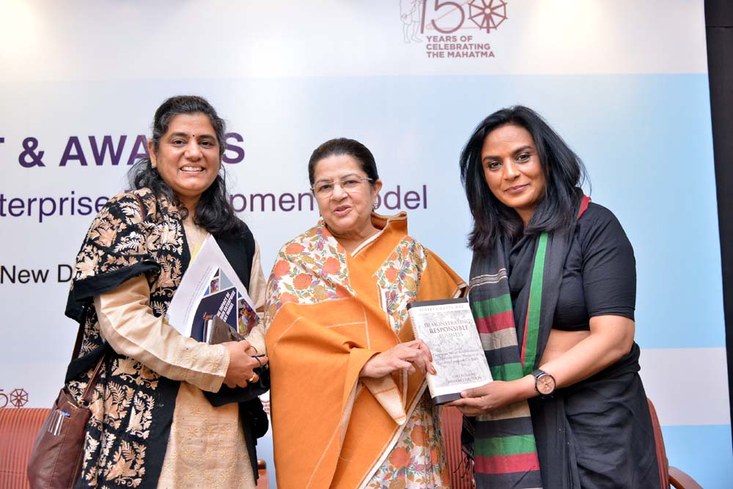 And formally released during the 19th FICCI- Annual CSR Summit and Awards by Smt. Rajashree Birla, Chairperson Aditya Birla Centre for CSR, Ms Jyoti Vij, Deputy Secretary General FICCI and Ms Uma Seth, Director FICCI CSR Centre.

Consultancy and capacity building

Impact Evaluation for JK Paper Mills
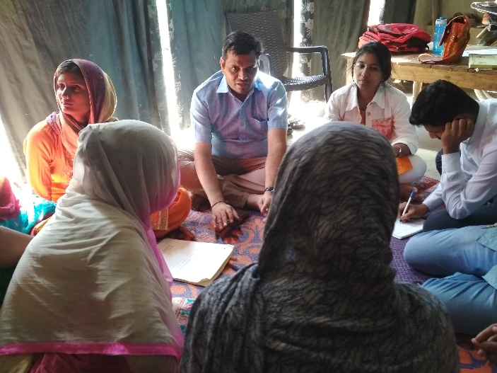
The Centre for Sustainability & CSR (CSC), BIMTECH has been entrusted by JK Paper Mills to conduct Impact Evaluation of 650 Dairy Interest Groups (Self-Help Groups) formed and nurtured by the company under one of its CSR projects. The data collection was completed from 21 April 2019 – 26 April 2019. The study covered 15 villages, 65 SHGs and 346 HHs.
Training programme on Need Assessment and Impact Evaluation for the executives of JK Organisation
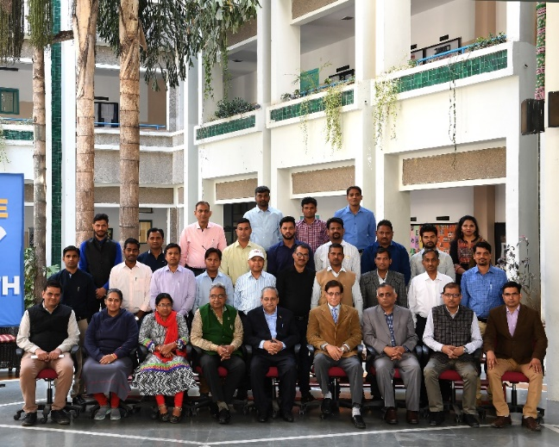
This programme was organised by Birla Institute of Management Technology (BIMTECH), Greater Noida for the CSR professionals of companies of JK Organisation on 15-16th March 2019 at BIMTECH campus in Greater Noida. There were 24 participants from J.K. Fenner (India) Limited, JK Lakshmi Cement Limited, JK Paper Ltd., JK Tyre & Industries Ltd., SPARSH, Odisha, Udaipur Cement Works Limited, Umang Dairies Limited.

Situation Analysis and Needs Assessment for ACC
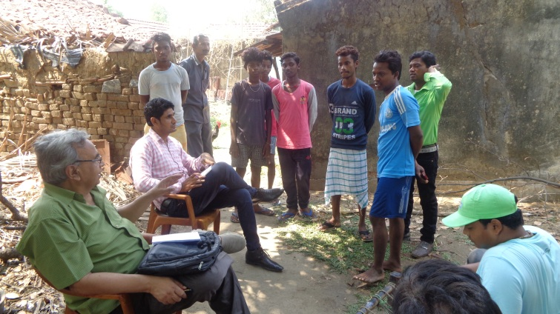
ACC Ltd., being a good corporate citizen, is undertaking initiatives for improving the socio–economic conditions of people residing in locations in the proximity of their manufacturing units. To evolve a strategy for future interventions, it was decided by ACC to conduct situation analyses and to ascertain the needs, aspirations, perceptions and priorities of the community residing near its plant and the adjoining mining areas. The assessment was intended to be the ﬁrst step towards the development of a robust strategy for appropriate CSR interventions. The Centre for Sustainability and CSR at BIMTECH completed Situation Analysis and Needs Assessment of six villages located in Purulia District in the state of West Bengal from 26 July 2018 to 01 August 2018.
Baseline Survey and Need Assessment for JSW Cement Limited
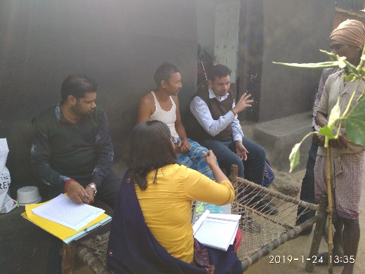
JSW Foundation has entrusted BIMTECH to conduct the Baseline Survey and Need Assessment of 35 villages located under its Direct Impact Zone (DIZ) in West Bengal and Odisha. The field visit in 28 villages located near to JSW Cement Plant in Salboni, West Bengal has been completed on 8th February 2019. Moreover, a pilot study has also been conducted in in three villages near to Shiva Cement Works of JSW in Sundargarh district of Odisha in last week of May 2019.
Skill gap analysis in district Mathura for Ministry of Rural Development, New Delhi
The Centre for Sustainability and CSR (CSC) is conducting Skill Gap Assessment of Mathura district. In this regard a meeting was held on 2nd July 2018 at DM office, Mathura. The meeting was chaired by Shri Srawagya Ram Mishra, IAS and District Magistrate and attended by, Shri Vinay Pandey, Head, Roshni & Head Monitoring, DDU-GKY, Prof. N. N. Sharma, Chairperson, Centre for Sustainability & CSR, Birla Institute of Management Technology (BIMTECH), Dr Rishi Tiwari, CEO, BIMTECH Foundation, and Satender Rana, Programme Manager, BIMTECH and officials of various departments, and representatives of industry and, academia.
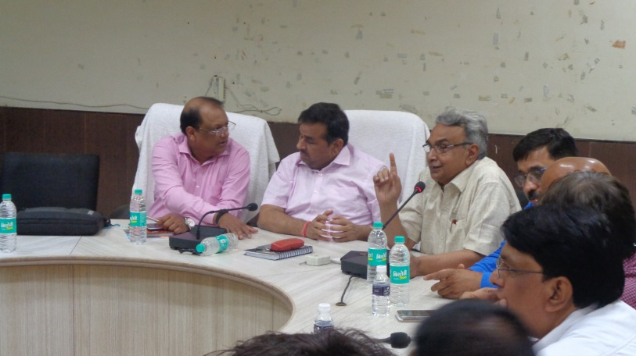

Community outreach

Inauguration of Library in District Jail Bulandshahr
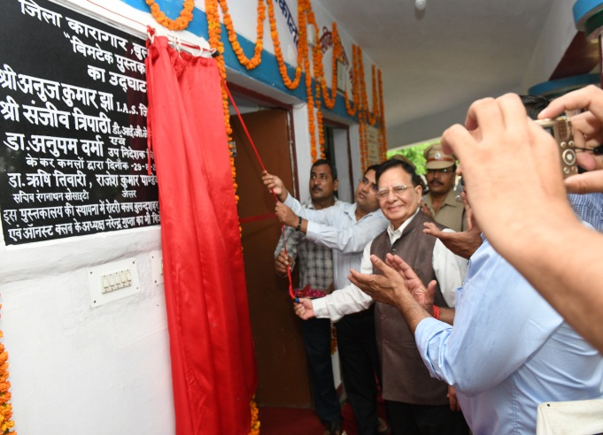
BIMTECH Foundation and Ranganathan Society for Social Welfare and Library Development (RSSWLD) under the guidance of Dr. Rishi Tiwari, CEO, BIMTECH Foundation opened ninth “BIMTECH Pustkalya” at District Jail Bulandshahr on 29th August 2018.

Inauguration of Library in District Jail Firozabad
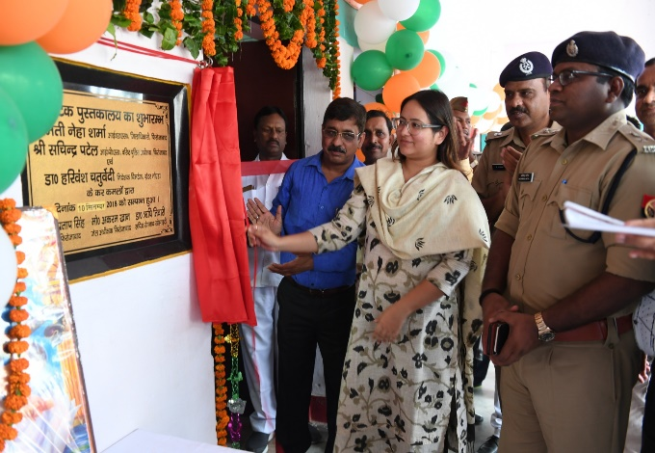
BIMTECH Foundation and Ranganathan Society for Social Welfare and Library Development (RSSWLD) under the guidance of Dr. Rishi Tiwari, CEO, BIMTECH Foundation opened ninth “BIMTECH Pustkalya” at District Jail Firozabad on 10th September 2018. The inauguration ceremony was attended by Ms. Neha Sharma, District Magistrate, Prof. Manoj Pandey, BIMTECH and Jail Superintendent Mr Akram Khan. The library will bring a respite to prison inmates by breaking the monotonous prison schedule and expected to contribute towards their mental wellbeing.
Mathura Jail Inauguration
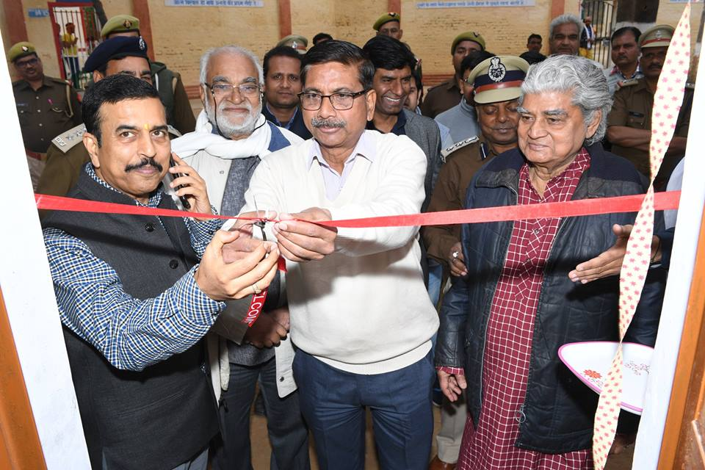
BIMTECH Foundation and RSSWLD inaugurated its 10th Jail Library at Mathura District Jail on 4th January 2019. This library was financially sponsored by the Raja Rammohun Roy Library Foundation. The library was inaugurated by Mr. Ram Niwas, IAS & Chief Development Officer, Mathura.
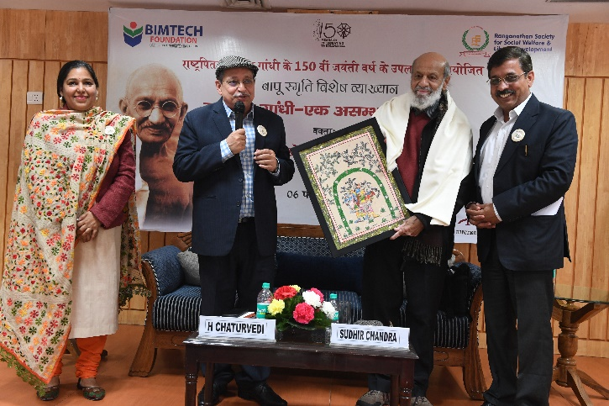
Special Lecture on Mahatma Gandhi
BIMTECH celebrated the 150th birth year of Mahatma Gandhi on 6th February 2019 by inviting Prof. Sudhir Chandra, a renowned historian, and author of the proclaimed book “Gandhi: An Impossible Possibility.” Prof. Chandra shared his ideas and beliefs and presented Gandhiji in a new light.

RSSWLD and BIMTECH Foundation to start an initiative for the welfare of inmates of Kerala prison
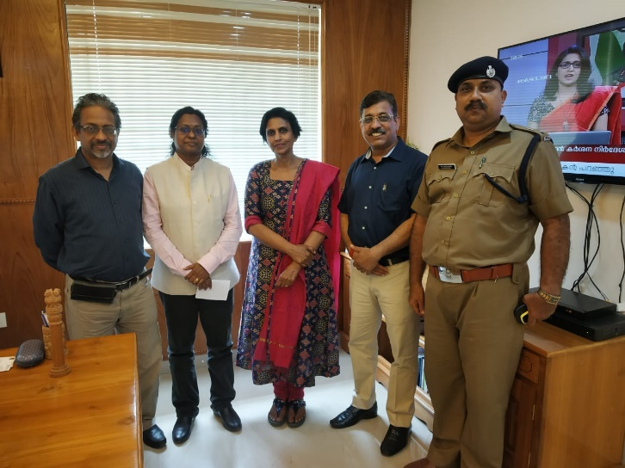
Dr. Rishi Tiwari and Dr. Abha Rishi met Smt. R. Sreelekha, IPS & Director General Prisons and Correctional Services and Sh. Vijay Kumar, Superintendent on 19 February 2019. The meeting was held with the agenda to understand the rehabilitation practices of Kerala Jail inmates. RSSWLD and BIMTECH Foundation will soon start a collaborative initiative with the Kerala Government for the welfare of prison inmates.
Sports at Greater Noida Jail
Two sports competitions were organized between inmates and BIMTECH students on 27th January 2019. The trip was facilitated and organized through Ranganathan Society for Social Welfare and Library Development (RSSWLD), the CSR wing of BIMTECH, Greater Noida total of 28 BIMTECH students were taken to jail for volleyball and cricket competition out of which 4 were executive members of RSSWLD.
Unnat Bharat Abhiyan
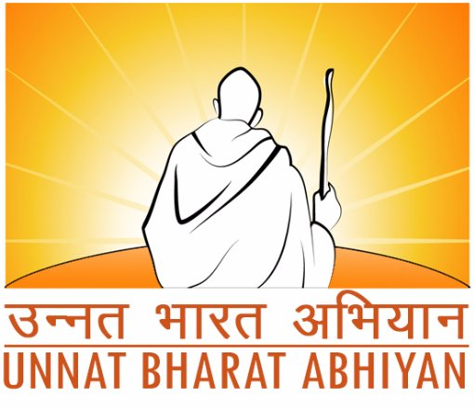
BIMTECH has been selected as Participating Institute (PI) under the Unnat Bharat Abhiyan (UBA) 2.0. UBA is a flagship programme of the Ministry of Human Resource Development which intends to enrich Rural India. The programme envisions to involve the reputed higher educational institutions of the country in the process of indigenous development of self-sufficient and sustainable village clusters in tune with the notion of ‘Grām Swarāj’ propounded by Mahatma Gandhi.
All participating institutions (PIs) are expected to establish a UBA Cell which will be responsible for carrying out the activities of the UBA. This will involve the development of an active working group consisting of motivated faculty members drawn from various disciplines. Further, PIs are also expected to identify at least five villages to carry out the out the activities of the UBA. BIMTECH has identified Neemka Shahjahanpur, Alli Ahmadpur Urf Garhi, Bankapur, Khwajpur, and Mahvalipur village in block Jewar of Gautam Buddha Nagar district of Uttar Pradesh. The village and household survey as well as participatory situation analysis will be done shortly to develop development plan for each village.
Hands- On- Training - Library Management Software: KOHA
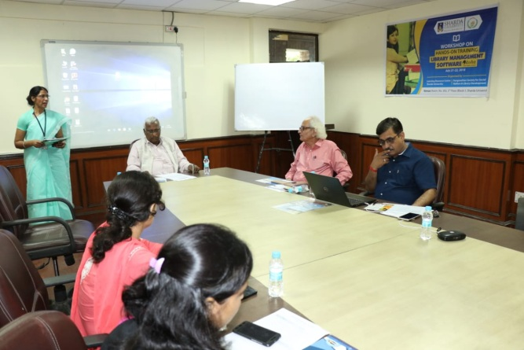
A two days’ Workshop on Hands- On- Training - Library Management Software: KOHA was organized jointly by Learning Resource Centre, Sharda University and Ranganathan Society for Social Welfare & Library Development in the campus of Sharda University, Greater Noida on 21-22nd July 2018 for Staff of Library of Sharda University.
The purpose of the workshop is to familiarize the participants with the KOHA software which is open source software. The training offered technical know-how to the participants for the installation, customization and running of various library applications. Dr. Rishi Tiwari, BIMTECH, Greater Noida and Sh. D. P. Tripathi, NIIT Rourkela were invited as resource persons during the workshop. KOHA is considered as a highly sophisticated ILS in the open source domain which offers full featured ILS including OPAC, Circulation, Cataloguing, Acquisitions, Serials control etc.
Workshop on wheels: three-day workshop on KOHA
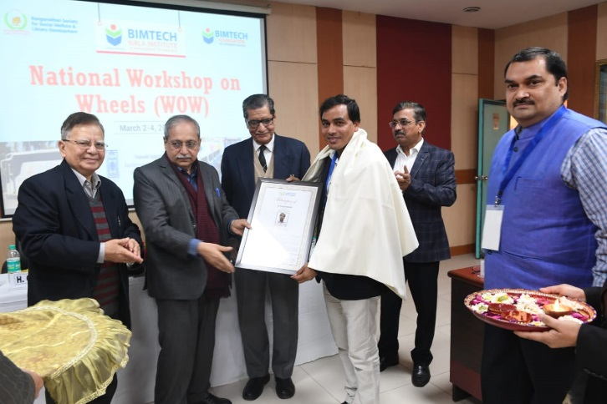
A three-day workshop on library management using KOHA software was organized from 2-4th March 2019 by Ranganathan Society for Social Welfare and Library Developed and BIMTECH Foundation with support from Raja Rammohun Roy Library Foundation (RRRLF). During the inaugural session, Dr. Badan Barman, Assistant Professor, Gauhati University was felicitated by Shri Brij Kishore Sharma and Dr. H Chaturvedi for his contribution in the area of library information system.
National workshop on "Open source solutions tools & techniques KOHA & Data Migration
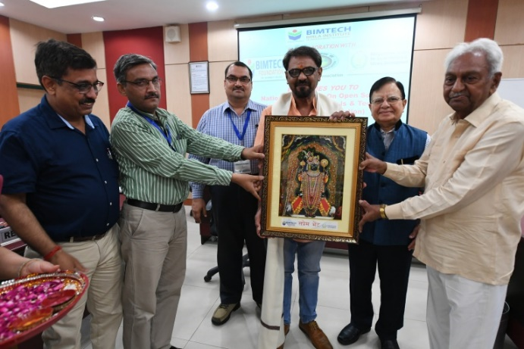
BIMTECH, Greater Noida in Collaboration with Indian Library Association (ILA) , BIMTECH Foundation & Ranganathan Society for Social Welfare and Library Development (RSSWLD) organised a two day workshop on “"Open source solutions tools & techniques KOHA & Data Migration” on 8–10th June 2018 at BIMTECH, Greater Noida.
Prof. Lallan Prasad from Delhi University who is also a member of governing body of Delhi Public Library was invited as the chief guest. The event was also graced by the presence of Dr. Ramesh Yernagulla, Director (DOC), ICSSR, New Delhi, Dr. Anupam Varma. Dy. Director BIMTECH, Dr. Anil Singh, Dr. Prabhat Pandey, and Shri D.P. Tripathi.
The workshop was attended by 42 participants from ten states.
Launch of HP World on Wheels (HP WoW) – Digital Inclusion Initiative
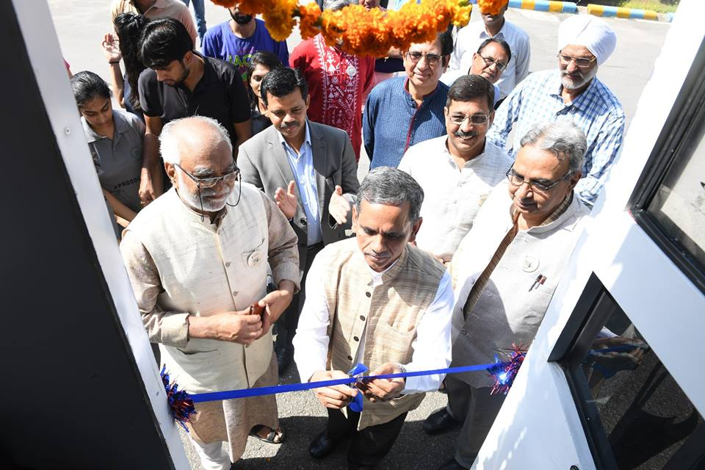
On 2nd October 2018, the 31st Foundation day of Birla Institute of Management Technology, the institute in collaboration with HP India and Jubilant Bhartia Foundation launched the HP World on Wheels (HP WoW) vehicle. Sh. Ram Mohan Mishra, Additional Secretary & Development Commissioner, The Ministry of Micro, Small and Medium Enterprises, a branch of the Government of India, inaugurated the HP WoW bus having 20 computers and IT enabled services. The solar powered backed vehicle is supported by several software suites. The initiate envisions to help bridge the digital divide between urban and rural areas by bringing easy information technology access to the isolated and disadvantaged groups. The vehicle will assist BIMTECH Foundation and RSSWLD in promoting IT enabled education through e-learning modules and help train school children, rural youth and communities, among others. The bus already started the journey of achieving the goal of digital inclusion under the guidance of Dr. Rishi Tiwari, CEO, BIMTECH Foundation.
Visit of foreign delegates to Neemka village
BIMTECH Foundation and Ranganathan Society for Social Welfare and Library Development (RSSWLD) organized a village to Neemka village for the foreign delegates who participated in the International Conference on Management Cases (ICMC) organized by BIMTECH on 29-30th November 2018. The visit was aimed at giving a flavor of rural dynamics in India to the foreign delegates. Several recreational and educational activities were organized during the visit.
Essay Writing Competition at District Jail, Gautam Buddha Nagar
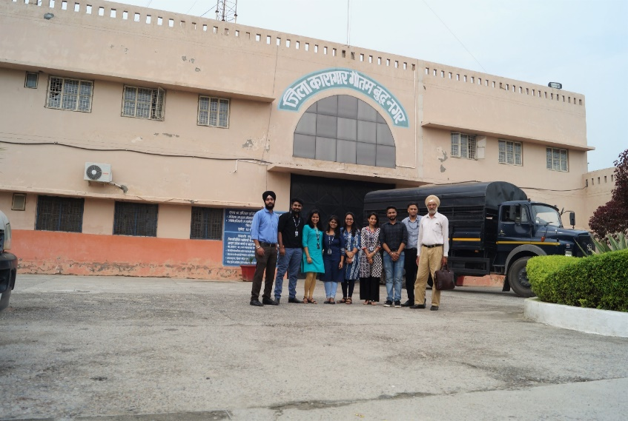
As a part of regular practice to motivate the inmates and to keep them engage in productive activates, an “Essay Writing Competition” was organized for both male and female inmates at District Jail, Gautam Buddha Nagar on 1st September 2018 by Ranganathan Society for Social Welfare and Library Development” and “BIMTECH Foundation” under the guidance of Dr. Rishi Tiwari, CEO, BIMTECH Foundation. 34 males and 9 females inmates participated in the competition.
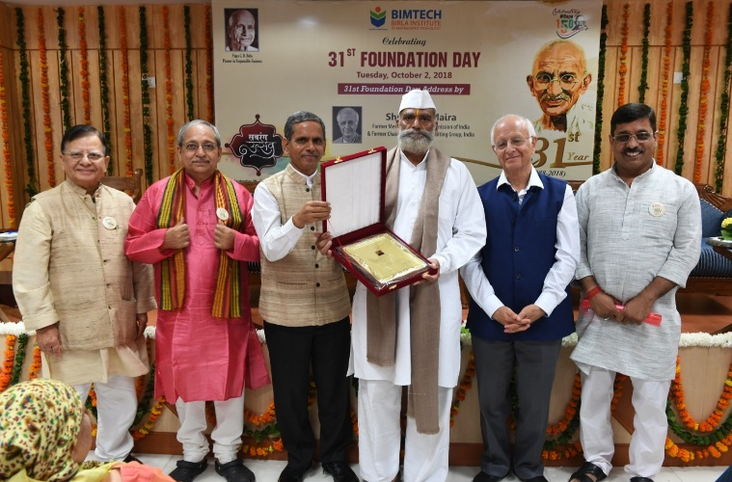
Felicitation of Inmates
During the occasion of 31st Foundation day of BIMTECH, Sh. Arun Maira, former Member, Planning Commission and former Chairman, Boston Consulting Group, India, felicitated Sh. Vijay Singh (Ghaziabad Jail), Sh. Arun Gaur and Sh. Chandra Mohan Sharma (Gautam Buddha Nagar Jail) for being instrumental, while serving their term, in smooth and effective functioning of “BIMTECH Library” stabled by BIMTECH Foundation and RSSWLD in these jails.
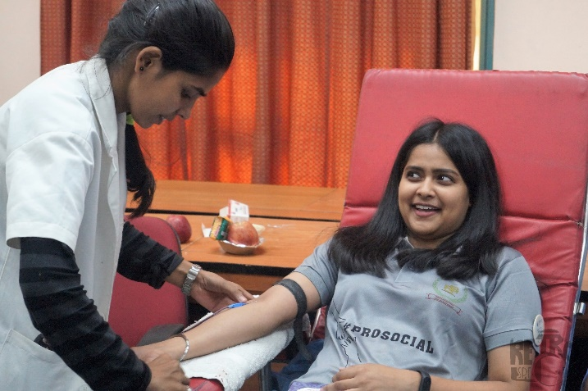
Blood Donation Camp
On 2nd October 2018, on the eve of 150th birth anniversary of Mahatma Gandhi, a blood donation camp was organized at BIMTECH Campus in collaboration with LIONESS CLUB PRAGATI and NOIDA CHARITABLE BLOOD BANK. The event was organized by Ranganathan Society for Social Welfare and Library Development (RSSWLD). 124 individuals donated the blood including Dr. H. Chaturvedi, Director, BIMTECH & Dr Anupam Verma, Deputy Director & Dean- Academics, BIMTECH.
Diya Selling - Charity Event
Under the guidance of Dr. Rishi Tiwari, CEO, BIMTECH Foundation, BIMTECH Foundation and RSSWLD organized a Diya Selling - Charity Event for the beneficiaries of Project “Protsahan Chiraiyya”. A stall was setup at BIMTECH campus on 17th October 2018 to sell Diyas for Diwali. A profit of INR 6000 was earned which will be used for the said project.
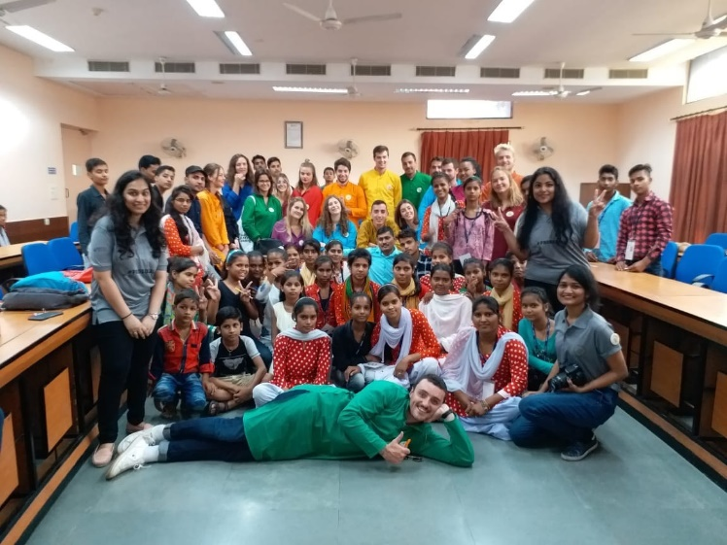
Recreational Activities for Chiraiyyas
The girls from Neemka village participated in the festivities of celebration of Gandhi Jayanti at BIMTECH on 2nd October 2018. The Ranganathan society organized an event for the underprivileged. Beside showing documentaries on the life of Gandhiji, several interactive sessions with students and teachers, quizzes and games were organized for the girls and villagers accompanying them by the executives of RSSWLD which was followed by community lunch.
Orientation session on Digital Literacy
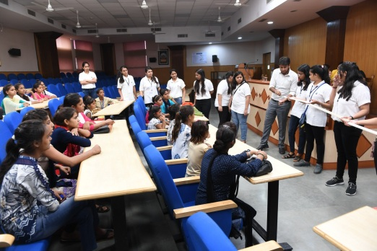
Ranganathan Society for Social Welfare and Library Development (RSSWLD) conducted an orientation session for the beneficiaries of project “Protsahan Chiraiyya”. The girls were informed about the Digital Literacy intervention soon to be implemented by RSSWLD. BIMTECH students volunteered to provide basic computer skills. They provided basic information about how to use E – Books, mobile, internet or new technologies.

Publications
Roy, V. (2019). Demonstrating Responsible Business: CSR and Sustainability Practices of Leading Companies in India (1st ed., p. 250). Bloomsbury Publishing.
Rana, S., & Sahay, A. (2018). The Role of Law in Promoting CSR: The Case of Indian Maharatna Public Enterprises. International and Comparative Corporate Law Journal, 13(2), 57-106.
ABDC Rating: A

Annexure 1: Details of students’ field visits under “Responsible Business” course during the academic year 2018-19
S. No. | State | District | Block | S. No. | Village | Date of Visit | Number of Students | Programme
i | Uttar Pradesh | Gautam Buddha Nagar | Jewar | 1 | Mahvalipur | 11-Aug-18 | 59 | PGDM Sec A
 |  |  |  | 2 | Bankapur | 11-Aug-18 | 57 | PGDM Sec B
 |  |  |  | 3 | Chiroli | 18-Aug-18 | 59 | PGDM Sec C
 |  |  |  | 4 | Alli Ahmadpur | 18-Aug-18 | 58 | PGDM Sec D
 |  |  |  | 5 | Dustumpur | 28-Oct-18 | 50 | PGDM IB
 |  |  |  | 6 | Chicholi | 05-Dec-18 | 57 | PGDM RM
 |  |  |  | 7 | Cancelled due to poor weather | 14-Feb-18 | 59 | PGDM IBM

