9th October, 2019
The Secretary General,
United Nations,
New York,
USA.

UNITED NATIONS GLOBAL COMPACT

REQUEST FOR GRACE

Dear Stakeholders,

We recognize that a key requirement for participation in the UN Global Compact is the annual preparation and posting of a Communication on Engagement (COE) that comprises of a CEO statement of continued support for the UN Global Compact, a description of practical actions with regard to the principles of the UN Global Compact, and a measurement of outcomes or expected outcomes.

We are late in creating, sharing and posting our COP report due to the loss of our organisation’s records, including our login password, which made it practically impossible for us to assess our dashboard. We had to contact the UNGC head office to assist in rectifying the issue which took some months.

We hereby ask for an extension period in order to be able to post a COP that describes our company’s efforts and progress to implement the principles of the UN Global Compact. Our new COP report will be posted on the UN Global Compact website by 1st September, 2019 at the latest.

We however note that this may not be feasible because we have long passed the grace date. We implore to be given another three months which will expire in December 2019. We look forward to this support.

Thank you.

Yours faithfully,

Sincerely yours,

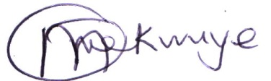

Mekwuye Olabisi (Mrs)
Executive Director

