ANNUAL REPORT-2019
Sai Star Society is an active member of UNGC since August, 2009
Brigadier Amarjit Singh Randwal (Retd)
President, J&K Sai Star Society

“Healthcare, Education & Environment”
“Welfare of Ex-servicemen & Widows”

J&K SAI STAR Society
(Annual Report for year 2018-19)
Nagrota Gujroo, Ramkot, Jammu- 184210, (J&K) INDIA
* Registered No. 4680/S, under J&K Govt. Act VI of 1998 (1941 AD), **Member United Nations Global Compact
***Donations exempted from Income Tax under Sec 80 G of the IT Act

Committed to: - “Ex-servicemen Welfare, Healthcare & Education”

Sainiks, Agriculturists and Intellectuals Society for Total Agrarian Rural Reforms (Sai Star) are a charitable NGO dedicated to improve the quality of life of rural population in Remote villages. The Society is mainly devoted to Rural Development, Promotion of Youth Activities and Adventure Sports, Healthcare, Environment up-gradation, empowerment of Women , Children; Welfare of Ex-servicemen and widows.
Vision
To improve quality of life of rural population by sustainable development at grass root level.
Mission
All-inclusive development by working at gross root level and employing sustainable technologies and information with regard to Healthcare, education, agriculture. Correct use of natural resources and environment with special emphasis on empowerment of women, children and specially welfare of ex-servicemen and widows.

Area of Work & Methodology
The State of Jammu and Kashmir has geographical area of 2.22 lakhs sq. kilometers which is 6.93 percent of total Indian Territory. Out of total area Ladakh covers 70%, Jammu 19% and Kashmir 11%. As per 2001 census population of the State is one Crore and 70 thousands; population density per sq. km is 99 and 75.12% of the people live in rural areas. There are 22 Districts, 6758 villages, 143 Blocks and 4378 Panchayats. There are no major Industries in the State and thus corporate social responsibilities (CSR) activities are almost non- existent.

It was observed that some of the remote areas of J&K State are most neglected specially in the field of Education and Healthcare. Keeping this in view SAI STAR SOCIETY has undertaken rural development work in backward areas of Udhampur and Kathua Districts of Jammu Division. People living Below Poverty Line (BPL) are worst suffers and need Civil Society intervention. This Society area of intervention specifically covers more than 100 Panchayats of Basoli, Billawar, Ramkot and Majalta Tehsils.
Sai Star Society being NGO member of the United Nations Global Compact is also adhering to its ten principle charter. The Society embraces the core values of integrity, excellence, professionalism and optimism.

Activities during the year 2018-19
Focus of the Society has been to create facilities and awareness in the rural areas on Self-Help basis, which will act as pivots for grass root social work in consonance with overall mission. This is being achieved through “Shamdasani SaiStar Helpline” (SSS helpline), as Society Focal Point, which are co-located with the Society Office at Nagrota Gujroo on Dhar-Udhampur Road.

Development Work Undertaken and Impact on Target Group

Health and Family Welfare

- Society Ambulance was provided for conveyance of patients from Helpline to Hospitals/ Polyclinics and nearest medical facilities.
- ) Healthcare of veterans and Veer Naries was taken care through ESM Healthcare Polyclinic and the Society acting as facilitator. Daily footfall at ECHS Polyclinic is 40 to 50 patients, who are provided medical treatment, Healthcare and other assistance. The OPD has increased 100 percent during this year as against last year.

Education & Youth Activities.
(a) Fine Arts and Crafts course was conducted by the Society from Jan to Mar 2019, in which rural Girls were trained in Fine Arts, Stitching and Tailoring.

- Since the year 2009, this Society is providing Internship Training to Post Graduate (MBA) Students of SP Jain Institute of Management & Research (SPJIMR), Mumbai, which is one of the TOP TEN Management Training Institute in India. This year based on a request from Chairperson, Department of Corporate Citizenship of SPJIMR four students were provided guidance and following project studies were carried out and implemented from 14 Mar to 12 Apr 2019:-
- Mr Utkrish Saxena, B Tech Graduate from Institute of Technology Trichy & Miss Saumya Agarwal, B Tech (Electronics &Communications) from VIT Vellore undertook the Project--Designing & Execution of Career Awareness Programme (CAP) to empower youth in rural area.
- Miss Eshita Vyas, (B.E. Hons.) Civil & Msc. Bio from BITS Pilani Rajasthan & Mr Sumit Agrawal, B.E. (Electronics) from Sardar Patel Institute of Technology Mumbai worked on the project-- Designing & Execution of Educational Awareness Programme to rural Students.
- Above mentioned team of Engineers also worked to design software for Automation of the Society Office, which will facilitate the Helpline work by creating a database.
- With a view to reach larger section of marginalized society, a publicity Leaflet was also designed by the above team of Software Engineers.

- High School Babey which is located in remote area and was Up-graded with efforts of the Society has been adopted. Students of this School are being provided assistance/ counseling.

Welfare of Ex-Servicemen, Widows and local Marginalized Community
- Large number of Ex-servicemen were provided assistance in their pension related cases and some of them were taken up with various Regimental Record offices pertaining to arrears in their dues.
- Veterans/ widow pensioners and their Dependents were provided assistance in Healthcare through Polyclinic.
- Female Patients and widows were provided assistance & counseling through Lady Counselor by the Helpline.
- Ex-servicemen and Widow Pensioners were provided assistance in becoming ECHS Members by preparing documents for them.

General Welfare and Miscellaneous Work
- ) Environment awareness campaign is being organized in rural areas. An Environmental park is being established and sample medicinal plants have been procured and planted in Nursery.
- Special assistance was provided to BPL, persons in distress and deserving girl students.

Shamdasani SaiStar Helpline
Scope of SSS Helpline sponsored by “The Shamdasani Foundation” has been enlarged to include rural empowerment. The Helpline is co-located with the Society Office at Nagrota Gujroo, Km 67 in the center of 135 Km long Dhar- Udhampur Road. It provides support to an area of 1200 Sq. Km in Shivalik Hills consisting of more than 100 Panchayats of Tehsil Majalta of Udhampur District and Tehsils Billawar, Ramkot & Basoli of Kathua District of Jammu Province. In addition to civil population, it is providing assistance to approx. 8,000 Ex-servicemen and their Dependents living in the area.
Shamdasani SaiStar Career Awareness Project (SS CAP).
A study was carried out by Post Graduate Management students of S P Jain Institute of Management & Research, Mumbai under the aegis of J&K Sai Star Society. The study project on the education and employment scenario revealed that the J&K State lacks in all the key indicators of educational development. The state of higher education is even worse. In terms of access, J&K has only 108 colleges, which is hardly 0.4% of the total in the country, whereas it has 1.03 % of the total population of the country. It suffers from a high pupil teacher ratio and a lack of private institutions and universities. Participation is low with a 13% Gross enrolment ratio and nearly 63% dropout rate. The J&K board is one of the low performing boards of education in the country. There is a misalignment between the education and employment sectors of the state which can be attributed to labor supply demand mismatch, scrotal mismatch, skill education mismatch and geographic mismatch. All these factors contribute towards the problem of unemployment and un-employability in the state. An interesting finding was that incidence of unemployment among the educated is much higher than the overall unemployment.
A survey of school students in Classes 10th, 11th and 12th revealed that there is a lack of awareness about higher education, vocational and professional training and job opportunities in the focus area of Kathua and Udhampur districts. This confirmed the assessment of the need of a matching institution/ mechanism to guide students and help them make informed choices. The Study team had interacted with more than 2000 students in 10 schools and 2 colleges in 2 districts of Jammu province.
The Project report recommended bridging the information gap through means such as career awareness campaigns and a helpline. It envisaged the use of an information system which is updated with latest information about courses, institutes and jobs relevant to the local students.
Keeping above in view, it was felt that a Career Counseling campaign for Higher & Vocational Education Awareness will be able to bridge this information gap. Thus with support from Shamdasani Foundation, SaiStar Society launched, a Career Awareness Project (SS CAP).

The Project
(a) To design Educational & Career Awareness Campaign for students studying in Rural Schools.
(b) Further the scope includes the introduction of the youth to national level institutions for learning and skill development and helping them in application and examination related queries, and in Career Counseling
The campaign will endeavor to create awareness about role and importance of higher education and vocational and professional training. It also encompasses the information about various opportunities of education and employment and the advantages and prerequisites of each of them. Further, the campaign will aim to motivate and encourage the youth to choose fields of education according to their interests and needs of the industry.
The awareness campaign is likely to have following advantages that come with this form of communication –
  - Low awareness and motivation level necessitates outbound communication
  - Higher effectiveness of direct means of communication as compared to indirect means makes the campaign suitable for disseminating information among youth.
  - Interactive discussion results in better information exchange
  - Low reach and usage of internet or broadcasting services is a barrier to indirect communication channels
  - Feedback and data collection is easier for further analysis and action through a campaign.

The Project described will endeavor to bridge gap through Career Counseling for Higher and Vocational Training in Rural area of Jammu Province of J&K State, which is subsumed as educationally backward in reference to established indices namely literacy rate, teacher pupil ratio, dropout rate. It is envisaged that a suitably modified Vehicle equipped with audio visual system where information can be imparted to the students by way of Power Point Presentation and personal Interaction by a Counselor/Mentor.

Community Development
A community Development Centre (CDC) at village Babey, Udhampur is being maintained and run by the Society for welfare of rural public.
To empower Villagers the Society provides individual citizens and village Panchayats members with knowledge and confidence to become informed active self-advocates for the development of the community.

Cooperation with other NGOs to achieve the Objectives
The Society has achieved excellent networking with sister NGOs, specially, HP Sanstha, Ex-servicemen league Jammu, Indian Red Cross Society, International Committee for Development & cooperation (IRDRC).
The Society also interacts with NGO at National Level.

We Support - United Nations Global compact

J&K Sai Star Society is a NGO Member of United Nations Global Compact and adhering to its Charter & Ten Principles. The Society participated in activities of UN Global Compact India at New Delhi.

Environment

The Society is actively working towards up-gradation of environment and awareness in rural area. It has established an Environmental Pak on Dhar- Udhampur Road in Jammu & Kashmir State. The Society is planning to establish an Herbal Garden “Arogaya Vatika” in this Park for which a Project Report has been prepared with the assistance from the Department of Corporate Citizens SP Jain Institute of Management & Research, Mumbai. Total Cost of the Project is Rs Sixteen Lakhs over a period of 3 Years. One time funding of Rs 9 Lakhs is required for the first year. Members are requested to assist find suitable Donors for this noble Healthcare Project.
Seminars & Conferences
J&K Sai Star Society Participated in the following Conferences and Seminars:
- National Security Seminar- 2018, conducted by United Services Institution of India (USI) on “Evolving Geopolitics of the Indo-Pacific Region: Challenges and Prospects” at New Delhi on 01-02 Nov 2018.
.
- India and Sustainability Standards: International Dialogues and Conference, Held at New Delhi from 15 to 16 Nov 2018. .

Way Ahead - Future Action Plan.
- To construct a Check Dam for water conservation at Environmental Park site.
- Environment up-gradation and Clean India Mission (Swash Bharat Abihan).
- To establish an Herbal Garden (Arogaya Vatika) in remote rural area.

Special Mention during AGM 2018
. The President specially conveyed his thanks to the Trustees of The Shamdasani Foundation (Charitable Trust) which is serving the under-privileged and destitute in India for their kind financial support to the Society for running the Helpline and also Career Awareness Project. During AGM, the House acknowledged and applauded the Financial Support by the Trust with humility and gratitude.

Summary
Sai Star Society works with rural people and communities to create sustainable programs and has been able to achieve most the objectives set for the Year, like improving Healthcare in rural areas and Career Awareness Project for young students. There has been significant impact during the year under review in improving quality of life of the rural people in the target area of intervention, especially Healthcare awareness and Vocational Education. The Society has made major contribution with regard to welfare of ex-servicemen veterans, particularly Healthcare and Veteran’s age related issues.
The Shamdasani Foundation (Charitable Trust) which is serving the under-privileged in India and it is providing support to the Society for running the Helpline and also Career Awareness Project. This kind gesture was acknowledged and appreciated during the AGM and a Resolution on the same passed by the House.
20. Sai Star Society Website “www.saistar.co.in” is very popular. The Society Face book page has also been redesigned and large number of people have visited and shown interest in this site. Information about the society is also in public domain on Government of India NGO Darpan Website- www.ngodarpan.gov.in
Sd---------------------------
(Brigadier Amarjit Randwal, (Retd))
President No.4680/S/R/2018
Dated-20/4/2019 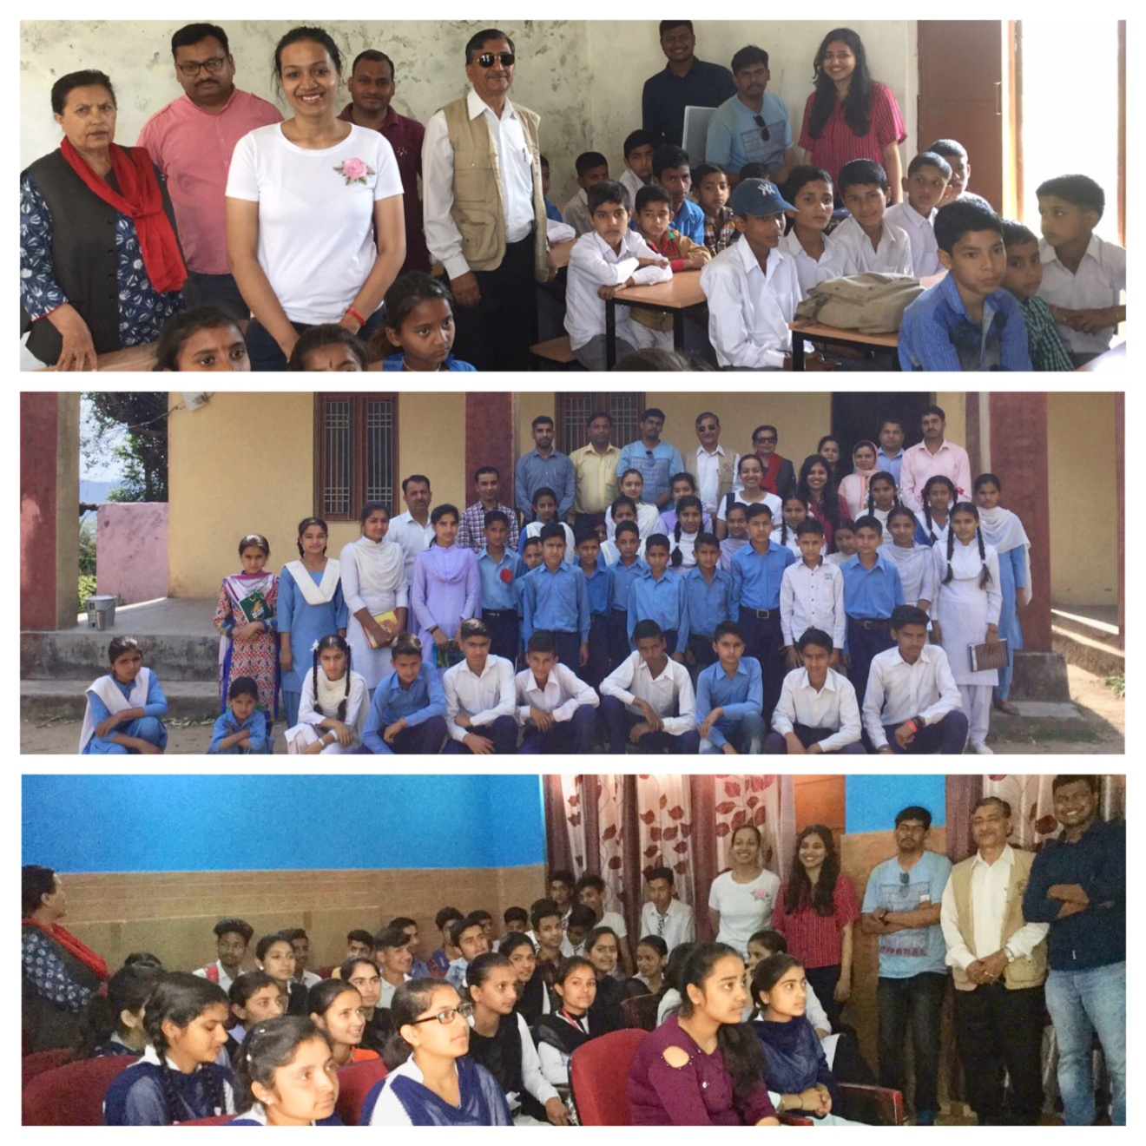 (“SS CAP” Career Awareness team interaction with Students in Rural Schools)
“GOD grant me the serenity to accept the things I cannot change, Courage to change the things I can, And Wisdom to know the difference.”

