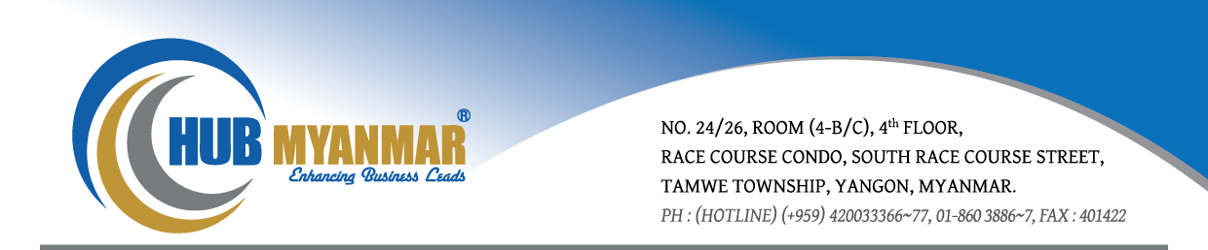

Communication On Progress (2015)
Statement of Continued Support
In 2015, Hub Myanmar Co., Ltd. became a signatory to the United Nation Global Compact (UNGC). I am pleased to confirm that Hub Myanmar Co., Ltd. reaffirms and fully supports the ten principles of the Global Compact with respects to human rights, labor, environment, and anti-corruption.
In this annual communication on progress, we describe our actions to continually improve the integration of the Global Compact and its ten principle’s into our strategy, culture and day to day operations within our company and its employees, and to engage in collaborative projects that may advance the broader development goal of the United Nations.
We will continue to support the UNCG Principles and look forward to report our progress again next year. In order to support public accountability and transparency concerning our efforts, we are committed to share this information with all our stakeholders.

Yours sincerely,
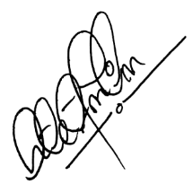
Dr. Htet Zan Linn
Chief Executive Officer
Hub Myanmar Co., Ltd.

Hub Myanmar Company Limited.
HUMAN RIGHTS PRINCIPLES
Principle 1: Businesses should support and respect the protection of internationally proclaimed human rights.
Principle 2: Make sure that they are not complicit in human rights abuses.

Hub Myanmar Co., Ltd. is committed to develop an organizational culture which supports internationally recognized human rights and avoid any involvement in the abuse of human rights. We provide an environment which supports and promotes equal opportunities, dignity and mutual respect. This is clearly stated in our Human Rights & Sustainability Policy.

Implementation
Hub Myanmar Co., Ltd. is committed to creating a culture in which employees respect the dignity and worth of individuals. Hub Myanmar strives to foster respect for human rights that we operate our business while providing an environment that encourages employees to understand and realize importance of human rights.
- Equal Employment Opportunity and Respect for Human Rights
Hub Myanmar Co., Ltd. strives to provide equal employment opportunities. Hub Myanmar Co., Ltd. is committed to treat our employees with no illegal discrimination based on race, religion, gender, social status, physical or mental disability, and sexual orientation.
- Compliance with Employment Laws and Regulations
Hub Myanmar Co., Ltd. adheres to the applicable laws and regulations which it operates in treating our employees.

Hub Myanmar Company Limited.
Measurement of Outcomes
We believe that as a result of these measures, there was no employees regarding any violation of Human Rights. We monitor and evaluate performance through our yearly employee survey. From this survey we measure the temperature of how the employees regard working in Hub Myanmar Co., Ltd.. We conduct yearly performance appraisals with every employee on a one to one basis to ensure that everyone is heard.

LABOUR PRINCIPLES
Principle 3: Businesses should uphold the freedom of association and the effective recognition of the right to collective bargaining,
Principle 4: The elimination of all forms of forced and compulsory labour
Principle 5: The effective abolition of child labour; and
Principle 6: The elimination of discrimination in respect of employment and occupation

We respect the rights of employees to freedom of association and collective bargaining. An open door policy has been established where employees can report grievances to their upper management and the Human Resources Manager.
We do not employ any form of forced labor because we consider that as fundamental violation of human rights. Also, we are totally against the practice of child labour. All job applications are subject to detailed screening by our Human Resources personnel.

Hub Myanmar Company Limited.
All employees in Hub Myanmar Co., Ltd. are given equal opportunities; hiring and promotion of employees are based on criteria like academic qualifications, skills and track record.
Implementation
Hub Myanmar Co., Ltd. has always been supportive of the freedom of association and the effective recognition of the right to collective bargaining. Prior to employment, it is our policy to be transparent about the working terms and conditions.
Hub Myanmar Co., Ltd. employee’s policies are specified within employment contracts. These contracts clearly state the actual working conditions and their rights. So, all employees are aware of its existence and must agree upon it before signing.
Hub Myanmar Co., Ltd. strives to achieve and maintain a healthy and safe work environment that motivates its employees.
Measurement of Outcomes
No complaints were reported during this reporting period. It treats all its employees with dignity and respect, and not uses corporal punishment or threats of violence or other physical or mental abuse.

ENVIRONMENTAL PRINCIPLES
Principle 7: Businesses should support a precautionary approach to environmental challenges;
Principle 8: Undertake initiatives to promote greater environmental responsibility, and
Principle 9: Encourage the development and diffusion of environmentally friendly technologies.

Hub Myanmar Company Limited.
We are, however, motivated and highly committed to protecting and making a positive impact on the local environment, while conducting our daily business activities. By increasing the deployment of ICT throughout society, Hub Myanmar Co., Ltd. will expand our contributions to solving environmental challenges together with customers and society. We will continually strive to lower the environmental burden of our business activities. By doing so, we will continue working together with our stakeholders in the global value chain including our customers, partners and suppliers to shape a sustainable and prosperous society.

Implementation
Hub Myanmar Co., Ltd. started to reduce paper consumption and encourage its employees to use alternative products such as recycle paper and avoid unnecessary expenses. Hub Myanmar Co., Ltd. encouraged the staff to correspond and communicate via electronic mail to minimize paper usage.

Measurement of Outcomes
In our continuous effort to improve our environmental performance we are pleased to report that Hub Myanmar Co., Ltd. has accomplished the following over the past year:
- Completed our transition to a paperless operating environment.
- Distributed our new yearly newsletter to all employees detailing environmentally friendly practices they can incorporate into their work and personal lives.

ANTI-CORRUPTION
Principle 10: Businesses should work against all forms of corruption, including extortion and bribery

Hub Myanmar Company Limited.
Hub Myanmar Co., Ltd. managed its business with honesty, fairness, transparent and committed to responsibility to social and all stakeholders, in compliance with the accepted good corporate governance principles and business ethics. Hub Myanmar Co., Ltd. believes that the bribery and corruption issues must be tackled by all levels of society. Hub Myanmar Co., Ltd. role as a private company is to act responsibly in all aspects of how services of Hub Myanmar Co., Ltd., as well as actively support relevant initiatives to combat corruption.

Implementation
Hub Myanmar Co., Ltd. is against all forms of corruption and will work actively to ensure that this does not occur in the group's business activities. Over the past years, internal and external checks and balances system over transactions were audited by internal audits, external audits, finance, administration and HR department.

Measurement of Outcomes
Hub Myanmar Co., Ltd. has not experienced any cases of corruption within the past year. There have been no reported cases of attempted bribery or conflict of interest.

