United Nations Global Compact |  | Your reference
 |  | Our reference
 |  | NZP/UKDP/PERSONAL/PERSONAL
 |  | UKG/96445690.1
 |  | 1 July 2019

To the stakeholders:
GRACE PERIOD REQUEST

We recognize that a key requirement for participation in the UN Global Compact is the annual preparation and posting of a Communication on Progress (COP) that comprises of a CEO statement of continued support for the UN Global Compact, a description of practical actions with regard to the principles of the UN Global Compact, and a measurement of outcomes or expected outcomes.
We will be late in creating, sharing and posting our COP report due to the fact that we are still finalising our environmental data, especially our energy data and as such we will not be able to complete and sign-off the report in time for due 18 July 2019 deadline.
We hereby ask for an extension period in order to be able to post a COP that describes our company's efforts and progress to implement the principles of the UN Global Compact. Our new COP report will be posted on the UN Global Compact website by 90 days from COP deadline (18 July 2019) at the latest.
Sincerely yours
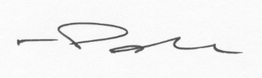
Nicolas Patrick
Partner, Responsible Business
DLA Piper UK LLP

nicolas.patrick@dlapiper.com

