Report
in the area of
sustainable development
2018

Content

1. MESSAGE FROM THE DIRECTOR
2. ABOUT THE COMPANY
2.1 Field of activity
2.2 Production efficiency
2.3 Technology and innovation
2.4 The development of relations with business partners and promote the principles of corporate social responsibility
2.5 Awards
3. HUMAN RIGHTS
4. Working conditions
5. ENVIRONMENT
5.1 Environmental policy
5.1. 1 Separate waste collection
5.1.2 Ecoeducation
5.1.3 Ecological action "Bring The battery - rescue a hedgehog!"
5.1.4 Forest protection and reforestation
5.1.5 Save Kaluga oaks
5.1.6 Competition readers
5.1.7 International Ecological Meeting
5.1.8 Shores of friendship
5.1.9 Environmental and patriotic route
5.1.10 World Day cleanliness
5.1.11 theatrical performances
5.1.12 Co-organized non-profit organization
5.1.13 Assistance for the implementation of the presidential grant
5.1.14 In support of the project
5.1.15 Charity trip
5.1.16 Cooperation with the Russian Union of volunteers
5.1.17 Combining care about the environment with patriotic education
5.2 Industrial environmental control
6. ANTI-CORRUPTION
7. CONCLUSION

1. MESSAGE OF THE DIRECTOR

Colleagues, friends, like-minded people!

I am pleased to present a report on the achievements of the "Remmontazh" Ltd. in the field of sustainable development in 2018.

In his work "Remmontazh" LLC continues to be guided by the ten principles of the UN Global Compact. They relate to the sphere of human rights, labor, environment and anti-corruption. Their observance helps us to achieve the highest standards of business conduct to which we aspire.

The activity of our company is based on openness, transparency, quality of their services, responsibility to customers, employees and society as a whole, partnership, caring for nature and respect for human values. Implementing the program of social responsibility organization "Remmontazh" focuses on projects aimed at building a dialogue with the business community, development and personnel training, professional development of employees and improvement of their quality of life, as well as environmental education, charity and voluntary work.

During the reporting period in the life of our company there were many significant events. 2018 Year graced us with important operational changes, the expansion of the staff of the personnel, increasing the service area, the introduction of innovations in the production process. All of these changes have opened up new possibilities. However, at the same time they put on us, and additional responsibilities.

"Remmontazh" LLC is not going to stop there. The company makes every effort to develop itself and to develop its presence in the territory.

Respectfully,
Director of "Remmontazh"
Radik Zakiryanov.

2. ABOUT THE COMPANY

2.1 Field of activity

"Remmontazh" LLC - young, dynamic organization that has potential for stable growth and continuously improving its main activities - transportation system, handling and waste disposal.
Guided by the principles of the UN Global Compact, the company is very active in promoting the values ​​of responsible production and consumption and attract a wide variety of stakeholders, including small and medium businesses, the activities for sustainable development.
"Remmontazh" LLC - the initiator, co-organizer and partner of a number of environmental campaigns, events, roundtables and workshops.
LLC "Remmontazh" (Kirov, Kaluga region) provides services in the field of waste hazard class IV.
In his work of "Remmontazh" strictly adheres to the values ​​of social responsibility and sustainable development in the territory of its presence. The organization "Remmontazh" invests in the development of environmentally friendly technologies, thrifty use of resources, providing customers with high quality services, participates in the life and development of communities in the regions where it operates, supports charitable and volunteer projects.
In 2018, the organization has set itself the following objectives:
-development of the professional competencies of employees,
-improving human resource management practices,
-providing public employment,
-providing a decent wage to workers,
-realization program for comprehensive modernization of the production of equipment,
-providing a reliable and safe operation of production facilities,
-formation model careful use of resources among users,
-compliance environmental legislation,
-minimizatsiya impact on the environment,
countering the corruption through regulatory compliance,
-providing transparency of operations,
Constructive cooperation with partners in sustainable development.
For all of the company designated areas of "Remmontazh" succeeded.

2.2 Production efficiency

Collective "Remomntazh" Ltd is constantly working on how to improve production efficiency.
According to the analysis of the main indicators of the company's activity, you can draw the following conclusions. The company "Remmontazh" works efficiently and is cost-effective. Proceeds from the sale of works and services grew by 39% in 2018.

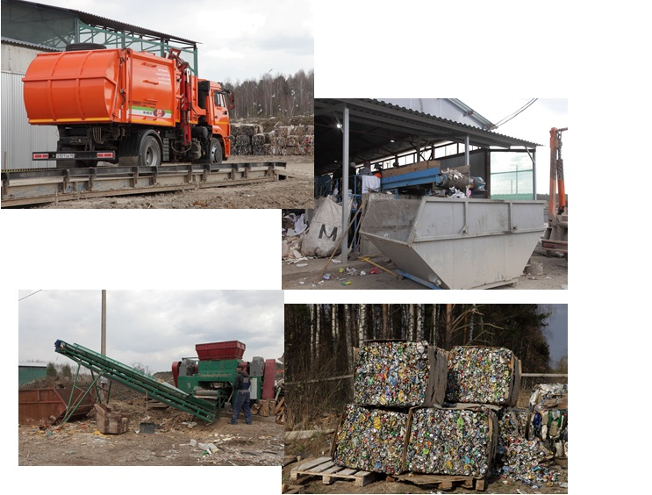
2.3 Technology and innovation

LLC "Remmontazh" is the only company in the Kaluga region to enter in 2018 the state contract with the Kaluga regional environmental statement.

MSW landfill power company LLC "Remmontazh" is 225 thousand tons.

In 2018 LLC "Remmontazh" was put into operation a complex for processing MSW capacity of 36 thousand tons per year.

To control the quality of services each garbage truck company was equipped with advanced photo and video equipment.

Due to changes in legislation in the field of radioactive waste and the Russian Federation for the performance of the Kaluga regional environmental problems of the operator company "Remmontazh" has implemented intelligent waste management system in 2018.
With the help of intelligent waste management system LLC "Remmontazh" now runs transportation of waste in 5 districts of the Kaluga region.transportation of waste management is carried out online. The company moves to a new concept of the target model of the waste management organization. This concept includes the integration of the needs of all industry participants through automation and software, starting from the moment of generation of waste to recycling or disposal at landfills.
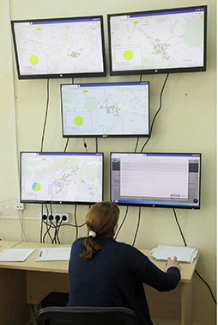
The purpose of implementation of the system: increasing the transparency of actions the industry participants, enhancing the quality of the waste disposal services, prevention of violations in the field of waste management, cost reduction work on the removal and disposal of wastes
The task of information-analytical system of waste management: maintenance of a unified database, planning and optimization of export, quality control, export, identifying violations, payment for work performed, analytics and reporting, interactive communication participants treatment industry with a TKO (including public awareness), communication with adjacent information and automated systems for the purpose of unloading the information about the state of the industry of waste management in the subject of the Russian Federation.

2.4 The development of relations with business partners
and promotion of corporate social responsibility principles

In 2018, the organization of "Remmontazh" actively developing relationships with business partners. They were built on the principles of mutual understanding and respect of interests. The company also promotes the development of business practices through partnerships with the business system, state and departmental agencies, professional societies.
The company is a member of the Kaluga Chamber of Commerce, co-operates with the Public Chamber of the Kaluga region, is an expert in matters of improvement in the field of waste management services.
With the participation of representatives of the team of "Remmontazh" in the Kaluga region are significant events related to business development, waste management, environmental protection and environmental education.

In September 2018 the director of LLC "Remmontazh" Radik Zakiryanov participated in the traditional meeting with representatives of business circles of the region, which took place in the Kaluga Chamber of Commerce. The event held the Governor Anatoly Artamonov. The meeting discussed ways of improving the business environment at the end of the National rating of the investment climate in the regions of the state Agency for Strategic Initiatives. It draws are taken into account 44 indicators that determine the comfort level of doing business. Obtaining information is performed by interviewing local entrepreneurs and experts, and using statistical data.

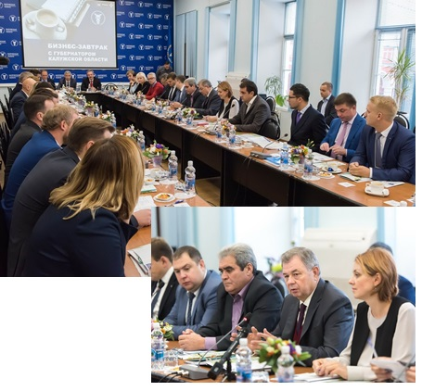

In sentyabre2018, the director of "Remmontazh" Radik Zakiryanov and employees took part in the large-scale events, which took place in Moscow in the World Trade Center. It hosted the Congress of the All-Russian public organization "Russian Union of taxpayers" and I All-Russia Forum "Dialogue with the taxpayer." At these sites, it is going to discuss issues of interaction of the tax service with business, civil society and the public, as well as increasing the availability of the tax authorities of services and the formation of public control.
"At the congress and forum addressed the problem of literacy and taxpayer liability. Cultivate such a citizen can only be an atmosphere of trust between the state and society. Now we have made a big step in its strengthening " - said Radik Ahnafovich.

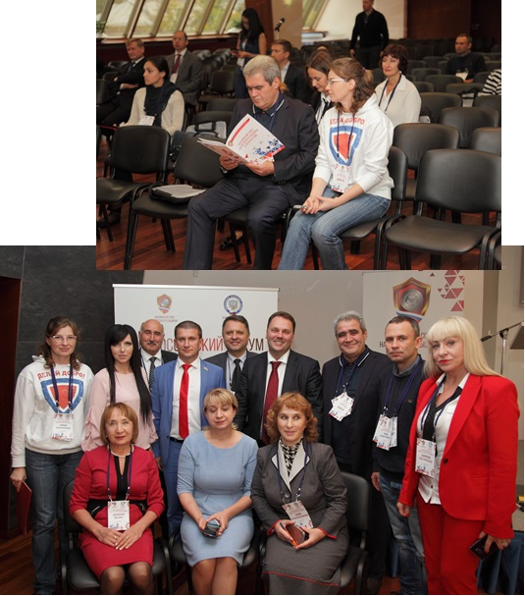

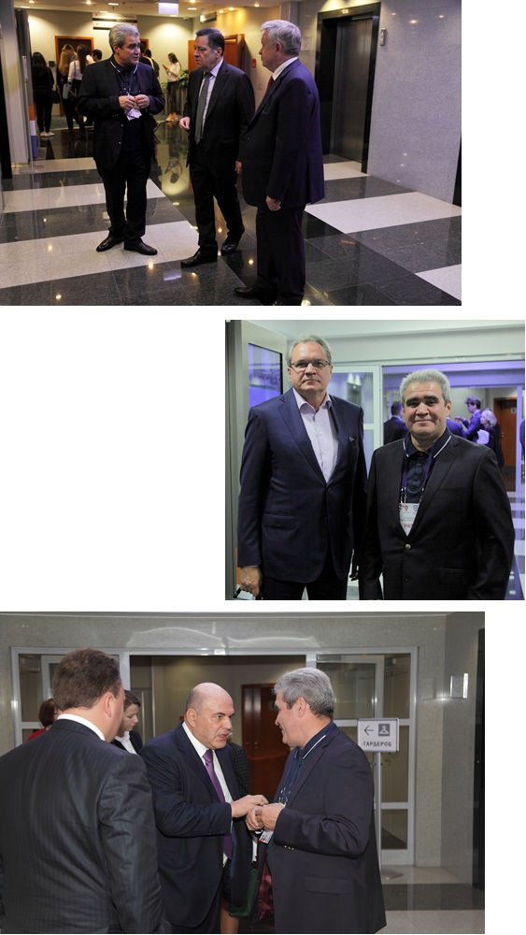
Their vision of the issue Radik Zakiryanov outlined honorary guests of the forum: pof the Chairperson Committee on Budget and Taxes of the State Duma of the Federal Assembly of the Russian Federation Andrei Mikhailovich Makarov, Secretary of the Public Chamber of the Russian Federation Valery Alexandrovich Fadeyev, Deputy Finance Minister Ilya Vyacheslavovich Trunin.

In August 2018 LLC "Remmontazh" employees took part in the forum "Boundary", "junior ONF." It took place in the Kaluga region in Zhukovsky area. Members of the organization interested in the work of public monitoring center ONF for Environment and Forest Protection. Popular Front monitors targets "May decrees" of the president regarding the various directions. Particular attention is paid to the head of state national project on environmental protection. It includes 10 federal programs, which, in particular, devoted to the creation of a fundamentally new waste management system, "General cleaning" - One of the front ONF projects. In its basis - interactive map of landfills.

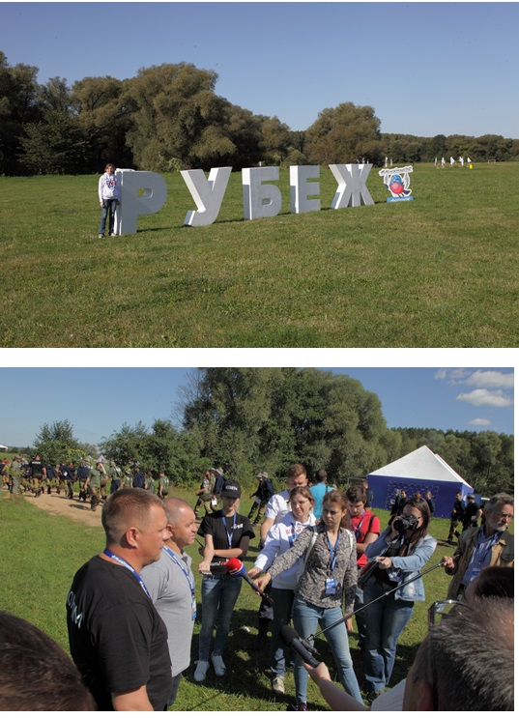

In August 2018, LLC "Remmontazh" actively involved in volunteer activities, have been trained in the school of social volunteering "Discover the World". It is open to the social partners of the company - Autonomous Nonprofit Organization "Center for social and legal assistance to children" Start into the future. " This project aims to help orphans confident start an independent life, and is implemented using a presidential grant. The training program includes a 4-day course devoted to the topics of volunteering and mentoring. Lectures were given by experts from various fields of activity. LLC "Remmontazh" on completion of training at the school of social volunteering to get a certificate.

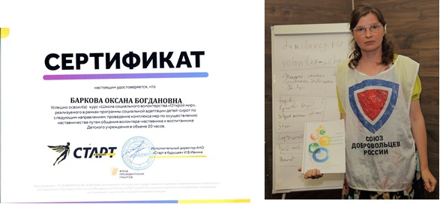

In November 2018, LLC "Remmontazh" together with its partners of the Autonomous Nonprofit Organization "Environmental and patriotic initiative" became participants of the XII International Orthodox exhibition "Peace and Clear", which was held in Kaluga. This significant event took place with the blessing of Metropolitan Kliment of Kaluga and Borovsk, and with the generous support of the Government of the Kaluga region, including the regional Ministry of Natural Resources and Environment.
The exhibition was accompanied by a variety of socio-cultural and educational activities. It is worth noting that for the first time in the exhibition program "Peace and Clear" reflected co-operation for the protection of the environment committee of the Kaluga archdiocese with the Ministry of Natural Resources and Ecology of the Kaluga region. By understanding the importance of maintaining "beauty of God's world," the Orthodox Fair has turned into a kind of platform for the presentation of a variety of environmental projects implemented in the region, non-governmental organizations and voluntary movements. LLC "Remmontazh" and ANO "EPI" presented their joint activities in the field of environmental protection and ecological education of the population.

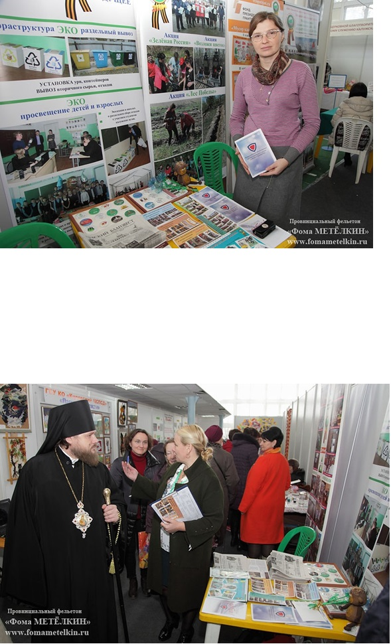
Before the opening ceremony of the exhibition-fair "Peace and Clear" bypassed Kaluga Diocese Vicar Bishop Seraphim Tarussky. Particular attention he paid to the exhibition stand of the Ministry of Natural Resources and Ecology of the Kaluga region, which placed information materials partners: "Remmontazh" LLC and ANO "EPI". Lord of bright banners liked collaborating organizations, decorated with pictures of activities involving children and adults.
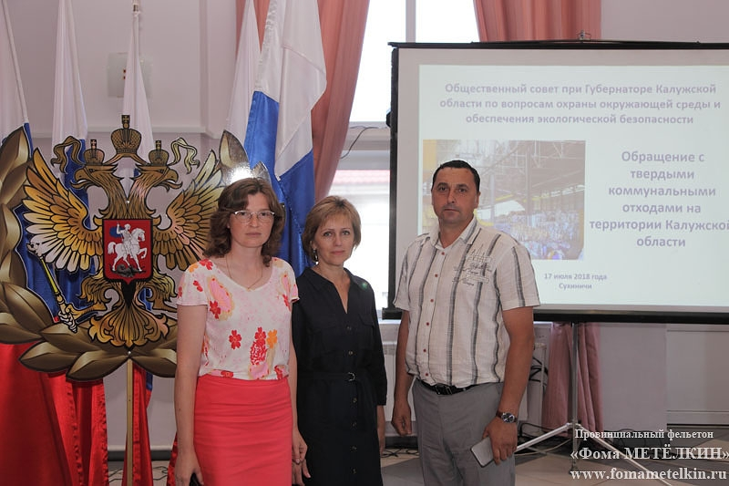
In July 2018, LLC "Remmontazh" took part in the meeting of the Public Council under the Governor of the Kaluga region on issues of environmental protection and ecological safety. A significant event took place in Sukhinichi chaired by first deputy head Dmitry Denisov region. Public Council experts discussed the transition of the Kaluga region to the new waste treatment system.

In June 2018 the staff of "Remmontazh" and their partners - the representatives of the NGO "Environmental and patriotic initiative", as well as activists of the Kaluga regional branch of the "Russian Union of Volunteers" were invited to the house of the Kaluga regional government to participate in the roundtable "Public sector Kaluga Specialties: vector of development. " At the round table brought together non-profit organizations, the media, civil society activists, members of the Public Chamber of the Kaluga region, representatives of legislative and executive authorities, local self-government.
During the round table discussed the state of the non-profit sector issues in the Kaluga region, the participation of NGOs in the region, the results of the first contest of the presidential Fund grants in 2018, state support for socially oriented non-profit organizations.
In 2018 the partners of "Remmontazh" - NGO "EPI" - have become the winners of the presidential grant and received the support of the Foundation of presidential grants for the implementation of the project on environmental education of children, "Be a man, man, you are in their own land!". The company "Remmontazh" LLC provided ANO "EPI" support to the project.
The roundtable participants noted that the nonprofit sector is actively developing, but needs support from both the government and on the part of business.
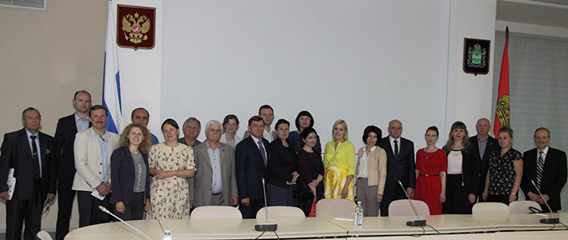
In November 2018 the employees' Remmontazh "LLC together with its partners from the NGO" EPI "participated in the All-Russian Congress of volunteer environmentalists, who held in Moscow All-Russian environmental public movement" Green Russia ". The event was attended by over 60 representatives of various regions of the country.
Congress members have been trained under the program "National environmental standards" Green Russia ". It has been designed according to Food Security Doctrine of the Russian Federation. For its development in 2018, experts of the environmental movement "Green Russia" together with the Moscow State University. University created the National Research Center "Biomed".
Congress solemn moment was the presentation of a specially instituted medals "Ekodobrovolets 2018". Award "Green Russia" were the leaders of the public environmental movement in the regions. Among the awardees and includes members of the delegation of the Kaluga region - LLC "Remmontazh" and representatives of the NGO "EPI".
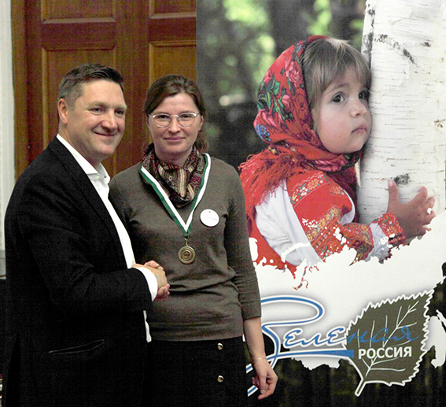

In September 2018 the employees' Remmontazh "LLC together with partners from the NGO" EPI "became participants of XXI Bogorodichno-Christmas Educational Readings. They were devoted to summarizing co-operation and discussion of prospects of interaction of the system of the Church and the state in the sphere of youth policy.
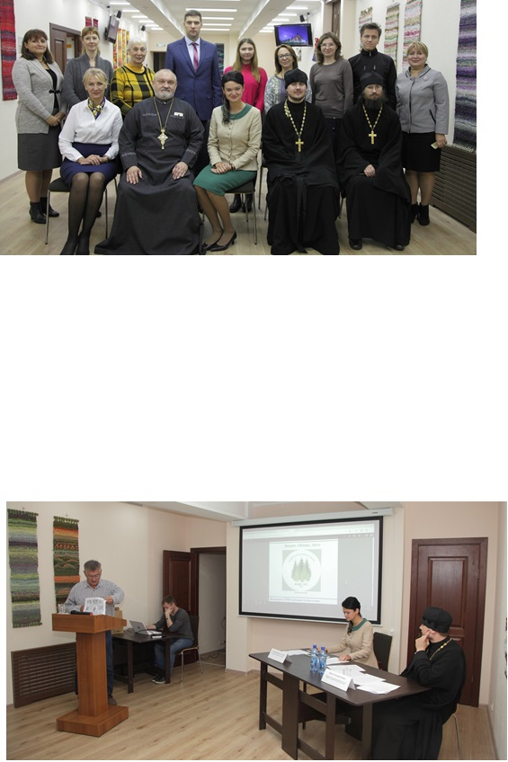

Already familiar it is that in an extensive program of traditional reading of the section "Environmental Protection Church Interaction environment" has been included. As part of this trend a round table "Save the creation of the Creator." The event was held in the visitor center "Ugra" National Park, located in the living room the ranks of the city of Kaluga. The organizers of the thematic meetings made created with the Archdiocese of Environment Protection Commission, together with the Ministry of Natural Resources and Ecology of the Kaluga region. The discussion was attended by ministers, members of the profile of the regional authorities led by Minister Barbara Antokhina, educators and institutions involved in environmental education.

A report on the event, the Director of the NGO "Environmental and patriotic initiative", the head of the Kaluga regional department of the Russian Union of Volunteers Michael Chuprinin, who introduced the participants with the results of the interaction of ANO "EPI" volunteer activists, relevant agencies and representatives of the business community in the face of " Remmontazh ". It was noted that working mainly with children, the partners are of the view that any initiative should meet the spiritual and moral traditions of the country. It has developed in co-workers and the practice of interaction with the Church. They very much value the good relationship with the deanery of the 1st District Pesochenskoy diocese. Almost every event involved students of the Sunday school of the Cathedral of St. Alexander Nevsky city of Kirov.

In May 2018 Director of "Remmontazh" Radik Zakiryanov and employees took part in the meeting of the Public Chamber of the Kaluga region. The round table was held in the town of Spas-Demensk and devoted to the Year of Volunteers in Russia. The meeting was attended by representatives of state authorities and local self-government, heads of public, charitable and non-profit organizations, leaders and organizers of volunteer work, employees of social service agencies. Under the chairmanship of the Public Chamber of the Kaluga region Galina Donchenkovoy at the event discussed good practices and new opportunities for the development of volunteering in the region.
During a free microphone, the director of LLC "Remmontazh" and a member of the NGO "Union of Volunteers of Russia" Radik Zakiryanov. He warned the audience of over-organization of voluntary movement. An attempt to combine all the volunteers in a single structure and bureaucratize their activities, in his opinion, will lead to the discrediting of volunteering as a social phenomenon. People have the right to have freedom of choice. Today, they can do something useful in the improvement of tomorrow - in landscaping, and the day after tomorrow - in working with the elderly or with children. The task of the authorities not to interfere with voluntary activities and to help her.
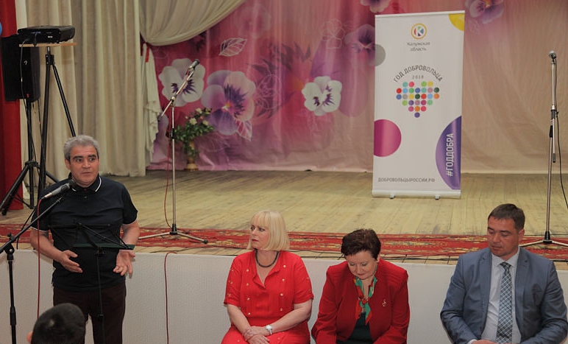
-What can have this help, will show a constructive discussion that is born, in particular, and in the open area of ​​the Public Chamber- concluded Radik Ahnafovich.

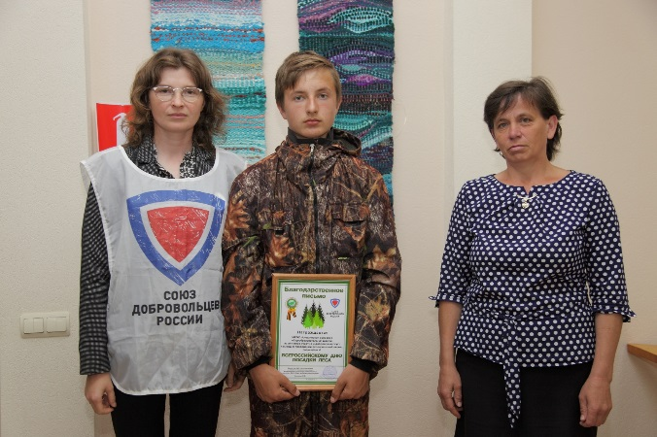
LLC "Remmontazh" assists its partners in the face of ANO "EPI" for reforestation. Showing great interest in the case of reforestation, the company's employees, who are activists of the volunteer movement, took part in the presentation of new thematic lectures of All-Russian public and state educational organization "Russian society" Knowledge "in the Kaluga region. It's called "forest preserve and increase the wealth of the Kaluga region". Informative event was held in the visitor center of the National Park "Ugra" with the support of the regional Ministry of Natural Resources and Environment, in charge of the recently are all the forests of the region. Significantly, this lecture was held within the announced Russian President Volunteer of the Year. Therefore, its main participants were people with good will, which seeks to protect nature. They are representatives of various social organizations and voluntary environmental focus, school forestry and Kaluga regional branch of the Society "Knowledge". Lecture for the participants of the event was accompanied by a tour of the visitor center of the National Park "Ugra".

In April, in Kaluga a meeting of the Public Council under the Governor of the Kaluga Region for environmental protection and ecological safety. It was held by Deputy Governor Gennady Novosel. A distinctive feature of the event was the fact that it was attended by representatives of non-profit organizations and volunteer associations. But the agenda was formed from the actual region of the issues raised, including the residents.
Examples of successful social partnership with local authorities and business in his speech brought a guest Michael Chuprinin Public Council. He is the Director of the Autonomous Nonprofit Organization "Environmental and patriotic initiative", as well as coordinator of the Kaluga regional department of the Russian Union of Volunteers. The organization's activities aimed at environmental education and patriotic education, is supported by the LLC "Remmontazh". On account of ANO "EPI" a lot of projects. A measure of fruitful interaction is presidential grant received for the project "Waste as a work of art."

In March 2018 the Ministry of Natural Resources and Ecology of the Kaluga region discussed the projects with the participation of activists and community members volunteer movements. The meeting was held in Kaluga Regional ecological and biological center. Here we gathered a large team of people are not indifferent to environmental issues. Including Representatives LLC "Remmontazh" and the company's partners - the team of the Autonomous Nonprofit Organization "Environmental and patriotic initiative" and Kaluga regional branch of the "Russian Union of Volunteers." Together they sounded projects that intend to implement with a view to familiarizing young people in environmental activities and environmental education.
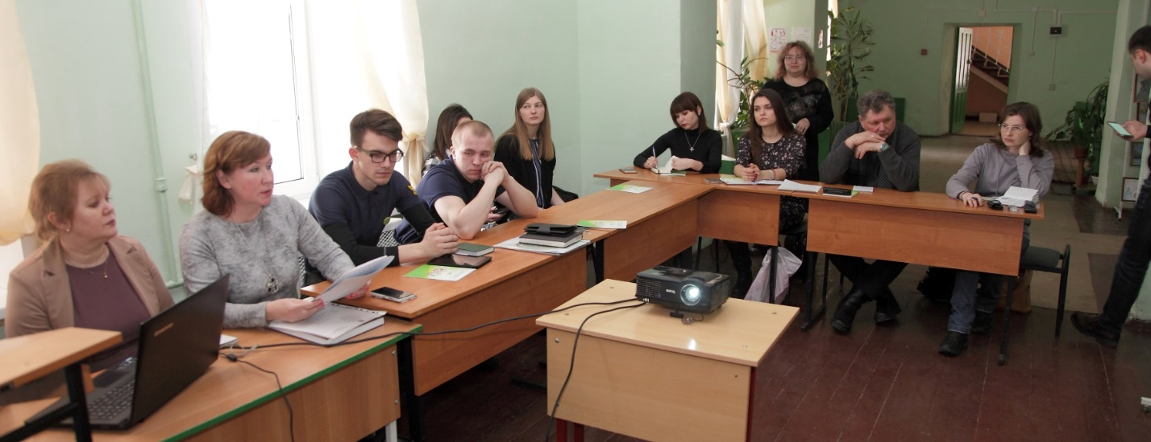
In March, employees of "Remmontazh", is an activist volunteer movement, together with its partners in the face of ANO "EPI" took part in the expanded board of the regional Ministry of Natural Resources and Ecology of the Kaluga region. The event was held at the Government House and was dedicated to summing up the past in 2017 the Year of Ecology and develop a plan for the near future. The event was attended by representatives of the executive and legislative authorities, clergy and non-profit sector, as well as heads of organizations and enterprises in the region. It is worth noting that the meeting was held in the presence of important guests - Deputy Governor Gennady Novoseltseva, Deputy Head of the Department of Mineral Resources of the Central Federal District Xenia Gurina,
Joint projects of "Remmontazh" ANO "EPI", NGO "Union of Russian volunteers" were presented at the exhibition, which "clearly demonstrated the key points of activities relevant ministry" and its interaction with both the business community and with the public. Exposure scanned the Deputy Governor of the Kaluga Region Gennady Novosel, accompanied by the regional Minister of Natural Resources and Environment Barbara Antokhina.
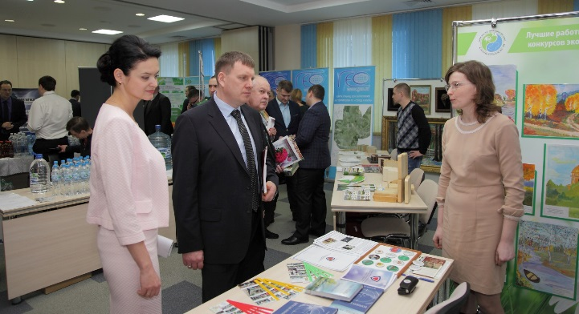

Taking this opportunity, the team of "Remmontazh". ANO "EPI" and the Union of Russian volunteers more detailed account of two major events: the annual environmental lote for schoolchildren "Give the planet a life" and the project "Waste as a work of art '' with the Russian President's grant for the development of civil society, granted by presidential grants ".

In March, the director of LLC "Remmontazh" Radik Zakiryanov gave an interview to the correspondent of the Kaluga regional newspaper "News" Svetlana Malyavskoy. http://www.vest-news.ru/article/110307They were talking about how to make the scope of waste management really sensible? We are talking directly to the Kirov range of TCRs, as the company is engaged in transportation and disposal of garbage in the Kirov region, and also takes TKO of Kuibyshev, Lyudinovo and Bariatinskii areas. We communicate not interfere with any "flavor" or clouds of crows, since both are absent. We were at the construction site, where this year will be installed first in the field of automated sorting plant for municipal waste.
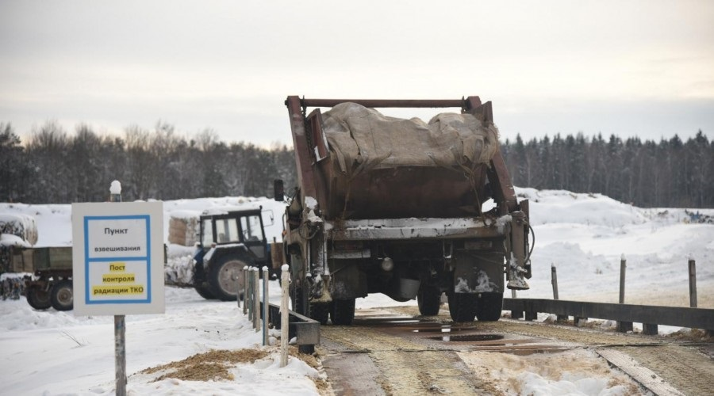

R. Zakiryanov told what the situation is at the Kirov range today. It has existed since 1975, is filled with slightly more than 65 percent. But waste is a property - their number is increasing every year by about five per cent due to the fact that there are more products in the package. The equipment for the optical separation of waste will allow to sort more thoroughly than it can make a person: only 11 varieties of paper and plastic for more than 20!
Most of the waste is recyclable. But now 70 percent of the processing is very little waste, as there is no technical capabilities. Therefore, Ltd. "Remmontazh" builds the station to engage in new economic turnover greater recycled materials and reduce the burden on the environment. It should close all the volumes of MSW coming from the surrounding areas. All waste, except for the production, sorting will take place, and large too.
"Remmontazh" LLC introduces a system of separate waste collection. Here believe that the need to separate the waste, where they are formed - on the premises. To this end, the company has established a free infrastructure for separate waste collection in the city's schools and kindergartens. And removal of separately collected garbage 10 percent cheaper than mixed. But the main focus of the company "Remmontazh" are doing on environmental education. Specialists regularly conduct classes with students and preschool children, talk about the proper handling of waste.

2.5 Awards

In 2018, the year the company "Remmontazh" team proved once again that the joint efforts aimed at achieving a common goal, always give a good result. It is this commitment and allow workers' Remmontazh "LLC in the last year to become owners of awards in industrial activity in the area of ​​environmental education, as well as in the area of ​​corporate volunteering.

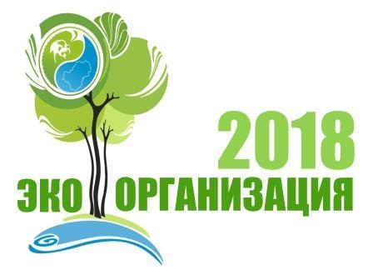

The Ministry of Natural Resources and Ecology of the Kaluga Region is holding a contest "Ekoorganizatsiya 2018". The objectives of the competition is to promote ecological culture of socially responsible business and the application of modern management systems and technologies aimed at reducing the negative impact on the environment.

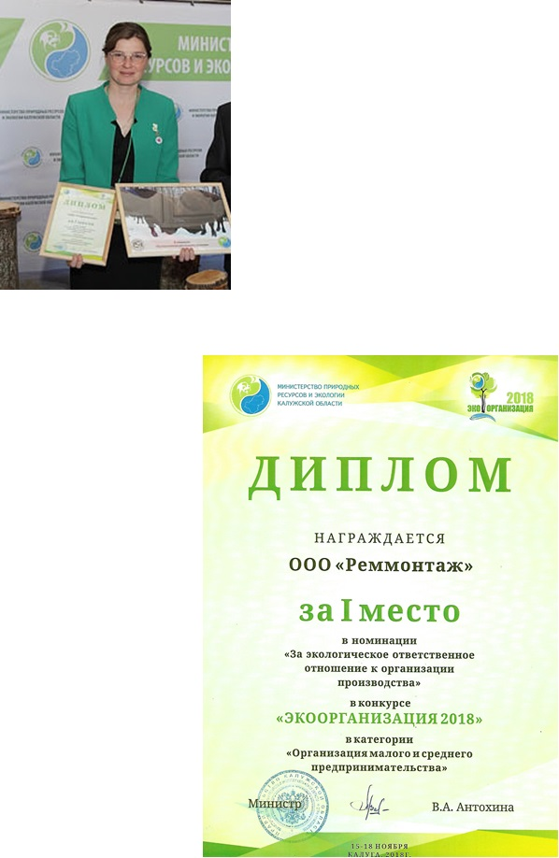
The competition was attended by organizations of all forms of ownership operating in the Kaluga region, implementing environmentally friendly production and implement projects and programs aimed at sustainable use of natural resources, development of ecological culture and environmental education.

According to the results of the contest company "Remmontazh" won the I place in the category "Organization of Small and Medium Business" in the category "Environmental responsibility related to the organization of production."

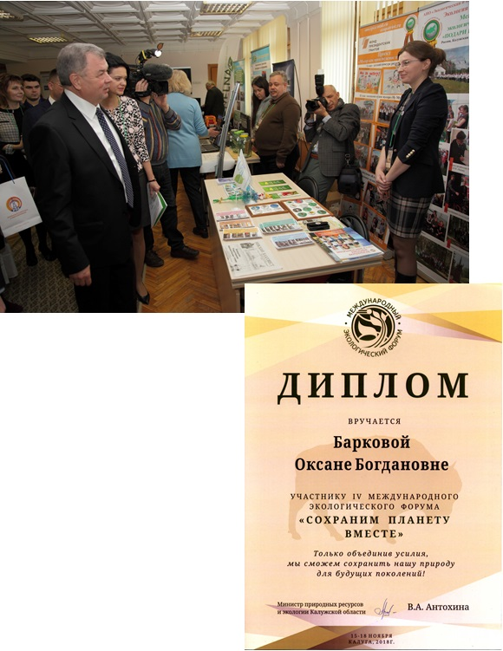

LLC "Remmontazh" participated in the program of the IV International Ecological Forum "Save the Planet Together", which was held in Kaluga in 2018, and received a diploma for active participation.
The company "Remmontazh" was presented in the informational exhibition, visitors who met with the organization's activities on environmental education of young people, the introduction of separate waste collection, promotion of sustainable development territory.
As representative of "Remmontazh" was an active participant in a discussion platform, dedicated to the topic of volunteering in the region.
In addition, the LLC "Remmontazh" participated in the program "El Gracey" ecological weekend camp, which was opened on the basis of Business park "Rooks" in Zhukovsky area. Specialist held for participants ekolektsiyu camp on separate collection of waste and assist in the implementation of the educational program.

In 2018 the Ministry of Natural Resources and Ecology of the Kaluga region conducted regional competition among journalists and media outlets for the best coverage Ministry.
The objectives of the competition: - the formation of the population of careful attitude to the environment, sustainable use of natural resources; - raising public awareness of environmental issues and environmental safety; - the development of environmental education and the formation of ecological culture in the Kaluga region. The competition was held in two categories:
"Preserve the nature - Save Yourself";
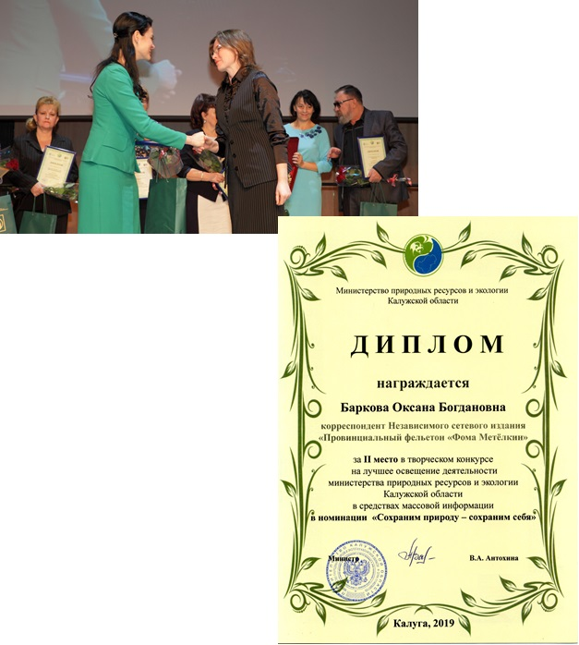
"Environmental education".
LLC "Remmontazh", is a freelance correspondent for online publications "Provincial lampoon" Thomas Metelkin "and activist of the Kaluga regional branch of the NGO" Union of Russian volunteers "took 2nd place among regional journalists in the" Save the nature - save yourself. "
Winners of the contest took place on the Day of the Russian press at the annual Ball of the press.

LLC "Remmontazh" actively developing corporate volunteering. Corporate volunteers are activists of the All-Russian public organization "Russian Union of volunteers". On a voluntary basis the employees' Remmontazh "LLC took part in the planting of forests, in the improvement of container yards, in conducting educational programs, cleaning of war graves. "For active participation in the work of the Kaluga regional branch of the NGO" Volunteers' Union of Russia ", as well as assistance in organizing and carrying out activities aimed at environmental education, patriotic education and social assistance" Letters of thanks of the regional and nationwide Staff SDR few employees have been awarded by LLC " Remmontazh ". Awards were given to Elena Filatova, Mikhail Fedotkin, Elena Solovieva, Ludmila Savoskin. Letter of thanks to the NGO "Union of Russian volunteers" was awarded and the company "Remmontazh" "for assisting in organizing the activities of the Kaluga regional branch of the NGO" Union of Russian volunteers ", aimed at environmental education, patriotic education and social assistance, as well as promoting the idea of ​​corporate volunteering. The award document was written, "It is a good deed, you have contributed to the development of the Russian Volunteer Movement!". aimed at environmental education, patriotic education and social assistance, as well as for the promotion of the idea of ​​corporate volunteerism. The award document was written, "It is a good deed, you have contributed to the development of the Russian Volunteer Movement!". aimed at environmental education, patriotic education and social assistance, as well as for the promotion of the idea of ​​corporate volunteerism. The award document was written, "It is a good deed, you have contributed to the development of the Russian Volunteer Movement!".

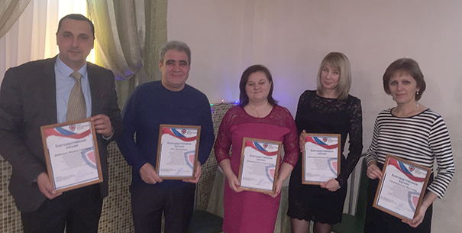

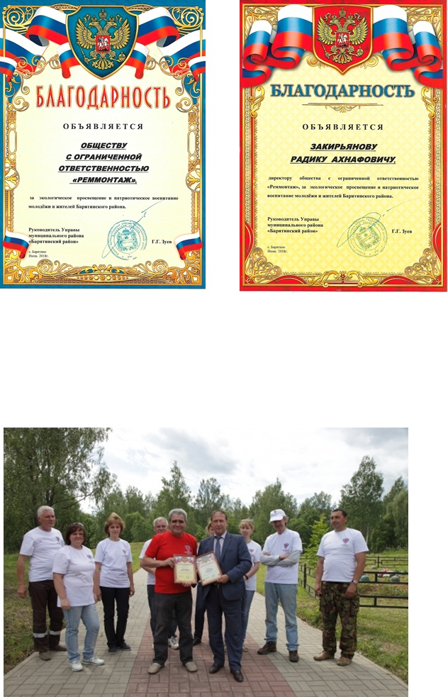
In 2018 corporate volunteers "Remmontazh" LLC took patronage over the military memorial in the village Tsvetovka Bariatinskii area. The head of council Bariatinskii district Gregory Zuev handed Ltd. "Remmontazh" and director of the company Radik Zakiryanova Letters of thanks "for the environmental education and patriotic education of the youth and the population."

3. HUMAN RIGHTS

LLC "Remmontazh" observes the principles of the Global Compact in the field of human rights.

Principle 1: "Businesses should support human rights, proclaimed by the international community."

LLC "Remmontazh" respects the rights of clients, which is reflected through the provision of comprehensive and objective information about the services provided.
All employees have access to information about the processes and programs that occur within it and outside. All operational information is posted on the company's website. It also presented reports on the economic and financial performance, as well as the future challenges.
The main value of the company - its employees. For each employee to create the most comfortable working conditions. All employees are provided modern equipment and IT infrastructure to work. The company also takes care of the appearance of the employees. Landfill workers and production provide specialized workwear and protective equipment.
If necessary, the company accounts for and pays overtime staff time.
The company supports all sporting hobbies of their employees.
The company pays attention to the health of employees. Employees involved in the clinical examination of population programs. And to ensure that employees hurt as little as possible, welcome seasonal influenza vaccination.
Company employees creates conditions not only for work but also for recreation. Are traditional corporate events.
In the workplace "Remmontazh" LLC has created a favorable psychological climate and provide decent working conditions. Attention is paid to the development of professional and creative potential of employees. It creates the conditions for professional and personal development of employees.
Key areas of social policy: the development of corporate culture, staff training, improvement of the living standards of workers and their families through the use of a system of corporate benefits and guarantees.
Aware of the high social responsibility, the company OOO "Remmontazh" takes part in charitable activities.
One of the most important areas of cooperation between business and non-profit sector - the organization and implementation of measures aimed at environmental education of the younger generation, patriotic education of youth and assistance to vulnerable groups, especially orphans and children in difficult situations. In 2018 the company "Remmontazh" rendered charity assistance in the event "Environmental and patriotic initiative" autonomous non-profit organization with which cooperates. In 2018 LLC "Remmontazh" provided charitable assistance to NGO "Center for Social and Legal Aid" Start to the Future "in the implementation of social projects - the creation of a culinary studio" Rolls does not grow on trees "for children living in social institutions, and graduates of orphanages. The project was launched December 20, 2018.

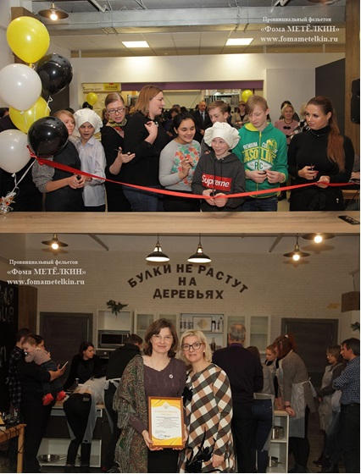

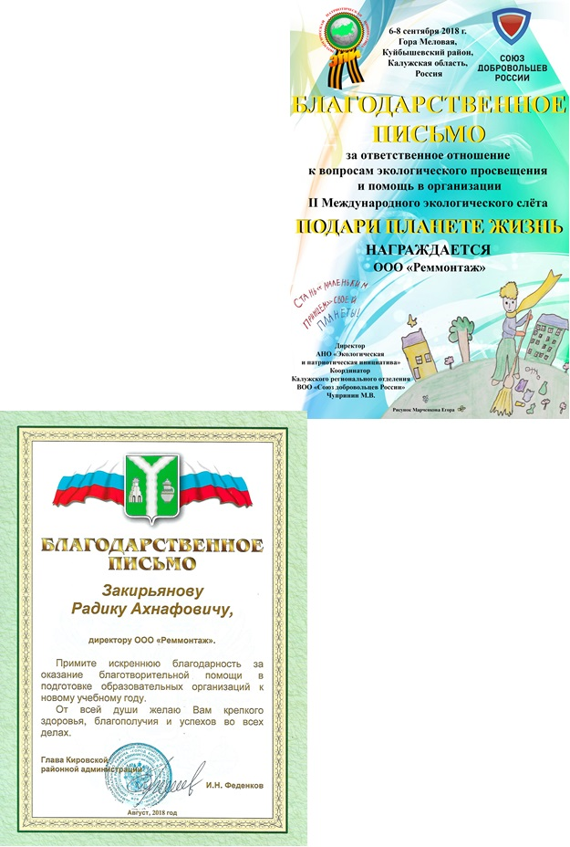

The company "Remmontazh" LLC has provided charitable assistance to educational institutions of the Kirov region. Charitable assistance was directed to the preparation of educational institutions for the new school year. The head of the Kirov district administration, IN Fedenko sent to the Director of LLC "Remmontazh" Radik Zakiryanova Letter of Appreciation.

Company LLC "Remmontazh" received a letter from the NGO "Environmental and patriotic initiative" for "a responsible attitude towards environmental education and financial assistance in the organization of the II International environmental rally" Give life of the planet, "which in September 2018 took place on the territory of the Kuibyshev district and gathered more than 100 participants from the Kaluga region, the city of Ryazan, and the Republic of Belarus.

The company's success provides its staff, so in the "Remmontazh" Ltd. pays special attention to work with the staff. The company welcomes the willingness of staff to develop and improve their skills. That is why the company "Remmontazh" strives to ensure that employees continue to evolve in the professional plan.
In 2018 the staff team have been trained and training courses in various fields of activity.
CEO, CFO and Head of the landfill of "Remmontazh" passed the test of knowledge of labor protection requirements of managers and specialists in the training program "OSH Program of workers' (groups of managers, professionals, authorized by the labor commission members to verify the knowledge and labor protection requirements Protection workers' organizations) in 40 hours. Further training was carried out on the basis of ANO DPO "Institute of cadres."
Ecologist of "Remmontazh" took part in the project "Be aware: the inspector explained," Commerce and Industry Chamber of the Kaluga region. The project ecologist participated in an information seminar "The duties and responsibilities of entrepreneurs in the field of environmental protection", which was held CCI Kaluga region, together with the Ministry of Natural Resources and Ecology of the Kaluga region, as well as the Office of Rosprirodnadzor in the Kaluga region. The seminar program covered issues of changes of environmental legislation, payments for negative impact on the environment, environmental data collection, licensing of waste disposal, the procedure of verification activities and business responsibility for violation of legislation in the sphere of environmental protection.
Ecology and financial director of "Remmontazh" took part in a round table on the topic "Migration from 2019 to the new waste management system, including a TKO. The functions of the regional operators. New requirements of environmental legislation ", which was held in the Chamber of Kaluga Region in the framework of the project" Be aware: the inspector explained. " The agenda included the following issues: the main activities and challenges in the implementation of reforms in the treatment of solid municipal waste in the Kaluga region; territorial scheme for the management of waste, including municipal solid waste, and a regional program in the field of waste management in the Kaluga region; changes in legislation regarding the management of solid municipal waste in 2019; regional operators for the management of municipal solid waste: authority and responsibility; cooperation between regional operators with the forming of waste and current TKO market participants; topical issues of implementation of the provisions of the federal legislation on waste production and consumption in 2019; State waste cadastre and state registry of waste disposal facilities; fee for placement of solid municipal waste, regulation in the field of waste management from the use of the goods.
In 2018 we trained 26 employees of "Remmontazh" on the program "Training people for the right job with the waste hazard class 1-4" in the amount of 112 hours of training. Environmental training was carried out in order to implement article 15 of the federal law on waste production and consumption. The training took place on the basis of LLC Firm "Ecoanalytics".
Diploma of professional retraining was issued by OOO "Remmontazh" retrained under the program "Ecology and environmental protection and ecological safety." Retraining allows the specialist organizations to conduct professional activity in the field of ecology and environmental protection and ecological safety. The training took place on the basis of ANO DPO "Academy of advanced training and innovative development of staff."
Engineer LLC "Remmontazh" passed test of knowledge of the documents and instructions, rules of electrical devices, labor protection regulations for electrical installations, rules of technical operation of electrical installations, instructions for first aid in case of accidents in the workplace, instructions for use and testing of protective equipment, used in electrical, instructions for lightning protection of buildings, structures and industrial communications, rules of fire regime of the Russian Federation. Training took place in the industry of the territorial commission Prioksky Rostekhnadzor.

Principle 2: "Businesses should not be complicit in human rights abuses"

"Remmontazh" LLC provides equal access to employment to all qualified candidates. In the recruitment of non-discrimination on sex, age or disability.The company implements a number of social programs aimed at helping employees who are in difficult situations.

4. CONDITIONS OF WORK

"Remmontazh" Company adheres to the principles of the Global Compact in ensuring decent working conditions to employees.

Principle 3: "Businesses should uphold the freedom of association and recognize of the right to collective bargaining"

Principle 4: "Businesses should uphold the elimination of all forms of forced labor"

Principle 5: "Businesses should uphold the effective abolition of child labor"

Principle 6: "Businesses should uphold the discrimination in employment and occupation"

All documents developed by the company, are subject to mandatory negotiation with employees. Any candidate at the stage of the interview, to the principles of the company, with the main activities.
All work with the staff of the company is in full compliance with the labor legislation of the Russian Federation.
The company has developed and implemented a social support of employees (financial aid, tuition).
The company has developed the basic provisions on the protection of workers.
In 2018 reconstruction of heating was conducted in a central office. Established independent heating system will ensure uninterrupted supply of heat and significantly improved working conditions in the workplace.
The company monitors the working conditions and to develop proposals to improve them.
The company pays for uniforms for employees. The enterprise established bottled water, and arranged a place for eating and relaxing working.

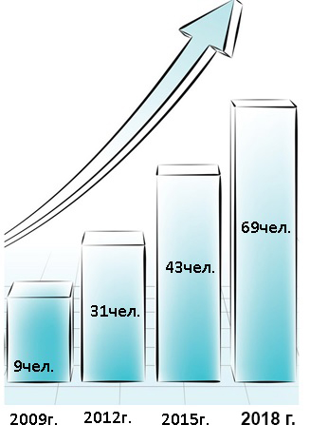
Dynamics
number
employees

- collective -
69 people

.

In "Remmontazh" LLC made timely payment of wages, taxes and contributions.
In 2018 tax deductions amounted 2 mln 841 thousand Rub..
contributions - 2 million. 619 thousand Rub.
Total: 5 million 460 thousand Rub.
Annual indexation of wages

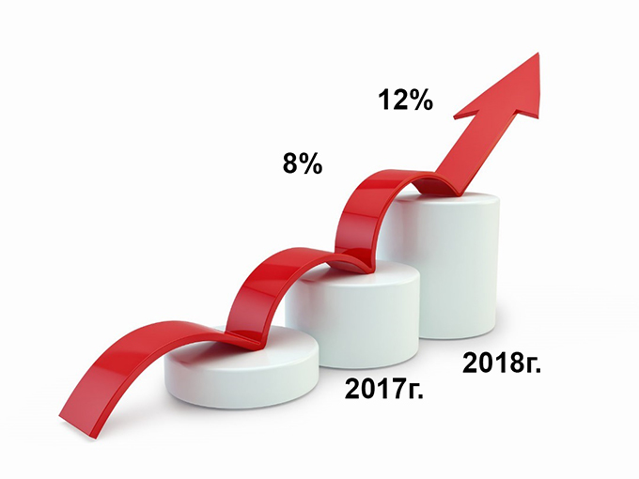

5. ENVIRONMENT

"Remmontazh" Ltd. complies with the basic principles of the UN Global Compact in the field of environmental protection.

Principle 7: "Businesses should support a precautionary approach to the environment"

Principle 8: "Businesses should undertake initiatives aimed at increasing the responsibility of the state of the environment"

Principle 9: "Businesses should encourage the development and diffusion of environmentally friendly technologies"

5.1 ENVIRONMENTAL POLICY

The LLC "Remmontazh" developed environmental policy, which is based on the implementation of environmental education and promotion of the values ​​of sustainable development

5.1.1 The separate collection of waste

For several years in the city of Kirov, Kaluga region, a project to introduce separate collection of waste. With the support of local authorities, and in collaboration with the NGO "EPI" and the NGO "Union of Russian volunteers" of its implementing LLC "Remmontazh". By providing the appropriate infrastructure, take part in it all city schools and kindergartens.

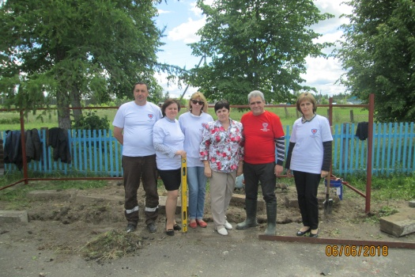
Today date due to significant changes in legislation in the field of waste management "Remmontazh" project of the company was in the Kirov region's development. To it began to join the rural educational institutions. We hasten to inform you that Berezhkovskaya primary school was the first in the village, where students and teachers will be engaged in the division of solid municipal waste. It created all the necessary infrastructure for RIS.

"It is important for us that the villagers feel the fullness of its responsibility for the conservation of nature and, as a consequence, the need for separate collection of waste. The head of the educational institution in Berezhko herself approached us with a request to include the school in the RIS project. We, of course, have been happy to help our associates in this good deed. The organization of separate waste collection in the new location, we have helped our partners from the NGO "Environmental and patriotic initiative", as well as activists of the Kaluga regional department of the Russian Union of volunteers ", - said the director of" Remmontazh "Radik Zakiryanov.

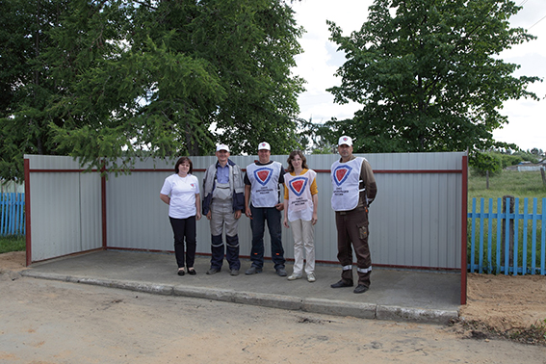
June 6 jointly in school Berezhkovskaya container yard was built. In accordance with the requirements of the project it was equipped with four containers for separate collection of MSW. At the beginning of the new school year at the educational institution established bins to separately collect paper / cardboard, glass / aluminum cans, plastic / PET bottles, household waste.

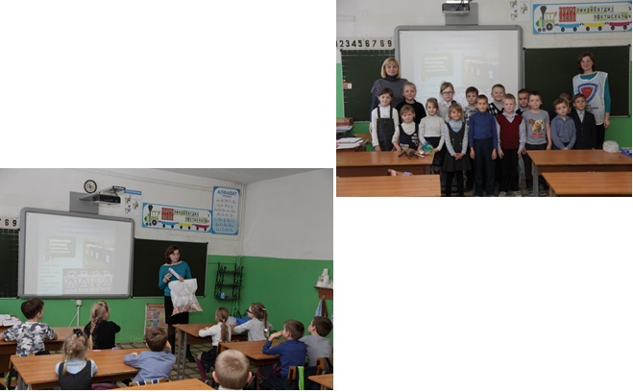
5.1.2 Ecoeducation

Implementing the program of environmental education specialists "Remmontazh" LLC carried out in schools and kindergartens environmental lectures on separate collection.

On September 1 and December 31, 2018 in Kirov city schools educational lectures were held in the first grades. In Berezhkovskaya rural school ekolektsii held in all classes.

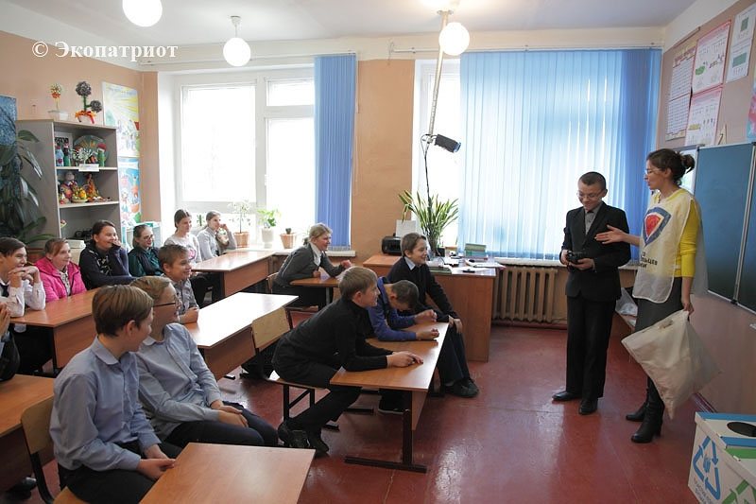
"As soon as the relevant infrastructure, to the project of environmental education have joined our experts was established in Berezhkovskaya school. They spent the environmental lectures for students about what is waste than they are dangerous as they can be re-used in order to conserve natural resources and reduce pollution around the world. These classes are, in our opinion, are necessary not only for the purchase of separate collection of MSW skills, but also extremely important for the formation of the younger generation of ecological outlook, "- emphasizes Radik Ahnafovich.

Experience kirovchan to introduce RIS is used for carrying out many activities. Therefore ekolektsii "Remmontazh" OOO expand the geography of its participation. So, Kirov RSO methodology tried out in the Environmental prosvetlagere "El Gracey" weekend, which is based on the business park "Rooks" in Zhukovsky area. The opening of the camp was held in the framework of the IV International Ecological Forum "Save the Planet together." To start with the participants of "El Gracey" camp listened to a lecture of "Remmontazh" of separate collection of waste. From lecturer boys and girls learned about the different ways of waste treatment and concluded that their recycling helps to save resources and, therefore, protect our planet. The main thing - to overcome their own laziness and learn how to determine in which the urn to throw out unnecessary items. Guys even practiced for sorting domestic waste plastic / PET bottles, paper / cardboard, glass / aluminum. His ekopraktikum they continued in a motel room, where special containers for PCO were installed. We provided the necessary infrastructure residing partners organizers - Ltd. "Remmontazh".
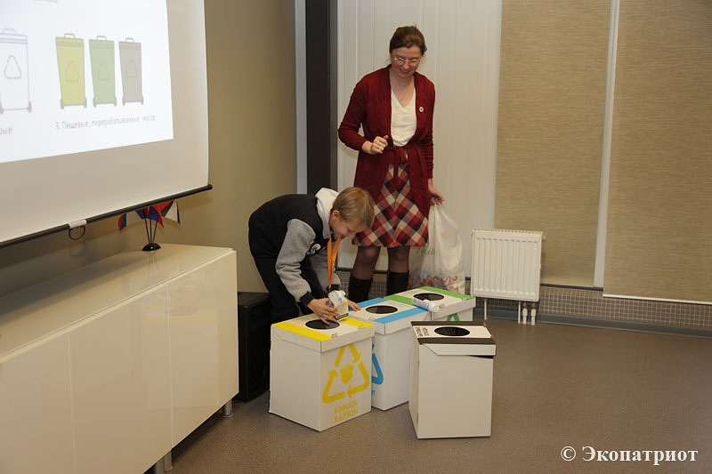

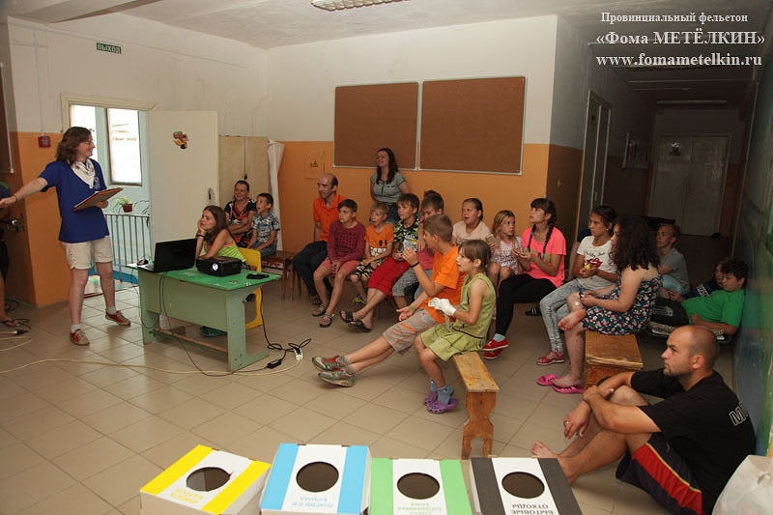
RIS system, developed by OOO "Remmontazh" has been used in the Orthodox children's camp "Alexander Nevsky", where, besides ekolektsy employees, activists of the Union of Russian volunteers who helped organizers in the implementation of such program areas as a "day of good deeds."
"Caring about the environment" - according to this principle, camp life was organized, dealing with the issue of utilization of solid municipal waste. In cooperation with the Kirov musorovyvozyaschey company "Remmontazh" are taken care of separate collection of MSW, which public spaces are equipped with special urns in which to separately collect plastic, paper, glass / aluminum cans and household waste.
Whether enjoying the camp residents established infrastructure for separate collection of waste daily checked activists Kaluga regional branch of Russian Union of Volunteers. Environmental raids on targets RSO found that the process of implementation of selective collection of waste in our daily lives requires environmental education. Assessing the situation, representatives of voluntary movements performed in front of children and adults with ekolektsiyami the main directions of the struggle for the purity of the planet, as well as the audience involved in the practical training of RIS.

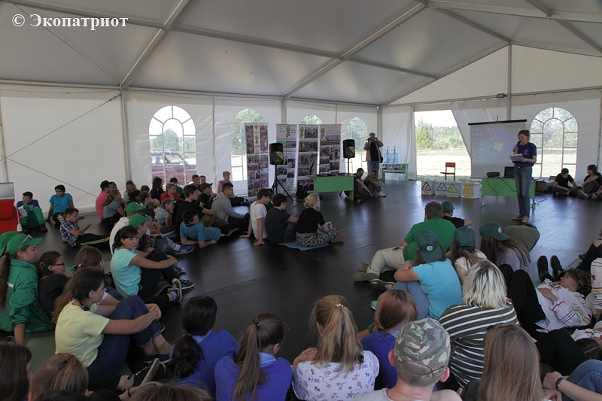
And, of course, no separate collection is complete the main organization for «Remmontazh" event - the International Environmental gathering "Give life of the planet."The principle of separation of waste fractions used in the organization of the camp life ekoslote. Here, in the areas of waste generation, to install eco-friendly (made from cardboard) colored boxes and their corresponding containers at the site. How to use this infrastructure, the participants explained to ekolektsii "Divide right!".
5.1.3 Ecological action "Bring The battery - rescue a hedgehog!"

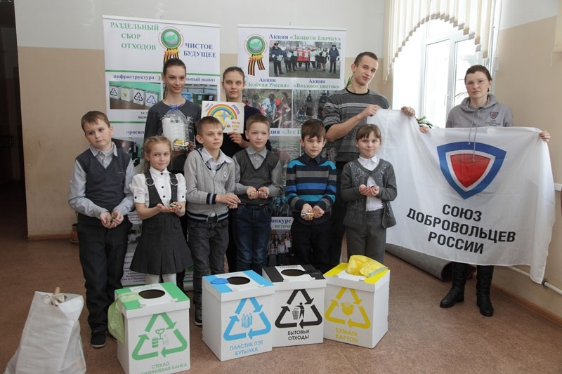
February 20, 2018 in Betlitskoy high school Kuibyshev district of the Kaluga region was ekolektsiya for students 2.3 and 4 classes, "Let's share", dedicated to the separate collection of waste. It was organized by the NGO "Environmental and patriotic initiative." The lecturers were specialists of "Remmontazh", is an activist of the Kaluga regional department of 'volunteers' Union of Russia. "
Particular attention during the event was given to the pressing issue of today recycling of waste batteries. It turned out that betlitskie students know a lot about it, as actively involved in the environmental campaign "Bring The battery - a hedgehog rescue!", Which takes place in the Kaluga region on the initiative of the regional Ministry of Natural Resources and Environment.
Coincidentally, just the day of the guests ekolektsii "Let's share" in Betlitskoy high school, the first day of battery collection. With one time effort for all students managed to fill 5-liter bottle of one-third. It seems that at the time of summing up, and the action will last until May 7, 2018, these tanks in the account will be a lot of young ecologists.

Assistance in the implementation of this action to the regional agency providing non-governmental organizations and business representatives. Thus, the NGO "Environmental and patriotic initiative" with the support of "Remmontazh" helps the Ministry of Environment of the region to dispose of collected kaluzhane batteries. In 2018 thanks to the ELN "EPI" and LLC "Remmontazh" in St. Petersburg, 484 kilograms of hazardous waste was disposed of.
-Our cooperation with the Ministry of Natural Resources and Ecology of the Kaluga region in this direction will be continued. We believe it is important that children know that their efforts to collect the batteries do not go into an empty and have the final results- said the director of "Remmontazh" Radik Zakiryanov.
5.1.4 Forest protection and reforestation

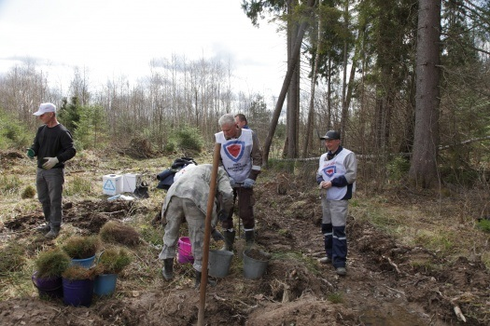
LLC "Remmontazh" pays special attention to the protection of forests and reforestation.
In the Kaluga region April 27, 2018 were held public events dedicated to the Day of the All-Russian forest planting. Environmental actions have been carried out under the auspices of the regional Ministry of Natural Resources and Environment. During the event, the planting of trees in different municipalities of the region.
Site of one of the tree-planting events was carved out of the forest land in the territory Borovsky District, near the village Iklinskoe. There organizer shares issued Autonomous Nonprofit Organization "Environmental and patriotic initiative" with the support of "Remmontazh". Thanks to the NGO "EPI" and LLC "Remmontazh" in reforestation attended by a big team of nature lovers.
In total, about 50 people were involved in the work. The main actor in the planting of forests are the representatives of the various enterprises of the Kaluga region and other regions, as well as students Erdenevskoe Maloyaroslavetsky school district. For a useful act of goodwill also joined the staff of "Remmontazh". Besides, are not left behind members of the Kaluga regional department of the Russian Union of Volunteers. A tree planting was carried out under the supervision of specialists Balabanovo district forestry. During the action, a friendly team of vexation 5100 seedlings.
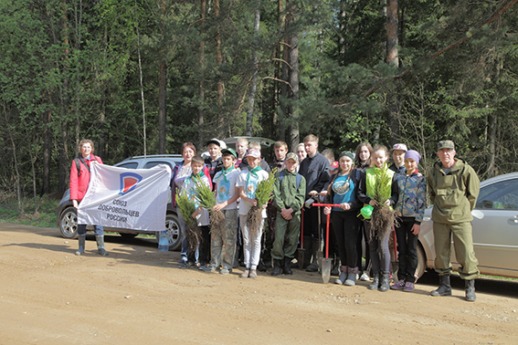
With the support of "Remmontazh" and ANO "EPI" mass actions, dedicated to the All-Russian Day of forest planting continued in the Kaluga region. May 7, 2018 to the reforestation in the region on a voluntary basis, students joined Alechinsky Meshchovsk school district. Students from 6th to 9th grade dropped 3.5 thousand seedlings fir.

5.1.5 Save Kaluga oaks

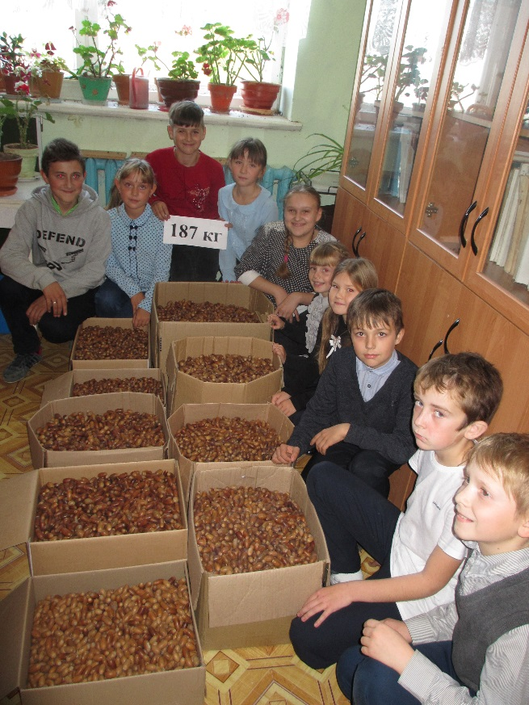
In autumn 2018 the National Park "Ugra" appealed to residents of the Kaluga region to help collect acorns for the recovery of the region protected oak. As announced by the regional action on a voluntary basis with the support of partners - LLC "Remmontazh" ANO "EPI" and Kaluga regional department of the Russian Union of volunteers - students participated Alechinsky Meshchovsk school district. 12 students collected over 187 kilograms of seed material. oak seeds were taken to preserve Zaseki Kaluga, where they were planted kaluzhane-volunteers.
As a sign of gratitude for helping pupils who have taken part in the campaign "From small acorn a mighty oak!", Was awarded the "Oak diplomas." The ceremony took place in an educational institution on the eve of New Year holidays. Awards to young defenders of the nature of the support "Remmontazh" Ltd. brought the activists of the Kaluga regional branch of Russian Union of Volunteers. In addition, during a solemn line of children received gifts. Autonomous Nonprofit Organization "Environmental and patriotic initiative" presented reducers Forest Volunteer T-shirts and badges.

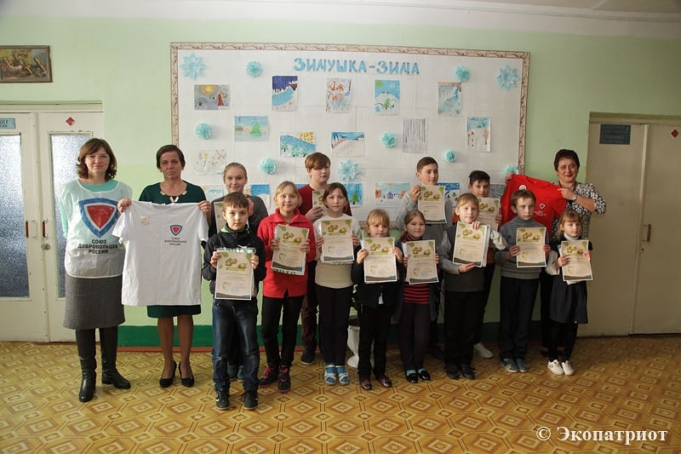

5.1.6 The competition of readers "Nature - a source of inspiration"

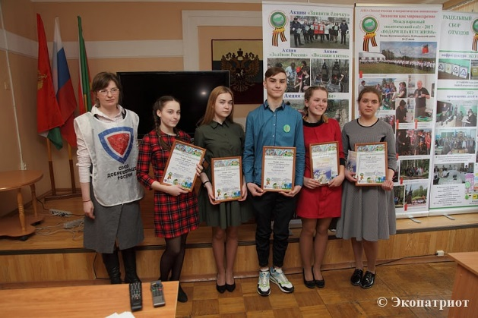
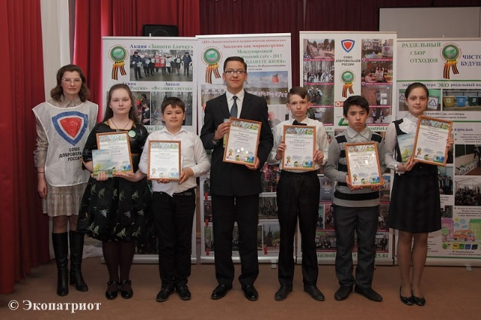
With the support of "Remmontazh" in the Kaluga region is a competition of readers "Nature - a source of inspiration." is heIt aims to promote reading among children and the preservation of the best traditions of art literature. However, apart from this, the task of educating the younger generation in the aesthetic perception of the variety of images that gives us the world around us, as well as the task of instilling in young people, starting from school, ecological culture.
In 2018 the competition was held in 4 areas of the region.
April 12 Days of environmental protection from environmental hazards competition was held in Meshchovsk area in the center of creative development and humanitarian education "Education." The competition was attended by 54 student.
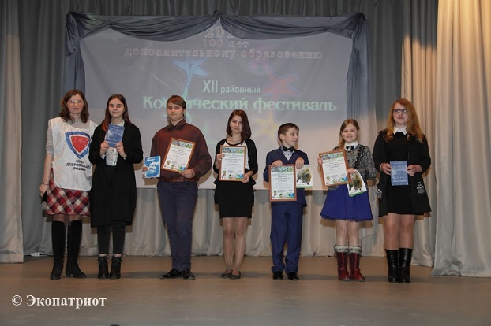
2018 Year in Russia was marked by the development and support of volunteerism. For students in schools №1 and №2 city Savior Demensk Kaluga region he will be remembered Recitation Contest "Nature - a source of inspiration." This creative event was held here March 23 and was dedicated to the promotion of volunteering in the preservation of nature. The jury made 44 schoolboy!
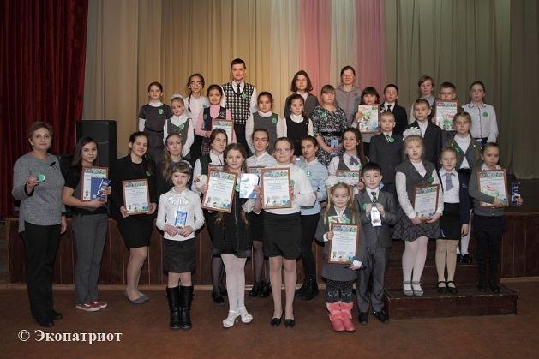
February 17, 2018 in the city of Kaluga region Zhizdra among Zhizdrinsky District educational institutions passed the XII District Space Festival, aimed at the identification and development of creative abilities of students. His conduct was dedicated to the 100th anniversary of additional education in our country. One of the festival nominations became Recitation Contest "Nature - a source of inspiration." The custom - "environmental" - the nomination of the festival was attended by 10 readers.
In 2018 the baton competition of readers "Nature - a source of inspiration" took Iznoski. The competition was held here on 15 February. 32 students participated in the competition.
All participants of the competition readers of "Nature - a source of inspiration" were awarded sweet prizes and badges. The winners were awarded with diplomas and gifts.

5.1.7 International Environmental gathering of "Give the planet a life"
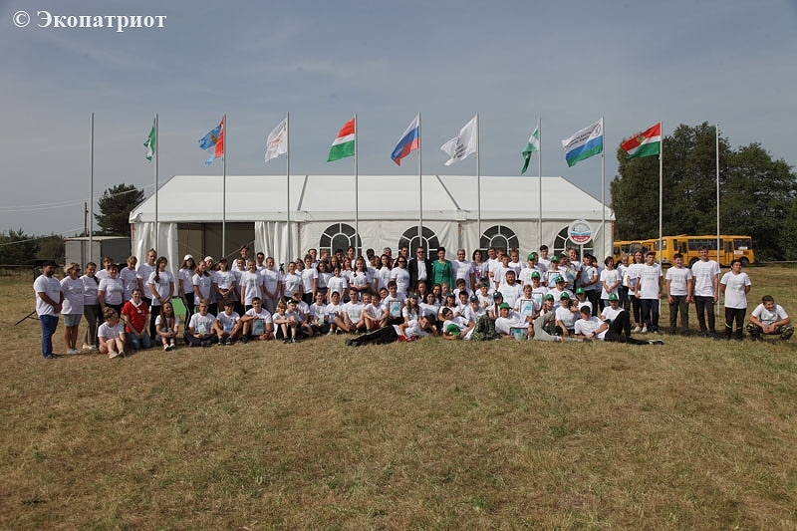
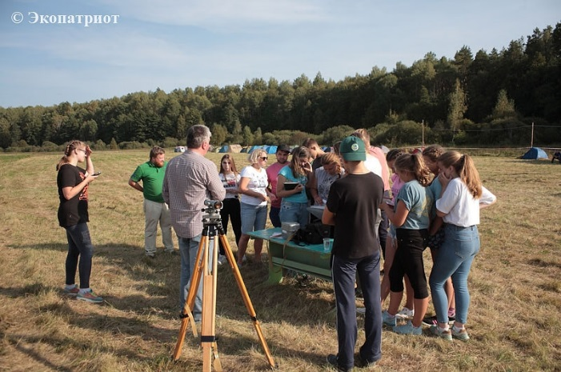
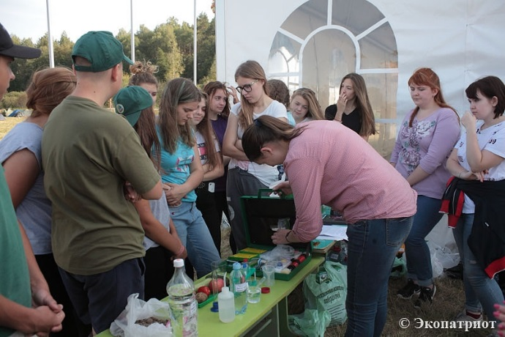

From 6 to 8 September 2018, with the support of "Remmontazh" in the Kaluga region on the territory of the Kuibyshev district in the picturesque place called Chalk Hill passed II International Environmental gathering of "Give the planet a life." Ekoslet represents a 3-day camp. It was attended by, first of all, students removed from the regional center of Kaluga region areas, guests from the neighboring region - students of the city of Ryazan, the delegation of the Republic of Belarus.

In ekoslote was attended by 10 teams. More than 130 people - pupils, students and teachers - are here to socialize, share experiences of environmental work and learn a lot about what surrounds us.
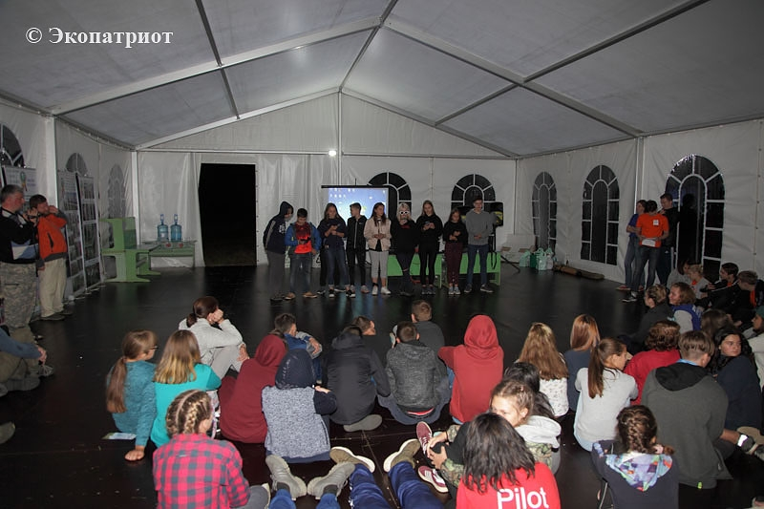
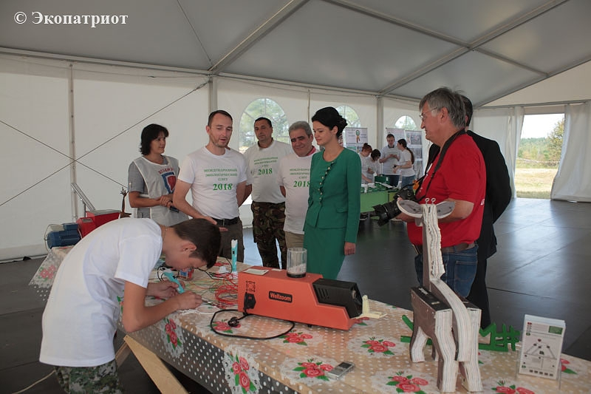
As part of the gathering are meetings with interesting people, group training sessions, common evening activities that allow children to meet, to talk about themselves and to exchange views on environmental issues. Evening meetings are held by students, volunteers, representatives of the "Russian Union of Volunteers." For the participants of the gathering forces of the Institute of Natural Sciences KSU. Tsiolkovsky organized group professional orientation sessions in the main areas of study: biology, chemistry, geography, ecology. Classes on separate collection of MSW. Guys are professionals with forest and meadow trail, where they get acquainted with the world around them. Mandatory element of the rally are morning exercise and sports pause, carried out within the framework of healthy lifestyle programs. The staff of the Art Museum of garbage "Mu Mu" familiar with the work, and museum exhibits, hold master classes. The children also get acquainted with the work of forestry. An important element of the program - a campaign at the mass grave of soldiers who died during the Great Patriotic War.
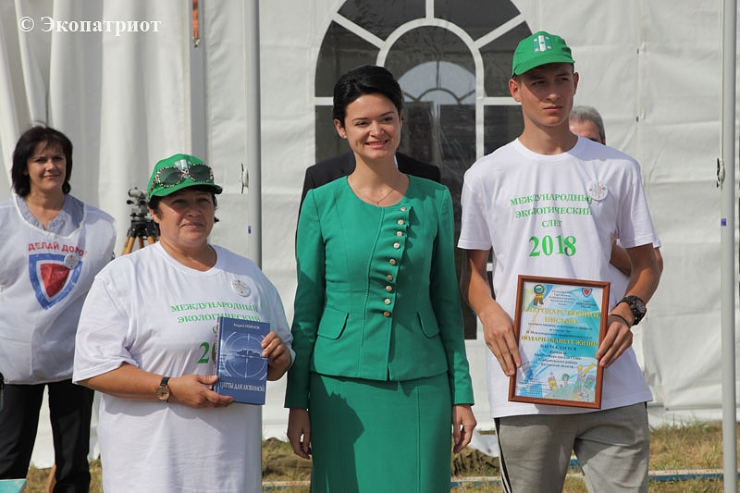

In 2018 ekolagerya participants were able to meet and talk personally with the Minister of Natural Resources and Ecology of the Kaluga region Varvara Anatolevnoj Antokhina, professor Sh. KE Tsiolkovsky Igor Lykov, academician of the Russian Academy of Sciences Valery Fedorovich Gal'chenko.
Teams were awarded Letters of thanks the organizers for participation in the rally, and all participants commemorative badges and T-shirts. Minister of Natural Resources and Ecology of the Kaluga Region Varvara Antokhina awarded to the team from Ryazan and Belarus Letters of thanks of the Ministry and the book of Marshal Georgy Zhukov Victory as a gift.

5.1.8 Shores of Friendship

Shore united friendship thanks LLC "Remmontazh". In the Gomel region of Belarus the VII Inter-regional Youth Environmental gathering of the study and conservation of biodiversity in the Polesie region "Friendship Beach - 2018". It was held from 6 to 9 August and brought together more than 70 people - students and teachers. The event was attended by 14 teams, including those from Ukraine and the Russian Federation. Russia was represented by the Bryansk and Kaluga regions.

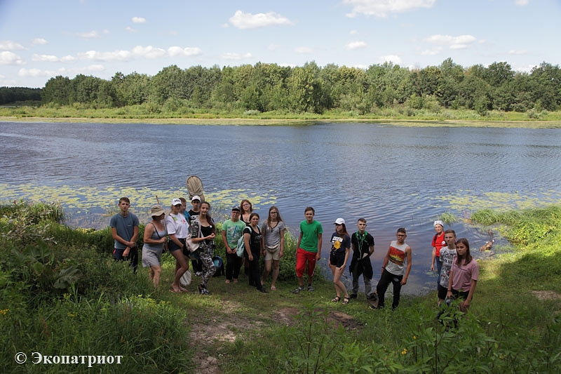
The delegation of the Kaluga region has been very significant. In ekoslote participated 4 teams. They were representatives of the Kaluga Regional Eco-Biological Center, Children's and Youth Center for Space Education "Galaxy" the city of Kaluga, Maloyaroslavets Erdenevskoe school district and school Voylovskoy Lyudinovsky District. It is worth noting that the three teams to get to the "Coast of Friendship" in Belarus was made possible thanks to the financial help of "Remmontazh" in partnership with the Autonomous Nonprofit Organization "Environmental and patriotic initiative", LLC "ICC-Energo" and the regional office of the NGO "Union Russian volunteers ".
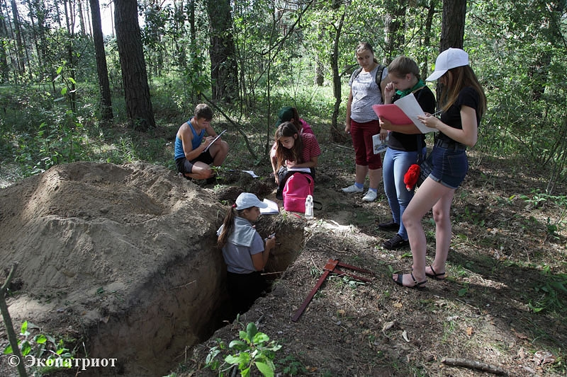

Participants of the rally placed at the tourist camp in the village of Old Dyatlovichi. Young conservationists expect an extensive program aimed at sharing experience of environmental activities, as well as on the development of practical skills of research activity in the field of environmental monitoring. As part ekoslota held the following events: the grand opening, business cards, competition, environmental tournament (theory and practice), a round table "Ecological problems of Polesie and adjacent territories", interactive quizzes, a visit to the palace and park complex of the city of Gomel, night ekokvest with elements of orientation, farewell bonfire, summing up and closing ceremony.

Results kaluzhan participation in the VII Inter-regional Youth Environmental rally "Friendship Beach - 2018" evoke a sense of pride for our guys, gleaming knowledge, and their mentors. Kaluga team excelled in the individual categories and in the team event.

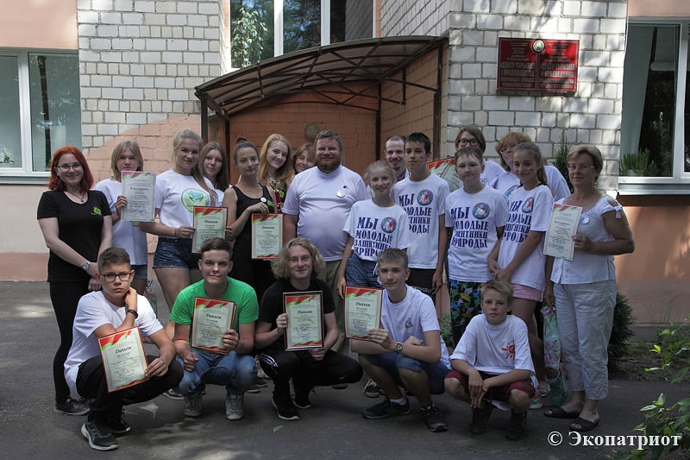
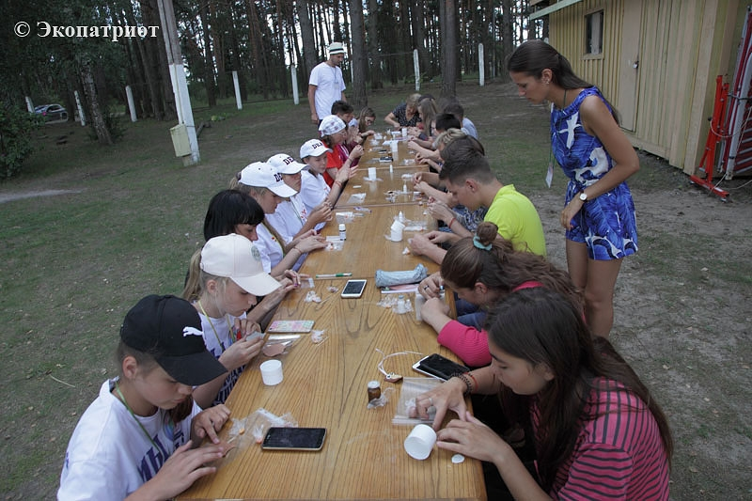

5.1.9 Environmental and patriotic route

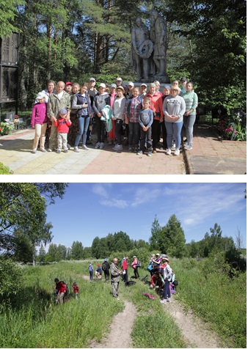
With the support of "Remmontazh" partners in the face of ANO "EPI" and Kaluga regional branch of the "Russian Union of Volunteers" was developed eco-patriotic route. It acts as Savior Demensk area and passes through the scenic storing traces of the Great Patriotic War. The walking part of the route is 17 kilometers. Stops are provided on military graves in Lazinkah, High, Sluzne, Gnezdilovskoy height. On the route visited pupils of the Sunday school of the Cathedral of St. Alexander Nevsky city of Kirov, pupils of the social rehabilitation center "Cheryomushki" Savior city Demensk, students and teachers of the Kaluga State University. KE Tsiolkovsky, the activists of the Kaluga regional department of the Union of Russian volunteers, residents Savior Demensk. Total in 2018 in campaigns route was visited by about 40 people. Route participants received a souvenir badges and books Spas-Demensk writer AN Child.

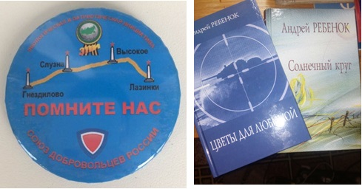

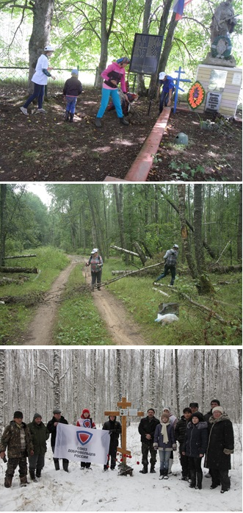
On the route was held Saturday. The event was attended by students and teachers of the Kaluga State University. KE Tsiolkovsky, the activists of the Kaluga regional department of the Russian Union of volunteers, employees of "Remmontazh".
December 9, 2018 at the map of ecological and patriotic route has been added to another point. This place is the last fight tankman IS Povoroznyuk posthumously awarded the Hero of the Soviet Union. At this point, with the support of "Remmontazh" and partners of the company was established worship cross and plaques. The event was attended by activists, searchers, students center "Cheryomushki". A total of 13 people.
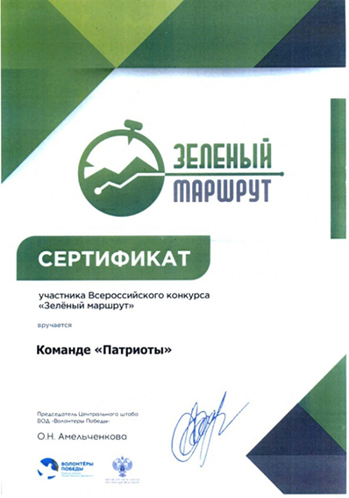
Ecological and patriotic route presented "Patriots" team won the regional stage of the All-Russian contest "Green Route". As part held in Kaluga from 15 to 18 November 2018 the IV International Ecological Forum "Save the Planet Together!" Were awarded the winners of the "Certificate" Offeror.

5.1.10 World Day cleanliness

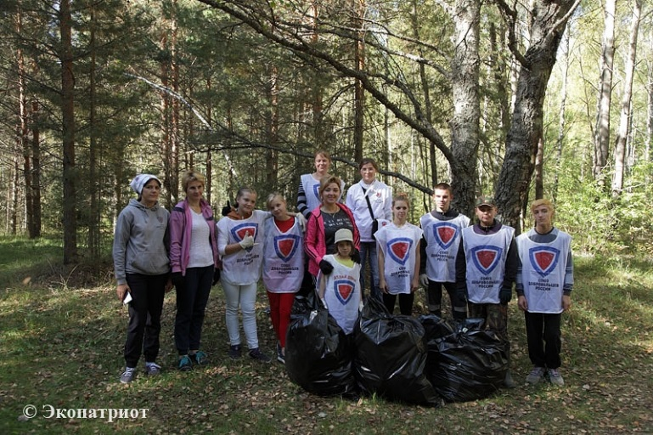
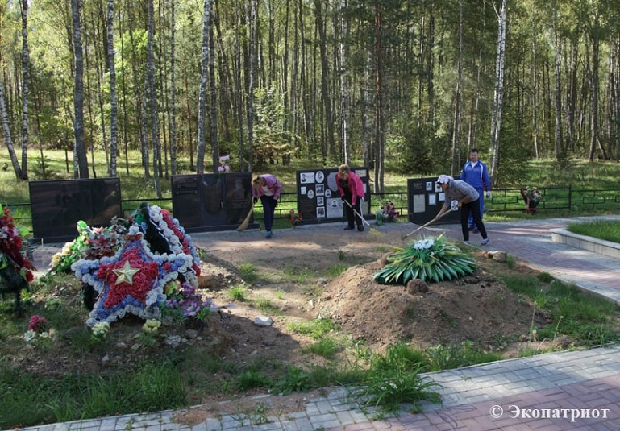
At the initiative of the worldwide movement "Let's Make!" September 15, 2018 passed the cleanliness day in all corners of the Earth. As reported Internet resources, "it is a civil project aimed at to unite the society, government, business and the media in a single command to clear the nature of the waste." He was born in 2008 in the Baltic States, but after 10 years, it has taken over 133 countries, including the Russian Federation.

"For Russia," World Day of cleanliness was held in the Russian Federation under the auspices of a public movement "Russian Popular Front. September 15 ONF held an ecological action "General cleaning of the country." According to official information, the initiators, on this day in 1200 it was held cleanups. They were conducted activists forces in 65 regions and joined volunteers in 290 cities.

For the World Day of cleanliness and the All-Russian Environmental Cleanup responded to the Savior Demensk district of the Kaluga region. There has been organized on a remote cleaning from the district center, nestled in the woods "Gnezdilovskaya height" military memorial. The event was organized by activists of the Kaluga regional branch of Russian Union of Volunteers, with the support of the Autonomous Nonprofit Organization "Environmental and patriotic initiative" as well as "Lespromtop" and LLC "Remmontazh". Promotion of the creators of good deeds had Savior Demene district administration.

It is worth noting that the point for the campaign on the map in their region the organizers have chosen not by chance. In 2018 for the spring-autumn period Kaluga team of volunteers with the support of "Remmontazh» Ltd. visited Gnezdilovskoy height several times. She was developing a "green route" that passes through the mass graves in Lazinkah, High, Sluzne, Gnezdilova. During the visit to the memorial activists drew attention to the existing in the vicinity of the garbage. Household waste from snacking on fresh air filled the nearby craters from shells and lingering grass trenches. Announced worldwide Day of purity, and in our country - and even Russian Saturday - was a good opportunity to restore order around the whole well-groomed and well-contained military-memorial complex.
More than 20 people participated in the action. We worked together adults and children. Showing an example of connection between generations and preserve the memory of the immortal feat of defenders of the Fatherland, they cleaned up the area around the memorial and the site where visitors like to spend a memorable place. The result of their work friendly fit into a 6-liter bags 180, which are mostly filled with glass and plastic bottles, disposable tableware, cans from the cans.
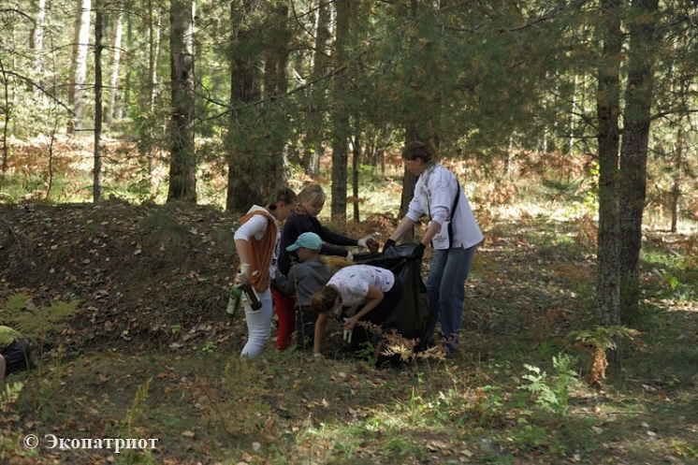

5.1.11 Theatrical production of "Ecology of Mind"

Theatrical production of "Ecology of Mind" - is a project of "Remmontazh", implemented in cooperation with NGO "EPI" and a team of teachers and pupils of the school №45 of the city of Kaluga.

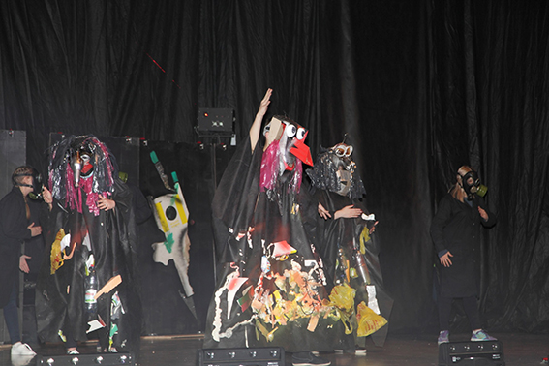
"It is noteworthy that the idea of ​​putting an unusual theatrical performance by a man not from the world of art. The main initiator of the project - businessman Radik Zakiryanov. He heads the company «Remmontazh", which operates in the waste management system and participates in the UN Global Compact for Sustainable Development. Radik Ahnafovich - our good friend and partner, actively promoting volunteerism in the Kaluga region. All of our co-operation with it is aimed at increasing the level of ecological culture, as the younger generation as well as adults, including through creativity. "
More than a hundred young artists from the stage set in front of spectators pressing issues of today: preserving the world around us, the purity of the native language, the introduction of separate collection of waste, the need for joint problem-solving. Fervent and sincere performers game has not left indifferent hall.
The play was presented to the audience three times. It was visited by numerous guests from the Ministry of Natural Resources and Environment, the Ministry of competition policy, the ministry of road construction of the Kaluga region, representatives of the company "Rostelecom", the students of the right bank of Kaluga and Dzerzhinsky district. The third demonstration took place in the framework of the IV International Ecological Forum "Save the Planet together."

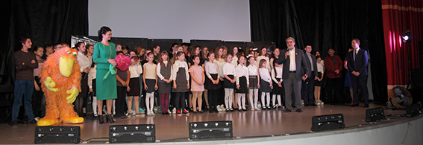

After the final song an acting troupe and the organizers of the pageant with a successful project in the embodiment of life congratulated the Minister of Natural Resources and Ecology of the Kaluga Region Varvara Antokhina. Children and teachers, she thanked for their participation in a creative experiment, which, judging by the incessant ovation spectator success. "You - the big well done, thank you for your help in the formation of ecological culture of the population," - said Barbara A., referring to the school team. And the ideological inspirers and sponsors leaders of specialized departments confessed: "I have seen a lot of your projects, but this one - the coolest!".

Do not stop there and look for new ways of working with young people promised fellow director of "Remmontazh" Radik Zakiryanov, who co-founded the NGO "Environmental and patriotic initiative." "We will continue to maintain the children's interest in creativity and environmental activities so that the younger generation for life according to the laws of the ecological balance has become the norm", - assured Radik Ahnafovich. And, in a sign that the "Ecology of mind" does not say goodbye to kaluzhane protagonist presentation dinosaur Eco prepodnos Minister of beautiful rose made of plastic bags.

5.1.12 Co-organized non-profit organization

Director of "Remmontazh" Radik Zakiryanov is a co-founder of NGO "Environmental and patriotic initiative." LLC "Remmontazh" and ANO "epi" has close partnerships in the field of environmental education of young people and familiarizing the younger generation to environmental activities. Together "Remmontazh" LLC and ANO "EPI" done a lot of good deeds in 2018.

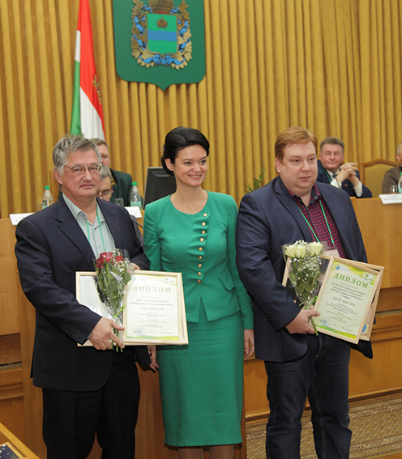
The result of a fruitful collaboration was the high evaluation of the ANO "EPI" by the Ministry of Natural Resources and Ecology of the Kaluga region. In the competition "Ekoorganizatsiya 2018" ANO "EPI" won the I place in the category "environmental education" and was awarded a diploma of "green" office.

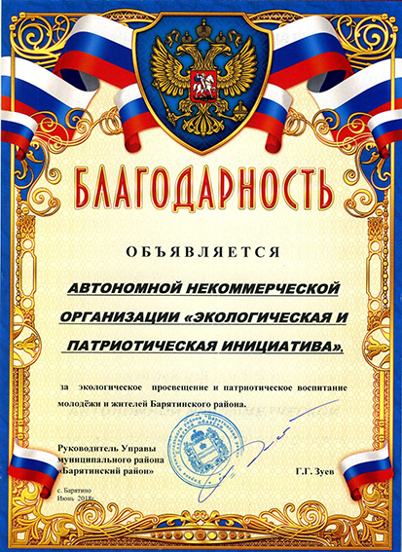

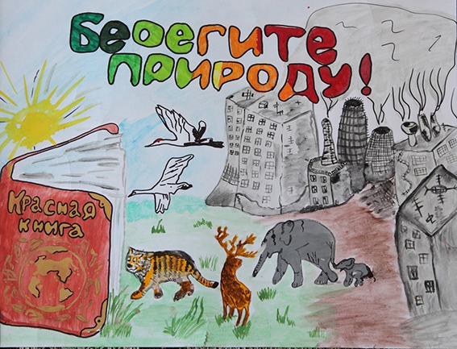
December 20, 2018 in Kaluga was opened unusual culinary studio, which is called the "Rolls does not grow on trees." The idea of ​​its creation belongs to the Autonomous Nonprofit Organization "Center for legal assistance to children" Start into the future. " And it was created with a grant and with the support of many concerned people and organizations. One of these organizations was caring company "Remmontazh" LLC and its partner NGO "EPI". For the assistance provided benefactor ANO "epi" has been awarded a letter of thanks.

5.1.13 Assistance for the implementation of the presidential grant

In 2018 company "Remmontazh" supported the NGO "Environmental and patriotic initiative" in the implementation of the project on environmental education of schoolchildren "Rubbish as a work of art," to win the contest for a presidential grant. Thanks to the support of "Remmontazh" This project was launched in 13 municipalities of the Kaluga region. It was attended by Baryatinsky, Meshchovsk, Masalski, Kuibyshev, Lyudinovo, Spas-Demensky, Hvastovichsky, Ulyanovsk, Duminichsky, Yukhnovsky areas, as well as the city of Kaluga.
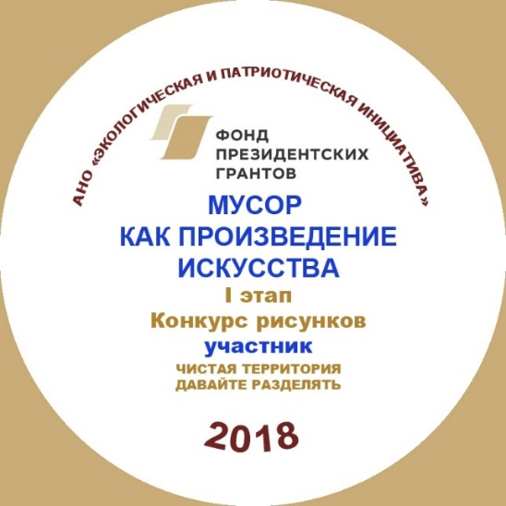
In accordance with the position of participants is expected to pass three stages of the project. The first stage was associated with carrying out in the municipalities of drawings competition among schoolchildren on the two themes of "clean area" and "Let's share". The competition was attended by over 700 children. The second phase of the project includes visits to the winners of a drawing contest in the municipalities of the Art Museum of garbage "Mu Mu" in Zhukovsky area. It was visited by 180 children. For kids entertainment program was prepared, which included a tour of the museum, the quest, visit the recreation center "Igrachi" and dinner. In the third stage of the contest children visited the Museum of debris, had to share their experiences, expressing them in the picture or the craft. In total, the third stage has received more than 400 works.

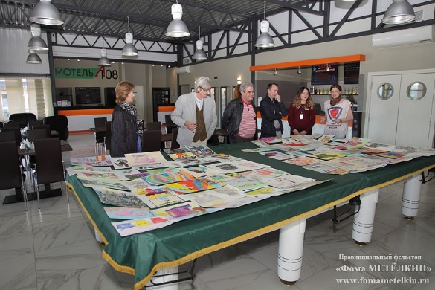
All the participants received commemorative badges. The winners of drawing competition were awarded with diplomas. Diplomas were awarded and the boys, who had gained the victory in the third stage of the project. Some contestants were presented with certificates proving that their crafts have become part of "Mu Mu" exposition of the Art Museum of garbage.
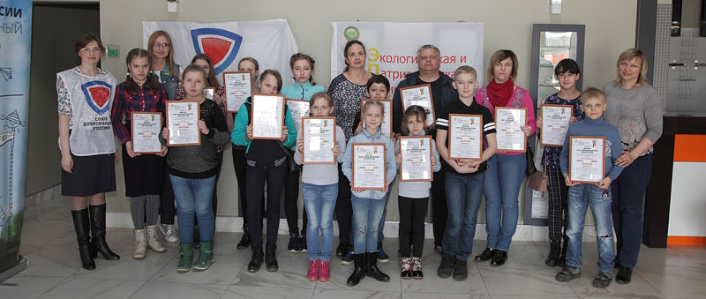
Thankyou earned corporate volunteers of "Remmontazh". Organization experts were members of the jury drawings helped award winners, accompanied the team in all activities planned during the visit to the museum of garbage.
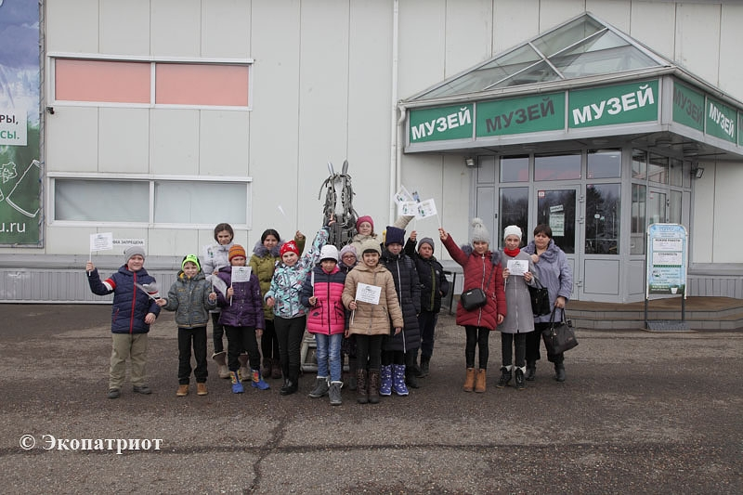
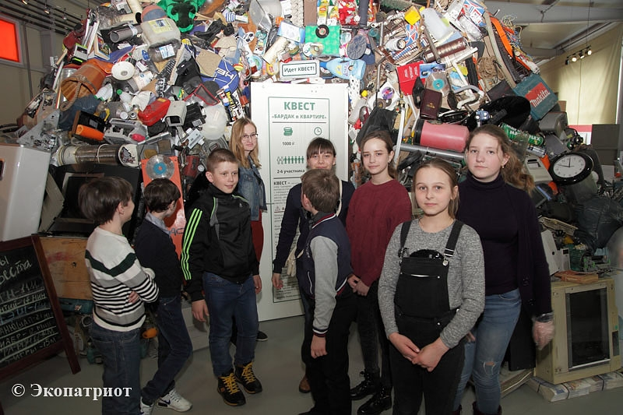

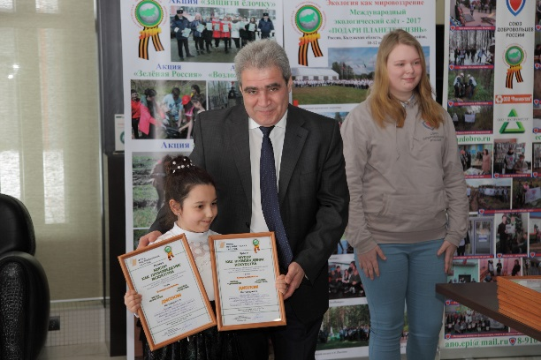
April 2, 2018 in a business park "Rooks" creative delegation arrived Iznoskovsky District. For a mini-exhibition of drawings marked by the jury it was organized, followed by the awarding of inspection. In a solemn ceremony the children handed diplomas.

Honorable mission of awarding well-deserved rewards fulfilled Radik Zakiryanov, director of "Remmontazh" only a small enterprise in Russia, which is a member of the UN Global Compact for Sustainable Development. "I really liked your drawings. You guys are great fellows, because you know that if a garbage mistreated it threatens nature serious danger, and if the right to address, it may benefit to bring, and also be a work of art "- shared Radik Ahnafovich .

5.1.14 In support of the project "Waste as a work of art"

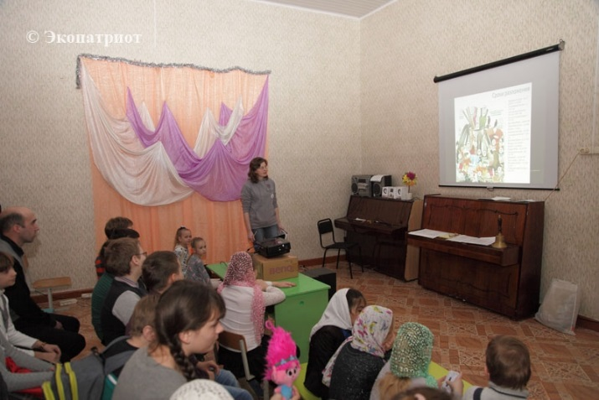
In support of "Garbage as art" project, which has successfully implemented ANO "Environmental and patriotic initiative" using the presidential grant, experts' Remmontazh "LLC held ekolektsii of separate collection of waste. These classes were held in educational institutions that participated in the project. It Betlitskaya Kuibyshev district school and Sunday school at the Cathedral of St. Alexander Nevsky city of Kirov.

Lecturers are not only told the children about the advantages and disadvantages of the methods of waste management, but also offered the participants of the event to practice in separate collection of waste. The workshop was built on a sample project, to introduce the Kirov company "Remmontazh". Kirov boys and girls, this task was not new, as the proposed system of North Ossetia for several years acting in kindergartens and schools in the city of Kirov.

5.1.15 charity trip

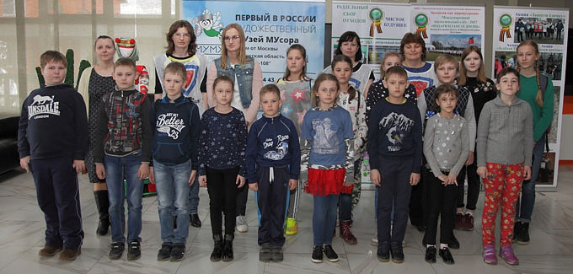
In April, a trip for new discoveries in Art "Moo-Moo" garbage museum went 15 young artists of the Sunday School Kirov city, whose work has been recognized as the best in competition of drawings "clean area" and "Let's share", which was held in the framework of the project "Waste as a work of art ", implemented by NGO" EPI "using the presidential grant. This trip was made possible by the support of "Remmontazh" LLC.

5.1.16 Cooperation with the Russian Union of Volunteers

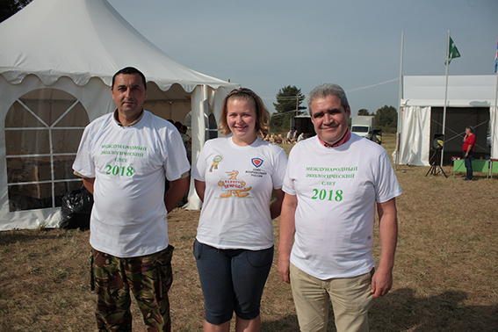
In 2018 we continued the cooperation of "Remmontazh" with the All-Russian public organization "Russian Union of volunteers" and its regional branch in the Kaluga region on environmental education and nature conservation. Within the framework of social partnership of "Remmontazh" and SDR carry out various activities of ecological orientation. In particular, planted forests, is holding a contest of reciters and drawings, organized environmental clean-up.

A great help in organizing a 3-day event had corporate sponsors and volunteers from "Remmontazh" LLC. It was on the initiative of the Kirov organization, the only one among the small businesses in our country entered into the UN Global Sustainable Development agreement in 2016 hosted the first ekoslot titled "Present life of the planet." Thanks to "Remmontazh" holding the rally has become a good tradition.
The activists of the regional branch of the Russian Union of volunteers, as well as corporate volunteers of "Remmontazh" took part in the activities of the separate collection of waste, helped in the patriotic action "Throw Flower" (all participants of the rally made a 9 km trek to the mass grave), spent the evening meeting " acquaintance "and" Candle ", were involved in economic work in the territory of the rally.

5.1.17 Connecting the care of the environment and patriotic education

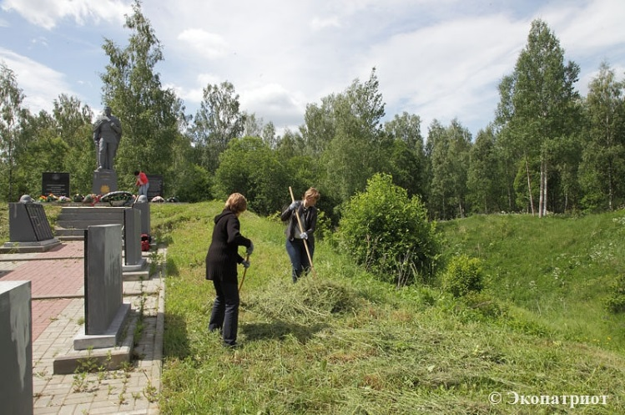
In the activity of "Remmontazh" connects the care of the environment and patriotic education.
June 8, 2018 corporate volunteers of "Remmontazh" in cooperation with NGO "EPI" and activists of the Kaluga regional branch of Russian Union of volunteers took part in cleaning the military cemetery, located in Baryatinsky District.
In Baryatinsky District Kaluga Region are having difficulties with the care of the military-memorial complex in the village Tsvetovka. This memorial site is located at a considerable distance from the district center (40 km) and occupies a large area. Its content in decent form requires serious resources, and especially human, which, in the municipality, unfortunately, not enough.
A memorial complex in Tsvetovke includes a memorial to "The explosion at the mine", a monument to the fallen soldiers and military cemetery, where the efforts of search engines, since 1993, were reburied the remains of more than 4 thousand defenders of our homeland. With the onset of summer, the area of ​​the memorial site thoroughly overgrown with grass. To bring in the order of the memorial had to unite the efforts of government agencies, businesses, community members who have decided to hold a work day.
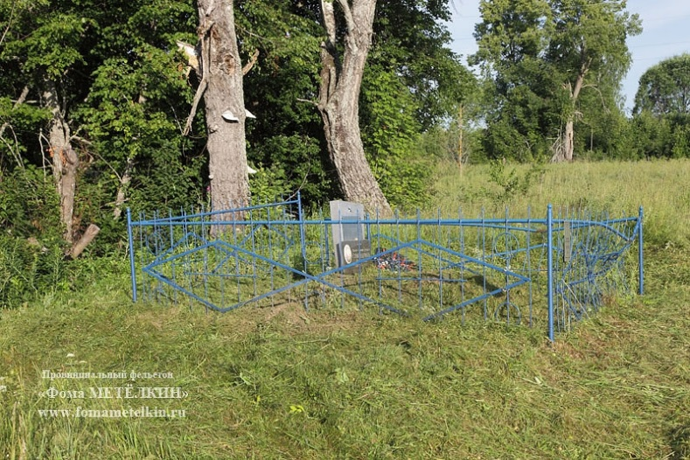
Participants of the action wiped out the entire territory of the complex, sawdust tree branches hanging over the fence of the military cemetery, was removed from the pedestals and burials wilted flowers and wreaths shabby.

June 28 LLC "Remmontazh" ANO "EPI" and activists of the Kaluga regional branch of Russian Union of Volunteers spent cleaning on military graves in the village of umbilical.

Industrial environmental monitoring

Company objectives are to ensure the openness, security, viability and sustainability of cities and towns; the availability and efficient use of water and sanitation for all; protection, restoration of terrestrial ecosystems and contributing to their rational use.
In order to increase the environmental sustainability of the city is necessary to improve air quality and reduce the volume of waste and to increase the area of ​​green zones.
in the sphere of protection of environment policy is aimed at reducing the negative impact on the nature of the waste generated during the life of the population.
To achieve the desired objectives "Remmontazh" LLC monitor and analyze the impact of TCRs on the state of the landfill environment.

Monitoring air pollution

Production control of chemical pollution of the atmosphere is divided into two types:
- control directly on the sources of emissions;
- control of harmful substances in the air on the boundary of the sanitary protection zone.
The main objectives of industrial emission sources monitoring is to assess the qualitative and quantitative composition of emissions directly to the emission sources.
The main sources of air pollution at the landfill area are working polygon maps; vehicles carrying waste; vehicles, working at the landfill site.
Landfill deposits represent gas-generating objects, atmospheric pollutants and subsurface air biogas. The composition of the biogas generated at the site depends on a number of factors such as the stage of the decomposition process, the composition of waste storage height, sealing conditions, etc.
Measuring, processing and evaluation of the results of observations of air pollution are performed in accordance with the GOST 17.2.3.01, GOST 17.2.1.03, GOST 17.2.4.02, 17.2.6.02 GOST according to regulatory guidance documents and methodical Federal Service for Hydrometeorology and Environmental Monitoring and the Federal Service for Supervision of consumer rights protection and human welfare (Rospotrebnadzor) and GN 1338-03 2.1.6.
Evaluation of atmospheric pollution is carried out separately for each agent and each combination of substances harmful to the summing unidirectional action.
The degree of air pollution is set by the multiplicity on SPZ excess of harmful components measurement results on average daily maximum permissible concentration (their MPCs) based hazard class, the total biological effect of air pollution at a certain frequency elevations (their MPCs).
With the predominance of anaerobic processes the main components of biogas, providing environmental threat to the well-being are methane (CH4) and carbon dioxide (CO2). As the most important impurities may be present, hydrogen (H2), hydrogen sulfide (H2S) other compounds. In this regard, using the landfill areas should take into account a number of possible hazards, such as:
- explosion of the situation;
- lack of oxygen;
- toxicological adverse conditions;
- unpleasant odors;
- suppression of vegetation.
Laboratory monitoring of ambient air quality is carried out under contracts with FGBI "Center for laboratory analysis and technical measurements in the Central Federal District" FGUZ "Hygiene and Epidemiology in Kaluga region Kirovsk area".
As a result of air investigations exceedances were found. Consequently, TCR polygon has no adverse effect on the atmospheric air.
water pollution control

TCR on the landfill, about d. Zimnitsa not performed organized wastewater discharge into surface water bodies. water pollution may result from a planar flush pollutants together with storm and melt water. Thus, within the framework of production and environmental control is carried out quality control of surface water p. Bolva and p. Shrink relative to the background cross-sections of rivers where there is no effect on their range - below the landfill body, above the landfill.
Monitoring of natural waters is carried out 2 times a year in the hydrological regime of peak phases: spring high water, low water or high water fall.
Water sampling required preservation, storage and transportation is carried out in accordance with the requirements of GOST 31861-2012 ( "Water. General requirements for sampling").

LLC "Remmontazh" carrying out activities on rented landfill MSW produces no organized sewage discharge into aquifers

The source of pollution of underground aquifers can be filtration of water leaked through the body dumps and contaminated with hazardous substances. Thus, production and environmental pollution control of ground water is accomplished by the ratio of water quality in the background and control wells. Organization of the background and observation wells network, according to regulatory documents provided by target. alignment with the selected location of the main direction of the flow of groundwater.
well design provides protection of groundwater against ingress of dirt and random convenient for water sampling.
Conducting hydro-chemical observations carried out 2 times per year (spring, autumn) for determining the quality of groundwater seasonal changes seepage water and polluting power layer of soil in the test area.
Laboratory control of surface and underground water is under a contract with FGBI "Center for laboratory analysis and technical measurements in the Central Federal District", «Center of Hygiene and Epidemiology in Kaluga region in Kirovsky region".
Polygon TCRs do not have a negative impact on water bodies as a result of the studies, water samples correspond SaNPiN requirements, therefore we are acting within the framework of environmental legislation.

Soil pollution control

Soil Testing in environmental surveys carried out for the ecotoxicological evaluation of the territory adjacent to the landfill as a component of the environment, able to accumulate significant amounts of pollutants and have a direct impact on public health.
Sampling is performed in accordance with the GOST 17.4.3.01, and 17.4.4.02-84 GOST Standard 28168. The testing is recommended from the surface layer by the "envelope" (mixed sample on the area of ​​20-25 m2) to a depth of 0,0-0,9 m.
Assessment of the level of chemical contamination by heavy metals and arsenic soil, technogenic soils and sediments is estimated on the total index of chemical pollution (ZC), which is an indicator of the adverse effects on public health.
In the absence of actual data for regionally controlled-background content of the chemical elements in the soil allowed to use reference materials.
Assessment of the level of chemical contamination of soil and soil is determined in accordance with SanPiN 2.1.7.1287.
Laboratory soil monitoring is carried out under contracts with the State Organization "Center for Laboratory Analysis and Technical Measurements in the Central Federal District," Plague "Center for Hygiene and Epidemiology in the Kaluga Region in the Kirov region."
As a result, studies of soil, the negative impact of the landfill TKO in the quality of the soil is not revealed.

Control of noise pollution

When the operation of the landfill run garbage trucks, tractors - all this creates a certain noise load on the occupants at the site and living nearby. In this connection it provides measurements produce equivalent sound levels and sound pressure levels at the boundary polygon and the SPZ.
Monitoring the noise pollution is carried out in garbage truck unloading area and stacking of waste in accordance with GOST 27409-97, ECE regulations ONN № 48-03, ext. 1-3, CH 2.2.4 / 2.1.8.562-96, GOST R ISO 9612-2013, Sanitary rules on occupational health drivers of cars № 4616-88 and on the border of the SPZ.
Laboratory control of noise pollution is carried out under contracts with the «Center for Hygiene and Epidemiology in the Kaluga Region in the Kirov region."
At the landfill TKO made measurements of sound levels and equivalent sound pressure levels at the boundary of the landfill and the SPZ. As a result of measuring the sound levels comply with the requirements.

radiation contamination control

Evaluation of radiation situation is performed as part of environmental monitoring, since storing waste in landfills does not exclude situations associated with premeditated or accidental release the disposal of radioactive substances in the soil technogenic representing the radiological hazard.
Also, in order to ensure radiation safety of personnel engaged in laying waste the work necessary in the implementation process to conduct radiation survey of anthropogenic soils and adjacent territory.
Radiation survey soil landfill is carried out to meet the requirements of SP pp 2.6.1.758 5.1.-5.3 (NRB-2010) that restrict the exposure of the public man-made and natural sources of ionizing radiation.
Laboratory radiation control is carried out under contracts with the «Center for Hygiene and Epidemiology in the Kaluga region in Lyudinovsky District."
As a result of studies, the values ​​DER gamma-ray portion are within acceptable levels. Surface radiation anomalies in the territory were found. The studied soil samples meet the requirements.

6. ANTI-CORRUPTION

LLC "Remmontazh" follows the principles of the UN Global Compact, aimed at combating corruption.

Principle №10: «Businesses should work against corruption in all its forms, including extortion and bribery".

Anti-corruption policy "Remmontazh" Ltd. is a set of interrelated principles, procedures and specific measures aimed at the prevention and suppression of corruption offenses in the company.
The main range of persons falling under the policy, are employees of the company who are with her in labor relations, as well as other persons, physical and (or) legal, with which the company enters into certain contractual relationships.

The organization of "Remmontazh" Regulation on Anti-Corruption Policy. Conflict of interest - it is an internal document "Remmontazh" Ltd., to establish procedures to identify and resolve conflicts of interest arising from the company's employees in the course of performing their job duties.
The Regulations apply to all employees, regardless of the level of the position. Under the stakeholders are understood director and employees, acting on the basis of an employment contract or a civil contract. Conflict of interest is a situation in which self-interest referred to in the situation of persons affected by or can affect the performance of their professional duties and (or) entails a conflict between such personal interest and the legitimate interests of the Company, or the threat of a conflict that could lead to harm the legitimate interests of the company. Under the personal interest of the persons specified in the Regulations refers to financial or other interest,

The study is based on conflicts of interest management in the Company on the following principles:
• the duty of disclosure of information about an actual or potential conflict of interest,
-Individual review and assess reputational risks for the company in the identification of each conflict of interest and its resolution,
CONFIDENTIAL process of disclosure of conflicts of interest and the process of settlement,
-compliance balance of interests of the company and the employee in resolving conflicts of interest,
-protection of workers from harassment in connection with the communication on conflict of interest, which has been disclosed in a timely manner the employee and regulated (prevented) now.

LLC "Remmontazh" changed its approach to building relationships with customers and partners, and were included in contracts binding mutual commitments to anti-corruption, as well as the obligation to operate in accordance with the principles of caring for the environment (focus on the use of resource-saving technologies, comply with applicable requirements industrial and consumer waste, take measures aimed at increasing the recycling of materials).

Implementation of anti-corruption policy of the company:

Systematic monitoring of the Russian Federation and the Kaluga Region in the field of combating corruption.

Systematic analysis of current local regulations of "Remmontazh" for compliance with the existing legislation on anti-corruption, and if necessary, make the necessary changes to improve the regulatory support and organization of the company's activities in the field of combating corruption.

Ensures the implementation and control of the approved LLC "Remmontazh" Regulations on Anti-Corruption Policy

The LLC "Remmontazh" systematically carried out legal examination of draft orders, the organization of local regulations in order to identify them in the corruption factors and their elimination.

Systematic analysis and maintenance of up to date information available at the booths located in the office building of the company "Remmontazh" and on the official website of the organization.

It carried out a systematic updating of information about the activities of the performance targets, procurement, reporting on the UN Global Compact. Details of this work are publicly available on the Internet.

When applying for a job "Remmontazh" Ltd., all employees are required to attend familiarization process with the Regulations on Anti-Corruption Policy, which defines the behavior of the anti-corruption in the performance of job duties.

During the reporting period for non-compliance with provisions of appeals facts have been reported on anti-corruption policy. The facts of corruption offenses in the activity of the company is not established.

During the reporting period have been identified cases of conflict of interest.

Regularly carried out legal education of workers LLC "Remmontazh" by reference to the provisions of the Russian legislation in the field of combating corruption.

Held to familiarize new employees with the company adopted an anti-corruption policy, the Regulation on conflict of interests and other local normative acts regulating the issues of prevention and counteraction of corruption.

Employees of "Remmontazh" explains the requirements and procedure for preventing or resolving conflicts of interest, employees responsibilities in the anti-corruption measures of liability for corruption offenses.

Representatives of the company responsible for the work on the prevention of corruption offenses, participate in seminars on anti-corruption, as well as in seminars on public procurement issues and prevent corruption in procurement.

Implemented internal control accounting data availability and reliability of primary accounting documents.

7. CONCLUSION

The company "Remmontazh" Ltd. appreciates the importance of the implementation of the 10 principles of the UN Global Compact. The company's management and all employees share business commitment to Corporate Social Responsibility. The staff of the company understands that it is possible to achieve sustainability of business, only in a stable society, and that public confidence in the company is based on its specific action in relation to society.
The team of "Remmontazh" open to dialogue and cooperation. Let us work together to develop partnerships to promote sustainable development of the territory.

