Version 2.6

Date: 8 April 2019

**Nutreco 2018 Sustainability Report**

Table of contents

Introduction 3

Conversation between our CEO and Sustainability Director 3

About this report  3

Our strategy 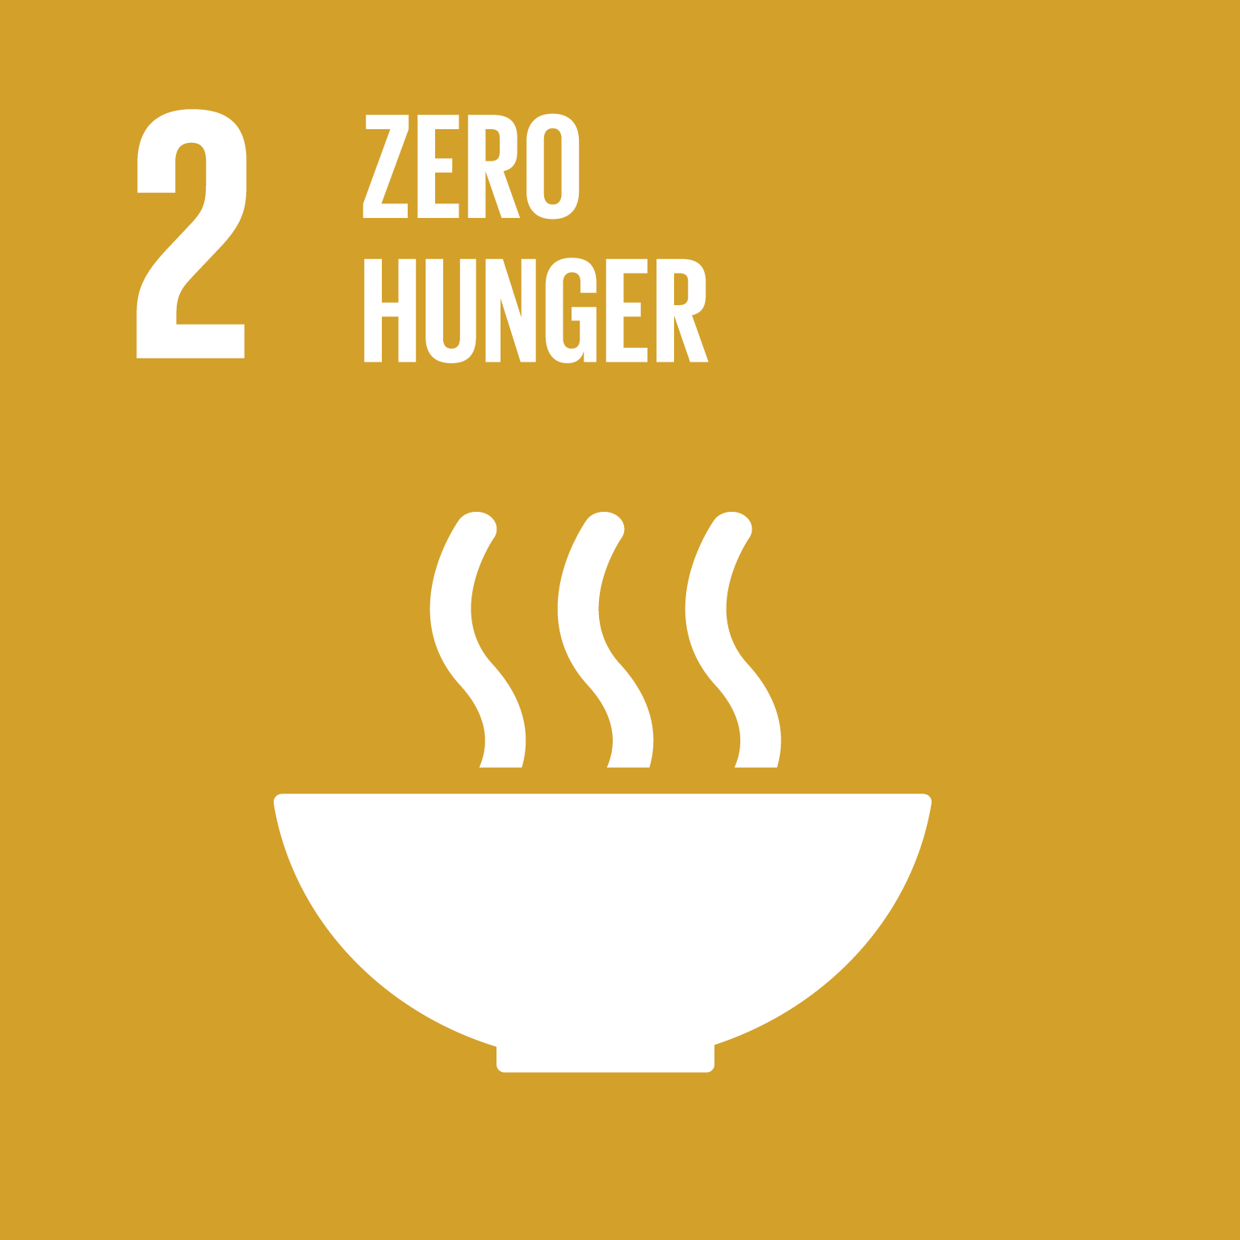 4

Our approach  4

Materiality  6

Organizational divisions 6

NuFrontiers 7

Our value chain  8

Nutreco brands, customers and suppliers 8

Sustainability governance 9

How we create value  10

Trouw Nutrition case study 1 11

Trouw Nutrition case study 2 13

Trouw Nutrition case study 3 14

Skretting case study 1 18

Skretting case study 2 20

Skretting case study 3 22

Sharing our dilemmas with you 24

Deforestation-free Related image 24

Antimicrobial resistance (AMR) Image result for SDG icons 25

Who will pay? Overcoming the cost obstacle of innovative ingredients  26

Creating a positive impact with our community development projects  27

Nigeria Related image 27

Zambia Related image 29

Guatemala Related image 30

Vietnam Related image 33

Brazil Related image 34

Our collaboration with multi-stakeholder platforms 35

Seafood Business for Ocean Stewardship (SeaBOS) Image result for SDG icons 35

Pincoy project Image result for SDG icons 36

AquaVision Related image 37

Human capital 38

Global Community Day 40

Ethics and compliance 40

Feed-to-food quality and safety 41

Enhancing sustainability in the supply chain 42

Our sustainable sourcing of ingredients 42

Supplier Code of Conduct (SCoC) 42

Auditing suppliers 43

Taking responsibility within our own operations 45

Operational excellence 46

Safety and accidents 46

Our operation’s environmental footprint Image result for SDG icons 48

Our partnerships Related image 50

Further stakeholder engagement 52

Global Reporting Initiative (GRI) Index 54

External report on sustainability data quality 58

# Introduction

Each year, we reflect on how best to report on the challenges we’ve faced and the progress we’ve made while pursuing our Nutreco sustainability program, Nuterra.

This year, more than ever, it struck us that our progress on sustainability at Nutreco is a direct result of the passion, expertise and great work being done by people every day across our organization. This sustainability report is an acknowledgement of our people, who make sustainability an ongoing priority within our operations and activities.

And this is why, throughout this report, we share our colleagues’ insights and experiences. Stories from the people who work in our plants, visit our customers and purchase our ingredients. You’ll read about the unique ways we’re partnering within our supply chains – building trust with suppliers, vendors and farmers – to drive change and unlock new possibilities for all. The many faces of Nutreco’s people make all the achievements in this annual report possible.

## Conversation between our CEO and Sustainability Director

**[ To be transcripted by NoSuch and formatted by Patty ]**

## About this report C:\Users\JVillalo\Pictures\SLA19 finalist seal - vert1.jpg

For the past two consecutive years, Nutreco was nominated one of ten finalists for sustainability reporting in the UK’s prestigious, RSA-accredited, edie Sustainability Leaders Awards. This year, we have kept our successful overall reporting concept but have adopted a more candid narrative, focusing on the following main areas:

1. The people representing our company
2. How we create value
3. Sharing our dilemmas
4. Supporting our communities
5. Partnering across the value chain
6. Operating sustainably – every day
7. Assessing our performance

This report complies with the Global Reporting Initiative (GRI) Standard for core reporting. Since 2016, we remain committed to the United Nations Global Compact and continue to make progress on eight of the United Nation’s Sustainable Development Goals (SDGs). A detailed description of our progress on SDGs can be found in the chapters of this report – we’ve used the SDG icons to make them easy to identify.

Last year, we changed our policy and committed to seek independent, third-party, reasonable assurance every third year on all our sustainability claims and data. During the intermittent years, we have once again engaged Sustainalize to have a critical look at our sustainability data and our report’s content. This will allow us to drive continuous improvement and continue to independently verify the accuracy of our reporting.

We hope you enjoy reading about our sustainability journey in 2018.

**Progress against the SDGs**

In this year’s report, we describe our progress on each of the eight Sustainable Development Goals (SDGs) that we focus our efforts on by indexing the corresponding SDG icon to the chapters in the report.

## Our strategy Image result for SDG icons

 In 2016, Nutreco launched our comprehensive sustainability program, Nuterra. Since then, we have continued the diligent work of ensuring our sustainability goals are an important part of our day-to-day work across the company and are embedded into our corporate culture. The Nutreco Sustainability Platform (NSP), our governing body for sustainability within the company, is responsible for not only developing the Nuterra program but also continuously improving it to ensure it retains its relevancy over time.

   Nuterra’s simplicity is a big part of its success. The program has three main components: the Nuterra roadmap, the Nuterra standard and the Nuterra environmental assessment tool.

## Our approach Image result for SDG icons

The Nuterra roadmap

The Nuterra Roadmap is Nutreco's plan of action, outlining what we want to achieve on sustainability by 2020. It is our statement of purpose, an aspirational list of aims that include our commitment to source sustainable ingredients, our efforts to make manufacturing more efficient, our work to develop products that address environmental concerns and, finally, our responsibilities to our associates and our communities, everywhere we operate.

The food industry is currently facing an alarming paradox. The United Nation's Food and Agriculture Organization has projected we will need to produce 70% more food to satisfy the estimated increase in global population over the next 30-years. At the same time, the World Wildlife Fund predicts that we are already consuming the equivalence of 1.5 planet Earth's of natural resources. The Nuterra roadmap shows Nutreco’s commitment to make a difference in resolving this paradox.

Nuterra standard

To effectively manage a sustainability program, it is important to measure your progress. With this in mind, we developed the Nuterra standard: a self-assessment tool designed to measure progress made on our Nuterra roadmap 2020. The Nuterra standard is a series of 93 multiple-choice questions (compliance criteria) that enable us to determine where we stand on reaching the sustainability aspirations in our roadmap, and give managers a clear picture of where they are on their own local journeys.

In addition to providing a numerical score for progress made, the standard is also an effective tool for guiding managers on where to apply their resources and focus in the coming years. Through the Nuterra standard, aspirational targets such as, "Nutreco will source from sustainable ingredient suppliers" are converted into measurable, multiple choice questions that determine our level of compliance, such as, "What percentage of your suppliers have signed on their commitment to comply with the Nutreco Supplier Code of Conduct?" and "What percentage of those suppliers have been audited for compliance?" We aim to achieve an overall, Nutreco-wide score of 100% on our Nuterra standard by the beginning of 2020.

We recently moved from having a matrix management structure, governed by geographic business units, to being organized under two divisions. In addition, we changed from a bi-annual self-assessment to an annual self-assessment, starting in 2018, to drive focus and delivery on our roadmap as we move closer to 2020. As a result of these changes, it is difficult to compare our progress from one year to the next except by looking at the total Nutreco score. However, it is possible to make useful comparisons. In 2015, we self-assessed half of Nutreco’s companies, and in 2017, we assessed the other half. Then in 2018, we assessed 100% of Nutreco companies. So by combining the bi-annual reports of 2015 and 2017 – which together represent the whole of Nutreco – and comparing this total to the 2018 score – which also represents the whole of Nutreco – we can see a relevant trend.

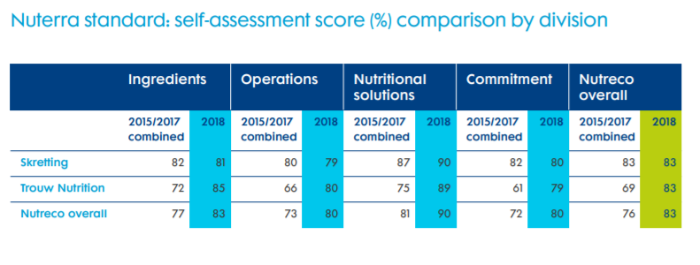

Overall, we achieved a Nutreco-wide increase in performance on our Nuterra roadmap 2020 of 9% in 2018 over our combined 2015-17 score. Although the improvement is good, an overall score of 83% may indicate a likelihood that we will fall short of our 100% expectation by January 2020. While both divisions scored equally for 2018 (83%), our Trouw Nutrition division improved its 2018 score by 20% compared with its combined 2015-17 score. Trouw Nutrition stepped up to the challenge, as observed by its 20% year-on-year score improvement.

In summary, the Nuterra standard has proved to be an excellent tool for measuring year-on-year progress against our Nuterra roadmap. General Managers within our company are encouraged to evaluate their annual scorecards and identify areas where they need to focus resources to successfully achieve completion of pending tasks.

### Materiality Image result for SDG icons

We assess the materiality of issues facing our company through a process by which we ask our internal and external stakeholders what they perceive are the most important (material) issues concerning Nutreco and its future.

Though Nutreco continues to address and focus on the material issues that came out of the full materiality assessment we ran in 2015 and revalidated and confirmed in 2016 and 2017 (see figure below), we completed another full materiality assessment in 2018 in preparation for developing our new roadmap 2025. We invited 700 stakeholders to participate in a web-based questionnaire. These stakeholders represented suppliers, customers, non-governmental organizations (NGOs), academia, our parent company SHV’s sustainability platform and Nutreco employees. We had an incredible response rate of 42%. In 2019, we will take these results and convene an internal workshop with representatives from our functional leadership and Executive committee (ExCo) to define and ultimately develop Roadmap 2025, which will be launched in the first quarter of 2020.

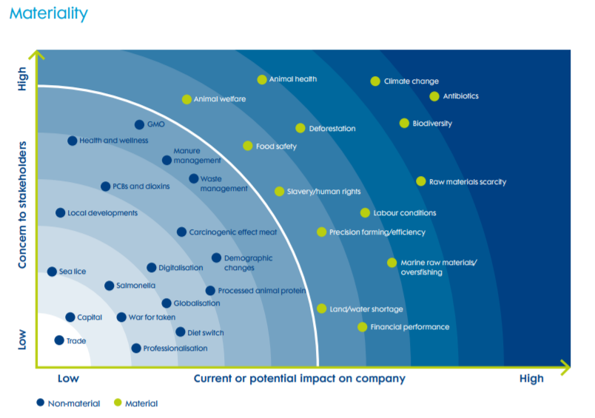

## Organizational divisions

   At the end of 2017, Nutreco’s Executive Committee (ExCo) announced the restructuring of the company from a matrix management system organized under six geographical business units to a divisional structure, organized under two divisions: Trouw Nutrition and Skretting. All of our operating companies (OpCos) producing for land animals now fall within Trouw Nutrition's domain, while those producing for aquaculture animals fall under Skretting's oversight. The composition of the Executive Committee was reduced from nine to six members, as shown in the diagram on page 12. The Executive Board remained the same, comprising the CEO and CFO. In August 2018, Knut Nesse stepped down after six years as CEO and Rob Koremens took on leadership of Nutreco. The Corporate Sustainability Director, Jose Villalon, continues to report directly to the CEO, chair the Nutreco Sustainability Platform (NSP) and represent Nutreco on sustainability-related issues with Nutreco's owners, SHV, through the SHV-Sustainability Platform.

### NuFrontiers

In 2018, Nutreco took a bold step in creating a new department that is focused on supporting our outlook for the future through strategic innovations and investments. Called NuFrontiers, its objective is to identify, develop and invest in next generation sustainable technologies throughout the protein value chain. NuFrontiers focuses on new technologies that address major bottlenecks and opportunities across our value chain and that could ultimately change the way food is produced, including by significantly reducing its environmental footprint.

As a complement to our existing research and development, NuFrontiers engages in open innovation by partnering with and investing in innovative technology companies. This can be through minority investments in start-ups and scale-ups or through joint ventures and project-based partnerships.

As a strategic investor that contributes expertise, experience and resources, we seek to be a growth platform and an active developer of the companies that we work with.

In 2018, we evaluated more than 100 companies working on new solutions in nutrition, animal health, precision farming / digital solutions, new aquaculture farming systems and alternative protein production for potential partnership or investment.

Out of the companies we evaluated, we selected three start-up companies for investment, and formed project-based partnerships with three others. One example is NuFrontiers’ investment in the Internet of Things (IoT) start-up, Eruvaka. Eruvaka’s products monitor shrimp pond parameters and remotely control automated equipment to increase feed efficiency, and reduce environmental impact. Nutreco’s aquaculture division, Skretting, is working directly with Eruvaka to implement the latest in precision farming technology at shrimp farms, starting in Latin America.

Another example is NuFrontiers’ investment in Project “Aquantum Leap,” a new salmon farming system that overcomes the main biological and environmental challenges in today’s production: the escape of farmed fish into the wild, disease problems because of sea lice, and water pollution by fecal waste and uneaten feed.

Our objective for 2019 is continue to expand NuFrontiers’ portfolio of exciting innovation projects with new technologies.

## Our value chain Image result for SDG icons

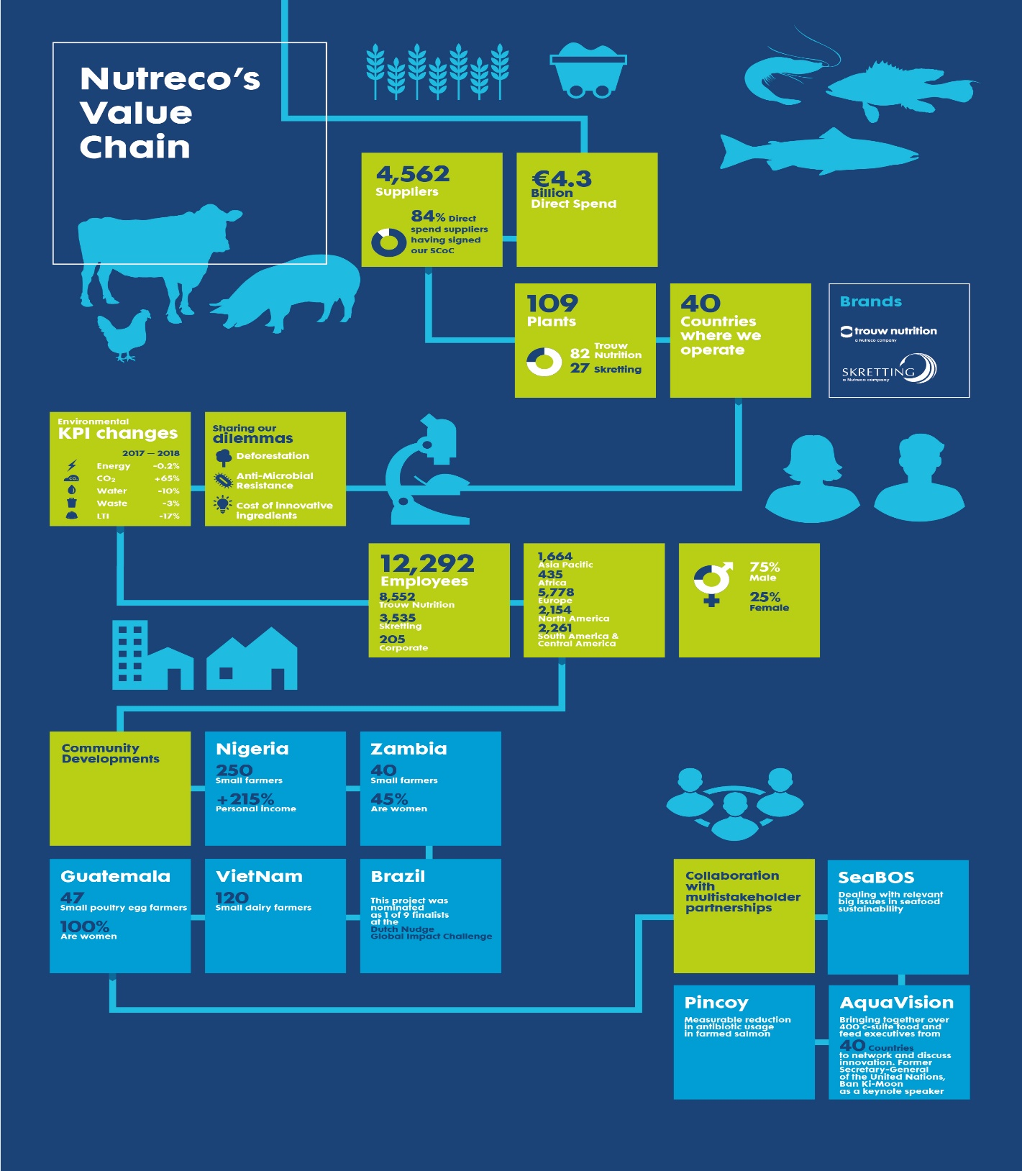

# Nutreco brands, customers and suppliers

**Trouw Nutrition**

**Market**

Trouw Nutrition is the #2 premix producer globally, with a #1 position in Europe and Canada

In Iberia, Trouw Nutriton holds a #1 position in compound feed and a #1 position as a poultry producer

**Presence**

82 plants globally with strong market presence in West Europe, Central and East Europe, the Middle East and Africa (EMEA), Asia, Canada, USA and Latin America

**Customers**

Feed compounders, integrators, distributors, farmers, companion animal industry, retail, wholesale, food industry and pig meat processors

**Suppliers**

Producers of grains, vegetable proteins, land animal products, amino acids, trace elements and minerals, vitamins, dairy products, vegetable oils, preventive animal health products and organic acids

**Skretting**

**Market**

Skretting is the #1 salmon feed producer and the #3 shrimp feed producer globally

**Presence**

27 plants in Chile, Asia, Canada and Norway

Joint ventures in Honduras, Nigeria and Zambia

**Customers**

Fish and shrimp farmers

**Suppliers**

Producers of marine ingredients, vegetable proteins and vegetable oils, among others

**Nutritional solutions**

Nutreco’s unique combination of products, services and models are designed to help farmers boost their productivity and support animal health. By doing so we address two of the UN SDGs.

### Sustainability governance

   The Nutreco Sustainability Platform meets on a monthly basis and governs sustainability policy within Nutreco. The Platform continues to have broad representation from the business, with five members (see diagram below). Typically, sustainability governance begins when the NSP develops sustainability policy or action through a consensus agreement. After this, the Chair proposes action at the ExCo level. If approved, the policy or action returns to the NSP, to be communicated to the Nuterra Champions and their respective General Managers across all OpCos.

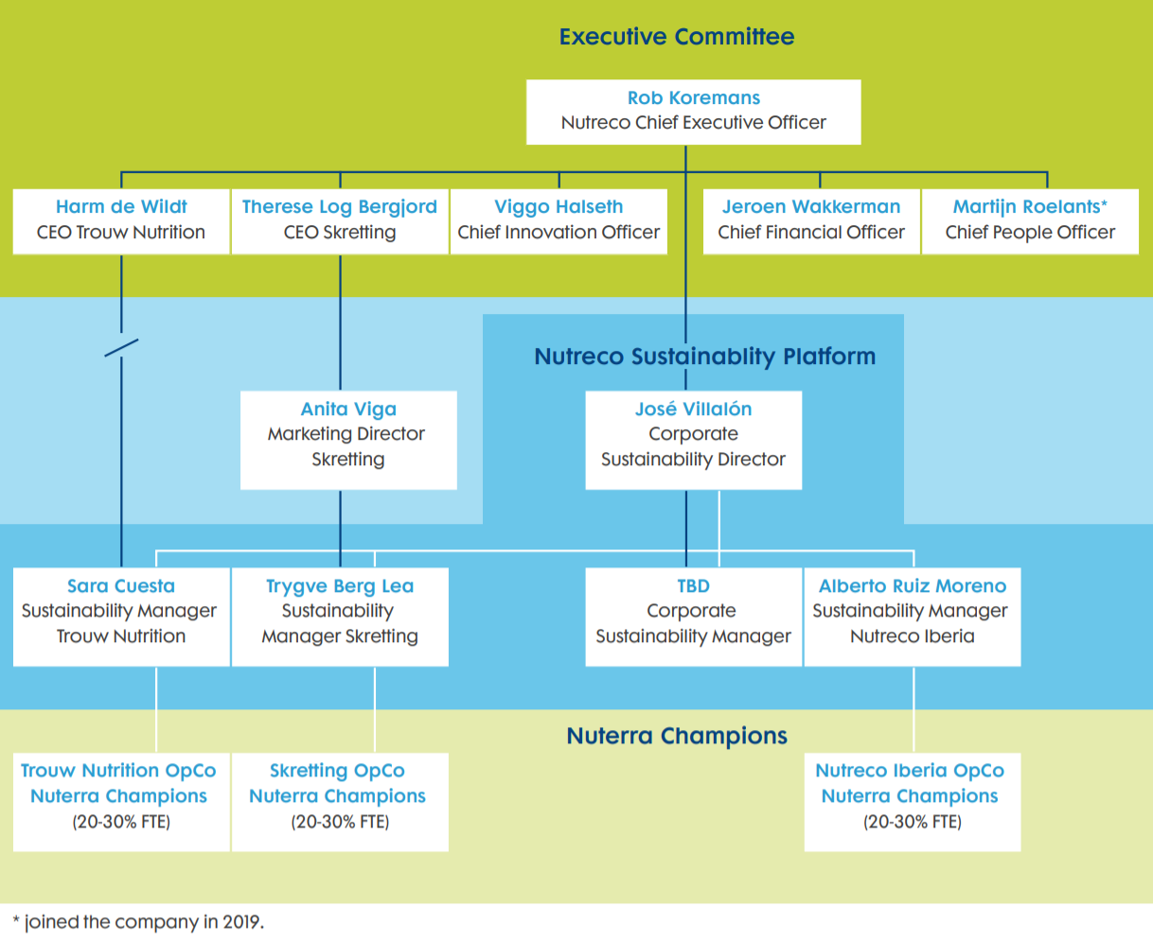

# How we create value Image result for SDG icons

At Nutreco, we understand that there are many ways we can creating value through our place in the value chain. We’re strategically positioned in the middle, between suppliers of basic ingredients and producer or farmers producing food. We create value in a two-fold manner, by asking our suppliers to operate and extract their products in an environmentally responsible way while also offering nutritional solutions to our clients that enable them to produce their products efficiently and with care for the environment.

Nutreco strives to develop nutritional solutions that address specific environmental concerns. These can range from product attributes that promote the efficient use of natural resources and reduce greenhouse gas emissions, promoting our integrated Feed-Farm-Health management approach or protecting biodiversity loss on our planet. In the section below, we present six case studies (three from Trouw Nutrition and three from Skretting) that demonstrate how some of the nutritional solutions we produce and sell address outstanding environmental concerns.

## Trouw Nutrition case study 1

**Harnessing the true potential of large litters**

Genetic selection in pig farming has generally focused on generating highly prolific, or even hyper-prolific, sows: animals that produce 17 or more piglets per litter. However, this strategy presents a dilemma: the larger the litter size, the higher the risk of stillborn piglets.

On many farms, the total number of piglets born per litter will exceed 15. The focus of successful farrowing has been on litter size at birth, which is generally considered one of the most important measures for evaluating a sow’s ability to produce healthy piglets. Although more piglets are being born per litter, the physiological maturity and number of piglets born alive is not keeping pace. “*Over the last 25 years, the focus of the industry has been on litter size rather than successfully weaned piglets,” says Jan Lamers, the Swine Research Centre Manager at Trouw Nutrition. “And in many countries, we have seen an increase in pre-weaned piglet mortality rates as a consequence.”*

As half of a pig’s life takes place under the direct influence of a sow – whether through gestation or under lactation – the mother sow significantly affects the survivability and lifetime health and performance of her piglets. The right sow nutrition – at the right time – can drive a piglet’s ability to develop into a strong and healthy pig.

For many years, Trouw Nutrition researched different approaches for supporting a piglet’s lifetime performance – starting at conception or even earlier. Our researchers identified a series of dysfunctional sow mother traits occurring during gestation, parturition, and the post-farrowing period, that irreversibly compromised piglets’ lifetime performance. This complex web of interactions is known as the Sow Peripartal Syndrome.

Research on the peripartal, or prenatal, period has led our scientists to focus on four piglet parameters observable at birth:

- Being born alive

- Adequate birth weight

- Colostrum intake

- Vitality

Our scientists sought to understand the root causes leading to issues with each parameter and to develop structural solutions. Their first breakthrough findings tackle piglet viability and were brought to farmers in 2018 in the form of a complementary feed solution for sows called Gestawean OxiLiv.

Trouw Nutrition researchers noticed that in the pre-farrowing period, the sow’s appetite is at its lowest, while its thirst remains at a normal level. The therefore developed Gestawean OxiLiv as a liquid solution added to drinking water and designed to be given to the sow five days pre-farrowing. It improves the oxygen supply to the neonates, increases the chances of survival and strength of the litter and positively impacts piglets’ long-term performance and animal welfare.

Lamers says, *“When we conducted the trials with Gestawean OxiLiv, we observed unprecedented results. We were able to get one (from 0.8 to 1) extra weaned piglet per litter and reduce the number of piglets drinking insufficient colostrum by 50%. As a result, we could achieve consistent litter sizes with more viable and vital piglets.”*

By supporting pig farmers in the management of hyper-prolific sows, Trouw Nutrition helps them produce more animal proteins from their herds.

Eveline and her partner Jeroen have a farm with 240 sows.

*‘Our experience with Gestawean OxiLiv is very positive. Farrowing is faster and we do need less intervention during the farrowing process. This results in a clear drop in neonatal piglet mortality. The piglets are clearly more vital since we use the product and start drinking faster, resulting in a better intake of colostrum. It was a challenge for us to ensure all the extra piglets made it to weaning. I will definitely recommend the product to my colleagues.’*

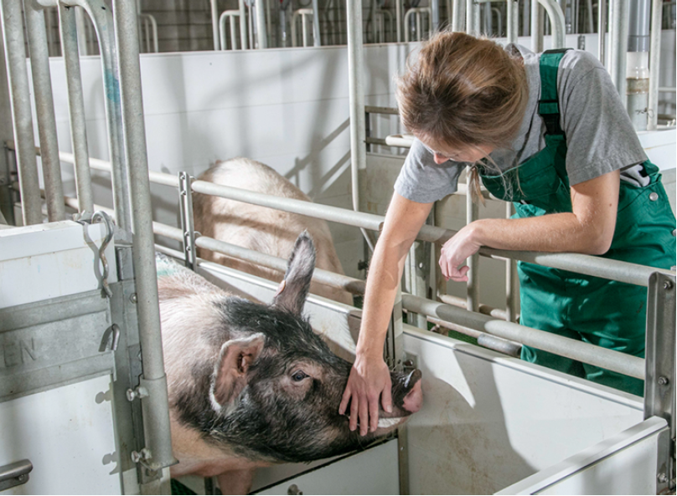

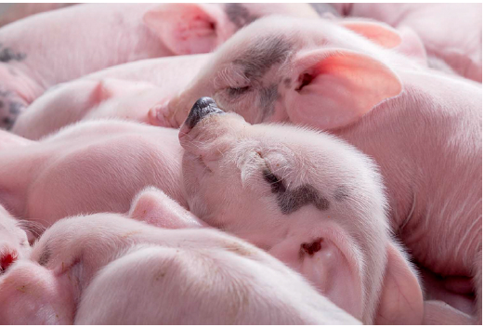 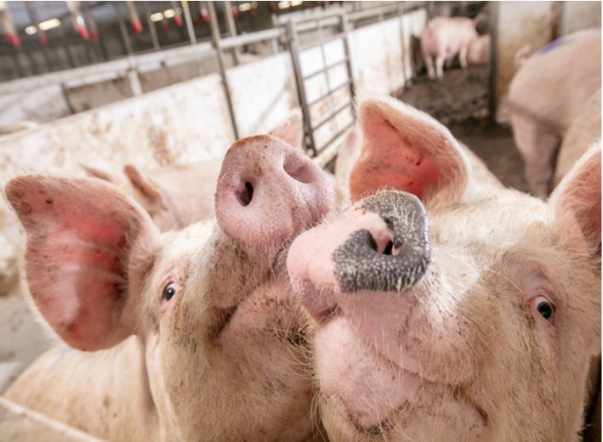

## Trouw Nutrition case study 2

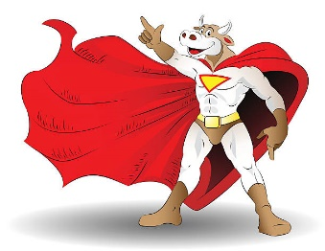**The super heroes of waste conversion**

As our global population grows, we’re putting greater demands on resources, while society is putting greater restraints on production because of concerns over environmental and social impacts along the value chain.

We need to produce more food to meet the nutritional requirements of our growing population, while at the same time reducing our environmental footprint. Being able to manage our available resources in a strategic way that is integrated with and aligned to specific production systems will be key to our success.

The solution to this challenge requires that we are able to integrate animal and plant-based production systems in a way that capitalizes on their respective strengths.

Plant-based production systems create non-food waste, for example, the leftovers from human food, fibre, and biofuel production systems. We need to be able to channel this non-food waste from production into animal protein production – and ruminants play a key role in this.

This view is supported by Prof. Dr. Wilhelm Windisch, Chair of Animal Nutrition at the Technical University of Munich who says, “*Around 90% of all the biomass agriculture is producing is not edible by humans; it first needs to be converted before humans can consume it. The ruminants’ unique advantage is being able to bring this biomass back into circulation, accelerating the circulation of nutrients between animal, soil and plant to boost the production of human consumable food.*”

Many millions of years of evolution have given ruminants a unique physiological advantage – the rumen. The rumen enables the ruminant to take low-quality, highly fibrous biomass and byproducts and waste that are inedible to humans, and turn it into high-quality protein (meat and milk) for human consumption. Further, the ruminant is able to take non-protein nitrogen sources, and – thanks to evolution and a symbiotic relationship with rumen microbes – turn them into some of the most nutritionally complete human food sources.

This unique ability means ruminants are effective and efficient nutrient “upcyclers”: taking low-quality, nutrient-poor, inedible resources and (industrial) waste products, and upcycling them to nutrient-dense, high-quality protein for human consumption.

It is also important to look at the complete production system, from natural resource utilization through to human consumption, factoring in aspects such as land use. Non-arable land is land that cannot be used for the production of crops. It can, however, be utilized for grazing – and helping to feed the future.

Capitalizing on the ruminants’ unique ability to graze poor-quality forages on non-arable land, combined with the consumption of byproducts that would otherwise be destined for landfill, creates a positive, net-beneficial production cycle. If managed correctly, the production of ruminants’ proteins becomes more efficient than the production of any other animal production system.

And think about the alternative: what other purpose could we use the non-arable land for? Where would we dispose of the millions of tonnes of plant-based waste?

It is without question that ruminant nutrition plays – and will increasingly play – a central role in our ability to feed the future.

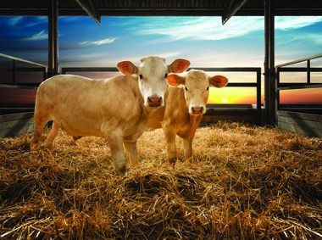

## Trouw Nutrition case study 3

**Helping hens produce more with less**

Trouw Nutrition is committed to improving the sustainability of the agriculture sector and striving to reduce our own environmental footprint. To ensure that our nutritional solutions contribute to our mission of Feeding the Future, we assess all our innovations according to our sustainability standards. NutriOpt Split-feeding is a nutritional solution for the layer market that has been assessed according the Life Cycle Assessment (LCA) methodology and has been found to contribute to reducing our environmental footprint.

Egg production is a physiologically complex process for the hen, involving the mobilisation of different amounts and types of nutrients at different times of the day. To match the circadian biological rhythm of the animal, precise feeding is required. Trouw Nutrition conducted extensive research to determine the exact nature of the hen’s changing nutritional requirements across the egg formation cycle. By opting for a split-feeding regime – feeding the hens twice per day instead of once – we can improve eggshell quality and laying persistency, with less intake of nutrients. The morning feed delivers the nutrition for energy, protein and phosphorous for egg lay production, while the afternoon feed meets the requirements for eggshell formation. This method not only offers a reduction in feed and production costs, but also results in more effective delivery of feed ingredients, with less excretion of nutrients.

We conducted a simplified LCA on this feeding method in 2018; you can see the result in the table below. The baseline for the assessment was a single feed throughout the day, and it looked at two different phases during the laying hen’s life: the pre-peak and laying phases. The nutrient content in the hen’s diet for both phases was higher for the baseline scenario than for split-feeding system, with the same feed digestibility maintained (Table 1).

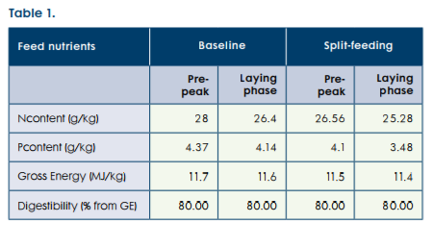

The performance parameters were the same in the pre-peak period, but during the laying phase, laying rate and egg production improved and feed intake, cracked eggs and Feed Conversion Ratio (FCR) decreased when split-feeding system was applied (Table 2).

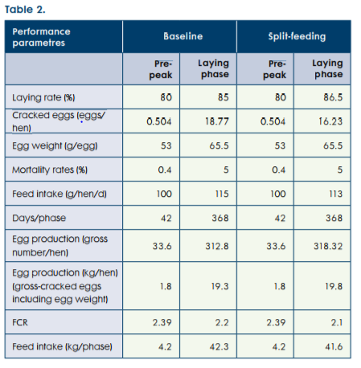

The results showed a 10% reduction in greenhouse gas emissions for hens in cage housing (9% for the voliere (non-cage) production system), a 23% reduction of eutrophication of fresh water, 12% less marine eutrophication, a 12% reduction in acidification potential and 2% less energy use (see Table 3 & Figure 1).

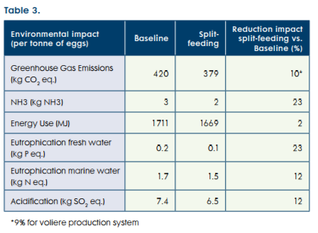

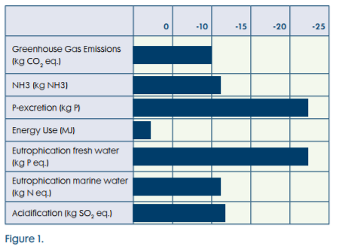

The sustainability assessment shows that the NutriOpt split-feeding system substantially improves production efficiency while reducing carbon emissions.

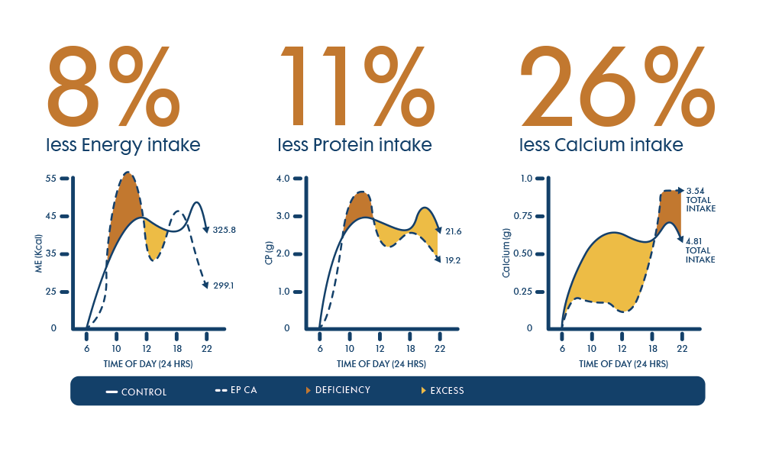

**[ Quotes; Could be a sidebar ]**

**Granja Alcazar Mancebo**

*“By applying Split-feeding, a higher laying rate and a better egg shell quality at the end of the productive cycle are being observed. Faeces are drier as compared with the one feed programme. In addition, there is a reduction in feed cost.”*

Owner: Antonio Alcázar

Municipio Villarrobledo, provincia Ciudad real (Spain)

**Granja Avicola Martinez**

*“With Split-feeding, egg shell quality improves and there are fewer broken eggs. Faeces are drier, facilitating, therefore, farm management and extraction of litter. On the other hand, feed cost is lower with SF when compared with the one feed programme”*

Owner: Miguel Martínez

Municipio Lliria, provincia Valencia (Spain)

## Skretting case study 1

**Making land-based aquaculture work better**

The team at the Skretting Aquaculture Research Centre (ARC) includes many knowledgeable researchers specialising in recirculating aquaculture system (RAS). These are land-based aquaculture facilities that cycle water through a filtration system so it can be used again. They are highly sustainable, reducing the amount of water and space needed for aquaculture.

Skretting introduced dedicated RAS feeds into the market back in 2009 – an industry first. Since then, the number of RAS-based facilities has grown exponentially and more are being implemented worldwide, year after year. The increased use of RAS represents a paradigm shift for aquaculture — they are becoming the standard, not only for early stages of growth in freshwater, but for the entire life cycle for many species.

Skretting has been investing research resources into RAS over many years, with three dedicated RAS-based research facilities across the world, each with a unique focus to support the growth of the land-based industry. We have introduced a specialised concept dedicated to RAS, called RecircReady. This concept includes solutions for predicting growth and waste, recycling nutrients and monitoring the health of the animals. Its feed solutions use patented ingredients to bind up faecal matter, making it easier to filter and remove solid waste particles.

In 2018, Skretting refreshed the RecircReady concept, tailoring its offering to changing customer needs. There is a lot of diversity in RAS, and producers want feeds with extremely specific characteristics to fit their needs. Flexibility in raw materials is essential, as well as precise composition and digestibility to maximise nutrient retention and growth. The physical quality must be high, with minimal faeces load on the system filters. Skretting’s portfolio of RecircReady feed ensures these parameters are consistently met.

Skretting also extended its growth and waste prediction models for different species and products in RAS in 2018. These models allow farmers to analyse alternative feeding regimes and make informed decisions to optimise production.

To facilitate the recycling of nutrients from these systems, Skretting has been involved in a pilot project together with Marine Harvest, Scanship, Ivar and Høst in Norway to reuse the non-waste byproducts of RAS. This project is ensuring that we can contribute to a circular economy.

https://ssl.gstatic.com/ui/v1/icons/mail/images/cleardot.gif

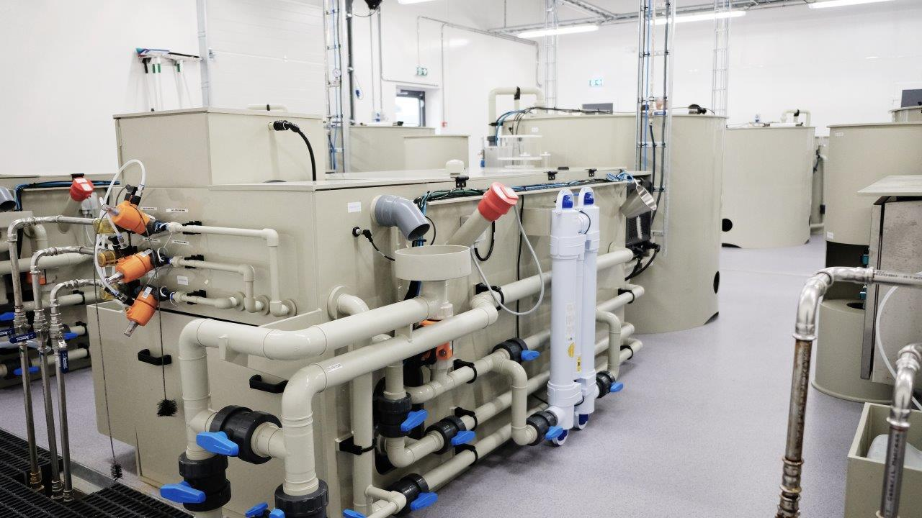

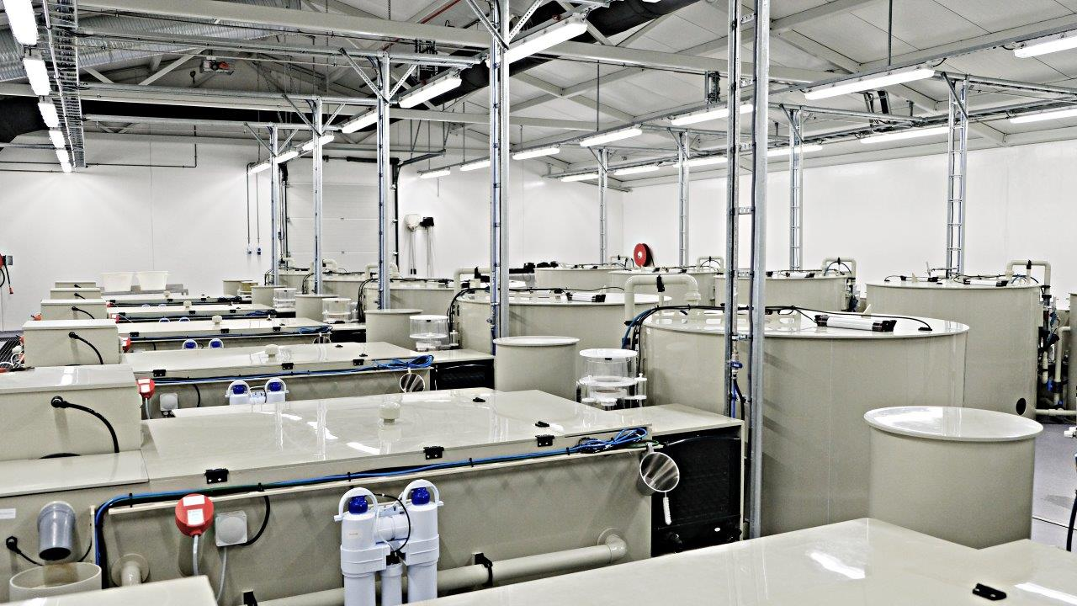

## Skretting case study 2

**Insect meal a first in commercial Skretting feed**

Skretting Norway’s factory in Averøy produced commercial salmon feed with insect meal for the first time in 2018. Nordlaks is the first customer to test the feeds containing insect meal, with 360,000 salmon fry receiving this pioneering feed.

"*We expect it to be as good as our regular feed and hope that the commercial test will show the same good results as Skretting has seen in its efforts to improve feed intake*," says Eirik Welde, freshwater director in Nordlaks.

Insect meal offers a more sustainable alternative to fish meal and soy. Siri Tømmerås, responsible for Skretting Norway’s feed for land-based farming, explains the results from experiments where fish show the same growth performance with feeds using insect meal as with traditional protein sources: *"Insects are an important food for wild salmon, and we see that insect meal can increase appetite in the fish. This is an interesting find, and we continue to take advantage of it,”* says Tømmerås.

**Solving quality challenges with insect suppliers**

Skretting believes insect meal will be an important protein source for aquaculture feeds in the future. They are using their expertise to help producers scale up production. "*The challenge has been to find manufacturers that can produce enough volume with consistent, good quality. We have seen more than thirty manufacturers and ended up moving forward with a handful of suppliers. After close cooperation for a long period of time, we have now obtained the raw material at a quality level that we can count on in the future,”* says Tømmerås.

**Consumers are positive about the sustainability story**

The feed produced by the Skretting Norway factory contains insect meal made from the larvae of the black soldier fly – an EU-approved commodity. Surveys show that Norwegian consumers are more positive about eating salmon that has had insect meal in the feed than other Europeans.

"*People who have grown up near a salmon river know that insects are natural foods for the salmon. People who have not thought as much about what a salmon eats are positive about insect meal when they hear that this is a good and sustainable raw material,*” Welde says.

**Industrial production of insect meal must be increased**

In the European market, there is now little available insect meal for use on a large scale, and Skretting is working with manufacturers who want to reach a commercial level of production. Ideally, by 2022 there will be at least five different European suppliers, each producing 20,000 tonnes of insect meal per year – or two-thirds of the amount of soybean concentrate Skretting Norway uses today.

"*Our goal is that in the future, ingredients used for aquaculture feed should not compete with food for human consumption. For us, it's important to invest in alternatives like insect meal*," says Mads Martinsen, Skretting Norway's Product Development Director, who has several new commodity projects in progress.

**Other new raw materials in the pipeline**

"*Insect meal seems to taste good to the salmon, which in nature are used to insects. We are also currently testing the plankton Calanus, which is a natural part of the wild salmon diet. When we explore further down the food chain, in fact, the Nordic waters have as much Calanus as the total biomass of all wild fish and sea mammals combined. The authorities have opened the plankton for regulated fishing, and Skretting is already commencing commercial trials with Calanus. Initial results show that salmon also like the taste of this plankton, so we have a fantastic new resource in addition to insect meal*," says Martinsen.

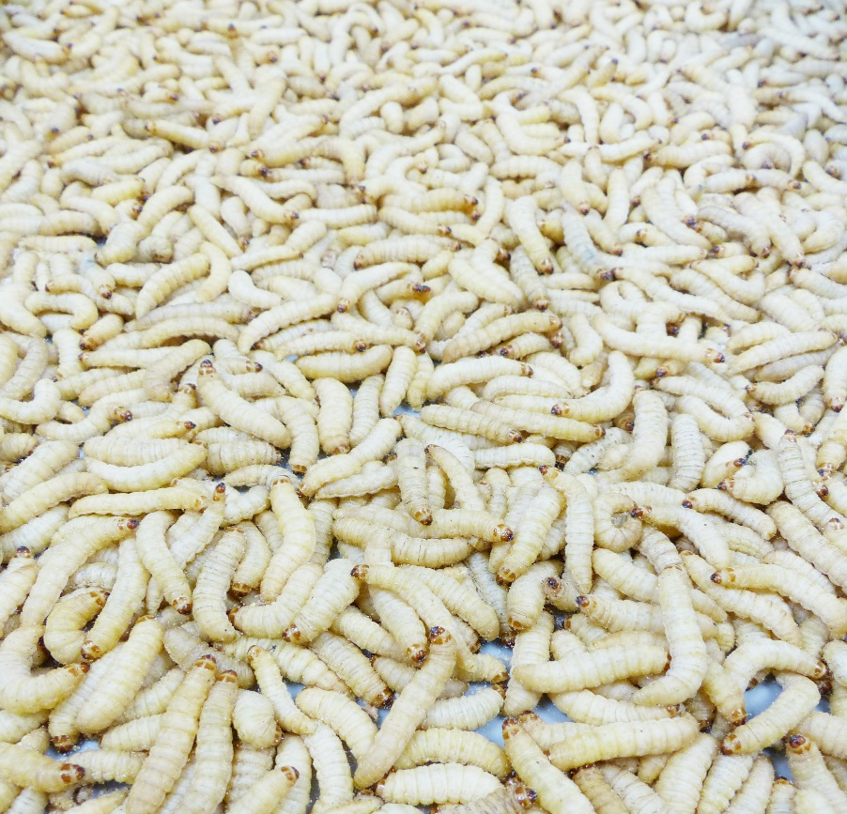

## Skretting case study 3

**The farm in the palm of your hand**

The launch of Skretting 360+ is an important step in the division’s long-term commitment to enabling Ecuador’s shrimp industry to sustainably increase its production while reducing its exposure to risk. This ground-breaking concept empowers farmers to bring much improved cost-efficiencies to their farms, and has been proven to boost farm profitability by up to 200%.

Using technology to bring innovation to the very manual process of shrimp production, Skretting 360+ is a complete package of precision-based tools, incorporating nutrition, farm management practices and technical services, most of which are accessible through a mobile app.

The team in Ecuador worked closely with Skretting’s global research unit, Skretting Aquaculture Research Centre (ARC), on the tool. The ARC analysed many aspects of shrimp feed management and health support over the course of several years, to find the best nutrient composition for its feeds as well as the best number of feed occasions for optimal growth.

This new concept also incorporates Skretting’s latest growth models and services, that can forecast and enhance farm performance. The system uses on-farm sensors to collect real-time data on a number of indicators that influence farm performance, including oxygen, temperature, feeding behaviour and waste. The moment a potentially problematic event occurs at a customer’s site, these sensors automatically inform Skretting Ecuador’s team of technicians, based at a central monitoring facility[“, so that they can help the farmer to manage the issue”?].

Each shrimp farm is unique with its own specific requirements. Skretting 360+ utilises this data and analysis to help each farmer better understand exactly what is happening in the water and enable them to make more informed choices about their operations.

The concept’s principle aim is to maximise shrimp farmers’ profit per hectare, per day. With the shrimp industry currently booming in Ecuador, Skretting 360+ has come at the ideal time to help farmers capitalise on the unprecedented global demand for high-quality, responsibly produced shrimp products.

The launch of Skretting 360+ followed a series of extensive trials conducted within Skretting’s own R&D systems as well as through performance evaluations in commercial shrimp farms. Together, these assessments provided conclusive evidence that, with Skretting 360+, shrimp farmers can expect to operate much more cost-efficient, productive and profitable businesses.

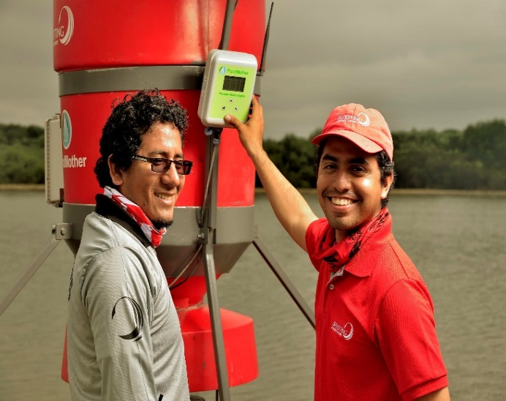 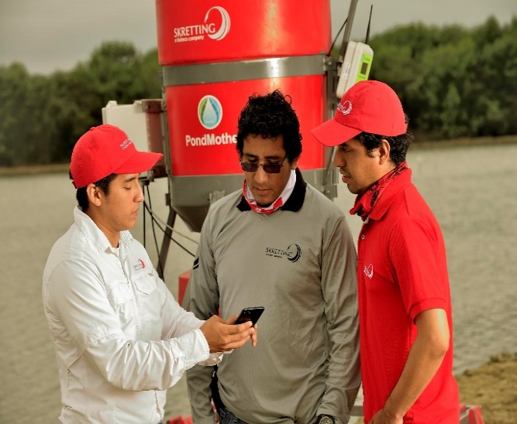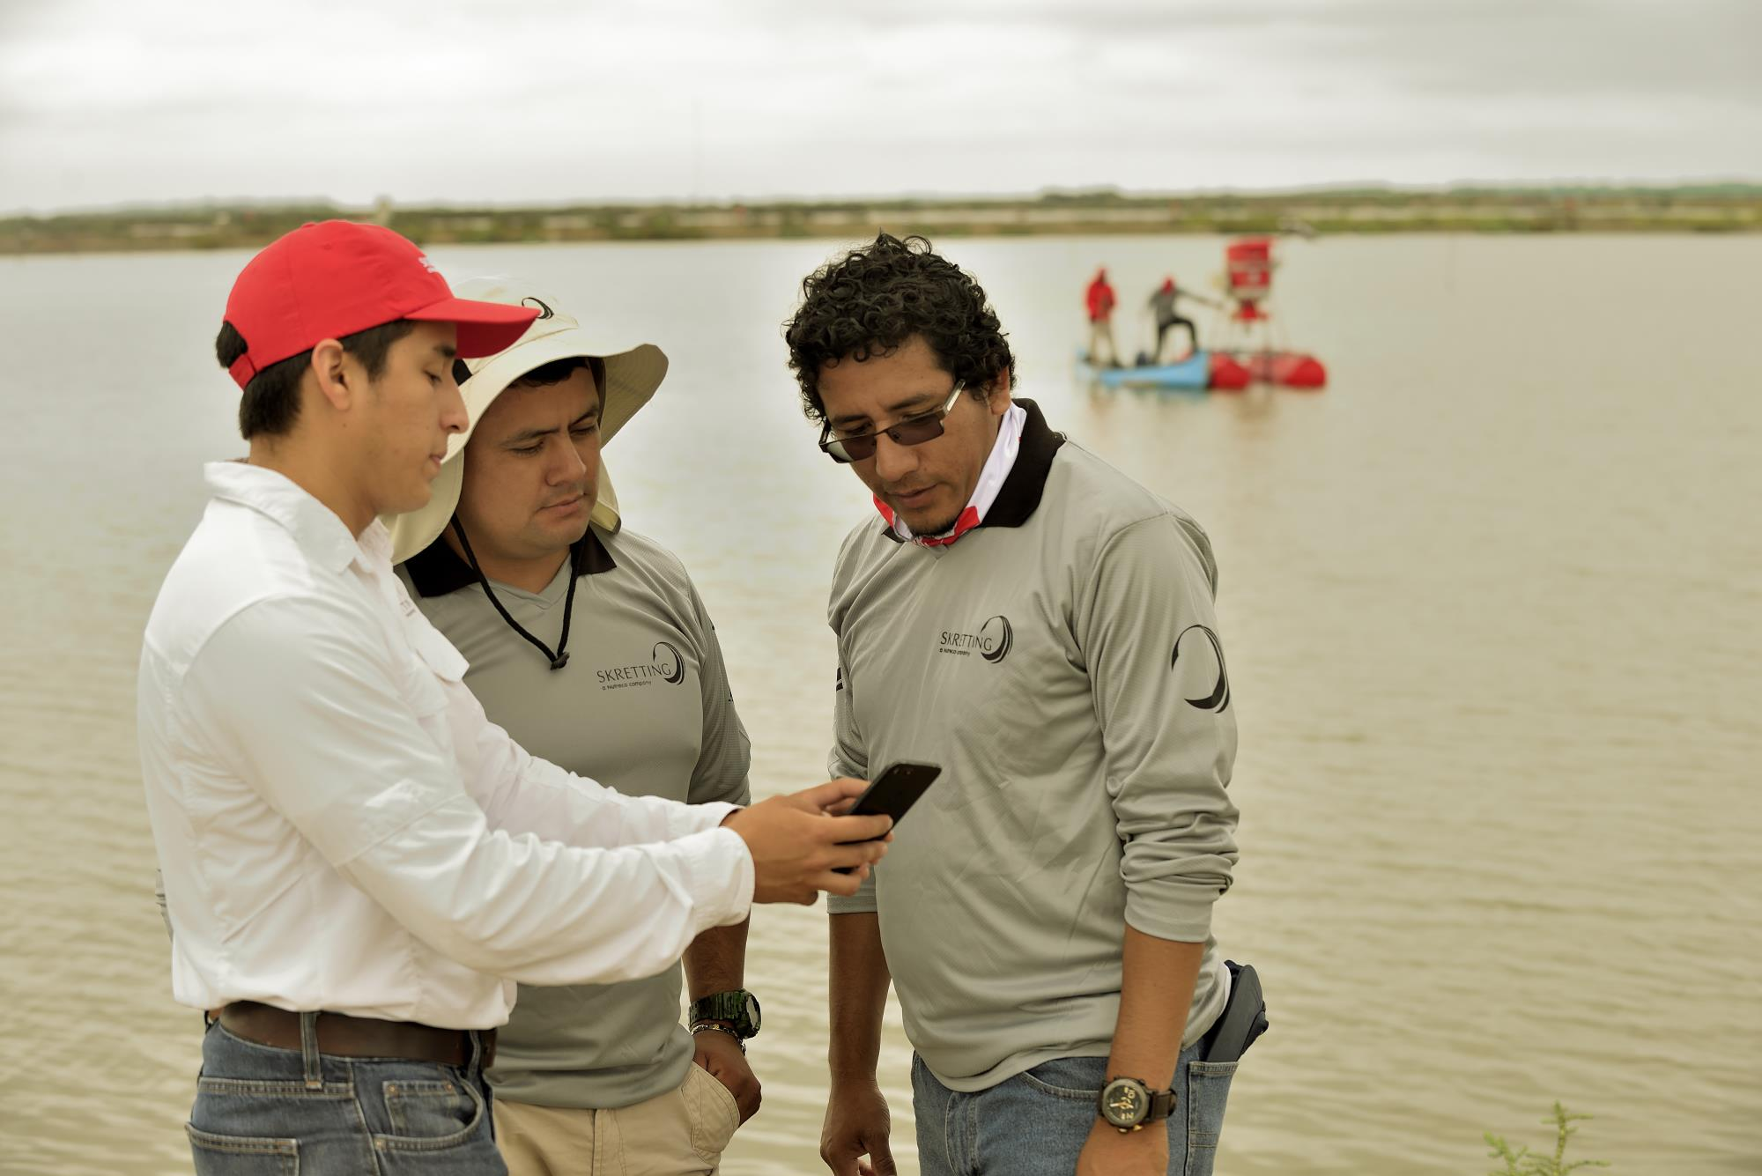

# Sharing our dilemmas with you

Although we recognize that we need to monitor and reduce our energy and water consumption and landfill waste, the most significant part of Nutreco’s environmental footprint is produced in the supply-side of our business model and activities. Our largest impacts on climate change and biodiversity loss take place in our supply chain and, in some cases, our customer base. Several of the issues connected with our wider environmental footprint are complex, extend to scope-3 suppliers, involve governmental and regulatory action – often across international lines – and/or often prove cost-prohibitive to implement. We call these issues “dilemmas,” because there is no easy fix, and resolving them often involves many layers and external stakeholders at international trade and industry-wide scale. The following three issues continue to be major challenges for which Nutreco dedicates significant resources and goodwill to find solutions.

## Deforestation-free Related image

The components of the supply chain that impact and are vulnerable to deforestation are complex. Most stakeholders (NGOs, food retailers and consumers) are in general agreement that palm oil, soybean and corn on the supply side and beef production on the customer side are the most readily highlighted commodities fuelling deforestation. Deforestation is often legally permitted by governments based on an economic rationale. Solving this economic issue will require engaging stakeholders from multiple layers of the value chain to address a vast spectrum of issues, ranging from improving production efficiencies to addressing the ethical and economic well-being of society. Resolving this dilemma in the supply chain is perhaps one of the greatest leadership opportunities of this generation, and Nutreco cannot solve this alone.

In 2017, Nutreco was one of 23 founding member signatories of the Cerrado Manifesto Statement of Support. We are also a signatory (through our Skretting division) of the New York Declaration on Forests, collaborate in the Roundtable for Responsible Soy (RTRS) Syntegration Steering Committee and are engaged with the Collaboration for Forest & Agriculture (CFA) in Brazil, all in support of addressing deforestation issues.

While we are aware that agriculture commodity raw crops and beef production are principle drivers in deforestation, we also recognize the ethical dilemma in the perception that countries like Brazil are disproportionately responsible, when they still retain up to 65% of their land area as virgin forest, compared to 35% in the United States and less than 5% in some European countries. We also recognize that Brazil’s recently reformed (2012) Forest Code is among the best in the world. Europe, and especially the European countries of the Amsterdam Declaration partnership, is working on deforestation-free, sustainable commodities, and highlighting the importance of preserving forests in order to reach the goal of 2 degrees Celsius. Brazil, Uruguay and Argentina are also signatories to the Paris Climate Agreement and have the ambition to limit deforestation.

The response to deforestation is neither simple nor one that any one company, however committed, can resolve. This is a task for the entire industry sector, governments and civil society to address together. Since 2015, we have purchased book & claim certificates to offset 100% of all palm oil ingredients purchased through our global business, excluding palm kernel oil, which accounted for 15% of our total palm oil purchased in 2018. The decision to exclude palm kernel oil is due to the limited availability of this product and the associated costs. In addition, 100% of the soy purchased by Skretting Norway and Skretting Australia is Proterra-certified.

Nutreco is convinced that a large component of the solution to this dilemma lies in bringing technology to the discussion. Beef herd intensification on pasture land with a holistic approach to best practices, including nutritional solutions supplied by Trouw Nutrition and its competitors, can go a long way to increase beef production output without the need to expand pasture land through continued deforestation. Integrating real-time land use satellite imagery to allow the market to select agricultural commodity row crops from farms not engaged in continued deforestation can lead to the transparency and accountability the market demands. Nutreco is committed to these industry-wide, pre-competitive approaches and will continue to participate as part of the solution.

## Antimicrobial resistance (AMR) Image result for SDG icons

The World Health Organization is estimating that by 2050, more people will die of bacterial infection that is resistant to medical antibiotic treatment than will die of cancer. This will be one of the challenges that future generations will be faced with if we don’t begin to address it today with effective and practical technology.

The inappropriate and excessive use of antibiotics in human and animal health, as well as in animal production, is considered to be a major driver for the development of antimicrobial resistance (AMR). Antibiotics are used in animal production for disease prevention and treatment and as growth promoters. They are often administered through feed. It has been estimated that about 80% of all antibiotic use is in animal production and this may increase by as much as 67% over the next decade. The complexity of using antibiotics across the production sector varies widely and may or may not always be supported by regulation or proper veterinarian oversight. Many animal nutrition companies offer viable solutions, but these are not being adopted at as widely as they should be.

Reducing the inappropriate use of antibiotics is on the agenda of companies, governments and NGOs worldwide. The World Health Organization, World Organization for Animal Health and the UN Food and Agriculture Organization have recommended that medically important antibiotics should be used in food-producing animals only to treat diseases and to prevent an imminent threat of infection. They recommend that producers should phase out the use of antimicrobials for growth promotion. To make this possible, farmers will need to implement additional measures to maintain productivity while reducing the use of antimicrobials.

The good news is that there is a wide range of good practices available in animal husbandry, hygiene and nutrition for reducing the need to use antibiotics. Taking an integrated approach, that combines multiple methods and involves a range of stakeholders in the value chain has shown the most promising results. In general, it is important to focus on reducing the risk of infection from environmental factors while optimizing the animals’ disease resistance and resilience. This approach needs to include the minimization of social and environmental stress, well-targeted vaccinations, appropriate breeds and diets that promote resilience.

It is important that animal nutrition strategies not only provide the proper amount of nutrients for body functions, such as reproduction and growth, but also help to sustain animal health and welfare. Nutrition can influence functions in the animal that are critical for host defence and disease resistance, improving its resilience when exposed to infectious diseases. Quality animal feed can ensure gut function by stabilizing the intestinal microbiota and strengthening the mucosal barrier; while feed safety will decrease the chances of feed-borne pathogens affecting the animals.

## Who will pay? Overcoming the cost obstacle of innovative ingredients

As we look to become increasingly flexible and sustainable in our feed formulation, we are finding that many new and novel ingredient innovations, often from start-up companies, are offering compelling solutions to the challenge of limited availability of traditional ingredients.

Often, these exciting proposals come to our attention at a stage while production still is in limited volumes. The costs are also often significantly higher than traditional ingredients, limiting the ingredient’s commercial viability. This presents a frustrating roadblock for advancing novel ingredients and innovation in the feed supply sector. As a direct result, Nutreco and Skretting have begun a number of initiatives targeted at making a paradigm shift in the business model – and so far we’ve seen some encouraging success.

The new model brings the entire value chain to the sales meeting between a processor, distributor and food retailer buyers. With everyone present at the table – including the novel ingredient manufacturer, feed manufacturer, fish farmer, fish processor and fish distributor – we can generate greater understanding and have a candid cost conversation that can often facilitate the uptake of “expensive” alternative ingredients. The discussion often helps all parties to realize that including the alternative feed ingredient only leads to a nominal incremental cost increase on, for example, the final 200-gram fillet of farmed salmon on the food retailer’s shelf.

We will continue to adjust the model, but based on our success in using this approach to come to workable solutions in some preliminary meetings, we believe it will ultimately support the mainstreaming of “high cost” novel alternative ingredients into the commercial value chain.

# Creating a positive impact with our community development projects

According to the World Bank, the percentage of people living in extreme poverty globally fell to a new low of 10% in 2015 (the latest data available) – down from 11% in 2013. The number of people living on less than USD 1.90 per day fell during this period by 68 million to 736 million. Still, the World Bank estimates that in 2018, 8.6% of the world’s population lived in extreme poverty. The latest projections show that if we continue on our current path, by 2030, it will become impossible for the world to eradicate extreme poverty. It is becoming even more difficult to reach the people who need help, as they often live in fragile countries and remote areas.

At Nutreco, we believe that a major component of sustainability is about *“producing more with less,”* but we have revised this mantra to include, *“... but in the right places!”*

We believe our five Community Development Programs are making a difference in the communities where we operate. One of the distinguishing features of these projects is that they are based on the concept of creating shared value. By raising awareness and sharing technology and best practices on the one hand, and offering appropriate nutritional solutions on the other hand, we empower small farmers, living in extreme poverty, to improve their economic situation. Our near-term target is to seek international partners who will join us to build on these results and increase the number of small producers we can impact.

The following five projects reflect the positive and encouraging results of our Community Development Projects.

## Nigeria Related image

**Helping small farmers grow catfish sustainably in the Ibadan region**

For the past three years, Nutreco and Skretting have worked together to help small farmers grow catfish sustainably in the Ibadan region of Nigeria, where 49.1% of the population lives below the poverty line. Our Nigerian project has been extremely successful, enabling farmers to pursue a sustainable income source that has significantly increased their standard of living. As a result, enrolment in the project increased from 50 farmers in 2015 to 258 farmers in 2018, of which 29% are women.

By participating in the project, farmers receive technical support from the Skretting team, through the sharing of best practices as well as physical visits to their ponds to address questions and resolve challenges. They also have access to a revolving fund that allows them to pay for the feed when they are better able to, after the harvest. Group meetings held every six months provide an open communication space where participants share results and discuss solutions for the challenges they faced during the farming cycle.

Positive results from the first cycles encouraged over two hundred additional farmers to join. When a farmer joins the project, he or she first receives training on pond preparation, stocking, feed management and the importance of data collection. Daily data collection in the Farmer Information System (FIS) booklet is one of the greatest takeaways for participants. Recording mortality rates, increasing average fish weight and feed consumption allows farmers to actively control fish growth, supervise farm management and respond quickly if they detect problems. Upon reaching the harvest stage, farmers learn about farm finance and marketing.

Participating farmers work together to ensure the water quality in the ponds remains adequate. As access to water from rivers is limited, a water outlet of one farmer’s pond may be the water inlet of another farmer’s pond. Consequently, a problem in one pond can quickly affect other ponds. Cooperation between adjacent pond owners and quick responses to problems helps the farmers avoid the spread of diseases and make sure the catfish are healthy and grow at the expected rate.

The active and committed participation from the farmers, the constant support from the local Skretting team and the strong partnership with the local NGO, Justice Development and Peace Centre (JDPC) have allowed the farmers to achieve excellent results. They have been able to overcome challenges, such as how to construct appropriate ponds and determine the best harvest weight. As a result, average annual family net income increased by 215% and Feed Conversion Ratios improved by 41% compared to baseline data at the beginning of the project.

We are proactively looking for external partners to help us expand the positive impact this project has achieved during the past three years. Scaling up the number of farmers has proved challenging, but, with more investment, could reach into the thousands to better address poverty in the Ibandan area and beyond. The next steps in the project will be to organize and promote more fair fish prices in the local markets where farmers sell their fish.

|  |  |  |  |
| --- | --- | --- | --- |
| **KPI** | **Baseline** | **2018** | **Improvement** |
| Feed Conversion Ratio | 1.57 | 0.93 | 41% |
| Harvest weight (g) | 578 | 870 | 51% |
| Survival rate (%) | 71% | 94% | 32% |
| Annual family net income (EUR) | 173 | 544 | 215% |

[ **Quotes: Could be in a sidebar** ]

* *“The training received taught me the ups and downs of raising fish. My profit increased massively compared to what I got before the project*.” – Funmi Egbedina
* *“The project has offered me excellent scientific, financial management and training programs. It has transformed me from a novice to a competent and profit-making fish farmer.”* – Adebimpe Akindele
* *“We have enhanced the production of healthy fish in our society. I no longer use rotten eggs, offal and dead animals to feed my fish, and dangerous chemicals for ponds preparation are no longer in use.”* – Akinola Komolafe
* *“The project has given hope to catfish farmers and sustained their interest in aquaculture through various interventions, with full support from Nutreco and Skretting.”* – Olorode Bolanle, HOD Integrated Development Project, JDPC

## Zambia Related image

**Increasing income through sustainable tilapia farming**

We implemented a community development project in Zambia in August 2018 in the Mpulungu region, in the northern part of the country. More than half the population in Zambia lives below the poverty line, and aquaculture is a significant sector in the country´s economy: on average, people in Zambia obtain 27.8% of their animal protein intake from fish. This percentage is high compared to the rest of Africa, where fish represents on average 18.4% of all animal protein intake (UN Food and Agriculture Organization (FAO), 2018)

The project aims to create shared value by helping forty local small-scale farmers increase their livelihoods and income by sustainably producing tilapia. In addition, it focuses on promoting aquaculture development by presenting fish farming as a profitable main economic activity, instead of a side business, to farmers whose main income currently comes from growing maize. Through the project, Nutreco is promoting women empowerment in aquaculture in the region, as 45% of participating farmers are women.

Access to feed and technical support and the availability of tilapia fingerlings have been the main challenges for fish farmers in the Mpulungu region. So, to address this, Nutreco is offering them technical support and providing them with fingerlings as well as fish feed. Together with our partner, Worldfish, a leading fish research institution, we will train farmers and promote best aquaculture practices in the region.

At the start of the project, enrolment was a challenge, because farmers had suffered losses in previous fish farming experiences. The project represents a new opportunity for the farmers to get involved in a profitable fish farming endeavour.

We will hold four workshops throughout the duration of the community project, addressing different topics depending on the famers´ needs at the time. Workshops also provide an opportunity to get all the farmers together to discuss positive outcomes, challenges and events they would like to share with the rest of the group.

The project is off to a good start, having achieved a mortality rate of less than 2% during the stocking of the fingerlings. The challenge now is for farmers to continue recording farm and feed management data. The next milestones will be the harvesting – expected to happen in May 2019 – and selling of fish in the local markets.

**[ Quotes: Could be a sidebar ]**

* *“I personally was hesitant [to join the project] but I decided to give it a try. Look at my fish, I am so proud and can’t wait to see the results.”* - Batista Mulenga
* *“I am now sure that this is a true project. It will be my first time using formulated feed and I will make sure I put it to good use.”* - Katai Lwao
* *“I would love to see the whole community continue fish farming even when Skretting goes. We will learn a lot from this project and thank you team Skretting for making us realize that fish farming is a business.”* - Mutale Lwao

## Guatemala Related image

**Plumas project: creating a poultry farming cooperative in Zacapa**

In the La Fragua region of Guatemala, 89% of people live in deep poverty and nearly half of all children suffer from chronic malnutrition. The Plumas project strives to secure a sustainable source of income for families who are suffering from a lack of economic and social supports in Zacapa, Guatemala, by creating a poultry farming cooperative. The project is a cooperation between Trouw Nutrition and Good Neighbors Guatemala and is supported by the Vice Ministry of Rural Economic Development (VIDER), which is part of the Ministry of Agriculture, Livestock and Food.

In 2018, we had a total of 47 families participating in the project, up from 22 in 2017. Each family has been provided with a poultry farm package that consist of a henhouse, drinking troughs, troughs, bedding, 100 laying hens and feed concentrate for two months. In December 2018, we finalized the construction of 25 additional henhouses and another delivery of hens.

To give the families the best start possible, on the day the hens were delivered, Trouw Nutrition veterinarian Lucy Garcia provided two practical trainings on nutrition and common diseases. These trainings were filmed and made available to the families for further reference. Trouw Nutrition also performed technical as well as onsite analyses to help identify improvement points per family regarding the current management of hens as well as attention points to take into account when the newly purchased hens were delivered.

The project is in the final phases of obtaining the legal status of a cooperative. The families received the required training course from the National Institution of Cooperatives, where they learned skills in business administration, organizational management and basic finance and accounting. With this legal status, the members will benefit from increased bargaining power and be able market their eggs in a more professional way.

The egg cooperative has struggled to make a profit from its business in 2018. Most of the families do not have enough, if any, experience in managing their own business, and we have found it is difficult to increase the margins they make on selling the eggs. We will address these challenges with a number of initiatives:

* Buying potable water takes up more than 15% of the farmers’ weekly income. In 2019, we will start constructing a water well to tackle this problem.
* Now that the cooperative has nearly obtained legal status, we will renegotiate the cost of supplies needed for the production cycle. Through Trouw Nutrition’s industry connections, we have already realized a 7% saving on overall costs by reducing feed costs.
* In 2019, we will focus on new potential clients and distributors through our network who will buy the eggs for a more reasonable price. For this reason, we have also created a promotional video.
* A savings and credits sub group will be formed within the cooperative to train members on micro-finance skills so they can accumulate small capital to continue their business by purchasing hens with their saved money.

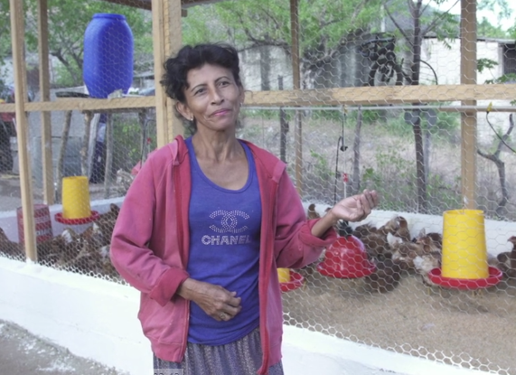

*“I hope that with the help of this project I can take care of my family, feed them; it will help us a lot.”*

Farmer: Rosa Elena Cabrera: *min.* *3:34 a 3:42*

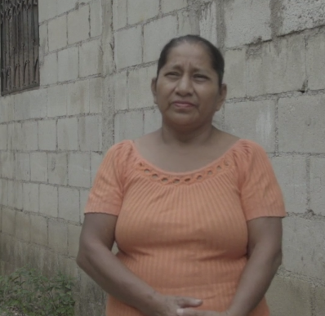

*“I decided to participate in the project because I have seen in other people the prosperity the project brought them.”*

Farmer: Paula Loyo: *min.* *3:54 a 4:01*

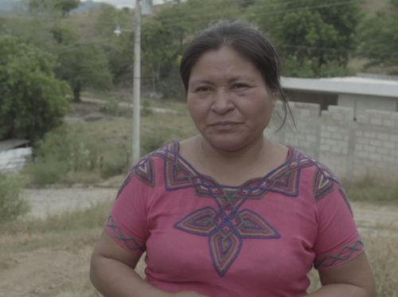

*“The difficulty with the water is that the water in the canal here is private property. We have learned a lot of different things: how to inject the chickens, how to vaccinate then and give them medicines. Besides the work with the hens, my son has received a scholarship, God blessed.”*

Farmer: Petrona Gomez: *min. 4:14 a 4:18, 4:40 a 4:46 y 4:50 a 4:58*

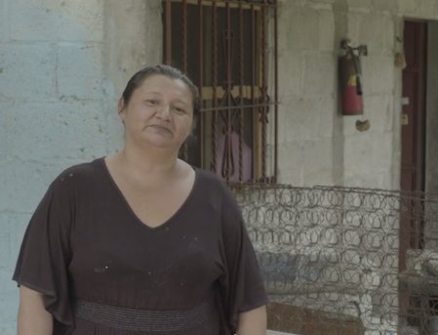

*“I decided to participate because it is something new that will help me cover my basic needs at home. I hope (the project) does not only help to cover my basic needs, but will also help me help my neighbors, because we can sell the product.*

Farmer: Elesbia Menjivar: *min.* *6:57 a 7:05 y 7:06 a 7:13*

## Vietnam Related image

**Increasing feed-to-food safety in a growing dairy industry**

The Vietnam Community Development Project was officially launched in June 2018. As in many Asian countries, dairy consumption in Vietnam is rapidly increasing and has doubled over the past decade. As a result, food safety hazards in milk products are growing in frequency. Trouw Nutrition Vietnam has joined forces with the Vietnamese National Department of Livestock Production, part of the Ministry of Agriculture and Rural Development (MARD), to increase feed-to-food safety in small-scale dairy production in the country.

The issue of aflatoxins is one of the major global feed-to-food safety concerns. Aflatoxins are mycotoxins produced by moulds in animal feed ingredients and are one of the strongest naturally occurring carcinogens. In small-scale milk production, there is a twofold danger related to aflatoxin contamination. Aflatoxin contamination in cow feed products has an adverse effect on efficient milk productivity but it also poses a human health risk as up to 6% of the cow’s intake gets transferred into its milk. This is especially dangerous for small children, whose diet consist largely of dairy and dairy-derived products. The Vietnamese legal limit for maximum toleration of aflatoxin in milk is aligned with the level set by the U.S. Food and Drug Administration and is ten times higher than the EU limit. Trouw Nutrition believes that its expertise, technology and nutritional solutions can play an important role in alleviating aflatoxin-related risks.

The community development project has several aims. One is to create viable models for increased domestic dairy production, including the proper food safety controls. A second is to help increase the income levels of Vietnamese small-scale dairy farmers. And, thirdly, the project aims to improve consumers’ access to safe dairy products. In 2018, we conducted a baseline study, consisting of a farm survey and analysis using Trouw Nutrition’s on-site testing method for aflatoxins. Preliminary results showed that aflatoxin was present in a number of milk samples, but all samples showed concentrations below the Vietnamese legal limit. This is a very positive observation, as there was no direct indication that Vietnamese dairy consumers are exposed to major aflatoxin-related risks. However, contamination levels differ from farm-to-farm and day-to-day. The government is looking to install systematic monitoring to eliminate all risks.

To date, through the project, several workshops were held for approximately 120 small-scale farmers, who typically own two to 40 cows. The workshops were instrumental in educating and raising awareness of the human health risks associated with high and/or chronic aflatoxin contamination in small-scale, home-based milk production as well as potential milk productivity loss. The farmer training focused on proper storage of feed as the main practice to limit aflatoxin contamination on farms.

The project will continue through 2019. Our objective is to develop small-scale farmer protocols to reduce aflatoxin contamination in feed, which will directly reduce contamination in milk products. In 2019, we will be organizing a major stakeholder event for different players in the dairy value chain focused on raising awareness. We will also complete the first phase of work towards implementing systematic monitoring and control as well as follow-up mitigation measures.

|  |  |  |
| --- | --- | --- |
|  | Before* | Target 2021 |
| Average number of cows | 11.3 | > 14.4 |
| Average milk production L/cow/day | 11.8 | > 17.7 |
| Daily income sales of milk (USD) | 6.02 | > 10 |
| % of milk samples exceeding U.S. legal limits | 0% | < 1% |
| % of farmers aware of the existence of aflatoxins | 0% | > 80% |

* Results presented are based on data found in Cu Chi District, July 2018.

**Quote: [Could be in sidebar box] ------- Photos sent by email**

“*Nobody in this room ever heard about aflatoxin before; this training helps us to understand about the dangers and how to prevent.*” Farmer in Cu Chi District

## Brazil Related image

**Helping small-scale dairy farmers in Minas Gerais**

Trouw Nutrition Brazil launched a Community Development Project in late 2018 to assist small dairy farmers from a very poor region in the state of Minas Gerais with the tools and opportunity to raise themselves out of poverty. The region where the project is being developed is known for severe droughts that compromise vegetation and the ability to raise cattle. Due to current conditions, many of the farmers are moving to urban centres seeking a better quality of life for themselves and their families.

The Community Development Project in Brazil is transferring knowledge to small dairy farmers through workshops and lectures on proper and efficient animal nutrition. Each farmer has an average of 10-15 dairy cows that produce four to five litres of milk per day. By April 2020, we expect to increase milk production by 25% and raise family incomes by 30%. This project will also empower women, further demonstrating their value in the household. In addition, we expect it to lead to better milk quality, better livelihoods and living conditions and encouragement for farmers' children to stay in school and families to stay on their farms instead of migrating to urban areas.

Trouw Nutrition Brazil is supporting the project with a project manager and will transfer best practices through its technical sales force. The group will show farmers in the region the benefit of growing their own fodder, so they can have it available all year long, and support them in using specific Trouw Nutrition products to increase milk production.

During the fourth quarter of 2018, this project was elected one of nine finalists at the Nudge Global Impact Challenge in the Netherlands because of its potential to have positive impacts in the community. The Challenge is an eight-month development programme for young professionals who are highly motivated to make a difference in the world. A Trouw Nutrition Brazil employee, Leticia Hanser, participated in this Challenge, representing Nutreco and the Community Development Project for Brazil.

# Our collaboration with multi-stakeholder platforms

## Seafood Business for Ocean Stewardship (SeaBOS) Image result for SDG icons

Nutreco continues to be a key contributor to the Seafood Business for Ocean Stewardship (SeaBOS) initiative. A brainchild of the Stockholm Resilience Center (SRC), the SeaBOS initiative is unique because it has transferred an ecological concept of “keystone species,” which are especially crucial for the functioning of their natural environments, to the business sector with respect to seafood production. CEOs from the ten largest global seafood companies (including fishing, aquaculture and aquafeed manufacturing) have joined forces through SeaBOS to create transformative change on the water and across their value chains.

The ten companies comprise Maruha Nichiro Corporation, Nippon Suisan Kaisha, Thai Union Group, Dongwon Industries, Mowi, Cermaq (a subsidiary of Mitsubishi Corporation), Skretting, Cargill Aqua Nutrition, Kyokuyo and Charoen Pokphand Foods. The work is divided into five task forces addressing, 1) Illegal, Unreported and Unregulated (IUU) Fishing & Modern Slavery, 2) Transparency and Traceability, 3) Improving Regulations, 4) Internal Governance and 5) Innovation.

Nutreco chairs Task Force 1, in partnership with SRC and through close collaboration with Maruha Nichiro Corporation, Charoen Pokphand Foods and Dongwon Industries as well as several external environmental NGOs. This task force is focused on delivering 1) A document that addresses the seven high-level voluntary principles and 45 main criteria to significantly reduce the prevalence of IUU Fishing activities and Modern Slavery and 2) A demonstration proving that the outfitting of commercial fishing vessels with deck cameras, crew facial recognition and captured fish species recognition computer software, vessel tracking and the use of blockchain platform technology can be economically feasible and effective in documenting and reducing these risks. The first component is intended for governmental regulators to potentially adopt into their national legislation programs and for companies to adopt into their corporate procurement policies. The second component is meant to be implemented and adopted into best practices by corporate fishing vessels and contractor fishing vessels protocols.

Our theory with SeaBOS is that change will succeed if food retailers and food service companies demand these practices, significantly reducing the access to market of suspect products in the supply chain. If it is successful, it will offer an unprecedented level of transparency and traceability in the high-seas fishing sector.

## Pincoy project Image result for SDG icons

**Pincoy: Collaboration and innovation for aquaculture in Chile**

The Pincoy Project was launched in Chile in 2016. It is a cooperative effort by seven companies spanning the entire salmon production chain, led by Skretting. The collective aim of the project is to reduce the industry’s antibiotic use by 50% through the sharing of knowledge and experience. We made considerable progress towards this long-term goal in 2018.

Historically, we have seen high usage of antibiotics by salmon farmers in Chile to control the Piscirickettsiosis (SRS) disease – a significant issue in the country’s salmon farming industry. Pincoy has confirmed that the SRS challenge can be proactively addressed through holistic measures. These include farming salmon that are genetically more resistant to SRS, using optimal vaccination strategies, feeding the fish with functional and high-performance diets, ensuring good farming conditions, and only performing appropriate and necessary handling.

After two years, Pincoy’s first four pilot farming sites in the X and XI regions have achieved very positive results and demonstrated the many benefits of focused, collaborative work. In addition, they have inspired the development of the “Good Practice Guide for Salmonidae Cultivation,” a manual that will be shared with the broader industry. The greater industry-wide emphasis on better production practices helped reduce the rate of antibiotic use in the Chilean salmon farming industry by 23% in 2018 (Source: Sernapesca).

Building on these successes, the partner companies are now preparing the second phase of the project, Pincoy 2.0, and identifying its strategies for further reducing antibiotic use.

## AquaVision Related image

Meeting the challenge of sustainably feeding the world in 2050 requires coordinated contributions from many stakeholders. Academics, aquaculture and agribusiness, food manufacturers, retailers, environmental groups, regulators and politicians need to work closely to identify, facilitate and implement the most significant improvements to the aquaculture industry so we can reach this goal.

Since 1996, AquaVision has served as the world’s premier aquaculture business conference. It brings together key stakeholders from business and government alongside leading global experts, scientists, speakers and decision-makers. Skretting and Nutreco take pride in the calibre of attendees at AquaVision, including presidents, CEOs and directors from the world’s leading and largest aquaculture companies. Fully booked conferences, with more than 400 stakeholders from over 40 countries attending, have highlighted the importance of AquaVision as a meeting place for leaders in the global industry.

In 2018, the AquaVision delegates welcomed former Secretary-General of the United Nations, Ban Ki-Moon as a keynote speaker. During his address, Ban Ki-Moon made the point “*the critical work you pursue in the fields of aquaculture, ocean sustainability, and food security is increasingly essential to ensure the future viability of both our planet and humanity.*”

Previous keynote speakers of note included HRH Crown Princess Victoria of Sweden, Sir Bob Geldof, and the late former Secretary-General of the United Nations, Kofi Annan.

The two-day conference provides the critical context and a forum for new ideas and challenging thinking. AquaVision 2018 provided an important networking opportunity contributing to stakeholder discussions on one of the biggest challenges of our time – delivering global food and nutrition security – aligned with the specific challenges and opportunities facing aquaculture today and in the future.

Attendee sectors:

• Farming • Pharmaceuticals

• Breeding • Processing

• Hatchery • Retail

• Processing • Non-governmental organisations

• Feed and nutrition • Logistic providers

• Finance/banking • Distribution

• Investors • Politicians

• Aquaculture technology providers • Public administration

• Ingredient and raw materials • Media

# Human capital

One of the cornerstones of Nutreco’s strategy is to employ talented and passionate professionals. Our committed employees, who feel proud to work for a global leader in animal nutrition, are the most important ambassadors of our employer brand.

In line with this strategy, our human resources strategy consists of three focus areas:

1. **Global talent and management development**

During 2018, Nutreco strengthened its talent management strategy. We made our talent review and succession management processes, which cover over 100 senior positions, more focused and efficient, establishing quality development plans for employees and ensuring leadership succession.

Because talent acquisition is about finding the right person for the right position at the right moment, we have identified a group of 65 emerging talents working across 23 different countries, enrolled them in a special training programme and continue to track their progress closely. We will continue to focus on talent in 2019, taking different approaches for different groups of employees within the company, in order to develop a unified structure of leaders, professionals and experts. By promoting a working environment consistent with our values (caring, collaborative, innovative and capable) we are making sure our talent management structure supports shared success by Nutreco and our employees. Similarly, SHV’s young talent programme (2:2:2 programme) continues to successfully create opportunities for growth. Currently, 11 young talents were hired by Nutreco as part of this SHV program, which aims to strengthen our general management pipeline.

“To do great things, you need great people more than anything else. Moreover, to achieve our ambitious objectives, we need our people to perform their best and develop to their full potential. Our managers play an active role in identifying, developing and growing our people. We encourage an entrepreneurial way of working, challenging the traditional ways of thinking and doing and sharing ideas and capabilities,” explains Sylvia Houwers, Global Talent Manager at Nutreco.

1. **Develop capabilities for the global market**

Since Nutreco’s restructuring in Q4 2017, we have remained focused on building capacity to serve both our local and global client base in the best way possible. As part of this, we made considerable progress in establishing a strong and consistent leadership approach, and in developing innovative and commercial skills. We established a blueprint for our divisions’ sales organizations, including a sales and product-training curriculum, and are currently in the process of reviewing our variable incentive scheme.

In terms of learning and development, we launched several new learning initiatives in 2018. We expanded our sales excellence curriculum with the addition of a basic sales skills course (Sales Foundations) as well as sales coaching. In addition, 12 sales training workshops were organized throughout the company during the year.

1. **Building our innovative global culture**

Although we have made significant progress in improving diversity of nationality in our leadership team, Nutreco’s two main boards, as well as our wider senior management, are still predominantly male. However, the talent pipeline looks more promising in this respect, showing an increased percentage of female top potentials and emerging leaders compared to last year. We actively encourage diversity of gender, geography and thinking style in our company, as we believe that more diverse teams lead to better decision making, which is a key business driver for us.

During 2018, we also introduced an online Cultural Awareness Program. The key benefit of this platform is that it helps our employees gain a better understanding of cultural differences, enabling them to develop strategies to enhance communication and improve collaboration. In total, 469 employees have used the platform.

|  |  |  |  |  |  |  |  |  |  |  |  |  |  |  |  |  |  |  |  |  |  |  |  |  |  |  |  |  |  |  |  |  |  |  |  |  |  |  |  |  |  |  |  |  |  |  |  |  |  |  |  |  |  |  |  |  |  |  |  |  |  |  |  |  |  |  |  |  |  |  |  |  |  |  |  |  |  |  |  |  |  |  |  |  |  |  |  |  |  |  |  |  |  |  |  |  |  |  |  |  |  |  |  |  |  |  |  |  |  |  |  |  |  |  |  |  |  |  |  |  |  |  |  |  |  |  |  |  |  |  |  |  |  |  |  |  |  |  |  |  |  |  |  |  |  |  |  |  |  |  |  |  |  |  |  |  |  |  |  |  |  |
| --- | --- | --- | --- | --- | --- | --- | --- | --- | --- | --- | --- | --- | --- | --- | --- | --- | --- | --- | --- | --- | --- | --- | --- | --- | --- | --- | --- | --- | --- | --- | --- | --- | --- | --- | --- | --- | --- | --- | --- | --- | --- | --- | --- | --- | --- | --- | --- | --- | --- | --- | --- | --- | --- | --- | --- | --- | --- | --- | --- | --- | --- | --- | --- | --- | --- | --- | --- | --- | --- | --- | --- | --- | --- | --- | --- | --- | --- | --- | --- | --- | --- | --- | --- | --- | --- | --- | --- | --- | --- | --- | --- | --- | --- | --- | --- | --- | --- | --- | --- | --- | --- | --- | --- | --- | --- | --- | --- | --- | --- | --- | --- | --- | --- | --- | --- | --- | --- | --- | --- | --- | --- | --- | --- | --- | --- | --- | --- | --- | --- | --- | --- | --- | --- | --- | --- | --- | --- | --- | --- | --- | --- | --- | --- | --- | --- | --- | --- | --- | --- | --- | --- | --- | --- | --- | --- | --- | --- | --- | --- | --- | --- |
| |  |  |  |  |  |  | | --- | --- | --- | --- | --- | --- | | **Employee by Gender and Contract type** | | | | |  | |  |  |  |  | **2018** | **2017\*** | | Number of employees at year end | | | | 12,292 | 12,383 | | Full-time |  |  |  | 94% | 94% | | Part-time |  |  |  | 6% | 6% | | % women |  |  |  | 25% | 27% | |  |  |  |  |  |  | | **Employees Gender per Division** | | |  | **2018** | | |  |  |  |  | **Male** | **Female** | | Corporate | |  |  | 128 | 77 | | Trouw Nutrition  (including Nutreco Iberia) | | | | 6,123 | 2,429 | | Skretting | |  |  | 2,952 | 583 | |  |  |  |  |  |  | | **Number of Employees per Division** | | | |  |  | |  |  |  |  | **2018** | **2017** | | Corporate | |  |  | 205 | 241 | | Trouw Nutrition (including Nutreco Iberia) | | | | 8,552 | 8,803 | | Skretting |  |  |  | 3,535 | 3,339 | |  |  |  |  |  |  | | **Employees per region** | | |  |  |  | |  |  |  |  | **2018** | **2017** | | Asia Pacific | |  |  | 1,664 | 1,499 | | Africa | |  |  | 435 | 385 | | Europe | |  |  | 5,778 | 5,933 | | North America | |  |  | 2,154 | 2,113 | | South and Central America | |  |  | 2,261 | 2,453 | | | | | |  |
|  |  |  |  |  |  |
| **\***The 2017 data collection system has been updated and therefore numbers for 2017 have been corrected with regard to our 2017 report | | | | |  |  |

## Global Community Day

Our 2018 Global Community Day was again a great success. Although this year’s global participation was down, totalling 3,400 compared to 4,000 in 2017, the number of local community projects increased from 102 in 2017 to 130 in 2018 in 25 countries.

Activities again ranged from painting elementary school classrooms to building school furniture, gardening and cleaning parks, taking adults with intellectual disabilities out for a day excursion on a boat and taking children with intellectual disabilities to the zoo. These projects often leave a long-term positive impact in the communities where we operate. In one such activity, a participant prepared for the day by proudly wearing the Nutreco t-shirt she had received two years prior during the same boat excursion. Colleagues at Trouw Nutrition Turkey said*, “I was proud to share our community day visit to an elderly care house. We renovated their recreational facility and for their bocce team we gave a whole new bocce set to them. But most importantly, we listened to them. We listened to their stories, we felt their emotions. I believe that the feeling of being heard and cared for is probably the best gift that we can offer them. I, personally, felt grateful for participating in such an event. I hope we managed to make a difference for them even for a day because, as our values say, ‘we care,’”* said Mert Tuzuner. Van Thuy Nguyen from Skretting-Vietnam said, “*Community day was actually a productive day – we had no time for a break, everyone worked very hard but happily. And we received very good feedback about the day. Especially, engagement from some of our customers, which made us very proud.”*

In our experience, not only do our communities enjoy and appreciate engaging with us on this day, but our own employees enjoy giving back to society and bonding with each other outside of the workplace, building team spirit and collaboration.

## Ethics and compliance

In 2018, we further solidified Nutreco’s ethics and compliance programme. In addition to the Corporate Ethics & Compliance team, fully dedicated Ethics and Compliance officers are now working at both Skretting and Trouw Nutrition. Next to these, several Ethics & Compliance staff support our clusters (regional groupings of OpCos) and operating companies.

Ethics & Compliance Committees consisting of executive staff meet on a monthly basis at our corporate headquarters, Skretting and Trouw Nutrition. During these meetings, the committees review our entire ethics and compliance programme and discuss any major outstanding developments.

One key focus area during the year was data protection, driven by the EU General Data Protection Regulation that became effective in May 2018. We implemented a data protection framework encompassing all the legal requirements and we appointed a Data Privacy Officer with extensive experience.

We also devoted a lot of time and effort to compliance with competition law, reiterating our policy to associates through risk assessments, management presentations, and classroom training sessions.

We launched a new whistleblower facility, called Speak Up. All reports during the year were handled with due care and speed, and feedback was provided to the reporters on the results of investigations and any actions taken. Most reports concerned workplace respect and HR issues.

We introduced new policies on Third-Party Due Diligence, Anti-Bribery and Corruption and Trade Sanctions & Export Controls.

In addition, we drafted a new Code of Conduct, which will be rolled out and published on our website in 2019. It explains what we expect from our employees and leaders in terms of business and personal conduct, maintaining an appropriate workplace environment, protection of assets and information and reporting of compliance violations. The new Code will be an important contribution to our goal of ensuring sustainable ethics and compliance throughout our businesses.

# Feed-to-food quality and safety

Our continuous commitment to improve Nutreco’s quality management procedures is based on Nutrace®, a common quality management programme shared between Skretting and Trouw Nutrition. It not only enables us to ensure feed-to-food safety and quality, but also build our customers’ trust by offering them nutritional solutions that match their expectations and preferences. Through Nutrace®, we have been able to implement stricter standards to guarantee that people around the world enjoy healthier, safer and sustainable seafood and animal proteins.

We reached a milestone in 2017 with the finalisation of our multi-purpose Nutrace®-Hazard Analysis and Critical Control Points (HACCP) system. In 2018, we worked to even further improve our risk analyses and focused our efforts on trainings to reduce the probabilities of issues in our operations that could affect the performance of our customers or cause any harm to the animals or end consumer.

Our approach to food safety covers the entire supply chain through collaborative work with our partners. It starts with suppliers – rigorous audits and selection criteria help ensure we use raw materials that are safe and high-quality from a nutritional and social perspective. In addition to the compliance with our internal scientific and nutritional standards, we consider responsible sourcing to be a key component of supporting social and economic development in different regions globally. In the coming years, we will keep strengthening our processes with current and potential new suppliers, to provide the best possible alternatives for Feeding the Future in a sustainable way.

Last year, we also focused on strengthening the internal procedures of our integrated quality management (1QM) platform for monitoring the quality assurance and quality control of all our key business processes. This has allowed us to make important progress on standardising the methods implemented in our different operating companies across the world. We are working to optimise the sharing of information and best practices across our global company to ensure local consistency on the results through high-quality feeds.

Our operating companies also kept working closely with third-party independent bodies, customers and local authorities during the year to ensure compliance with internal standards, regulations and certifications and guarantee the consistent formulation and production of high-quality animal nutrition and fish and shrimp feeds.

In 2018, we put significant emphasis on the improvement of our tracking and traceability systems. Our aim was to ensure an efficient information flow between our divisions and their suppliers, farmers and buyers by updating our electronic systems and holding trainings for our employees.  “*The continuous improvement on the processes is not only important for our internal efficiency, but also to contribute with more transparent information for our suppliers, customers and end consumers. As global leaders in aquaculture and animal nutrition, we are committed to lead our industry towards this goal and we will keep focusing on it during 2019,”* say Nina Flem and Peter Fidder, Directors of Quality Affairs for the Skretting and Trouw divisions, respectively.

# Enhancing sustainability in the supply chain

## Our sustainable sourcing of ingredients

We believe the most significant part of Nutreco’s environmental footprint is in our supply chain, the sourcing of the ingredients we use to make our products. The first step in engaging with our ingredient suppliers on this issue is asking them to sign and agree to comply with our Supplier Code of Conduct (SCoC). This is a three-page document (found on our website) divided into three components – general products, agricultural products and marine products – and covers criteria addressing issues such as biodiversity loss, child labor, pesticide use, water use, antibiotic use, traceability and fishery management.

The second step of engagement is to evaluate whether products, ingredients and geographic origins are high or low risk by filtering them through a risk analysis tool. The third level of engagement is to submit suppliers to quality audits (see *Auditing suppliers*) with a sustainability component.

## Supplier Code of Conduct (SCoC)

Nutreco has over 4,500 direct suppliers. To date, suppliers representing 84% of our direct spend have signed their commitment to comply with our SCoC.

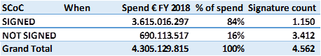

Since its launch in 2017, all of our Supplier Code of Conduct documents are stored in our new 1QM quality system.

The higher number of total suppliers overall and of suppliers that have not signed, and the slight drop in total signed spend percentage (~1.7%) versus last year is mainly due to the recent acquisition of Hi-Pro Feeds, which added a considerable number of new suppliers and amount of spend, from which about half is yet to be covered by SCoC. The trend of direct spend (suppliers) which have signed their commitment to comply with our Supplier Code of Conduct (SCoC) is increasing marginally yearly. In 2016, 86% suppliers signed. Again, 86% of direct spend suppliers, was maintained in 2017. In 2018, though the 84% rate reflects a step down, it is the result of introducing close to 1,000 additional new suppliers when Hi-Pro Feeds was added to our portfolio of companies as a new business.

Eliminating the effect of these new additions, for which approximately half have signed their commitment, the 2018 rate would have been 87%.

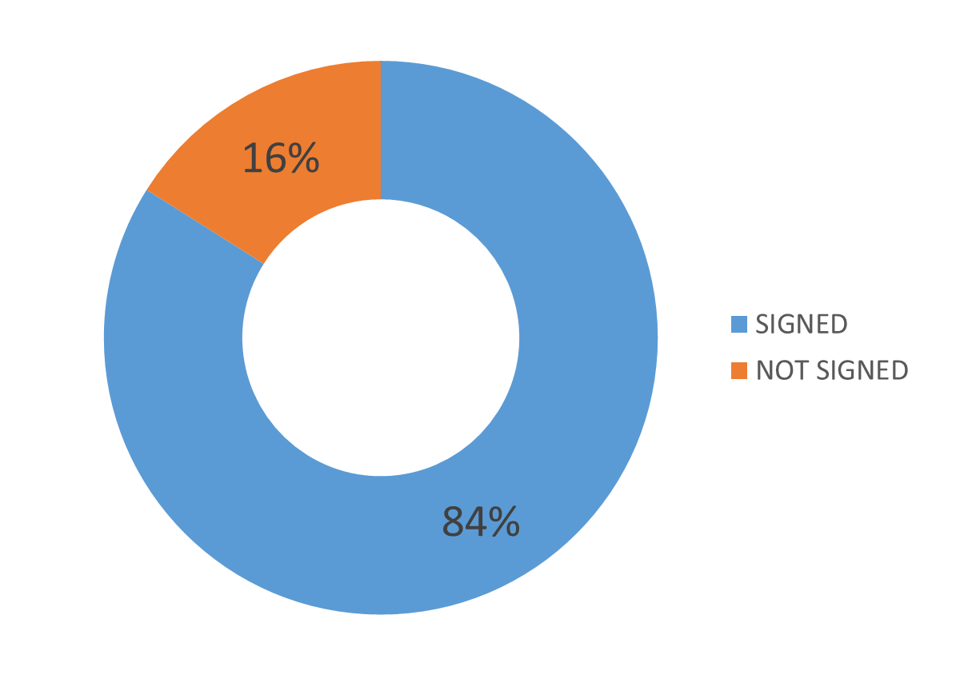 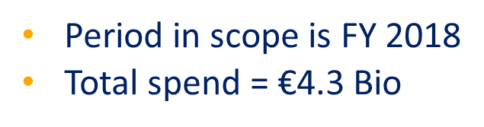

### Auditing suppliers

Nutreco is committed to ensuring the sustainable sourcing of the raw materials we use to produce high-quality nutritional solutions that enable farmers to grow healthier and safer seafood and animal proteins for the growing human population. We believe working collaboratively with our suppliers to meet our standards is the only way to ensure safe and reliable solutions for our customers around the world.

Through our divisions, during 2018, we performed quality audits at our key suppliers, according to the division supplier and supply chain improvement plan. Audits are mainly executed by the Quality teams at each division and partly outsourced to a third party. Though audits mainly focus on quality, product specification characteristics and as a key part of our supplier development program, a portion of the audit is structured to examine general sustainability issues relevant to the supplier.

Out of our total of 4,562 suppliers, approximately 325 suppliers represent 80% of our annual spend. Of these 325 suppliers, we have determined that approximately 225 suppliers represent a high risk, either due to the type of commodity they supply or the region it is sourced from. Our high-risk suppliers are placed on a three-year audit cycle (audited once every three years).

**Nutreco _**

**Number of direct suppliers                 4,562**

**Number of suppliers audited                62**

In October 2018, two NGOs in Norway released a report about Brazilian soy protein concentrate producers. These producers were accused of sourcing soybean from some specific farms that in the report’s opinion had violated the law in a variety of ways, including illegal deforestation, slave-like labour and illegal pesticide use. The report did not accuse Skretting of having received products that potentially had come from these farms as it had purchased certified products. However, it suggested that it is not enough to only buy certified products, and that feed producers also have a role to play in overseeing that the soy product suppliers only deal with soybean farms that operate responsibly. Skretting does not disagree with the NGOs on this issue in principle, but it has also emphasised the difficulty in being certain that all suppliers to our own suppliers operate in a responsible, legal way.

The audits found no evidence based on recent transactions (2018) that any of our suppliers have bought from soy farms engaged in illegal activity linked to deforestation, "slave like" labour or illegal pesticide use. Please find below some more detail regarding the specific allegations and the report findings.

**Illegal deforestation**

No soy bought by our suppliers came from farms that involved in illegal deforestation.

This was verified by comparing information about the farm against information such as IBAMA (Brazilian Institute of Environment and Renewable Natural Resources) which is publicly available. IBAMA has information about areas blocked for the sale of agricultural products because the areas are protected.

**"Slave-like" work**

No soy bought by our suppliers came from farms as the authorities had blacklisted for having slave-signed working conditions.

Working conditions were checked against lists published by the Brazilian Ministry of Labor (MTE). For MTE list was no soy from any supplier appearing on MTE "Slave Labor List" according to lists updated at 10 April 2018 and 8 October 2018. There were not discovered any purchases from farms that violated slave labor criterion.

**Illegal use of pesticides**

It is difficult for our suppliers to uncover direct illegal acts as proven by their suppliers. The companies have guidelines above their suppliers to use legitimate pesticides and to use pesticides with caution. Skretting buys ProTerra certified soy. Farms that are ProTerra certified may be revised in accordance with this Standard's provisions on the use of pesticides (which are stricter than Brazilian law).

**Land conflicts**

There will be cases where there is disagreement about the ownership of farms. Unfortunately, in Brazil there are examples that such disagreement can lead to violent conflicts.

Dispute over property rights will be a civil law case between the disputed parties. There is no public register in Brazil (and we will believe that will be the case in other countries) where one can investigate whether the farm a buyer is involved in a dispute about property rights.

**Indigenous people and rights to land**

No suppliers were found to have purchased soya from countries belonging to the indigenous people.

This was verified by investigating information about the property / farm against information available from IBAMA and information in the mentioned database Agrotools.

**Improvements**

The audit of suppliers also identified some areas where improvements have been made and will be made. Some soya is bought through cooperative organisations where co-operation can consist of several hundred farms. In such cases it has been difficult or impossible to trace back to the individual farm. Here companies have improved their routines.

# Taking responsibility within our own operations

Nutreco recognizes that we cannot demand responsible practices from our suppliers if we don’t have our own house in order. As a result, we make significant efforts to responsibly manage our own operations and seek ways to continuously improve what we do.

Nutreco currently operates 109 plants around the world. This includes 82 Trouw Nutrition plants, producing 7.6 million tonnes of feed, feed products and poultry meat products each year, and 27 Skretting plants, producing 2.4 million tonnes of feed annually. This footprint is always evolving, with new plants or major plant extensions underway in most regions. As reported in *Our operation’s environmental footprint,* we continually monitor and report four key environmental KPIs, the data quality of which is continuously improved by having a third party taking a critical look at our reporting process. We directly translate our sustainability mantra of “*producing more with less*” into our operations with a focus on operational efficiencies, particularly in energy and water use and waste products sent to landfill.

Our operations function is closely aligned with our product innovation processes so that we can factor operational criteria into all product developments or, where new or modified technologies are required, ensure they are well planned and have no negative impacts.

Nutreco’s divisions each have an operations director responsible for overseeing operational and supply chain capability and efficiency, capital investment programs and industrial automation. At each of our operating companies around the world there is an operations manager responsible for the effective running of our plants, including maximizing efficiencies and minimizing environmental impact and, of course, ensuring safe operations. Our plants are also supported by a network of process engineers, manufacturing specialists, product specialists, automation and IT specialists and researchers.

As part of our capital project development programme we have processes in place to “design in” operational efficiencies whenever an expenditure proposal is made and, where possible, prioritize renewable energy options.

## Operational excellence

At Nutreco, we encourage the prioritisation of renewable energy when possible. At some OpCos, such as Trouw Nutrition Guatemala, we have installed solar panels to supply 50% of our energy consumption, while at others, such as the new plant to be opened in 2019 by Skretting Ecuador, we have selected a 100% renewable energy source from hydroelectric power.

In 2018, Trouw Nutrition launched a “lean programme” that aims at reducing energy use by a measurable 5% and continuing to reduce landfill waste at half of the division’s plants by 2023. At our Skretting plants, we have a spectrum of activities underway, reflecting their development stage. All our plants monitor energy, water and waste and review the trends as part of our routine business reporting and management processes. Many plants have real-time energy, water and plant efficiency monitoring programs and are able to tune operating conditions to achieve the lowest energy and water use for the product being run.

A key objective of Trouw Nutrition’s lean programme is to reduce manufacturing waste through processing yield improvements, leading to a reduction of energy consumption and waste generation. This is supported by a set of KPIs for all our plants and the introduction of interactive daily meetings, based on Safety, Quality, Cost, Delivery, Motivation and Environment (SQCDME) principles, including the processing yield indicator, the waste indicator and the energy consumption indicator.

Skretting plants operate a similar, but less comprehensive, set of KPIs. The focus is on plant safety, throughput and availability (measures of plant production), yield (a measure of quality) as well as energy, water and waste. In Skretting, a key aspect of our operational excellence programme is the work of global teams covering production management and process engineering. These teams share best practices, initiate development projects and jointly deliver training programs, depending on need.

### Safety and accidents

Nothing is more important to us than Health and Safety. This is expressed in our Nutreco Health, Safety and the Environment (HSE) Policy and the rules and standards derived from this Policy, which apply to all Nutreco operations and are mandatory, without exceptions.

**Audits and inspections**

In 2018, we executed 40 audits and inspections in 14 countries ranging from China, Myanmar, South Africa, Ecuador and Guatemala to the United States, Canada, Spain and Chile. The frequency of audits by Nutreco’s Corporate HSE team is fully determined by the rating given at the previous audit.

|  |  |
| --- | --- |
|  | **Categories and minimum audit frequencies:**  A rating: 1 every 6 yrs  B rating: 1 every 5 yrs  C rating: 1 every 3 yrs  D rating: 1 every 2 yrs  *New: newly built or acquired sites that yet have to be audited* |

The objective of Nutreco is to achieve at least a B-level rating for all Nutreco operations.

**Special topics**

In addition to the more or less “standard” HSE topics, such as machine guarding, fire safety and working at a height, there are a number of topics to which we give special attention within Nutreco and for which we have established special programmes. These topics include: the risk of exposure to micro-ingredients applied in our feed and premixes, dust explosion hazards and manual handling.

Nutreco’s operations handle large volumes of mainly commodity materials, which, depending the part of the world, are often supplied and delivered in bags. Nutreco aims to limit the bag weights to a maximum of 25 kg at all its operations, which can be challenging.

**Safety first**

|  |  |
| --- | --- |
|  | In addition the safe operation of Nutreco’s plants, a general effort to build safety awareness and our company’s safety culture is another important factor for establishing safe operations. |

In 2018, we started our Safety First project, which aims to enhance safety awareness and safe behaviour throughout the company. In 2016 and 2017 we teamed up with 10 other companies – including Mammoet, ASML, Schiphol and Eriks – to share our experiences in working to create a strong safety culture and putting in place a global programme to help reduce the number of safety incidents. From these best practices, we established the Nutreco safety culture program, which was approved by the ExCo in February 2018 and launched soon afterwards.

As part of this program, we nominated safety champions at all our OpCos and set up and implemented a Safety Culture Campaign.

|  |  |  |
| --- | --- | --- |
|  |  | Our activities during the year culminated in a Nutreco Global Safety week, where each local OpCo organized activities to build safety awareness, ranging from fire drills and fire extinguisher training to very well-received family days. We nominated three of the OpCos to present their activity to the ExCo in the first half of 2019. |
|  |  |

In 2019, we will continue our Safety Culture Programme with a focus on introducing life-saving rules.

**Incidents**

In 2018, 150 lost time injuries (LTIs) were reported across Nutreco, a reduction of 15 compared to 2017. (note: LTIs at Nutreco include light duty cases, where the employee can return to work, with some limitations, on the next working day).

The frequency of LTIs per 1,000 employees (as employed at the end of 2018) was:

|  |  |  |  |  |  |
| --- | --- | --- | --- | --- | --- |
|  | **2014** | **2015** | **2016** | **2017** | **2018** |
| Skretting | 19.3 | 11.0 | 12.1 | 12.0 | 14.7 |
| Trouw Nutrition | 14.7 | 13.0 | 15.2 | 14.7 | 11.9 |
| Total Nutreco | 15.5 | 12.2 | 14.1 | 13.7 | 12.6 |

In 2009, the LTI frequency was 24.3 per 1000 full-time employees (FTEs). On the path to an accident-free company, in 2010, we set an intermediate objective to at least halve this number by 2020 to below 12.1. We are confident that we will achieve this objective, and afterwards intend to continue to reduce accidents at work.

## Our operation’s environmental footprint Image result for SDG icons

Nutreco continues to monitor, record and report its five environmental and social manufacturing KPIs on a quarterly basis. We began to do this in 2016, and now all production sites report through our financial reporting systems. We continue to strive for improvement and capitalize on our engagement with Sustainalize (the consultancy firm assessing our sustainability data) to give real-time feedback to our operational leadership with the goal of improving accuracy and clarity.

The table below shows our performance on these KPIs for all OpCos. Please note a difference in the LTIs reported in the table below as compared to the LTI data reported per 1000 FTEs in the table above in *Safety and accidents*. This difference (150 vs. 123 LTIs for 2018) reflects the fact that the data in the table below (2018 123 LTI Nutreco total) includes incidences in our OpCo (Operations) only, while the data above (2018 12.6 LTI per 1,000 employees Nutreco total = 150 LTI) in *Safety and accidents* includes incidences from our OpCos (Operations) plus hatcheries and offices and any OpCo that may have closed (discontinued) within the year.

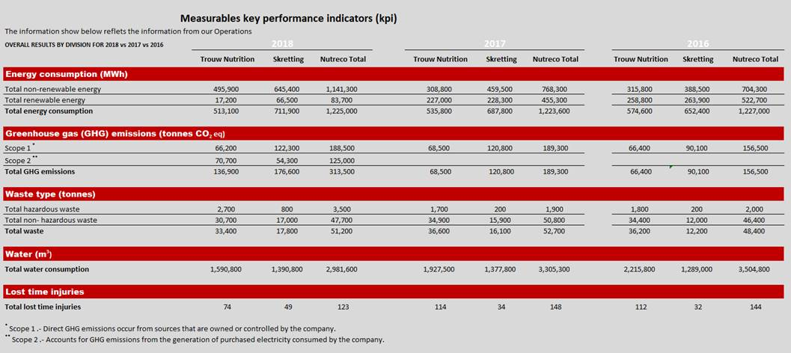

Nutreco utilizes the Intergovernmental Panel on Climate Change (IPCC) Tier Concept methodology to determine its CO2e emissions. Our preliminary approach is to use set and published international references (Tier 1) to convert energy consumption into CO2e emissions. When more precise references are available, we approach nationally published references (Tier 2) and country-specific conversion factors for calculating emissions from electricity consumption.

For additional clarity, the table below shows the differences between our performance in 2018 and 2017, normalised per tonne of product sold. The improvements shown in this table on our use of water per tonne of product sold (-10%) and LTIs per tonne sold (-17%) can be attributed to the closing of two Sada poultry processing plants in Spain. Poultry processing constitutes our largest water use footprint. In addition, waste showed a modest improvement in 2018, with a 3% reduction.

Though our consumption of energy use per tonne of product sold remained virtually unchanged (-0.2%), the substantial step up in CO2 emissions per tonne of product sold in 2018 is a direct result of the discontinuation of our policy to purchase green energy offsets for electricity consumption from the grid (scope 2). This policy will be fully revised during 2019 as we develop the new Nuterra Roadmap 2025, which we plan to launch in the first quarter of 2020 when our current Nuterra Roadmap 2020 is complete. This, in combination with the target set by the Operations teams of a 5% reduction in energy consumption by 2023 (see *Operational excellence*) for 50% of our Trouw Nutrition plants will ensure that we restore our focus on energy efficiencies.

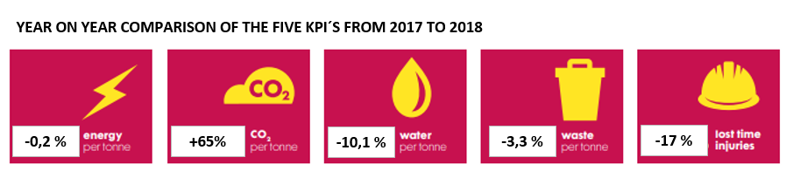

*Note: These percent variation have been “normalized” per tonne of product sold

# Our partnerships Related image

Nutreco engages in several platform groups and committees aimed at improving the sustainability attributes of systems and raw materials, including the following:

**Africa Agribusiness Academy (AAA)**  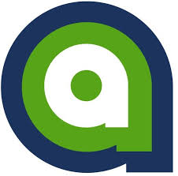

The Africa Agribusiness Academy (AAA), established in 2010, is a network of entrepreneurs seeking to foster innovation and the growth of small and medium-scale agrifood firms in Africa by connecting entrepreneurs within Africa and between Africa and the international business community. The objective of AAA is to support the African agrifood SME sector in its commercial activities by strengthening the capacity of individual entrepreneurs. Its ultimate aim is to contribute to economic growth and the improvement of rural incomes and food security in Africa. The network has 13 active business clubs with around 250 members covering six countries (Ethiopia, Kenya, Malawi, Rwanda, Tanzania and Uganda). Its main activities include the business-to-business exchange of experiences and business deals, peer-to-peer mentorship and providing services such as trainings, business fairs/expos and access to a dedicated small loan fund. Nutreco has actively participated in the AAA Advisory Committee for four years, culminating in 2018.

**Aquaculture Stewardship Council (ASC)** 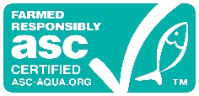

The ASC, established in 2010, is arguably the most stringent, robust and credible environmental and social standard in the farmed seafood sector. Currently over 1,600,000 metric tonnes of farmed seafood have been independently certified to be in compliance with the standard. Nutreco’s Sustainability Director sits on the Supervisory Board of the ASC. Nutreco and Skretting representatives have been engaged as Steering Committee stakeholders or as Chairman or Director of the Supervisory Board since 2004 (pre-ASC standards development). Nutreco is very proud of its role in the start-up and ongoing governance of the ASC.

**Cerrado Manifesto Statement of Support Group**

Established in 2017, Nutreco was one of 23 founding member signatories to the Cerrado Manifesto Statement of Support (SoS). The SoS has become the world’s largest business-driven group calling for immediate action in defense of Brazil’s Cerrado savanna by supporting local and international stakeholders. Today, there are 132 company signatories to the SoS across agro-industrial, farming and food processing, finance, packaged consumer goods, retail and foodservice and other supporter groups. Its key focus in 2019-2020 is to support the activity of the Brazilian Grupo de Trabalho do Cerrado (GTC) by accelerating the transition to deforestation and conversion-free soy production and to share knowledge and action plans with key Chinese companies and stakeholders.

**European Feed Manufacturers’ Federation** (**FEFAC)** 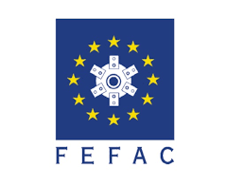

Nutreco is a member of the FEFAC Sustainability Committee, which meets two to three times per year in Brussels to address sustainability initiatives associated with the European feed industry. A positive outcome of this committee was the rollout of the FEFAC Soy Sourcing Guidelines, which lay out the minimum criteria that purchasing feed mills can incorporate when making their soybean, soybean meal and soy concentrate purchases.

**International Fishmeal and Fish Oil Organization –Responsible Sourcing (IFFO-RS)** 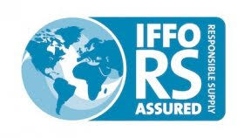

The Global Standard for Responsible Supply (IFFO RS) has become the leading independent business-to-business certification programme for the production of marine ingredients. Skretting is a member of the IFFO RS Governance Board. The main purpose of the standard is:

* To ensure that whole fish used come from fisheries managed according to the FAO Code of Conduct for Responsible Fisheries.
* To ensure no Illegal, Unreported and Unregulated fishery raw materials are used.
* To ensure pure and safe products are produced under a recognised Quality Management System, demonstrating they are free from potentially unsafe and illegal materials.
* To ensure full traceability throughout production and the supply chain.

**Peruvian Anchoveta Fishery Improvement Project (FIP)**

One of the most important fisheries in the world, the Peruvian anchovy fishery, is engaged in a Fishery Improvement Project (FIP) to get a “certifiable status” according to the guidelines of the Conservation Alliance for Sustainable Solutions (CASS). The FIP was launched in 2017 after the signing of a memorandum of understanding between the Peruvian National Fisheries Society (SNP) and the Center for Development and Sustainable Fisheries (CeDePesca). The action plan for the FIP includes an update of the former pre-assessment against the MSC standard, an evaluation of the trophic impacts of the fishery, the improvement of controls for the small-scale fleet and a better understanding of the direct impacts on other species, through a private on-board observers program. Skretting supports the FIP and is on its steering committee.

In 2019, the documentation on how fishery management of the Peruvian anchoveta can be achieved, including an ecosystem approach, will be finished. The improvement project is planned for completion in 2020.

**Roundtable for Responsible Soy (RTRS)**  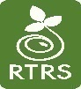

Nutreco has been a member in good standing of RTRS almost since its inception. We are committed to this multi-stakeholder platform, and participate in working groups and an initiative Steering Committee focused on mainstreaming responsible soy and deforestation-free soy in the value chain.

**Roundtable on Sustainable Palm Oil (RSPO)**

Nutreco has been a member in good standing of RSPO almost since its inception. We are committed to this multi-stakeholder platform, and we purchase green palm certificates for all our palm oil products excluding kernel oil.

**Sustainable Fisheries Partnership (SFP)**

Skretting is a sponsor of the Sustainable Fishery Partnership (SFP). SFP fills a specific gap between industry and the marine conservation community, utilizing the power of the private sector to help less well-managed fisheries meet the environmental requirements of major markets. Their work is organized around two main principles: making available up-to-date information on fisheries for the benefit of major buyers and other fisheries stakeholders and using that information to engage all stakeholders along the supply chain in fisheries improvements and moving toward sustainability. <https://www.sustainablefish.org/>

# Further stakeholder engagement

Nutreco acknowledges that internal and external stakeholder engagement is paramount to ensure the right focus and effort is invested in continuous improvement and dealing with the complex issues that face the future of sustainable food. As a direct result, we engage with several stakeholder groups and keep the conversation active and ensure that a diverse perspective is considered as we explore our solutions.

|  |  |  |  |  |
| --- | --- | --- | --- | --- |
| **Stakeholder group** | **Their concerns/expectations** | **How we engage (incl. frequency)** | **Main topics and activities addressed in 2018** | **Nutreco’s response** |
| **Employees** | - what is the company strategy?  - what is our financial performance?  - what is the company going to do around cost cutting?  - do we need to close down our factory?  - how can I make a (international) career at Nutreco? | - Regular (local) Townhalls  - Monthly broadcasted interviews with leadership  - Nutranet (intranet) announcements  - Divisional strategy updates (annual or bi-annual)  - Annual local community days  - Annual European Works Council  - Regular Local Works Council | - 2022 long term strategy  - 2018 financial performance  - new CEO vision  - any restructuring activities (marketing, specie councils for TN)  - Company performance in the industry (incl awards)  - Integrations (CA) or benefit harmonization (CA,NL) | - Regular (local) Townhalls  - Monthly broadcasted interviews with leadership  - Nutranet (intranet) announcements  - Divisional strategy updates (annual or bi-annual)  - Annual local community days  - Annual European Works Council  - Regular Local Works Council |
| **Government and regulations** | Protection of consumer and animal health | Showing leadership by continuous organization of/ participation in relevant stakeholder platforms, focussing on solutions | Establishment new regulatory possibilities for innovations (e.g. nutritional solutions as part of integrated multi-stakeholder ‘feed-farm-health’ concept) | Further development of Nutrace  -Roll-out ‘feed-farm-health’ concept, including launch nutritional solutions (e.g. YAF and health products) |
| **External sustainability (e.g.: food retailers and foodservice)** | Deforestation for commodity production | Refer to section *Sharing our dilemmas* | Dealing with the lack of “farmer-level” granularity when purchasing bulk commodity in major ports | Engagement with SoS Cerrado Manifesto; Collaboration Forestry and Agriculture, RTRS, FEFAC |
| **Food retailers and foodservice** | Illegal, Unreported & Unregulated (IUU) fishing and modern slavery | Refer to section *Sharing our dilemmas* | Steps to eradicate these illegal activities | Engagement with SeaBOS |
| **Non-Governmental Organizations**  **(NGOs)** | Biosecurity in aquaculture to reduce spread of farm disease | Twice annual workshops hosted by FAO, World Bank and Mississippi State University | Industry’s available functional feeds to reduce antibiotic usage in aquaculture | Raise awareness and collaborate with stakeholders on what technology exists and is commercially available |
| **Non-Governmental Organizations**  **(NGOs)** | Deforestation for soy commodity production | See *Our Partnerships* section above | Transparency and traceability around deforestation-free soy | Developing step-wise approach to tools to have transparency around deforestation-free soy |
| **Academia** | R&D collaboration and validation of animal performance on circularity, health (AMR reduction) and welfare and emission reduction | Set up or intensify collaborative projects | Product development and joint projects | Engages with over 80 academic institutions around the world |

# Global Reporting Initiative (GRI) Index

|  |  |  |  |  |
| --- | --- | --- | --- | --- |
| **GRI Content Index Nutreco – Core** | | |  | | --- | | **Image result for nutreco** | | |
|  |  |  | |
|  |  |  | |
| **SRS** | **Disclosure** | **Reference** | **Omission/Explanation** |
| **GRI 102: GENERAL DISCLOSURES 2016** | |  |  |
| **1. Organizational profile** | | |  |
| **102-1** | **Name of the organization** | **Colophon; GRI content index** |  |
| **102-2** | **Activities, brands, products, and services** | **Nutreco brands, customers and suppliers** [**https://www.nutreco.com/en/Corporate/**](https://www.nutreco.com/en/Corporate/)[**https://www.nutreco.com/en/brands/**](https://www.nutreco.com/en/brands/) |  |
| **102-3** | **Location of the organization's headquarters** | **Colophon https://www.nutreco.com/en/Contact/** |  |
| **102-4** | **Number of countries operating** | **Nutreco brands, customers and suppliers** |  |
| **102-5** | **Nature of ownership and legal form** | **Nutreco N.V.,** [**https://www.nutreco.com/en/Corporate/legal-information/**](https://www.nutreco.com/en/Corporate/legal-information/) |  |
| **102-6** | **Markets served** | **Nutreco brands, customers and suppliers** |  |
| **102-7** | **Scale of the reporting organization** | **Human Capital; Taking Responsibility within our own Operations; Our value chain** | **Nutreco is part of SHV. SHV gives a fair qualitative overview per company owned and discloses financial information at an aggregated level. It discloses net sales, income from operations, net income as well as its financial position, ratio information and cash flow information. For more information please read the SHV report on www.shv.nl** |
| **102-8** | **Information on employees and other workers** | **Human Capital** | **We are currently unable to provide a breakdown of the number of employees by employment contract. We are currently working on the implementation of a new HR system with which we be able to report the breakdown in future.** |
| **102-9** | **Supply chain** | **Our Value Chain** |  |
| **102-10** | **Significant changes to the organization and its supply chain** | **Organizational divisions; Enhancing sustainability in the supply chain, Supplier code of conduct** |  |
| **102-11** | **Precautionary Principle or approach** | [**https://www.trouwnutrition.com/globalassets/nutreco-corporate1/publications/sustainability/2016/nutreco-sustainability-vision-2020.pdf**](https://www.trouwnutrition.com/globalassets/nutreco-corporate1/publications/sustainability/2016/nutreco-sustainability-vision-2020.pdf) |  |
| **102-12** | **External initiatives** | **About this report** |  |
| **102-13** | **Memberships of associations** | **Our collaboration with multi-stakeholder platforms** |  |
| **2. Strategy** | | |  |
| **102-14** | **Statement from senior decision-maker** | **CEO statement** |  |
| **3. Ethics and integrity** | | |  |
| **102-16** | **Values, principles, standards, and norms of behavior** | **Human Capital, Ethics and Compliance** [**www.nutreco.com/globalassets/from-root/nutreco-supplier-code-of-conduct.pdf**](http://www.nutreco.com/globalassets/from-root/nutreco-supplier-code-of-conduct.pdf)[**https://www.trouwnutritionhifeed.com/contentassets/1e2258c18c9b4a08a3f42f305b7e4a4d/2015-code-of-ethics-brochure.pdf**](https://www.trouwnutritionhifeed.com/contentassets/1e2258c18c9b4a08a3f42f305b7e4a4d/2015-code-of-ethics-brochure.pdf) |  |
| **4. Governance** | | |  |
| **102-18** | **Governance structure** | **Sustainability governance** |  |
| **5. Stakeholder Engagement** | | |  |
| **102-40** | **List of stakeholder groups** | **Further stakeholder engagement** |  |
| **102-41** | **Collective bargaining agreements** |  | **This data is not currently unavailable. Working with the HR department to find a way to collect this in the future.** |
| **102-42** | **Identifying and selecting stakeholders** | **Further stakeholder engagement** |  |
| **102-43** | **Approach to stakeholder engagement** | **Materiality;  Further stakeholder engagement** |  |
| **102-44** | **Key topics and concerns raised** | **Further stakeholder engagement** |  |
| **6. Reporting practice** | | |  |
| **102-45** | **Entities included in the consolidated financial statements** |  | **SHV gives a fair qualitative overview per company owned and discloses financial information at an aggregated level. It discloses net sales, income from operations, net income as well as its financial position, ratio information and cash flow information. Read the SHV report on www.shv.com** |
| **102-46** | **Defining report content and topic Boundaries** | **Introduction; About this report** |  |
| **102-47** | **List of material topics** | **Materiality** |  |
| **102-48** | **Restatements of information** |  | **HR data for 2017 have been restated as the data collection system has been updated and therefore numbers for 2017 have been corrected with regard to our 2017 report.** |
| **102-49** | **Changes in reporting** |  | **No significant changes from previous reporting periods in the list of material topics and topic boundaries.** |
| **102-50** | **Reporting period** | **1 January 2018 to 31 December 2018** |  |
| **102-51** | **Date of most recent report** | **23 April 2018** |  |
| **102-54** | **Claims of reporting in accordance with the GRI Standards** | **About this report** |  |
| **102-55** | **GRI content index** | **GRI content index** |  |
| **102-56** | **External assurance** | **About this report**  **External report on sustainability data quality** | **Nutreco did not obtain external assurance on the disclosures made in the report. Nutreco has contracted the external party Sustainalize to assess the sustainability data quality in Nutreco’s 2018 Sustainability.** |
| **Material topics** | |  |  |
| **Financial performance** | | |  |
| **103** | **Management approach disclosures** |  |  |
| **201-1** | **Direct economic value generated or distributed** | **€6,357,000,000** |  |
| **Environment** | | |  |
| **103** | **Management approach disclosures** | **Taking Responsibility within our own Operations** |  |
| **302-1** | **Energy consumption within the organization** | **Our Operation’s Environmental Footprint** |  |
| **303-3** | **Water withdrawal** | **Our Operation’s Environmental Footprint** |  |
| **305-1** | **Direct greenhouse gas (GHG) emissions (Scope 1)** | **Our Operation’s Environmental Footprint** |  |
| **305-2** | **Energy indirect greenhouse gas (GHG) emissions (Scope 2)** | **Our Operation’s Environmental Footprint** |  |
| **306-2** | **Waste by type and disposal method** | **Our Operation’s Environmental Footprint** |  |
| **Employment** | | |  |
| **103** | **Management approach disclosures** | **Human Capital** |  |
| **405-1** | **Diversity of employees** | **Human Capital** |  |
| **403-2** | **Type of injury and rates of injury, occupational diseases, lost days, and absenteeism, and total number of work-related fatalities** | **Safety and accidents** | **As Nutreco's focus of the main KPIs is within manufacturing, Nutreco considers only parts of the GRI disclosure relevant for steering.** |
| **412-3** | **Significant investment agreements and contracts that include human rights clauses or that underwent human rights screening** | **Enhancing sustainability in the supply chain** |  |
| **Customer Health & Safety** | | |  |
| **416** | **Management approach disclosures** | **Feed-to-food quality and safety** |  |
| **416-1** | **Assessment of the health and safety impacts of product and service categories** | **Feed-to-food quality and safety** |  |

# External report on sustainability data quality

To readers of the 2018 Sustainability Report of Nutreco

**About this external report**

In its 2018 Sustainability Report Nutreco reports on the sustainability matters that Nutreco identified as being material to the company and its stakeholders. The quantitative data on these indicators were compiled on the basis of Nutreco’s reporting criteria and processes. We were asked by Nutreco to examine the reporting processes and controls and to assess the quality of the reported data in line with Nutreco’s criteria. This report provides an overview of our work and summarizes our observations.

**What is the purpose of our work?**

We advise management on how to improve its sustainability reporting processes and controls, enabling management to safeguard the quality of the reported data in the 2018 Sustainability Report of Nutreco. We conveyed our observations and recommendations for improvement to Nutreco.

**What did we look at?**

Nutreco asked us to have a critical look at a selected number of indicators that are published in its 2018 Sustainability Report. These constitute the key sustainability indicators of Nutreco and are disclosed in the chapters “Operating sustainably – every day”, “About this report - Our approach”, and “Sharing our dilmmea’s - Deforestation-free”:

• Energy data

• CO2

• Water withdrawal

• Waste

• Number of injuries

• Supplier Code of Conduct

• Nuterra Self-Assessment

• Workforce

• Deforestation-free supply chains

**How did we assess data quality?**

We started our work in September 2018 and finalized our procedures with the publication of the 2018 Sustainability Report. Altogether we worked approximately 300 hours on assessing data quality. We did this by conducting interviews and by assessing emails, systems, documents and spreadsheets. We performed amongst others the following key activities

* We visited 6 local operating companies in 5 countries. During these site visits we assessed the data that was reported to head office at the end of the third quarter. Part of our work consisted of assessing local reporting practices in line with Nutreco’s reporting criteria and reconciling the reported information to source data (e.g. invoices, local administrations, etc.);
* At head office level we performed trend and plausibility analyses on data that was reported by local operating companies that were not visited by us. We asked critical questions and requested supporting evidence on data outliers;
* We assessed the reporting process and related controls by performing over 10 interviews with people involved in the sustainability reporting process, which included walk-throughs on data that are reported on head office level;
* We assessed the narrative assertions in the 2018 Sustainability Report with regard to the indicators that Nutreco asked us to look at;
* We assessed the application of the GRI guidelines and the GRI table in the 2018 Sustainability Report;

**How did we follow up from our findings?**

Nutreco is continuously developing its sustainability reporting system and policies as explained in the 2018 Sustainability Report. Our assessment has led to some important recommendations for further improvement. We shared our detailed observations and recommendations for improvement with Nutreco. Misstatements and data errors that were identified as a result of our work were corrected by Nutreco in the 2018 Sustainability Report.

**Sustainalize, xx April 2018**

www.sustainalize.com

***About Sustainalize***

*Sustainalize is a management consultancy firm that fully specializes in CSR and sustainability. We support organizations in developing their strategy, organizing their sustainability processes and improving their performance and quality of internal and external reporting. As sustainability data experts we believe in robust data quality as an important prerequisite to measure progress and ultimately to improve sustainability performance.*