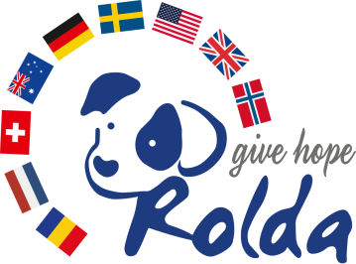

16.04.2018

Dear Mr. Secretary General,

I am pleased to re-confirm that Fundatia ROLDA supports the 10 principles of the UN Global Compact with respect to human rights, labor, environment and anticorruption.
We express our intent to support the UN Global Compact advancing these principles and we will continue to make a clear statement of this commitment to all our partners and supporters, spread on 3 continents: Europe, USA and Australia and online, to the general public.

We also pledge to participate at UN Global Compact actions globally, in the following ways:
1. Participate at local networks activities in countries where our charity is legally established: US, Norway, Sweden, Switzerland, Romania, Germany, UK and Australia.
2. Propose partnership projects in the above mentioned countries to involve individuals and philanthropic communities
3. Identify and involve corporate social responsibility
4. Participate at global events

In Romania, we built a strong partnership with ArcelorMittal corporation which successfully saved 90% of a homeless dogs population of 10000.
This partnership started in 2007 and ended in early 2016.

We support a transparent activity of all charities, public accountability; therefore we commit to report progress to UN Global Compact every two years, respecting the UN policy.

We also send you the latest annual report which includes the financial report.

Sincerely yours,

Elena Daniela Costin
Founder
Fundatia ROLDA

______________________________________________
Fundatia ROLDA
16 Feroviarilor Str., Bl.C2, ap.18 -800563 Galati, rolda@rolda.org, Mobil: 0040748903612
https://rolda.org Fundatia ROLDA este o organizatie non-profit, CUI 18416340

