United Nations Global Compact - Communication on Progress
Supremia Group - Period 2018-2019

Introduction to the COP 2018

Since 2014, Supremia has joined the United Nations Global Compact, the Supremia Group has further established and improved its processes and terms of business regarding full compliance with the 10 principles of “The Global Compact”. We are committed to further improve our Corporate Social Responsibility processes and strive for a clear and documented corporate CSR approach communicated to our employees as well as our partners and stakeholders.
The constantly changing Supply Chain requirements and settings demand a regular review of processes and procedures to ensure a safe, reliable and sustainable value chain. With this Communication on Progress (COP) we express our intent work hard to support and advance the UNGC principles within our sphere of influence throughout our supply chain. We are committed to make the Global Compact and its principles part of our strategy, corporate culture and day-to-day operations of our company and undertake to make a clear statement of its commitment, both to our employees, partners, clients, and to the public.

A Word from Our CEO

“Transparency within the supply chain has been and will be a hot topic throughout our sector. Transparency means to know where your goods are coming from and to be sure that they are produced under fair and sustainable conditions. As a service provider we see it as our duty to ensure our clients a safe supply chain that addresses all possible risks and ensures compliance within health and safety, human rights, business ethics and environmental factors. We are dedicated to further develop our efforts and to become a market leader in ensuring compliance within our supply chain. ”
Koen Heyvaert, CEO and Member of Board, Supremia Group

Supremia Group Statement of Compliance

The Supremia Group hereby states that all business activities are complying with the terms and regulations set out by the UN Global Compact ten principles as communicated by the United Nations. The Supremia Group further declares that all future and existing business activities with partners in the field of Supply Chain Management are subject to a regular compliance check with emphasis on human rights, labour rights, the protection of the environment and anti corruption.
Mechelen, March 2019
Koen Heyvaert
CEO Supremia Group

Supremia & Supremia Offices Covered by this COP

The below mentioned offices are fully owned subsidiaries of the Supremia Group and are covered by this Communication on Progress:

Supremia nv  Hanswijkvaart 51  B-2800 Mechelen  Belgium  BE0472 935 178 | Supremia (CPT)AG  Münchensteinerstrasse 43  4052 Basel  Switzerland  CH-270.3.004.127-1
Supremia Sales Promotion BV
Burg. Stramanweg 105
1101AA Amsterdam
Netherlands
NL8037 59 939 B02
Supremia BV  Franse Akker 9  4824 AL Breda  Netherlands  NL8215 33 162 B01 | Supremia France SAS  5 Rue de Chazelles  75017 Paris  France  FR56 533 327 193  SIREN: 533327193
Supremia (UK) Ltd  Jactin House, 24 Hood St.  Ancoats Urban Village  Manchester M4 6WX  United Kingdom  VAT 162709505  Company number 08537430 | Supremia Russia  115093, Moscow, Podolskoye Shosse st, house number 8, building 5  Russia  INN\KPP:7705538601 \ 772501001
Supremia GMBH  Rudolfstrasse 10V  41068 Mönchengladbach  Germany  HRB 13439 | Supremia International Ltd.  Caspian House, The Waterfront, Elstree,  WD6 3BS.  United Kingdom  Registered in England. No. 1559794 VAT No. GB 350 7178 59

Directory Communication of Progress (COP) 2017

Introduction to the COP 2018 1
A Word from Our CEO 1
Supremia Group Statement of Compliance 2
Supremia & Supremia Offices Covered by this COP 3
Directory Communication of Progress (COP) 2018 4
The Supremia Group 5
Supremia Mission 5
Supremia Vision 5
Supremia Procurement and General Business Policies 6
Supremia Code of Conduct 7
Supremia Code of Business Ethics 7
Supremia Green Purchasing Guidelines 8
Declaration on non-use of conflict minerals 8
Compliance Management Circle 10
CSR & QA Team 11
CSR Supply Chain Monitoring 11
Supplier Qualification and UNGC Signatory 11
Independent Supplier Auditing 14
BSCI – Business Social Compliance Initiative 14
SEDEX - Supplier Ethical Data Exchange 15
ECOVADIS – Comparable Monitoring of Sustainability 16
COP on Specific UN Global Compact principles 17
Human Rights Principles (1 / 2) 17
Labor Principles (3 / 4 / 5 / 6) 18
Environmental Principles ( 7 / 8 / 9 ) 20
Anti-Corruption Principles ( 10 ) 21

The Supremia Group

For over 30 years Supremia has been a provider of promotional products, premiums, sales promotion, clothing and fulfilment programmes. Ever expanding, with offices and partners in the Far East, the Americas and all over Europe, we have become a leading supplier of promotional items.
Our global presences mean our account and procurement teams’ partner with our clients and suppliers and ensure dedicated project management complying with all legal regulations as well as ensuring socially and environmentally secure procurement in Asian and Europe. We are committed to create the most creative and most outstanding promotions for our clients.
The Supremia Group employs over 300 staff in its offices in Europe and Asia. With its offices in 7 EU Countries and Procurement and Sourcing offices in China and Shanghai the Supremia Group ensures the best possible Service to all relevant stakeholders.

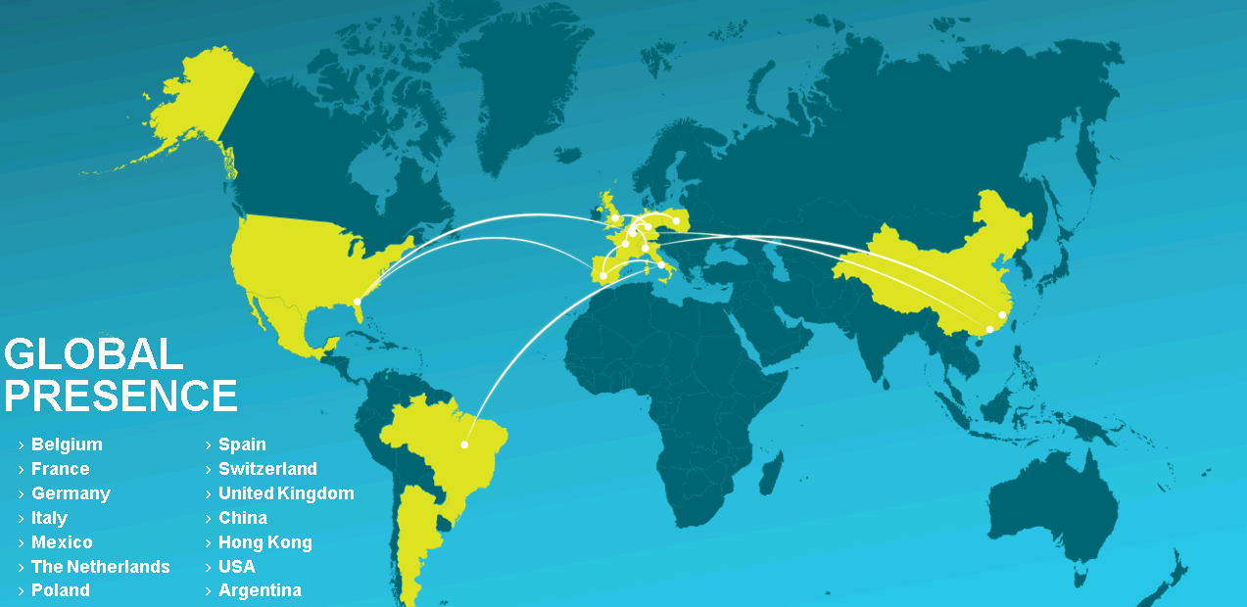
Supremia Mission
Supremia strives to boost your brand image and market share, by developing and delivering tailor-made promotional items that captivate your (future) customers.
With our extensive experience, both creative and logistical, we aim to win their hearts and minds through unique all-in concepts. Supremia offers your company a one-stop promotional solution, including the design, manufacture and distribution of an item that is perfectly adapted to your brand, budget and goals. By taking care of the entire process, our dedicated team of professionals will elevate your brand to new heights.

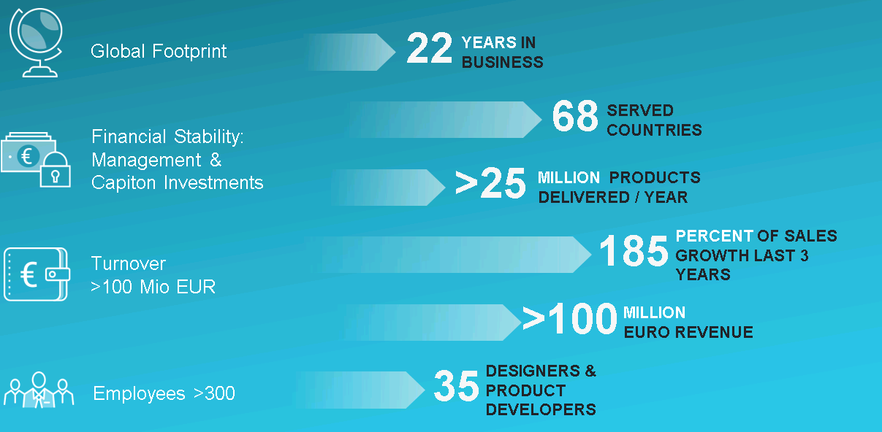
Supremia Vision
Every promotional item is an opportunity to create brand awareness and to carry out your brand values in front of existing and future clients, on the high street and far beyond.
A well-thought promotional strategy helps you to attract new corners of the market and to make a long-lasting impression on your target group. By selecting a promotional item that stands out from the crowd – because of its originality, its high quality and bespoke nature – your company undoubtedly leaps ahead of the competition. Supremia’s dedicated team of professionals has both the expertise and the experience to speak volumes for your brand.

Supremia Procurement and General Business Policies

The Supremia Groups has further established the policies for safe procurement. In this context the Supremia Group Code of business ethics has been pit in place in order to have a group wide policy on business behavior when dealing with customers as well as suppliers around the world.
Furthermore, one of the major aims within 2016/17 was to promote and generate awareness for the below business documentations both internally and externally with employees, partners and stakeholders. These Documents allow us to ensure that all employees within the Supremia Group are aware of their duties and possible restrictions as well as the responsibilities they have as part of an international company dealing with companies in different geographical areas.
The Focus has been on the following points:
Documentation: Establishing of policies with a group wide scope
Awareness: Generating awareness among employees, customers and suppliers
Controlling: Establishing of tools to control the adherence of these documents as well as reporting of non-conformities and
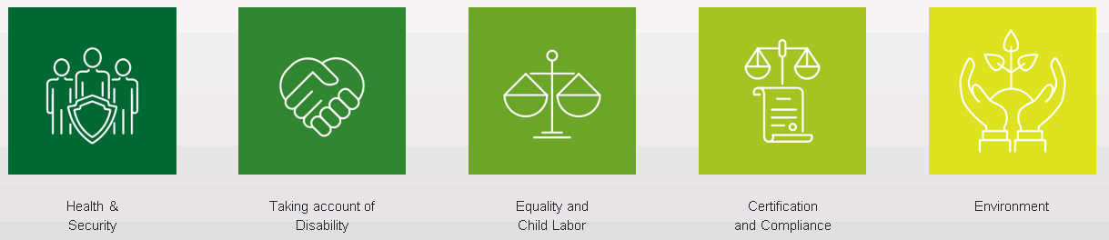
The Policies and its content have been duly agreed and confirmed by the Management Team of the Supremia Holdings. All subsidiaries of the Supremia Holding, its local sales offices and other organizations owned by the Supremia Holding are committed to adapt their processes according to the measurements and specifications declared in this document. Furthermore, they are requested to make this policy the basis of any decision in the area of business this policy represents.
Any deviation from these regulations may be reported to us

Supremia Code of Conduct

The aim of the Supremia Code of Conduct is to define the professional standards we aspire to in all our activities and the standards we expect of our employees. Supremia Group sees the Code of Conduct as a key element in our relations with employees and third parties. It will therefore be issued as part of the terms of employment for all Supremia Group companies. The Executive Board insists on full compliance with the Supremia Group Code of Conduct. In 2018 the Supremia Code of Conduct has been reworked on the basis of the UN Global Compact Code of Conduct.
The Supremia Code of conducts sets clear parameters for Suppliers follow the United Nations Global Compacts ten principles set in the areas of labor, human rights, environment and ethical conduct.

The Supremia Code of Conduct is part of the documentation every supplier of the Supremia Group has to sign before delivering any goods or service to one of the Supremia Groups affiliates.
A Copy of the Supremia Code of Conduct will be made available upon request

Supremia Code of Business Ethics

The Supremia Code of Business Ethics has been established by the Supremia Group during 2014 to give advice and a clear guideline towards employees and stakeholders for ethically responsible business behaviour.
Within all their business activities, both locally and in a global context, the Supremia Group and all of its subsidiaries and local offices are committed to promote honest and ethical business conduct and to adhere to the highest professional standards, including but not limited to treating others with respect and dignity and providing equal opportunity as well as a safe workplace to all employees, to diligently observe all applicable laws, rules and regulations in all markets with Supremia business activities and to respect social and environmental responsibility and to discourage any wrongdoing in relation thereto.
Furthermore, the Code of Business Ethics shall:
- Define procedure in case of conflict of interests
- Define best practice for dealing with other parties (e.g. suppliers)
The Code of Business Ethics shall cover and describe the following processes:
- Compliance with local law and competitive practice
- Safety, Health and Environment
- Fair Competition
- Discrimination
- Integrity
  - Privacy
  - Company Records
  - Personal Relationship and Insider Trading
  - Bribery and Fraud
A Copy of the Supremia Code of Business Ethics will be made available upon request

Supremia Green Purchasing Guidelines

In the 21st century, the entire society has increased awareness towards environmental issues, and urges companies to develop a recycling oriented society. As a supplier of gifts and premiums, we think we need to manage operations keeping the question in mind: “What does the society truly expect?” Since we consider environmental protection as one of the most important management issues, we have been working on reducing the impact on our environment. Our products are made of materials provided by many suppliers. Therefore, to reduce impact on environment at all phases of business operation, environmental protection activities for only our company are not sufficient. Total environmental protection activities that include our suppliers are needed.

Declaration on non-use of conflict minerals

The Supremia Group hereby confirms and warrants to its stakeholders that non-of their supplied products contains any of the following raw materials:

Tin, Tantalum, Tungsten, Gold, including the ores from which they were derived.

A copy of the declaration statement will be made available upon request.

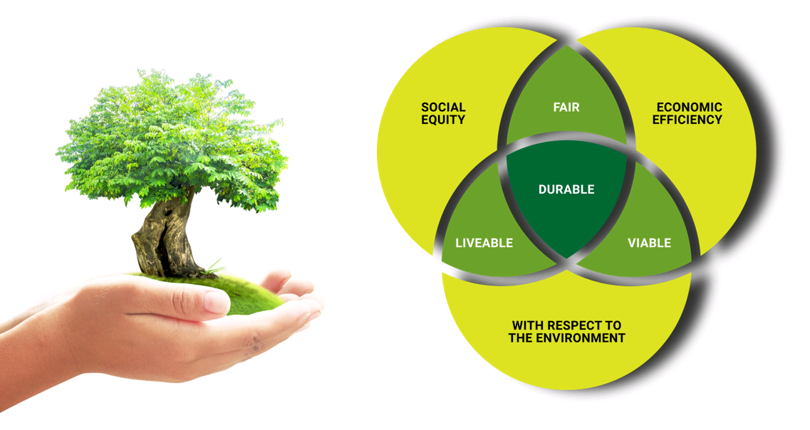

Compliance Management Circle

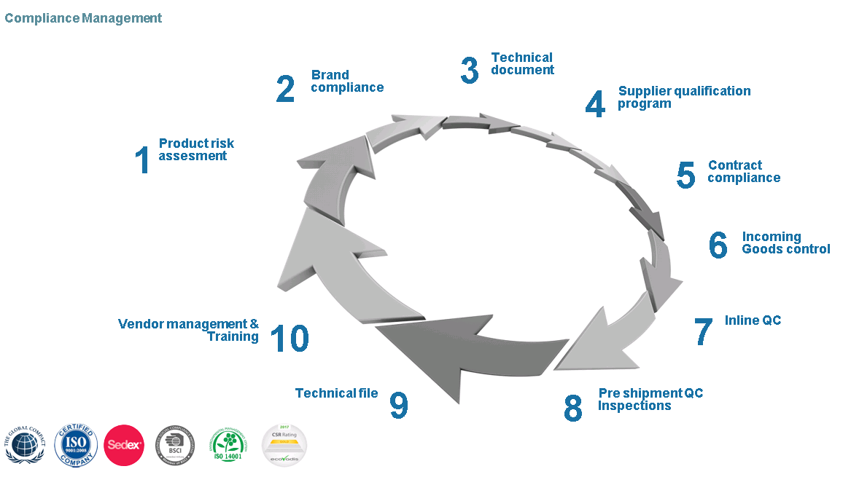

CSR & QA Team

At the Supremia Group we have installed a group wide standalone team ensuring compliance with all legal regulations as well as the ten principles of the UN Global Compact and the set out guidance of other significant CSR organizations such as BSCI (Business Social Compliance Initiative), Sedex and Ecovadis.
The team consists of members of the higher management of the Supremia Group as well as a dedicated CSR Manager taking care of all formal CSR aspects. The team defines CSR and QA relevant processes, ensures compliance with CSR regulations and undertakes regular examinations of the Supremia Group’s business partners.
The Team holds weekly meetings but also reacts immediately in urgent cases. Since the team features member of the higher management team it is ensured that CSR relevant topics are addresses directly to the highest authority of the Supremia Group.

CSR Supply Chain Monitoring

Supplier Qualification and UNGC Signatory
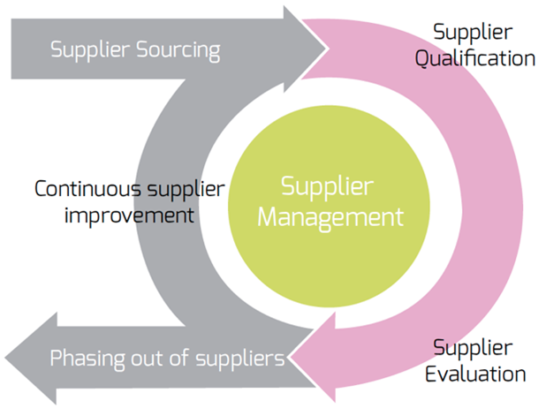
Quality and excellence is not a coincident. We at SUPREMIA belief that quality management starts with the right selection of the suppliers and partners. With a clearly structured supplier management process we ensure that our products meet the quality, ethical and sustainable requirements as set out by our clients and internal guidelines.
Together with inspections directly at the place of production (during the production process but also before shipment) by independent and leading inspection and auditing companies we ensure that only material is shipped to Europe that meets the defined and agreed quality and specifications. Possible defects are rejected directly at the point of production and needed improvements
Supremia Supplier Management Circle

can be arranged immediately. This process has lead to a almost 0% rate of claims on our products coming from far east. Unwanted surprises when opening the container in Europe are a story of the past.
The Supremia supplier Management process consists of the following steps:
STEP 5
STEP 6
Step 1: Supplier self assessment form
Collect basic information from supplier - The Supplier fills out the Supremia supplier self assessment form with information concerning Company Profile, production Capacity, CSR background, Quality Control Systems, Basic questionnaire on 4 pillars: Labor Standards, Health & Safety, Environment, Business Ethics

Step 2: SSA Validation
SSA Validation if conduced by QA manager together with the CSR Officer. It is assessed whether the received information is trustful. Further evaluation is done on general company profile, corrective Action Plan (CAP) in place, validation of provided certification, etc.

Step 3: Compliance and Documents check
Supplier is invited to sign documents that prove his intention to meet the Supremia Group requirements. Signatory of the following documents by the potential supplier:
- Supremia Supply Agreement
- Supremia Code of Conduct

Based on the finding of above research and findings, mainly based on the level of certification already in place, it is decided what level of on-site audit will be conducted.

The 10 principles of the United Nations Global Compact form an integral part of the Supremia Code of Conduct. It is mandatory for every supplier to sign the Supremia Code of Conduct in order to do business with the several Europe based offices of the Supremia Group.

Based on above Supplier qualification process a final evaluation is made and a scorecard is issued to the supplier. Based on the scorecard the supplier is eligible for procurement activities as follows:
  - Green score valid for 12 months
  - Orange CAP to be achieved within 6 months
  - Red CAP to be achieved within 3 months
Follow up is made by the QA and CSR team to ensure that CAP is achieved within timeline.

Example of final supplier evaluation:
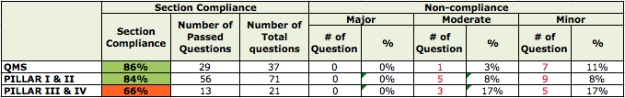
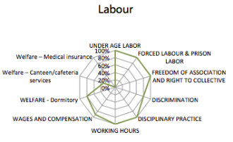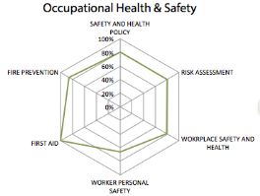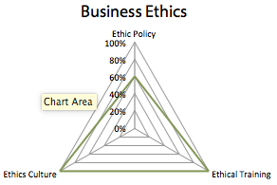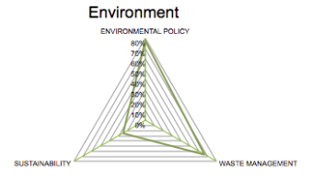

Independent Supplier Auditing

As one of our strategic key focus within QA and CSR is to provide reliable and transparent information to our partners, clients and stakeholders, we work closely together with international partner Institutions to cover the supplier audit aspect of our supply chain.
In this context, the Supremia group is member of the BSCI initiative, Sedex and Ecovadis. All companies strive to provide their clients a transparent audit protocol.
Please find on the following paragraphs some information about how these organisations work and how they ensure that out manufacturing partners meet the standards as defined by the United Nations Global Compact.

BSCI – Business Social Compliance Initiative

To continue to shape our objectives in the area of CSR, Supremia is a member of the Business Social Compliance Initiative (BSCI). BSCI is a part of the Foreign Trade Association (FTA), an organization that promotes the values of the free world and sustainable business.
Along with more than 1000 members in Europe, we are working on improving working conditions, human rights and environment in high-risk countries where our products are produced. By a jointly monitor system our suppliers are assessed on the requirements on basis of the BSCI code of conduct. By signing up the manufacturers, important improvements can be created in the area of CSR.
How it works:
The main suppliers of every product group are approached with a questionnaire to see what certificates and quotations are already in their possession. If they are already BSCI registered, we can immediately check their status and information. If not, the procedure towards a registration starts when the manufacturer signs the code of conduct.
With the questionnaire and statement signed, we can decide to present the manufacturer for an audit. This audit is carried out by one of the 15 independent audit agencies, also responsible for the SA 8000 audits. Based on this audit, a report about each manufacturer is made.
If a factory meets the requirements they will get an entry in the BSCI registry. This entry is valid for 3 years. After 3 years there needs to be a new audit carried out, commanded by Supremia.
If a factory does not meet the requirements, they will get a ‘Corrective Action Plan’ (CAP), based on BSCI guidelines. Supremia is responsible for the implementation of the CAP by the factory.
Find more information about the BSCI initiative on www.bsci-intl.org.

SEDEX - Supplier Ethical Data Exchange

SEDEX (Supplier Ethical Data Exchange) is a member-organization for companies that have committed to a sustainable improvement of ethical behavior within the supply chain.
CSR is not only about operational guidelines but also about empowering suppliers and other members of the supply chain to promote sustainable production and services. SEDEX offers a platform to track and exchange developments and improvements in sustainable production. Furthermore, SEDEX offers a safe database to administrate, share and report efforts with main scope in labor practice, health & safety, environment and business ethics.
Due to our membership at SEDEX our partners and customers have the possibility to track our efforts and developments concerning sustainable supply chain on a validated platform.
Within the SEDEX program the SMETA (Sedex Members Ethical Trade Audit) guidance provides a set of audit procedures and best practice examples based on which suppliers are audited. Basis for labor practice and human right principles are set by ILO (international Labor Organization)

Guidelines and Recommendations: The SMETA guidelines provide a standardized procedure that allows customers, shareholders and partners to work with a standardized procedure that makes efforts comparable and leads to a high-quality assessment of several supply chain elements. Audit reports are followed by corrective action plan (CAP) providing detailed information for companies on how to improve working and environmental conditions. Besides guidance for ILO based working practice and conditions the SMETA guidelines consist of a standardized time table for company audits, recommended number of to be interviewed working staff and requirements for training and experience for the auditors.
SMETA provides two different levels of audits. SMETA-2 pillar Audits covering the areas of labor practice, working conditions and health & safety. SMETA-4 pillar Audits are covering additionally the areas of environmental practice and business processes.
For companies ordering products produced within a SEDEX audited production facility the following documents are made available by the Supremia Group:
SMETA-Audit Report: Detailed audit report about the production facility including assessment of the production facility, interviews with staff members and general assessment of working conditions such as remuneration, working hours and safety measures. The Audit report is dispatched to the clients in full detail.
Corrective Action Plan Report (CAP): The CAP report provides a list of findings by the auditing party. Those findings, mostly deviations from the SMETA guidance and principles, are presented to the management of the audited production facility with clear instruction on how to resolve the issue, who must resolve the issue and by when the issue must be resolved. The CAP report also gives clear instruction to the producer how to prove that an issue has been resolved. The CAP report is dispatched to the client in full details.
Find more information about the SEDEX organization on www.sedexglobal.com.

ECOVADIS – Comparable Monitoring of Sustainability

At the Supremia Group we have made a dedicated commitment to improve not only the different players within our supply chain but also improve as a company and further reduce our own ecological impact as well as offering working conditions that are in line and above minimum requirements in Europe and Asia. To ensure sustainable improvement in all areas as well as making our efforts comparable and open towards our stakeholders the Supremia Group is working closely together with ECOVADIS.
ECOVADIS provides a platform that evaluates CSR and environmental processes and efforts with a scoring system that leads to a comparable overall score with subcategories for Environmental factors, Labor practice, fair business practice and sustainable procurement.
Within the system of Ecovadis the Supremia Group is assessed by independent auditors and based on supporting information made available to Ecovadis to prove the respective efforts. Based on the available information entered in a self assessment questionnaire and the respective supporting information a score is awarded for the different categories assessed. The final Result is expressed as an overall score (0 – 100). Furthermore, Ecovadis awards participants with 3 different recognition levels (Gold, Silver, Bronze)
The Supremia Group has with its last assessment in September 2018 been awarded with the GOLD recognition Level and a scoring average of 64 points. This places the Supremia Group in the top 1% of all assessed companies in the respective business segment.
Upon Request the full Ecovadis Report and CAP is made available to customers and Stakeholders.
Find more information about the ECOVADIS organization on www.ecovadis.com.

COP on Specific UN Global Compact principles

The following section contains information on progress for specific UN Global Compact principles:

Human Rights Principles (1 / 2)
Principle 1:
Business should support and rspect the protection of internation-ally proclaimed human rights,
and…

Principle 2:
Make sure that they are not complicit in human rights abuses Assess-ment, Policy and Goals
STATEMENT

The Supremia Group has always endeavored to conduct business responsibly and ethically. This main principle is an integral part of the Supremia Code of Conduct and the Supremia Supplier Agreement as well as our internal and external code of conduct. We respect international human rights principles aimed at promoting and protecting human rights, including the United Nations Declaration of Human Rights and the International Labor Organization’s Declaration on Fundamental Principles and Rights at Work. Our acknowledgment of these international principles is consistent with our dedication to enriching the workplace and preserving the environment where we operate and engaging with stakeholders to pursue progress toward these goals.

It is primarily the responsibility of governments to uphold human rights, but we also see it as our responsibility to use every suitable opportunity to encourage the observation of human rights even outside the area of our direct influence and to ensure security for Supremia Group.

Where we are the operator or responsible for managing operations and there are rumors of human rights abuses in the environment in which we are operating, we immediately undertake an objective investigation of the facts and the background circumstances and evaluate the extent of any abuse.

IMPLEMENTATION
Our health, safety, security and environmental protection policies form an integral part of our corporate mission, from which our business segments and Group companies derive their aims. All our efforts focus on the continual improvement of environmental quality and safety standards as well as security best practices throughout the Group.
The Supremia Group trains new employees to incorporate the Supremia Code of Conduct in all their doing from day one. Furthermore, the Supremia Code of Conduct forms an integral part of the conditions of employment every new employee must sign when coming aboard the Supremia Group. In addition, the management team of the Supremia Groups performs annual meetings with all employees at all sites of the Supremia Group to renew the commitments made in the Code of Conduct. This procedure ensures that every employee is aware of his duties and responsible concerning human rights.
The Supremia Group has established e special e-mail address (compliance@Supremia-group.com) where employees and other stakeholders may report any deviations from the Supremia Code of Conduct and any other internal or external directive in place.
In addition, the Supremia Code of Conduct must be signed by any supplier as part of the Supremia supply agreement. This signatory is compulsive and ensures that our suppliers understand the values and approach of the Supremia Group with respect to the human rights.

MEASUREMENT OF OUTCOME
Within our buying and procurement organization in Shanghai we have implemented measurements of efforts made such as signed Supremia Codes of Conduct by suppliers. Furthermore, all Supremia Group employees are sensitized to report any contravention of human rights directly to the attention of the COO. Any report will be followed up and the respective partner will be placed on probation and asked to resolve the issue immediately. In the mean time the Supremia Group stops all business activities with the concerned organization.

Labor Principles (3 / 4 / 5 / 6)
Principle 3:
Business should uphold the freedom of association and the effective recognition of the right to collective bargaining

Principle 4:
The elimination of all forms of forced and compulsory labour

Principle 5:
The effective abolition of child labour, and…

Principle 6:
The elimination of discrimination in respect of employment and occupation assessment, policy and goals
STATEMENT
Our business success and reputation are based on our employees; their dedication, creativity and qualifications and above all on their motivation and willingness to learn. We are happy to recognize their individuality and their desire for personal responsibility. We take it as understood that they want to give their best and we want our corporate policies to encourage them to be proud and happy to work for us. They should be able to find and pursue opportunities for personal development in the workplace. Successful employees have a high level of energy, a willingness to make decisions, a sense of urgency, the ability to be flexible and enjoy working as a team with people from different cultures.
As a global enterprise, we operate in host countries with the most varied socio-economic and socio-cultural systems and are bound by relevant national regulations. Supremia Group respects and complies the fundamental employment rights set out in international conventions of the united Nations (UN), the International Labor Organization (ILO), the Organization for Economic Cooperation and Development (OECD) and the UN Global Compact Initiative. We expect this commitment from all companies that do business with us but especially our suppliers.
Supremia Group assures and sets out in the Agreements made with its suppliers and subsidiaries to only employ workers at or above the legal minimum age. This minimum employment age is laid down in several conventions of the International Labor Organization (ILO). These conventions regulate internationally valid lower limits. If a higher minimum employment age is valid in the country in which a supplier maintains its business premises, then the supplier must adhere to it.
The prohibition of child labor is assured in our supply chain.
Our goal is to promote the economic well being of the enterprise and the long-term employment and personal development of all our staff through training and other development measures. It is the responsibility of the relevant management together with Operations to determine staffing requirements. Each employee is expected and encouraged to take ownership and responsibility for their personal development in relation to job skills required. Training and career planning is formally monitored on a regular basis using employee appraisals. We make sure that the company has the technical and managerial skills needed for our business development.
We take active technical, people-oriented and organizational precautions to avoid health, safety and security risks. Our facilities worldwide are planned to high safety levels that exceed local authority regulations and
meet the strictest industrial insurers’ regulations. All systems are tested in regular practice drills to make sure that they work properly. We attach great importance to the health of our employees at their place of work.

When we send our employees abroad we provide them with medical care tailored to their individual needs and the requirements of the country in question.

IMPLEMENTATION
The safety and security of our employees and all persons present at our sites is important to us. We provide periodical training courses to make our employees more safety-conscious and to give them practical skills in dealing with sources of danger. Preventive measures and active accident and incident avoidance through substantial improvements in workplace safety and analysis of potential risk factors allow us to optimize our workplace safety performance on an ongoing basis. Human life is always the priority for us. However, we expect staff members to treat the equipment and information entrusted to them with appropriate care and to use these assets for their intended purposes. Supremia Groups’ security standards and documents apply to all employees, consultants, partners and official guests of our company.
Only authorized persons can enter Supremia Group premises and have access to Supremia Group information. All employees are obliged to take any measures to avoid any risks for their own safety and safety of residents.
Labor principles form an integral part of the employment conditions and must be signed by each employee at the beginning of his work for the Supremia Group. The respective files are archived in each employee’s personal files.

MEASUREMENT OF OUTCOME
All working contracts for employees of the Supremia Group fully comply with local law and the guidelines of the International Labor Organization (ILO). In the past twelve Months there were no labor related incidents reported within the Supremia Group and all its offices. Possible labor right related cases in the future are being handled according to the regulations set out in the local laws

Environmental Principles ( 7 / 8 / 9 )
Principle 7:
Business should support a precautionary approach to environmental challenges;

Principle 8:
Undertake initiatives to promote greater environmental responsibility, and

Principle 9:
Encourage the development and diffusion of environmentally friendly technologies assessment, policy and goals

STATEMENT
Supremia Group is committed to responsible, visionary environmental management.
Through innovation and its products, Supremia Group influences not only future designs in the field of gifts and premiums, but also - with environmentally-friendly and resource conserving activities - looks to maintain and continuously improve high corporate environmental standards contributing to the conservation of an environment worth living in.
We take proven and economically effective technologies as a basis and accept responsibility for the health, safety and security of our employees.
We emphasize increasing energy efficiency, improved recycling levels and the reduction of emissions and waste to a minimum. Our processes and products are developed using state-of-the-art environmental and safety technologies. Our staff is responsible for the occupational safety of their operations and for actively protecting the environment. The qualifications of our staff are kept up-to-date by ongoing training programs.

Modern environmental technologies for minimizing emissions into air and water, up-to-date management of waste and wastewater are standard practices in our organization.
Climate protection and renewable energy sources: We see the climate debate as an important contribution to environmental stability and participate actively in it. Over and above that, we accept without reservation the need for active measures to reduce greenhouse gases. We recognize the need of a shift to renewable sources of energy supply and emphasize programs to achieve that goal.
We stipulate that our suppliers comply with our “Green Purchasing Guidelines”

IMPLEMENTATION
Supremia considers global environment protection as an important management issue, and is developing an ISO14001 compliant system in all of its branches. We are continuously promoting efforts to reduce the impact on our environment within the company under the environmental management system mentioned above. These activities are now becoming company-wide activities, beginning with global warming prevention, achievement of zero-emission and reduction / recycling of packing materials.
Many of these efforts relate to our Far East production sites so we need to start at the production stage with reducing the impact on the environment as stated in the ISO14001 environmental management system. We support prohibition of Substances of Concern (SOC) starting from “RoHS directive 2000/53/EC”, “76/769/EEC” and “Law Concerning the Examination and Regulation of Manufacture, etc of Chemical Substances”, domestic low and conformity with the “Europe REACH directives EC/1907/2006.” are additional environmental milestones.
In view of the circumstances, Supremia established the “Supremia Green Purchasing Guidelines” to facilitate activities in two main domains: the development and implementation of an environmental management system and subsequently the elimination of SOC in materials.

Specific guidelines to get our “Environmental declaration” into action are:
1. Aim to save and use limited sources efficiently.
2. Promote to save energy in all corporate activities, fulfil the responsibility for prevention of the global warming.
3. Change ozone-unfriendly substances to protect the ozone layer.
4. Control chemical substances adequately and eliminate harmful chemical substances.
5. setup a management system and make an effort to comply with in-house rules, which are stricter than local regulation.
6. Take part in social activities related with the environment.
We strongly recommend our suppliers to declare that products delivered to Supremia do not contain substances prohibited in the “Laws regarding products” and appendix “List of regulated chemical substances related laws and regulations”.
Product safety and especially the control of chemical substances are an integral part of the Supremia Supplier Agreement.

Anti-Corruption Principles ( 10 )

STATEMENT
Principle 10:
Business should work against corruption in
all its forms, including extortion and bribery

Supremia Group expects the highest standards of integrity in all business interactions. We prohibit any and all forms of corruption, extortion and embezzlement and have monitoring and enforcement procedures implemented to ensure conformance. Bribes or other means of obtaining undue or improper advantage are not offered or accepted. Information regarding business activities, structure, financial situation and performance is only to be disclosed in accordance with applicable regulations and prevailing industry practices. We respect Intellectual property rights; transfer of technology and know-how is to be done in a manner that protects intellectual property rights. Supremia Group upholds standards of fair business, advertising and competition. Appropriate means to safeguard customer information are available. Programs that ensure the confidentiality and protection of supplier and employee whistle blowers are maintained.
Above statement is an integral part of the Supremia Code of Conduct.

IMPLEMENTATION
The Supremia Group has established e special e-mail address (compliance@Supremia-group.com) where employees and other stakeholders may report any deviations from the Supremia Code of Conduct and any other internal or external directive in place.
Further, the Supremia Group holds annual training meetings with all employees at all Supremia sites where the Supremia Code of Conduct and other internal directives are presented.

MEASUREMENT OF OUTCOME
The Supremia Group has not been involved in any legal cases, rulings or other events related to corruption and bribery within the last reporting period. Our Accounting is subject to annual statutory audit which are performed by a specialized and independent third-party company. The resulting reports are one method to identify suspicious transaction within the company.

