25th May 2018

The United Nations Global Compact
801 Second Avenue
Second Floor New York 10017
U S A

Dear Sir,

COMMUNICATION ON PROGRESS – YEAR 2017 – E-W INFORMATION SYSTEMS LIMITED

We would appreciate you will consider giving us a grace period until 30th June, 2018 to forward our Communication Progress for the above period.

Thanking You

Very truly yours
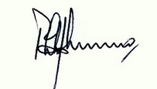
PHILIP WEINMAN
HEAD OF GROUP
HUMAN RESOURCE/ADMINISTRATION
AND COMPLIANCE

