02.03.2016

To our stakeholders,

We recognize that a key requirement for participation in the UN Global Compact is the annual preparation and posting of a Communication on Progress (COP) that comprises of a CEO statement of continued support for the UN Global Compact, a description of practical actions with regard to the principles of the UN Global Compact, and a measurement of outcomes or expected outcomes.
We are late in creating, sharing and posting our COP report due to the fact that we are planning to start doing integrated reporting. And the audited numbers will not be ready till end May each year.
We hereby ask for an extension period in order to be able to post a COP that describes our company’s efforts and progress to implement the principles of the UN Global Compact. Our new COP report will be posted on the UN Global Compact website by 31.05.2016 at the latest. And we would like the COP deadline to be 31.05 each year from now.
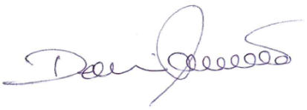
Sincerely yours,

Mr. Dennis Friis Thaagaard
Chair
International Furniture A/S

