11.08.2015

To our stakeholders:
We recognize that a key requirement for participation in the UN Global Compact is the annual preparation and posting of a Communication on Progress (COP) that comprises of a CEO statement of continued support for the UN Global Compact, a description of practical actions with regard to the main issue areas of the UN Global Compact, and a measurement of outcomes or expected outcomes. We want to align our internal reporting cycle with the COP deadline. We hereby request our COP deadline to be adjusted to May, 31st, 2016.

Sincerely yours,
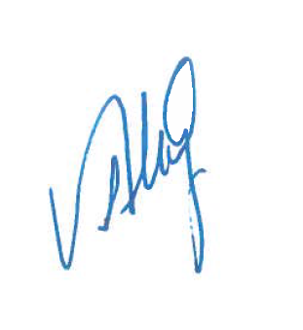
Mrs. Aslı Ünlü
CSR Manager
Turkcell

