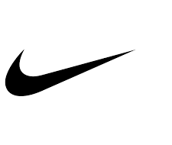

April 2015

Dear Stakeholders,

NIKE, Inc. continues its support of the United Nations Global Compact. We formally report on progress in a biennial reporting cycle. Our last report, published May 2014, covered fiscal years 2012 and 2013 in depth, with performance information and updates on human rights, labor, environment, and anti-corruption.

Please see www.nikeresponsibility.com for our most recent and relevant information.

Best regards,

Hannah Jones
Chief Sustainability Officer and VP, Innovation Accelerator
NIKE, Inc.

